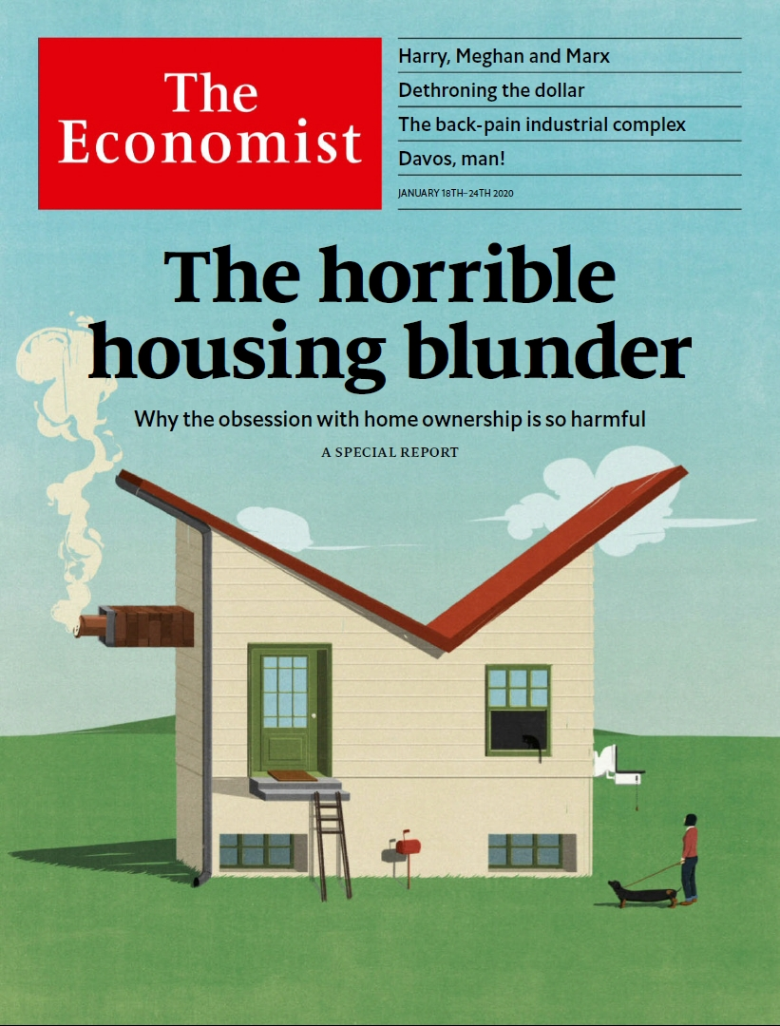

# Table of Contents

The world this week

Politics this week

Business this week

KAL’s cartoon

Leaders

Property markets: The horrible housing blunder

Iran: Sorry doesn’t cut it

Russia: Glued to the throne

Health policy: Back to basics

American economic power: Spooked by sanctions

Letters

Letters to the editor: On Iran, hormone therapy, Ireland, Dominic Cummings

Briefing

Chronic pain: Backs to the future

American financial hegemony: Dethroning the dollar

United States

The Democratic primary: The world intrudes

Retirement: Baby steps

America’s animals: City critters

The Department of Commerce: Weapon of choice

Immigration policy: Temporary toil

Lexington: The Senate’s coming test

The Americas

Haiti: Gourdean knot

Mexico: Out of left field

Bello: Argentina and the reality principle

Asia

Banyan: The Taiwan consensus

Freedom of speech in Myanmar: Pen, sword and scales

Military reform in India: A major modern general

South Korea’s justice system: Going south

China

Impaired vision: Hope for myopes

Chaguan: The digital divide

We’re hiring a new China correspondent

Middle East and Africa

Iran: Regime on edge

Oman: What comes after Qaboos?

Ethiopia: It’s all in your head

A journey up the Congo river: Follow the bottle

Europe

Russia: The transition begins

Milan thrives while Italy stagnates: The angel of the north

European industrial policy: L’industrie, c’est moi

France and the Sahel: A small Afghanistan

Language wars: Colonic irritation

Charlemagne: Geopolitics starts at home

Britain

The Atlantic alliance: Declarations of independence

Barbershops: Cut-throat competition

Criminal justice: What’s going wrong here?

Northern Ireland: The word was God

Airlines: Keeping Flybe aloft

Tax and benefits: The sausage-roll bonus

Bagehot: Harry, Meghan and Marx

International

Road safety: Crunch time

Road markings: You might as well do the white line

Special report

Housing: No place like home

A history: Building up

Supply: In my back yard

Housing finance: Whack-a-mole

Better off renting?: Money down the drain, right?

Home ownership: End of an era

Housing for the poor: A roof of one’s own

The future: Rebuilding

Business

The World Economic Forum: A tour of the Magic Mountain

Bartleby: The drugs don’t work

Pharmaceuticals: Cheap shots

Aston Martin Lagonda: Driving nowhere fast

Schumpeter: Blowin’ in the wind

Finance and economics

Emerging markets: Not just a first-world problem

Buttonwood: The semaphore of semis

Oil prices: Crude calculus

Sustainable investing: Green giant

US-China trade: Between the lines

Free exchange: Prometheus undirected

Science and technology

Emerging diseases: The seventh crown

Bioengineering: Robots that come alive

Palaeontology: What really killed the dinosaurs?

Books and arts

Conflict and culture: Pictures at an exhibition

American politics: Original sin

The second world war: Freedom fighters

Chinese fiction: Beneath the waves

Johnson: Who do they think they are?

Economic and financial indicators

Economic data, commodities and markets

Graphic detail

Obituary

Roger Scruton: Defender of the right



### Friday, January 17, 2020

|  |  |
| --- | --- |
| The world this week | 3 |
| Leaders | 5 |
| Letters | 1 |
| Briefing | 2 |
| United States | 6 |
| The Americas | 3 |
| Asia | 5 |
| China | 4 |
| Middle East and Africa | 4 |
| Europe | 6 |
| Britain | 8 |
| International | 2 |
| Special report | 9 |
| Business | 5 |
| Finance and economics | 6 |
| Science and technology | 4 |
| Books and arts | 5 |
| Economic and financial indicators | 1 |
| Graphic detail | 1 |
| Obituary | 1 |

|  |  |  |
| --- | --- | --- |
|  | Sections | Leaders |

The world this week

Politics this week

.

Business this week

.

KAL’s cartoon

.

|  |  |  |
| --- | --- | --- |
|  | Sections | Leaders |

|  |  |  |  |
| --- | --- | --- | --- |
|  | Articles | Sections | Next |

# Politics this week

Jan 16th 2020 |

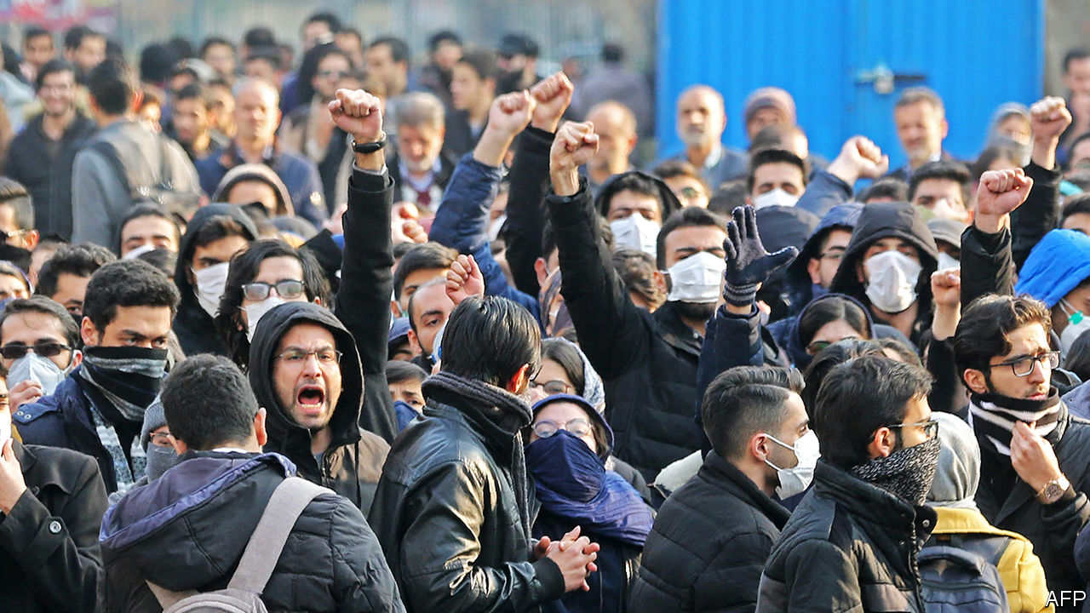

After three days of covering up the cause of the crash of a Ukrainian airliner near Tehran, the Iranian armed forces admitted that they mistook the plane for an incoming missile and shot it down, killing all 176 people on board. Thousands of Iranians demonstrated against the government’s handling of the accident. President Hassan Rouhani, who said he was also lied to, called for a full investigation. See article.

Britain, France and Germany triggered the dispute mechanism in a deal that is meant to curb Iran’s nuclear programme. The move was prompted by Iran’s gradual lifting of limits on its production of enriched uranium, which can be used to make energy or a bomb. Britain’s prime minister, Boris Johnson, called for a new “Trump deal” to replace the old agreement. Mr Rouhani dismissed this. See article.

Talks in Moscow over Libya broke down when Khalifa Haftar left without signing a ceasefire agreement. His forces are at the gates of Tripoli, seat of the internationally recognised government.

In Sudan former intelligence officers clashed with troops on the streets of Khartoum, briefly shutting the airport. It was the biggest display of force from those still loyal to Omar al-Bashir since his ousting as president last year.

Emmanuel Macron, the president of France, hosted a summit attended by five African leaders on the threat of Islamic militancy in the Sahel. Mr Macron pledged to send an extra 220 French troops to the contingent of 4,500 that are already there. Despite rising regional violence, some locals want them to leave

Ethiopia’s electoral commission set August 16th as the tentative date for an election, the first to be contested by the country’s reformist prime minister, Abiy Ahmed, who is leading a new party.

## Just impeachy

The House of Representatives at last sent the articles of impeachment for Donald Trump to the Senate, which will allow his trial to start. Democrats released new evidence against the president, based on the dealings of Rudy Giuliani, one of Mr Trump’s personal lawyers, with Ukrainian officials. See article.

The Democratic candidates for president held their last debate before the real contest kicks off in Iowa on February 3rd. Bernie Sanders denied that he had told Elizabeth Warren in 2018 that a woman could not be elected president. See [article](https://www.economist.com/node/21778380).

## A poke in the eye for Beijing

Voters in Taiwan re-elected Tsai Ing-wen as president by a margin of almost 20 percentage points. Ms Tsai’s Democratic Progressive Party also retained control of the legislature. The landslide victory was seen as a rebuff to China’s intensifying efforts to isolate and intimidate Taiwan. See [article](https://www.economist.com/asia/2020/01/11/in-a-blow-to-china-taiwans-president-coasts-to-a-second-term).

China reported the first death resulting from a virus that has infected more than 40 people, most of whom had visited or worked in a fish-market in the Chinese city of Wuhan. The WHO said it was possible that “limited” human-to-human transmission was occurring. See article.

The first of a new class of destroyer, the Type 055, formally entered service in China’s navy. It is regarded as one of the most advanced of its kind in the world. China hailed the official launch of the vessel, the Nanchang, as a “great leap” in its naval modernisation.

Taal volcano, one of the most active in the Philippines, erupted. The huge plume of ash disrupted flights at Manila’s main airport, some 50km away. Volcanologists fear a bigger eruption is imminent.

A court in Pakistan overturned the death sentence issued by a special tribunal last month against Pervez Musharraf, a former army chief who led a coup against the civilian government in 1999. Mr Musharraf had been found guilty of treason and subverting the constitution in relation to a separate incident in 2007.

## A new sherriff in town

Alejandro Giammattei, a pro-business conservative, was sworn in as Guatemala’s president. Although he has promised to fight corruption, Mr Giammattei has no plans to bring back a UN-backed anti-corruption body that was expelled from the country by his predecessor, Jimmy Morales. Mr Morales was sworn in as a member of a regional parliament, which may give him immunity from charges that he violated campaign-finance laws, which he denies.

Haiti’s parliament was supposed to start sitting on January 13th. But the country is now being governed without a functioning legislature because an election due last October was never held. President Jovenel Moïse can now rule by decree. See article.

## Power grab

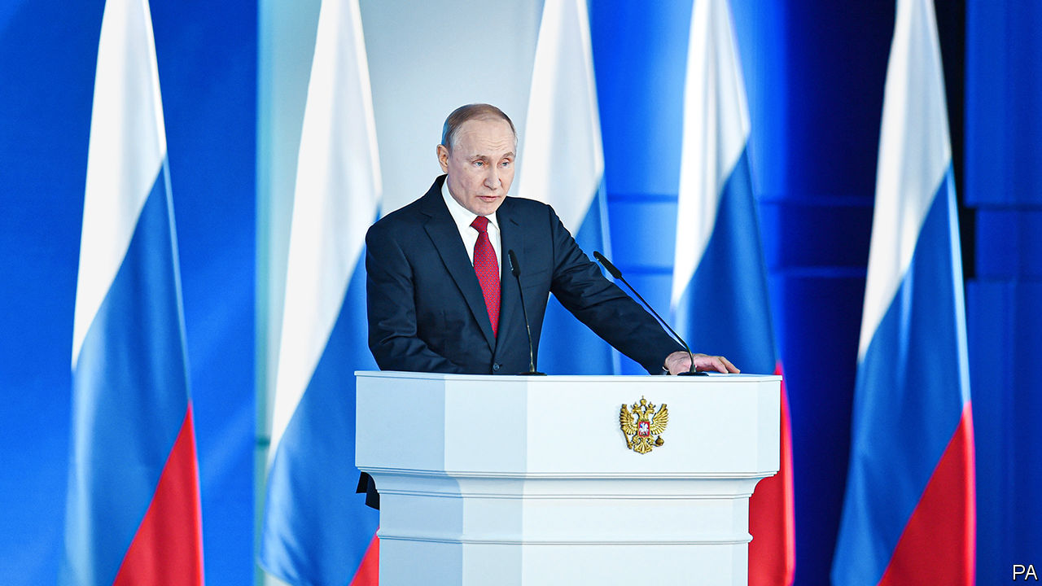

Vladimir Putin took Kremlin-watchers by surprise when he proposed an overhaul of Russia’s political institutions that could expand the power of the Duma and the state council, a body that currently has little weight but which he heads. Mr Putin must step down as president in 2024, according to the constitution. The opposition says he is manoeuvring to hold on to power. Dmitry Medvedev, an ally of Mr Putin, stood aside as prime minister. See [article](https://www.economist.com/node/21778375).

Robert Abela became Malta’s prime minister when the governing Labour Party elected him as leader to replace Joseph Muscat. Mr Muscat resigned amid an outcry over claims he protected friends linked to those accused of involvement in the murder in 2017 of a journalist who was investigating corruption.

Leo Varadkar, the Irish prime minister, called an election for February 8th. It will be the first ballot in Ireland held on a Saturday, which Mr Varadkar hopes will increase turnout.

A new power-sharing deal was agreed to in Northern Ireland, ending three years of stalemate for the devolved government. Pressure from Westminster and voter dissatisfaction forced the Democratic Unionists and Sinn Fein to compromise. The parties agree on one thing: they say that the extra spending promised as part of the deal is inadequate. See [article](https://www.economist.com/britain/2020/01/10/northern-ireland-gets-a-government-again).

Boris Johnson, Britain’s prime minister, gave his first TV interview since his election victory in December. Mr Johnson claimed it was “epically likely” that he would secure a trade deal with the EU by the end of this year, but conceded that “you always have to budget for a complete failure of common sense”. Mr Johnson was clearer about the cost of getting Britain bonging on Brexit day: £500,000. That is how much is needed to get the clapper ringing again on Big Ben, which has fallen silent during lengthy repairs.

Correction: Last week we said that both of Harvey Weinstein’s accusers in a court in New York were unnamed. In fact, only one of the women is unnamed. Sorry.

This article was downloaded by calibre from <https://www.economist.com/the-world-this-week/2020/01/18/politics-this-week>

|  |  |  |  |
| --- | --- | --- | --- |
|  | Articles | Sections | Next |

|  |  |  |  |
| --- | --- | --- | --- |
| Previous | Articles | Sections | Next |

# Business this week

Jan 18th 2020 |

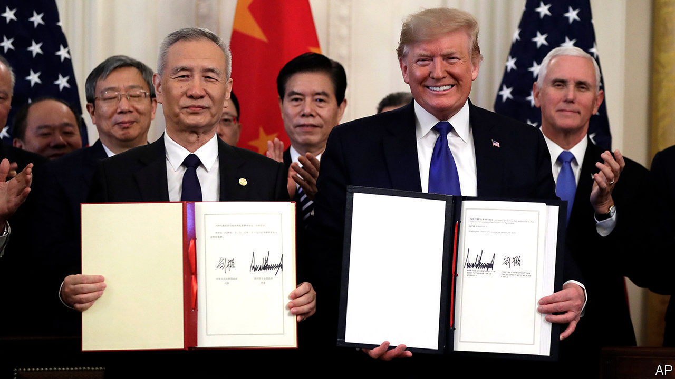

The “phase-one” deal suspending trade hostilities between America and China was signed in Washington. The agreement commits China to buy more American agricultural goods, among other things, in exchange for America withholding further tariffs. Most of the penalties that both sides have imposed on each other remain in place. Data this week showed that China’s global exports grew by 0.5% in dollar terms last year, the weakest rate in three years. Its exports to America fell by 12.5%. See article.

In another gesture that eases tensions, America said China was no longer a currency manipulator, having placed the People’s Republic on its list in August. Since then China has held back from devaluing the yuan in order to gain a trade advantage, according to the Treasury.

ZTE , a Chinese maker of telecoms equipment, launched a private share offering to raise $1.7bn that it will put towards R&amp;D in 5G networks. Like Huawei, a bigger rival, ZTE has faced a ban on working in 5G in America over security issues, but that hasn’t stopped it expanding in other markets.

Car sales in China fell by 8% last year to 26m vehicles. That followed a 3% drop in 2018, which was the first decline in decades. Even sales of electric and other new-energy vehicles went into reverse, after the government cut subsidies.

## Shaken, but not quite stirred

Aston Martin’s share price retained most of the gains it made after reports emerged that Geely, a Chinese carmaker which owns the Lotus and Volvo businesses, was interested in buying a stake. The British producer of sports cars, featured in many a James Bond film, recently issued a surprise profit warning and said it was talking to potential investors. See article.

Global trade tensions were in part to blame for Germany’s economy expanding by just 0.6% last year, the slowest pace since 2013 and below the 1.5% it chalked up in 2018. The export industry remains subdued.

BlackRock announced that it would put climate change and sustainability at the heart of its strategy, doubling the number of green funds it invests in and curtailing its investments in coal companies. As the world’s biggest fund manager overseeing $7trn in assets, BlackRock has come under pressure from environmentalists to divest from fossil fuel. Larry Fink, the chief executive, said that climate change is now a “defining factor” in business prospects that will also fundamentally reshape the finance industry. See [article](https://www.economist.com/node/21778411).

America’s big banks reported their earnings for 2019. JPMorgan Chase reported annual net profit of $36.4bn, its most ever. Bank of America’s net income came in at $27.4bn, dented by an impairment charge in the third quarter. Citigroup’s profit was up by 8%, to $19.4bn; at Wells Fargo it was down by 13%, to $19.5bn. Net profit fell by a fifth at Goldman Sachs, to $8.5bn, in part because it set aside money in the fourth quarter to cover litigation costs. The bank is expected to face hefty fines for its role in the 1MDB scandal in Malaysia.

The British government cobbled together a rescue plan for Flybe, an airline that provides services to Britain’s smaller regional airports. The bail-out, which includes deferring the loss-making company’s tax bill, provoked fury from other airlines. Willie Walsh, the outgoing boss of the group that owns British Airways, described it as “a blatant misuse of public funds” and filed a complaint with the EU. See [article](https://www.economist.com/node/21778390).

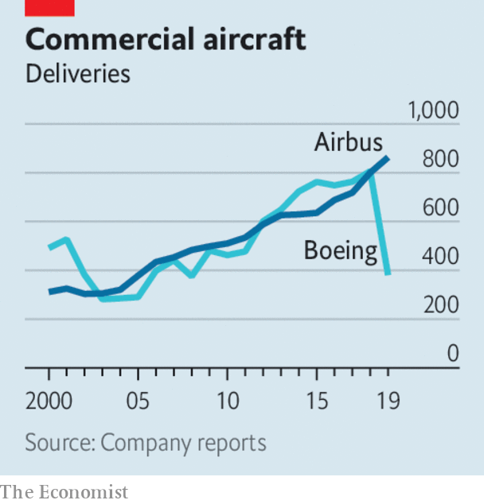

Buffeted by the grounding of its 737 MAX airliner, Boeing confirmed that last year had been its worst for orders and deliveries in more than a decade. The aerospace company delivered just 380 aircraft in 2019, compared with 806 the previous year. With airlines queuing up to cancel requisitions for new planes, Boeing’s overall net new orders turned negative, at -87. Boeing’s new chief executive, David Calhoun, who started his job this week, has promised to turn things around, assuring staff that he sees “opportunities to be better. Much better.”

A report on drinking habits in the United States from IWSR, which analyses the drinks industry, found that the consumption of wine fell by 1% last year, the first drop in 25 years (the market for sparkling wine remained bubbly, however). Americans in search of a libation are increasingly getting a thirst for ready-to-drink mixes, a market that grew 50% by volume, especially fruity hard seltzers.

## An orchestrated move

Following (unconfirmed) reports that Carlos Ghosn was smuggled out of Japan in a case for a double bass instrument when he fled bail, Yamaha issued a warning for people not to get stuck in boxes intended for musical instruments. The Japanese maker of musical equipment said that (for reasons it won’t mention) there has been a spike in social-media posts of people hiding inside large receptacles for transporting instruments. This could cause, an “unfortunate accident”, it said. Especially if squashed next to a trombone.

This article was downloaded by calibre from <https://www.economist.com/the-world-this-week/2020/01/18/business-this-week>

|  |  |  |  |
| --- | --- | --- | --- |
| Previous | Articles | Sections | Next |

|  |  |  |  |
| --- | --- | --- | --- |
| Previous | Articles | Sections | Next |

# KAL’s cartoon

Jan 16th 2020 |

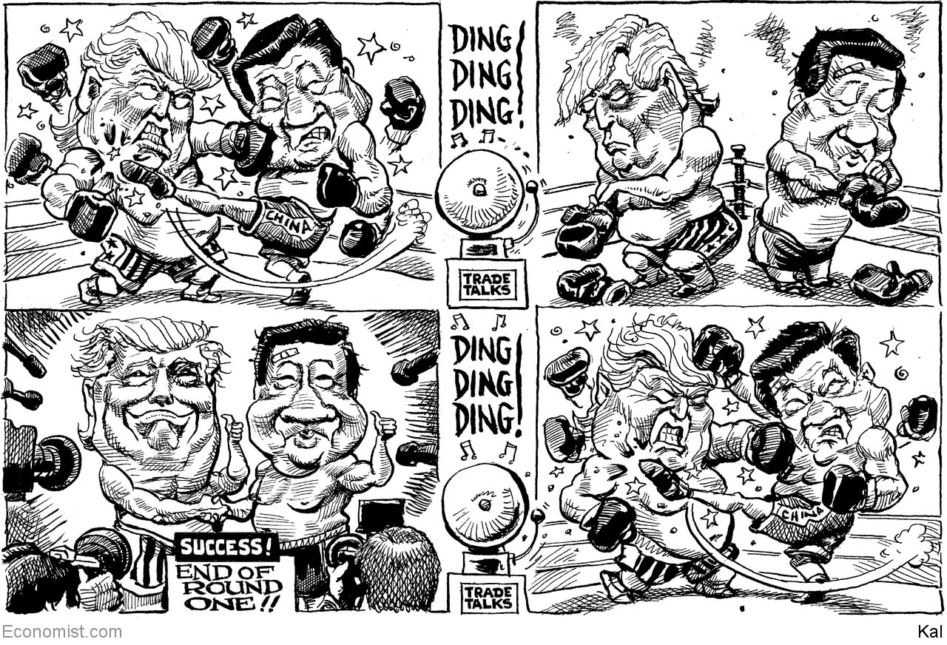

This article was downloaded by calibre from <https://www.economist.com/the-world-this-week/2020/01/18/kals-cartoon>

|  |  |  |  |
| --- | --- | --- | --- |
| Previous | Articles | Sections | Next |

|  |  |  |
| --- | --- | --- |
| The world this week | Sections | Letters |

Leaders

Property markets: The horrible housing blunder

.

Iran: Sorry doesn’t cut it

.

Russia: Glued to the throne

.

Health policy: Back to basics

.

American economic power: Spooked by sanctions

.

|  |  |  |
| --- | --- | --- |
| The world this week | Sections | Letters |

|  |  |  |  |
| --- | --- | --- | --- |
|  | Articles | Sections | Next |

#### The horrible housing blunder

# Home ownership is the West’s biggest economic-policy mistake

It is an obsession that undermines growth, fairness and public faith in capitalism

Jan 16th 2020 |

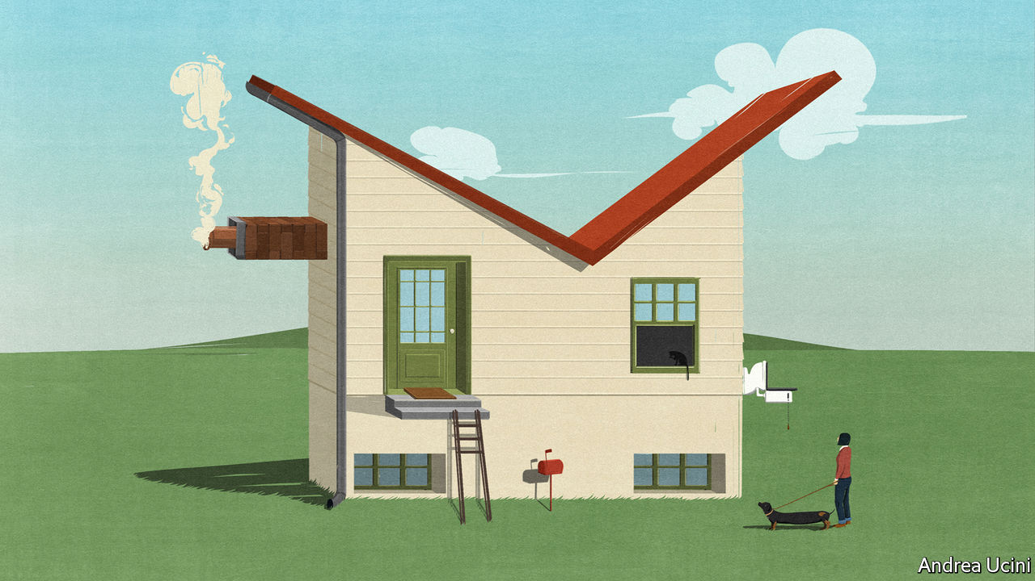

ECONOMIES CAN suffer both sudden crashes and chronic diseases. Housing markets in the rich world have caused both types of problem. A trillion dollars of dud mortgages blew up the financial system in 2007-08. But just as pernicious is the creeping dysfunction that housing has created over decades: vibrant cities without space to grow; ageing homeowners sitting in half-empty homes who are keen to protect their view; and a generation of young people who cannot easily afford to rent or buy and think capitalism has let them down. As our special report this week explains, much of the blame lies with warped housing policies that date back to the second world war and which are intertwined with an infatuation with home ownership. They have caused one of the rich world’s most serious and longest-running economic failures. A fresh architecture is urgently needed.

At the root of that failure is a lack of building, especially near the thriving cities in which jobs are plentiful. From Sydney to Sydenham, fiddly regulations protect an elite of existing homeowners and prevent developers from building the skyscrapers and flats that the modern economy demands. The resulting high rents and house prices make it hard for workers to move to where the most productive jobs are, and have slowed growth. Overall housing costs in America absorb 11% of GDP, up from 8% in the 1970s. If just three big cities—New York, San Francisco and San Jose—relaxed planning rules, America’s GDP could be 4% higher. That is an enormous prize.

As well as being merely inefficient, housing markets are deeply unfair. Over a period of decades, falling interest rates have compounded inadequate supply and led to a surge in prices. In America the frenzy is concentrated in thriving cities; in other rich countries average national prices have soared, especially in English-speaking countries where punting on property is a national sport. The financial crisis did not kill off the trend. In Britain inflation-adjusted house prices are roughly equal to their pre-crisis peak, while real wages are no higher. In Australia, despite recent falls, prices remain 20% higher than in 2008. In Canada they are up by half.

The soaring cost of housing has created gaping inequalities and inflamed both generational and geographical divides. In 1990 a generation of baby-boomers, with a median age of 35, owned a third of America’s real estate by value. In 2019 a similarly sized cohort of millennials, aged 31, owned just 4%. Young people’s view that housing is out of reach—unless you have rich parents—helps explain their drift towards “millennial socialism”. And homeowners of all ages who are trapped in declining places resent the windfall housing gains enjoyed in and around successful cities. In Britain areas with stagnant housing markets were more likely to vote for Brexit in 2016, even after accounting for differences in income and demography.

You might think fear and envy about housing is part of the human condition. In fact, the property pathology has its roots in a shift in public policy in the 1950s towards promoting home ownership. Since then governments have used subsidies, tax breaks and sales of public housing to encourage owner-occupation over renting. Politicians on the right have seen home ownership as a way to win votes by encouraging responsible citizenship. Those on the left see housing as a conduit for redistribution and for nudging poorer households to build wealth.

These arguments are overstated. It is hard to show whether property ownership makes better citizens. If you ignore leverage, it is usually better to own shares than to own homes. And the cult of owner-occupation has huge costs. Those who own homes often become NIMBYs who resist development in an effort to protect their investments. Data-crunching by The Economist suggests that the number of new houses constructed per person in the rich world has fallen by half since the 1960s. Because supply is constrained and the system is skewed towards ownership, most people feel they risk being left behind if they rent. As a result politicians focus on subsidising marginal buyers, as Britain has done in recent years. That channels cash to the middle classes and further boosts prices. And it fuels the build-up of mortgage debt that makes crises more likely.

It does not have to be this way. Not everywhere is afflicted with every part of the housing curse. Tokyo has no property shortage; between 2013 and 2017 it put up 728,000 dwellings—more than England did—without destroying quality of life. The number of rough sleepers has dropped by 80% in the past 20 years. Switzerland gives local governments fiscal incentives to allow housing development—one reason why there is almost twice as much home-building per person as in America. New Zealand recoups some of homeowners’ windfall gains through land and property taxes based on valuations that are frequently updated.

Most important, in a few places the rate of home ownership is low and no one bats an eyelid. It is just 50% in Germany, which has a rental sector that encourages long-term tenancies and provides clear and enforceable rights for renters. With ample supply and few tax breaks or subsidies for owner-occupiers, home ownership is far less alluring and the political clout of NIMBYs is muted. Despite strong recent growth in some cities, Germany’s real house prices are, on average, no higher than they were in 1980.

## A home run

Is it possible to escape the home-ownership fetish? Few governments today can ignore the anger over housing shortages and intergenerational unfairness. Some have responded with bad ideas like rent controls or even more mortgage subsidies. Yet there has been some progress. America has capped its tax break for mortgage-interest payments. Britain has banned murky upfront fees from rental contracts and curbed risky mortgage lending. A fledgling YIMBY—“yes in my backyard”—movement has sprung up in many successful cities to promote construction. Those, like this newspaper, who want popular support for free markets to endure should hope that such movements succeed. Far from shoring up capitalism, housing policies have made the system unsafe, inefficient and unfair. Time to tear down this rotten edifice and build a new housing market that works. ■

This article was downloaded by calibre from <https://www.economist.com/leaders/2020/01/16/home-ownership-is-the-wests-biggest-economic-policy-mistake>

|  |  |  |  |
| --- | --- | --- | --- |
|  | Articles | Sections | Next |

|  |  |  |  |
| --- | --- | --- | --- |
| Previous | Articles | Sections | Next |

#### Sorry doesn’t cut it

# It’s time for the Iranian regime to talk to America

And loosen up at home

Jan 16th 2020 |

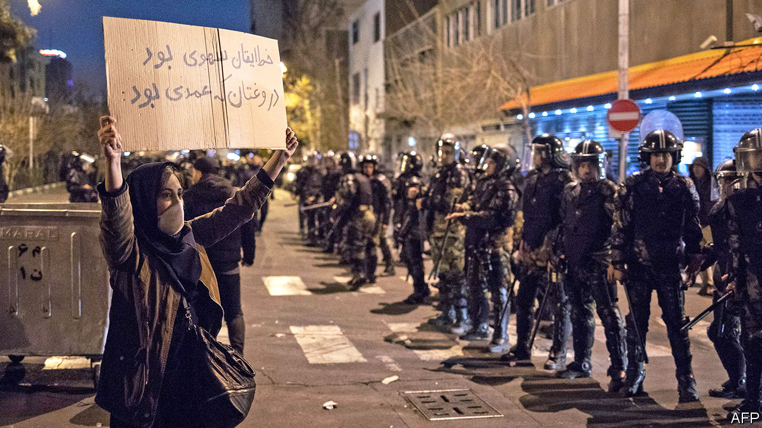

NOT SINCE the Ashura holiday, which some Shias mark by whipping themselves, had Iran witnessed so much self-flagellation. After three days of covering up the cause of the crash of a Ukrainian airliner near Tehran on January 8th, Iran’s leaders admitted that their own armed forces had mistaken the plane for an incoming cruise missile and shot it down, killing all 176 people on board. Hossein Salami, the head of the Islamic Revolutionary Guard Corps (IRGC), said he was sorrier than he had ever been in his life and wished he had died on the plane himself.

Coming from someone else, such remorse might have soothed the public. But this is Iran, where only two months ago the state killed hundreds of protesters. After a pause to berate America for killing Qassem Suleimani, Iran’s most prominent general, on January 3rd, Iranians are furious with their rulers again. Thousands have taken to the streets to challenge the regime’s lies and incompetence. Meanwhile Britain, France and Germany have taken steps that could lead to the reimposition of UN sanctions over Iran’s nuclear activity. The hard men of Tehran face pressure from all sides. They are not responding well.

Start at home, where beneath all the unrest lie broader grievances over a collapsing economy, stagnant politics and unaccountable leaders (see article). The regime seems concerned mostly with self-preservation. Officials promised a transparent investigation of the crash only after incontrovertible evidence of their lies was broadcast. Even so, some are resorting to tired tactics to deflect blame. “We will investigate the extent to which US warmongering caused this event,” said a spokesman for the judiciary, adding that several people have been detained. One is a person whom the authorities say posted a video of the missile hitting the plane.

President Hassan Rouhani, a moderate by Iranian standards, says IRGC leaders should be prosecuted. But more conservative clerics and the Guards, who together wield the real power, are already stifling dissent. General Salami has sent his thugs to club protesters. On January 13th the Council of Guardians, an appointed group of clerics and jurists, disqualified 90 MPs, nearly a third of parliament, from running for re-election next month. Most are moderates. (Imagine Britain’s Archbishop of Canterbury expelling all Labour MPs from Parliament. This is normal in Iran.)

So miserable is the situation, and so beaten down are the reformers, that some Iranians are pinning their hopes for change on the IRGC itself. After years of accumulating power, the Guards are in a position to challenge clerical rule and seek a rapprochement with America, or so the thinking goes. But such a volte-face is unlikely—and if the crash shows anything, it is that the IRGC needs to be reined in, not empowered. When he isn’t crushing protests, General Salami vows to continue Iran’s fruitless conflict with America.

The regime is not entirely to blame for the crisis with America. It was complying with the terms of a deal, signed in 2015, which curbed its nuclear programme in return for sanctions relief. President Donald Trump pulled America out of it in 2018. Since then, though, Iran has needlessly alienated the deal’s European signatories. This month it lifted all limits on its production of enriched uranium, used to make energy—or a bomb. Britain, France and Germany responded on January 14th by triggering the deal’s dispute mechanism, which could ultimately kill it.

“Let’s replace it with the Trump deal,” says Boris Johnson, Britain’s prime minister, perhaps hoping that Mr Trump would sign something like the current deal, but with his name on it—as he did with the North American Free Trade Agreement. That would be welcome but it is unlikely. For one thing, Iran’s leaders refuse to talk to Mr Trump. For most of the past 40 years they have chosen hostile posturing over constructive engagement. Iran is worse off as a result. Now would be a good time for the clerics to rethink their strategy. ■

This article was downloaded by calibre from <https://www.economist.com/leaders/2020/01/18/its-time-for-the-iranian-regime-to-talk-to-america>

|  |  |  |  |
| --- | --- | --- | --- |
| Previous | Articles | Sections | Next |

|  |  |  |  |
| --- | --- | --- | --- |
| Previous | Articles | Sections | Next |

#### Glued to the throne

# How Vladimir Putin is preparing to rule for ever

The details are murky, but Putin’s plan for constitutional change looks like a long-term power grab

Jan 16th 2020 |

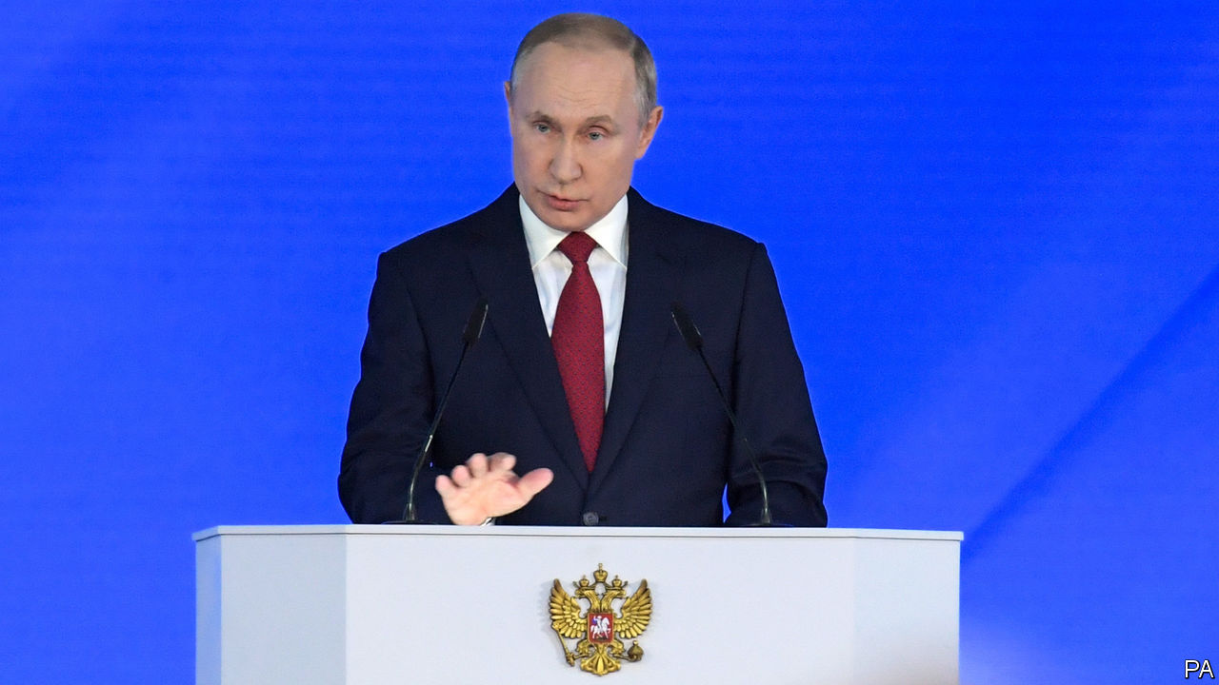

WHAT IS VLADIMIR PUTIN playing at? On January 15th Russia’s president took Kremlin-watchers by surprise. In his state-of-the-union speech, he announced a radical overhaul of the Russian constitution and a referendum on its proposed (still very unclear) terms. This bombshell was immediately followed by another. The prime minister, Dmitry Medvedev, resigned along with the entire cabinet. As The Economist went to press, the reasons for Mr Medvedev’s ejection and replacement by an obscure technocrat remained a riddle wrapped in a mystery.

To understand what might be going on, start with a simple fact. In the past 20 years Mr Putin’s regime has killed too many people, and misappropriated too many billions, to make it plausible that he would ever voluntarily give up effective power. Under the current constitution he cannot run again for president when his term expires in 2024, since no one is allowed more than two consecutive terms. So everyone has always assumed that one way or another he would game the rules to remain top dog. He already has form on this. His first two terms as president ran from 2000 to 2008. Term-limited out for the first time, he became prime minister for four years, during which time Mr Medvedev served as a distinctly neutered president. In 2012 Mr Putin was back in the suddenly re-empowered presidency, and was re-elected to a second term in 2018. The only enigma has ever been what job he would jump to in 2024.

We still do not know. One option, clearly, is for Mr Putin to return to being prime minister; an argument for this happening is his statement that the new arrangements he is seeking will make the post more important, with full powers to appoint the cabinet (subject to confirmation by parliament, which Mr Putin’s loyal United Russia party controls), rather than letting the president pick them. Another, and more likely, option is that Mr Putin will seek to maintain his hold on power by continuing to head a vaguely defined but powerful body called the State Council, which (funnily enough) Mr Putin said in his speech should be given more powers under the rejig.

In reality the details do not much matter. Russia is a dictatorship masquerading as a democracy. Mr Putin’s electoral successes owe much to years of economic growth (now brought to an end by corruption, uncompetitiveness, the end of the oil boom and Western sanctions following the annexation of Crimea in 2014) and the popularity of his reassertion of Soviet-era imperium. But they owe perhaps even more to state control of television, the barring of popular opposition candidates, the co-opting of tame opposition parties and the arrests and intimidation dished out to the less tame ones. The murder of political opponents is no way to foster genuine competition for power.

Whether Mr Putin is president, prime minister, head of the State Council or honorary chairman of the National Bridge Association (the post through which Deng Xiaoping ruled China for years after stepping down from his more prestigious offices), makes a lot less difference than it would in a real democracy. Nor does anyone know what the final shape of the new constitution will be. Mr Putin may decide, as many a despot has done before him, that a new constitution means resetting the existing term limits. Or, as Xi Jinping did in China in 2018, he could simply scrap term limits altogether (he says he does not want to do this). Mr Xi did not even bother with a referendum, pushing the change that will allow him to rule indefinitely through the supine National People’s Congress with 2,959 votes out of 2,964. Another model is offered by Kazakhstan, where Nursultan Nazarbayev, who became his independent country’s first president in 1990, stepped down last year—only to stay on as leader of the ruling party and holder of the title “Leader of the Nation”.

America would once have spoken out against such rule-twisting. Under Donald Trump, it does not; the American president makes little secret of his admiration for strongmen. Nor is the EU likely to do more than mutter as Mr Putin glues himself to the throne. It is spooked by a rising China and dependent on Russia for its gas supplies. The world’s autocrats will watch events in Moscow with interest, to see if Mr Putin can offer them useful tips for extending their own rule. For democrats everywhere, the only comfort is that even rulers-for-life don’t live for ever.

This article was downloaded by calibre from <https://www.economist.com/leaders/2020/01/16/how-vladimir-putin-is-preparing-to-rule-for-ever>

|  |  |  |  |
| --- | --- | --- | --- |
| Previous | Articles | Sections | Next |

|  |  |  |  |
| --- | --- | --- | --- |
| Previous | Articles | Sections | Next |

#### Backs on the rack

# Vast sums are wasted on treatments for back pain that make it worse

Most patients should be prescribed exercise and patience, not invasive surgery

Jan 16th 2020 |



FOR SOME people it starts with an injury: a skiing accident or a car crash. For others it starts with something seemingly innocuous, like picking up a pair of socks from the floor. But for most, back pain is as mysterious as it is excruciating. Some 85% of chronic sufferers have what doctors call “non-specific” back pain, meaning it has no clear physical cause.

In most countries, whether rich or poor, back pain is the leading cause of disability, measured by the number of years lived in poor health (see Briefing). It often strikes people in middle age and keeps them wincing, on and off, for the rest of their lives. Many lose their jobs, either because they feel physically unable to work or because they become depressed. Back pain is the main reason why Europeans drop out of work and a big reason why Americans get hooked on opioids.

The problem is not that back pain is undertreated. Far from it. Americans spend $88bn a year to treat back and neck pain—almost as much as the $115bn spent treating cancer. Add lost productivity to the medical bills, and chronic pain (the lion’s share of which is back pain) costs America an estimated $635bn a year—only a bit less than its defence budget. The scandal is that the treatments offered are mostly the wrong ones.

Doctors in rich countries are far too quick to prescribe addictive painkillers—a practice that is now spreading to the developing world. They are also too quick to offer magnetic-resonance imaging (MRI) scans. In rich countries perhaps 80% of MRIs for back pain are unnecessary. The scans often find an “abnormality”, such as disc degeneration or a “slipped” disc. These are common even in people who do not suffer back pain, but desperate patients often demand swift intervention to “fix” the “problem” the scan has revealed. Surgery with unproven benefits, or which has been shown not to work, is common. Cigna, an American insurer, found that 87% of customers who had spinal-fusion surgery for wear and tear of spinal discs were still in so much pain two years later that they needed more treatment. And spinal injections, another treatment, often do little good.

For most back pain, the best treatment is non-medical. Do some stretching exercises. Keep moving. Don’t give up work or lie in bed for days on end—that will probably make things worse. Above all, be patient. The problem may not be your back; it may be that the brain’s pain-signalling system is not working properly—and, alas, medical science does not know why. The pain may be partly psychosomatic. The stress of a bad marriage, a horrible boss or a sick kid may bring it on. People who suffer mental trauma when young are more likely to experience back pain in middle age. In many cases, the right exercises and the passage of time can ease the pain. And unlike surgery, they cost very little and are unlikely to make things worse.

Health systems get back pain wrong for several reasons. People who are in agony unsurprisingly want something to be done about it. It is easier for a doctor to prescribe painkillers, scans or injections than to explain to patients that such treatments are unlikely to work. Doctors and hospitals are often paid more for doing things than for giving advice. In America, Australia and the Netherlands, insurers pay for back operations costing tens of thousands of dollars, but barely cover physiotherapy.

The answer is to educate patients better, so they don’t feel they are being fobbed off when told to do stretching exercises. Doctors need better training, too—back pain gets short shrift in medical curriculums. More research is needed into the effectiveness of surgery. But most of all, governments and insurers need to start paying for the right things. This will be hard. Costly interventions have a powerful lobby, and there is no exercise-industrial complex to counterbalance it. With luck, more effective treatments for back pain may be developed in the coming years. But for now, policymakers should show some spine and turn their backs on treatments that don’t work.■

This article was downloaded by calibre from <https://www.economist.com/leaders/2020/01/18/vast-sums-are-wasted-on-treatments-for-back-pain-that-make-it-worse>

|  |  |  |  |
| --- | --- | --- | --- |
| Previous | Articles | Sections | Next |

|  |  |  |  |
| --- | --- | --- | --- |
| Previous | Articles | Sections | Next |

#### Dethroning the dollar

# The search to find an alternative to the dollar

China, Russia and others don’t want to rely on American high-finance

Jan 18th 2020 |

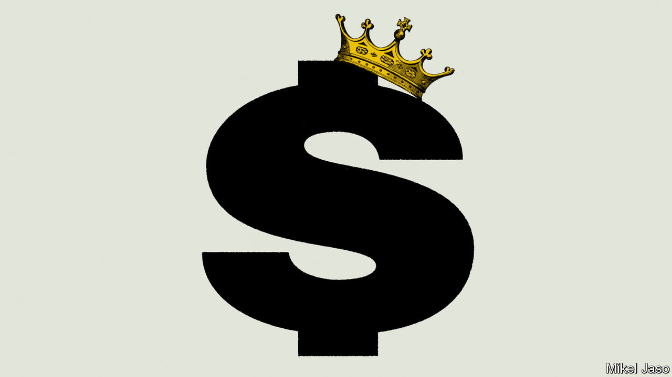

ON JANUARY 15TH America and China signed the first phase of a trade deal that eases tensions, with China agreeing to buy an additional $200bn of American products over two years. It may look as if peace is breaking out in global economic relations, but beneath the surface the tectonic plates of commerce are shifting (see [Briefing](https://www.economist.com/briefing/2020/01/18/america-is-weaponising-its-currency-and-financial-system)). America’s financial muscle-flexing—through the use of sanctions, tariffs and bans on blacklisted firms—has not escaped the attention of other countries, which have been intensifying efforts to avoid the global dollar-based financial plumbing. Though these could herald a more balanced international monetary system, they also carry risks for the world economy.

The Trump administration has turned its financial might on not only China but also Iran, Russia and a host of others—including even allies such as the European Union and Turkey. The latest Iranian sanctions, announced last week, will heap more pain on an economy already pummelled by economic missiles aimed at banks, oil production and shipping. So dollar-centric is global commerce that other countries have long found it difficult to trade, even among themselves, without recourse to America’s currency, banks and payments infrastructure. At least half of all trade invoices are in dollars. A majority of cross-border transactions are ultimately cleared through New York.

America started using the dollar system as a geopolitical weapon in earnest after the attacks of September 11th 2001. President Donald Trump has taken this policy to a new level of intensity, using sanctions as his main foreign-policy tool and even targeting allies with “secondary” sanctions that punish anyone who trades with states in America’s bad books. America’s power ultimately stems from its ability to prohibit firms from using its financial system, in turn leaving them isolated and unable to interact with most counterparties. Often the effect is fatal.

The moves to explore alternatives to dollar-dependence in the face of this bellicosity are varied. Russia has substantially de-dollarised its trade flows, foreign debt and bank assets. Its energy giants have started switching contracts to roubles. Russia, China, India and others are discussing—and signing—bilateral or wider deals to settle trade in national currencies. They are also exploring alternatives to SWIFT, the dominant payments-messaging network, over which America holds sway. Europe, meanwhile, has built Instex, a clearing-house, that could allow its firms to trade with Iran while bypassing America’s financial cops.

The search for workarounds has been given further impetus by the technological revolution sweeping through finance. Central bankers from Europe to China are stepping up work on public digital currencies. These could help bring down the cost of electronic cross-border payments, which is still relatively high. Some foresee the creation of cryptobaskets of reserve currencies.

It would be overdoing it to say these initiatives pose an immediate threat to the dollar. Instex has yet to be used; the SWIFT alternatives have yet to gain traction. The dollar’s share is holding up on most measures (though in forex reserves it has slipped from around 70% to 60% since 2000). It continues to enjoy strong network effects. The most complex bits of global finance, including a huge mesh of derivatives, are generally dollar-based.

Moreover, potential rivals have drawbacks. The euro is hobbled by structural and governance problems, not least the lack of a proper banking or markets union in the euro zone, and a dearth, relative to America, of risk-free financial assets such as German bunds. Blockchains alone cannot overcome such flaws. The yuan, too, has had false dawns. The tightening of capital controls after a financial crash in 2015 put paid to brash predictions that it would overtake the dollar by the early 2020s.

Nevertheless, an inflection point has been reached. Since Mr Trump began firing off financial ordnance, his targets have gone from merely musing about breaking free from the dollar to doing something about it, albeit tentatively for most. It is hard to see those efforts being wound down, even if America eases up.

A world in which the dollar is tested from several sides will be unpredictable. In the longer term, more balance among global reserve currencies may make the global monetary system less vulnerable to shock. And the dollar’s current pre-eminence is not an unalloyed good for America: it distorts the currency’s value (upwards) and market interest rates (downwards).

In the interim, however, the new era of monetary experimentation carries three big risks. First, a further escalation of sanctions could cause a financial shock, for instance if China’s giant banks, which together have over $1trn of dollar assets, were targeted. The second worry is that the more politicised America’s financial hegemony becomes, the less reliable it will be in its long-standing role as a lender of last resort to offshore dollar-based financial markets and banks. The third is that transitions in the global monetary order are inherently unpredictable. Some economists believe the Depression was partly caused by the absence of a hegemon to steady the world economy. Mr Trump’s upping of the financial pressure will have repercussions far beyond Tehran or Moscow.■

This article was downloaded by calibre from <https://www.economist.com/leaders/2020/01/18/the-search-to-find-an-alternative-to-the-dollar>

|  |  |  |  |
| --- | --- | --- | --- |
| Previous | Articles | Sections | Next |

|  |  |  |
| --- | --- | --- |
| Leaders | Sections | Briefing |

Letters

Letters to the editor: On Iran, hormone therapy, Ireland, Dominic Cummings

.

|  |  |  |
| --- | --- | --- |
| Leaders | Sections | Briefing |

|  |  |  |  |
| --- | --- | --- | --- |
|  | Articles | Sections | Next |

#### On Iran, hormone therapy, Ireland, Dominic Cummings

# Letters to the editor

A selection of correspondence

Jan 16th 2020 |

Letters are welcome via e-mail to letters@economist.com

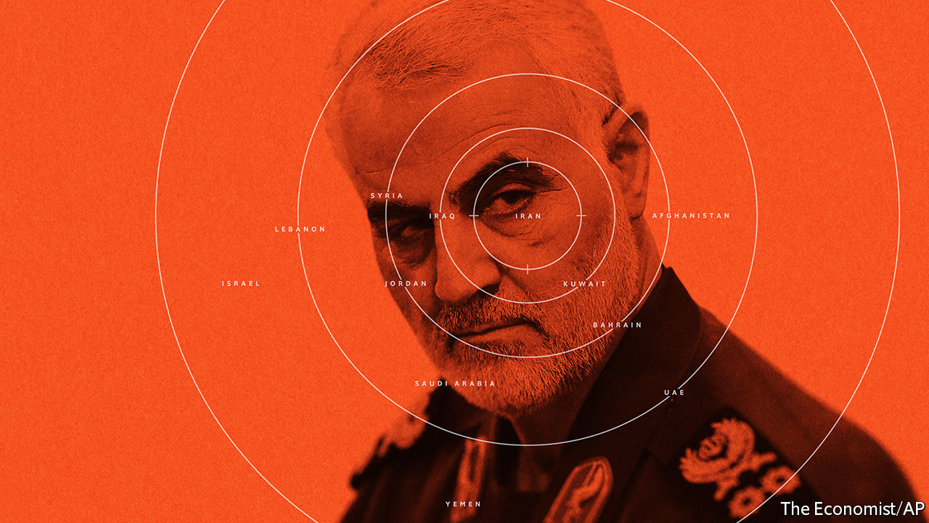

## A dangerous precedent

It is short-sighted to think that “two tests” will define whether the killing of Qassem Suleimani was a success: “its effect on deterrence and on Iran’s regional power” (“Masterstroke or madness?”, [January 11th](https://www.economist.com/leaders/2020/01/09/donald-trump-wants-to-curb-iran-has-he-gone-about-it-the-right-way)). The killing failed a more important test. It breached a settled rule of international law prohibiting the use of force in international relations, except in response to an actual attack or to an imminent threat. Mike Pompeo, America’s secretary of state, all but admitted that no such attack was foreseen when he claimed, irreconcilably, that an attack was imminent, but we simply didn’t know where or when.

That makes it harder to distinguish and reject the legality of Iranian justifications for retaliation in revenge. Indeed, how do we reject the legality of any country’s use of force to avenge some prior insult? Accepting the legality of the drone strike that killed Suleimani reverberates far beyond Iran and its neighbourhood. It makes the world a much more dangerous place.

GABOR RONA  
Professor of practice  
Cardozo Law School  
New York

I doubt that it was in line with your usual standards of prudence and civility to suggest, referring to Suleimani, that “ridding the world of a baleful individual” was a “worthwhile achievement”. I look forward to you trying to spell out the plausible and precise criteria for applying such complacent language to the killing of one obviously baleful individual but not, perhaps, to another.

AREND SMILDE  
Utrecht, Netherlands



## More on hormone therapy

It is surprising that your correspondents may have ignored an important aspect of hormone-replacement therapy (Letters, [January 11th](https://www.economist.com/letters/2020/01/11/letters-to-the-editor)), given that, in spite of many studies, the adverse effects of HRT, if any, remain unclear. It should be recognised that so many women have greatly improved their well-being while on these therapies, and that their libido and sexual function have been enhanced. Happiness and health go together.

ROBERT WINSTON  
Professor of science and society  
Imperial College London

I read with interest the heated exchange of letters commenting on your recent article about treating menopause. It appears that the correspondents were unaware of the recent update on the Women’s Health Initiative trial presented at the San Antonio Breast Cancer Symposium in December. Now that we have 18 years of data following on from that landmark trial, it appears that it is the combination of oestrogen plus progesterone in women who have not had a hysterectomy that is the cancer-causing problem, leading to a 29% increased incidence of breast cancer. The use of oestrogen alone in women who no longer have a uterus actually demonstrated a 23% reduction in breast-cancer incidence, in that same study.

These are important data for women to be aware of. As newer methods of molecular or radiologic screening for uterine pre-cancerous changes are developed, I predict we will be able to offer postmenopausal oestrogen replacement safely to the majority of women, whether or not they have had a hysterectomy.

LOWELL HART  
Associate professor of internal medicine, hematology and oncology  
Wake Forest University School of Medicine  
Winston-Salem, North Carolina

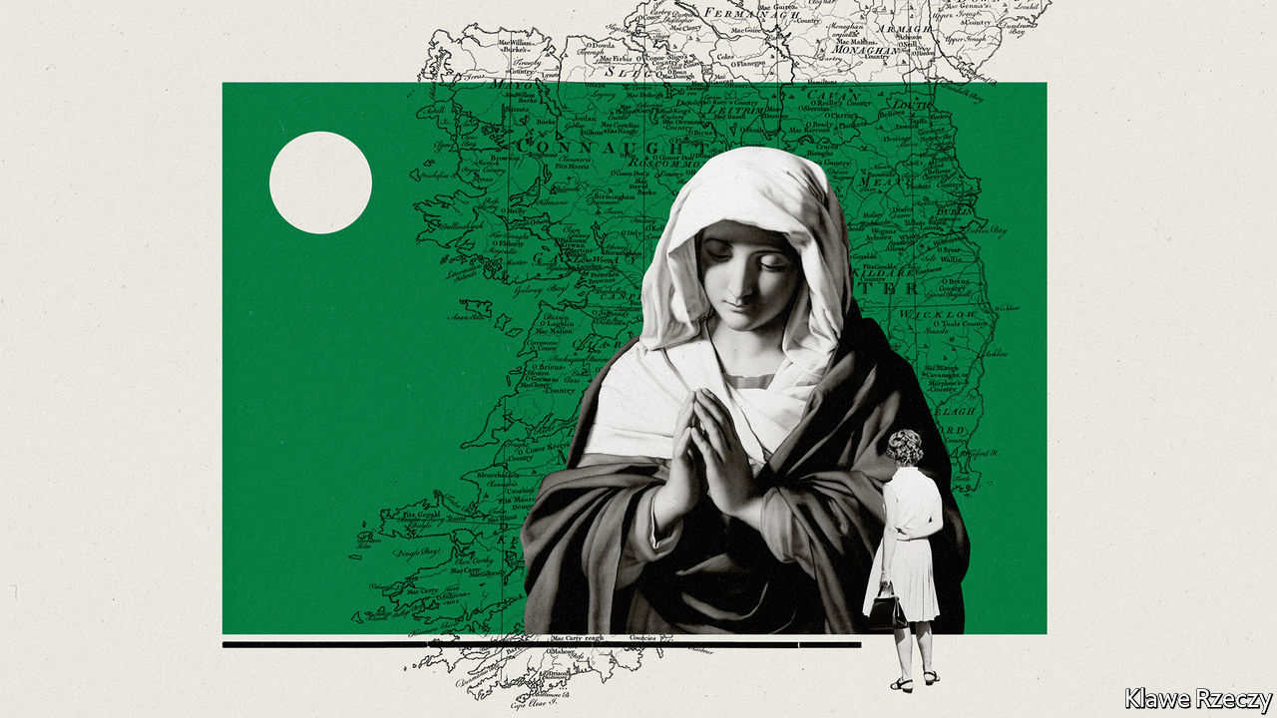

## Historical progress

Regarding the liberalisation of Ireland (“Personal and political”, [December 21st](https://www.economist.com/christmas-specials/2019/12/18/the-liberalisation-of-ireland)), the “profound shift” in Irish social attitudes over the past four decades has been matched by a similarly profound change in economic circumstances. Today’s older generation in Ireland lived through an era in which the economy transformed from one of the poorest in Europe to one of the wealthiest. It is perhaps unsurprising that people who have seen rapid economic growth bring about drastically increased living standards are less conservative and fearful of change in their social attitudes than those of similar generations elsewhere.

Vitriolic culture wars in other countries are normally accompanied by sluggish economic growth and stagnating living standards. So, instead of trying to persuade conservatives to change their social attitudes, liberals should focus on growth-enhancing measures to attain progress.

COLM HARNEY  
London

The introduction of universal free secondary education in 1967 was the single most important piece of social policy in the second half of the 20th century in Ireland, helping transform the culture. If ever there was a case study on the role of education in remoulding a country it was this. It made Ireland enlightened, successful and normal.

DAVID MERRIMAN  
Cork

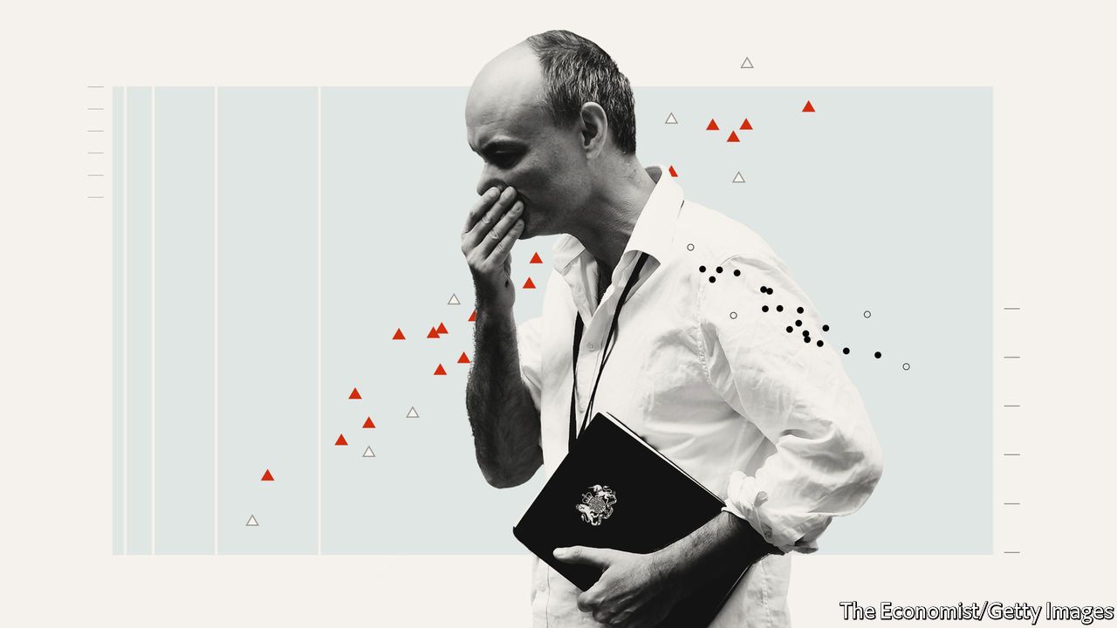

## Ra, ra, Rasputin

The ideas Dominic Cummings has put forth about reshaping the British state sound alarmingly familiar (“The Cummings plan”, [January 4th](https://www.economist.com/britain/2020/01/02/dominic-cummingss-plan-to-reshape-the-state)). It is the old arrogant and irrational dream (or nightmare) about central hierarchical steering and control by technocrats and managers, who know everything (and better) than consensus-oriented politicians and bureaucrats. The prime minister’s adviser points to the Apollo programme, which brought the world’s best scientists and engineers into government projects. I suggest he reads “The Moon and the Ghetto” by Richard Nelson.

This book, published in 1977, explains the difference between sending a man to the Moon and solving poverty, or why large technical problems are thoroughly different from engineering social systems. Governing involves continuous adaptation and learning about how to achieve what we want. This invariably involves conflict and consensus, not quick, arrogant and streamlined decision-making.

Is there a better description of Mr Cummings’s own role in Brexit? His devil-may-care, break-the-rules approach to policy sounds dangerously like a quip from his master, Boris Johnson: “There are no disasters but only opportunities, and indeed opportunities for fresh disasters.”

WERNER JANN  
Professor emeritus of administration and organisation  
Potsdam University  
Potsdam, Germany

“The Cummings plan” involves accumulating as many scapegoats as possible. His Leave campaign blamed Britain’s problems on the European Union. The onus for delays to the withdrawal agreement was shifted to Parliament. The purpose of his assault on a resistant civil service is to combine it with Brussels as whipping boys for the unravelling of Brexit that will shortly commence.

ROD TIPPLE  
Cambridge, Cambridgeshire

I recall that the gifted brother of Sherlock Holmes, Mycroft, is described in one affair as not just being in the government, but, occasionally, he is the government. Mycroft discreetly handles policy in every field, not always successfully, but with the highest loyalty and patriotism. And when taken into his confidence, Sherlock supports him completely. What are Mr Cummings’s credentials?

BRYAN STONE  
Ettingen, Switzerland

This article was downloaded by calibre from <https://www.economist.com/letters/2020/01/18/letters-to-the-editor>

|  |  |  |  |
| --- | --- | --- | --- |
|  | Articles | Sections | Next |

|  |  |  |
| --- | --- | --- |
| Letters | Sections | United States |

Briefing

Chronic pain: Backs to the future

.

American financial hegemony: Dethroning the dollar

.

|  |  |  |
| --- | --- | --- |
| Letters | Sections | United States |

|  |  |  |  |
| --- | --- | --- | --- |
|  | Articles | Sections | Next |

#### The burden of back pain

# Back pain is a massive problem which is badly treated

Why are better approaches to helping sufferers so slow to spread?

Jan 18th 2020 |



PETE MOORE was 43 when he woke up one autumn morning with back pain so excruciating that he struggled to dress himself. His doctor in Romford, an English town, referred him to hospital for an MRI scan; this showed that some of the spongelike discs that separate the spine’s vertebrae were bulging out of the slots into which they customarily fit. Such “slipped” discs can be caused by an injury; but they are also the sort of thing which can just happen with increasing age.

Mr Moore received a prescription for opioids to help him cope with the pain; but the pain persisted, and he found himself becoming loopy. Unable to work or do much else, Mr Moore, who had been a painter, sank into depression. Three years into his ordeal, he says, he was “thinking of ending it all”.

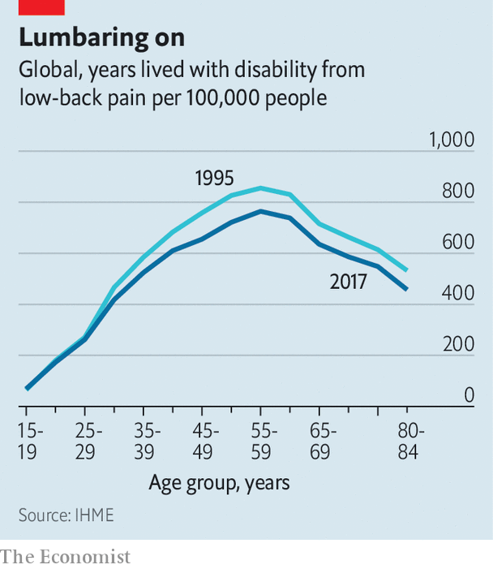

Back pain does not, in and of itself, kill people. But it makes a huge number of lives a misery. In most countries for which there are reliable figures, whether rich or poor, back pain is the top cause of disability, measured by the aggregate number of years lived in poor health. That burden is decreasing (see chart) but only very slowly.

The costs, however, have been rising quite quickly—and are enormous. In 2013, according to one study, $88bn was spent on medical treatments for back and neck pain in America, not far short of the $115bn spent on cancer (more recent figures have not been analysed in a comparable way). A great deal of this money seems, sadly, to do little good.

Doctors used to think that back pain was almost entirely the result of mechanical damage to tissue beyond the capacity of X-rays to detect. The advent of MRI scans showed this was not true. A definitive physical cause—such as a fracture, a tumour, pressure on a nerve, infection or arthritis—is found in 5-15% of people with back pain. The rest is all labelled as “non-specific”, and there is increasing evidence that it is not mechanical in origin.

Back pain, like all pain, is experienced in the brain not the body; nerves coming in tell the brain that something is amiss, and the brain projects an appropriate sensation of pain. Researchers who specialise in pain increasingly believe that, in most cases, chronic pain means that the system has become damaged in some way that keeps it switched on. “It’s like a fire alarm that goes off after the fire has been extinguished,” says Lucie Knight, a psychologist at a pain clinic in St Thomas’ Hospital, in London. Back pain may also be related to other aspects of a person’s life not going well.

Taking this view seriously throws into doubt a great deal of the medical treatment of back pain—much of which, in effect, seeks to silence the maddening sound of the fire alarm by putting out a fire that isn’t there. But it does not offer an obvious medical alternative. Some pain medicines, such as paracetamol, do not work at all for back pain. Opioids, for all their reputed analgesic potency, offer back-pain relief little if any better than options such as ibuprofen. Their continued use often makes pain worse rather than better, and is highly likely to cause addiction.

Drugs that worked better and did less harm would be a boon. But they have proved hard to develop. The mechanisms in the nervous system and brain which generate pain are complex, and can doubtless go wrong in a variety of ways, says Steve McMahon of King’s College London. He thinks that the development of drugs for chronic pain has a poor record because the people they are tried on have a range of different problems.

Evidence of ineffectiveness has not stopped doctors from writing prescriptions for the drugs they have. The prevalence of chronic back pain provided a huge expanse of fertile ground for the deceptive marketing and poor prescription behind America’s opioid epidemic (see Bartleby). In many countries doctors also frequently prescribe painkillers called gabapentinoids, despite strong evidence from trials that, as far as treating back pain goes, they offer no benefits.

There are also a lot of treatments for the back itself. Spines are injected with cement-like mixtures or fitted with various types of medical hardware. Vertebrae are fused together, discs excised or tampered with in various ways. Yet—unsurprisingly, if it is largely the pain mechanism which is the problem—there is a growing body of evidence that the benefits all this offers to most patients are limited or non-existent.

Even just looking at the back causes problems. Only 1-5% of people with back pain have a problem that requires urgent treatment, such as an infection or a tumour; in such cases the pain will tend to be accompanied by other symptoms too, such as weight loss, fever or incontinence. In America and western Europe guidelines say that it is only when such red flags are present that a patient presenting with back pain should promptly be given an x-ray or an MRI scan. Yet general practitioners and hospitals routinely ignore this, sending 40-60% of people with back pain to be scanned—far more than they did 20 years ago. According to Jan Hartvigsen of the University of Southern Denmark there is a broad consensus that about 80% of such scans are useless.

That might be fine if the scans were sometimes helpful and never harmful. But few bodies are completely normal, and learning of your particular “abnormalities” in a medical setting and while suffering is alarming even if a healthy back might look just as odd. Disc “degeneration” is seen in roughly half of young and middle-aged adults with back pain, but also in a third of those with no pain at all. Some 40% of people with back pain have disc protrusion, a form of “slipped” disc; but so do nearly 20% of people who are pain-free.

Both patients and doctors, though, tend to think that if they can see something they should do something. Some sufferers catastrophise the news into the idea that they have a broken, fragile back and start avoiding normal physical activity—not least, says Ms Knight of St Thomas’, because doctors often fail to explain to them that abnormalities are, in fact, quite normal, and that degeneration can basically be wear and tear. The stiffness and weakening of the muscles this inactivity brings often makes things worse. And doctors may take abnormalities as a cue for further medical attention. Many studies have confirmed that patients who receive unwarranted imaging in the first few weeks of back pain are more likely to have surgery and unnecessary follow-up tests than similar patients spared the scans—but that they enjoy no benefits in terms of pain reduction or lessened disability.

In 2011 Cigna, an American insurance company, ran a follow-up study on patients who had undergone procedures in which vertebrae are stitched together with implanted bolts and braces. “Spinal fusion” of this type is a frequently used surgical response to back pain that is associated with the degeneration of spinal discs; in 2015 there were roughly 85,000 such surgeries in America. The company found that two years after treatment 87% of customers were still in pain severe enough for medication or some other treatment; 15% had more surgery.

## This is going to hurt

It all sounds depressing. It need not be so. There are ways of dealing with back pain that waste much less money and leave patients less distressed and with a greater sense of their own agency.

Mr Moore, the patient with whom this story began, tried to come to terms with his disabling pain by starting a support group for fellow sufferers. A psychologist from St Thomas’, which has the biggest pain clinic in Europe, came to talk to them about “graded exercise” and the importance of pacing themselves when going out and about. “Nobody had told me I could do these things,” says Mr Moore. In 1996, three years after back pain had come to dominate his existence, a two-week residential programme at the pain clinic taught him what it teaches people today: exercise daily; accept flare-ups as temporary setbacks; don’t get fixated on the pain. Learning to keep going this way “saved my life”, Mr Moore says.

The programme, explains Ms Knight, aims not to reduce pain so much as to add to life. People naturally struggle against the pain, which means they are burdened with the pain and the struggle too. “If you can drop the struggle,” says Ms Knight, “then you have your hands free to do more.” Patients are taught how to gradually overcome their fears of exercise and daily activities that can cause some pain. The goals that they start with can be as simple as calling a friend and meeting for a coffee, or attending a wedding. In a typical class of ten people, Ms Knight says, one or two decide that the approach is not what they want, and may drop out. Most of them take away at least some skills which add to their quality of life. One or two, like Mr Moore, find the programme life-changing.

Various countries have tried to encourage people with back pain to stay active, with promising effects. One such campaign, in Australia, is reckoned to have led to a 15% reduction in the number of doctor visits for back pain and a 20% decrease in related medical costs. Such campaigns appear to work best when they provide practical advice on how to stay active and at work despite the pain, and when as well as speaking to the afflicted they enroll employers, clinicians and unions as partners.

Activity is not a panacea, and if leading an active life with pain is better than withdrawing from the world, it is still not ideal. But interventions like this seem to offer people more succour than highly medicalised approaches. Unfortunately, medical schools, patient expectations and the policies of insurers and governments all sustain the latter.

All around the world, family doctors are woefully undertrained to treat common, unglamorous conditions such as bad backs. In most medical curricula musculoskeletal conditions, like back pain, are a minor feature. Back pain is “not sexy” for medical students, says Chris Maher of the University of Sydney. Even if they are going to be family doctors they still want to hear about cures for cancer and impressive forms of surgery, rather than humdrum stuff like back pain or preventing falls in older people.

Spinal surgeons, for their part, often take a dim view of evidence that what they do may be ineffective. Surgical training is based on an apprenticeship model. “You learn from a master, a great guru, and you do what they taught you. You don’t learn from a paper in the British Medical Journal,” says Andrew Carr, who heads the department of orthopaedic surgery at Oxford University. Surgeons generally consider an operation successful if the incision is small, things heal nicely and there are no complications, says Maurits van Tulder from Vrije University in Amsterdam. If they ever hear back from patients, that is usually from those for whom the operation worked—which leads surgeons to believe that it works most of the time.

Though research on surgical outcomes is becoming a lot more widespread, it is still hard to convince surgeons that what they have been doing for most of their careers is ineffective, says Dr Carr. It is also hard to convince patients that, when it comes to treatment, less may be more. Told that the best thing they can do about back pain is exercise their body and their patience, they often think they are being fobbed off; a deluge of online marketing for ineffective treatments does not help. Some harangue their doctors for scans or injections, or find a new more biddable one. For a busy doctor, says Rachelle Buchbinder of Monash University in Australia, “it’s easier to prescribe an x-ray than explain why you don’t need one.”

Once pain becomes chronic, persuading sufferers that the cause is not a fixable physical defect becomes much harder. Graeme Wilkes, a British doctor, says that he might spend an hour telling a patient that the things seen on his MRI may not be the reasons for his back pain, and that a spinal injection is unlikely to help. “The reason they’ve got back pain is that they have financial problems, marital problems, disabled children, they are not sleeping at night—not those changes in their MRI scan,” says Dr Wilkes. “And they go home and someone says ‘Oh, that’s absolute rubbish that you can’t get an injection, because my mate at work had it and he was much better afterwards. Don’t listen to them, go back to your GP and get referred’.”

But the biggest reason why so many people with back pain get the wrong treatments is that governments and insurance plans pay for them. In America, Australia and the Netherlands health plans pay for back operations that cost $25,000-100,000 apiece. American plans often support the alternative therapy offered by chiropractors. There is some evidence that this may do some good in back pain, but the research is patchy and any benefits small and short-lived. Yet the same plans typically offer little support for physiotherapy to the same end. If a therapy has been accepted by an insurance company, or a government scheme like America’s Medicare, it is very hard to get it removed, even if evidence for effectiveness persistently fails to turn up. “Once they are in, it is hard to take them out,” says Dan Cherkin from the Kaiser Permanente Washington Health Research Institute. The manufacturers of medical devices are very good at lobbying to get them covered as treatments. They are also “incredibly effective” in marketing their wares to doctors, says Richard Deyo of Oregon Health and Science University.

Back pain is big business for many surgeons, doctors and chiropractors. ���If we stop doing low-value care, some entire professions have to change fundamentally what they do,” says Lorimer Moseley of the University of South Australia after enumerating a long list of ineffective treatments. In some systems cupidity encourages such things. In America, where procedures are more lucrative than talking to patients, an unscrupulous doctor might prefer to spend a 15-minute appointment giving a patient an injection rather than some education, just as a harried one might.

Other countries have had some success with an approach called “Choosing Wisely”, in which doctors explain to patients the evidence on the effectiveness of various treatment options and decide together what is best given each patient’s personal goals (which could range from simply wanting to be able to play with their grandchildren to cycling or running). In Britain there has been a determined move towards triage which assigns back-pain patients to more or less intensive treatment depending on the complexity of their problems. In Australia some emergency rooms have started sending some back-pain patients brought in by ambulance straight to physiotherapists, which avoids a significant amount of hospitalisation.

## Choosing poorly

But when professional associations in America urged doctors to take up the Choosing Wisely model their campaign made almost no difference to back-pain treatment—perhaps because doctors were under no obligation to change, says Dr Deyo. Nor has a change in the advice provided by the American College of Physicians had any great effect as yet. In 2017 the college stopped recommending medication as an initial response to back pain, suggesting instead acupuncture, yoga, tai-chi and psychological therapies aimed at reducing stress, all of which have been shown to reduce pain-related disability. Insurers have taken note, with some now covering some or more of these alternatives. That will make it easier for doctors moved to change their practice to do so.

Another approach might be to nudge doctors incrementally, rather than to change their practices once and for all. Tweaking the interface of the electronic systems doctors use to order MRIs so that it takes them longer to place an order has been shown to reduce the number of unnecessary scans. Adding a pop-up reminder explaining why imaging is frequently unnecessary has also shown effects.



Disability-benefit systems matter a lot, too. In many countries benefit systems give people signed off with back pain few incentives to improve, and their erstwhile employers no incentive to encourage them back rather than find someone else. In the Netherlands, though, this has changed. Medical assessment for disability benefits does not kick in for two years after a patient reports sick, and during this time employers must pay the sick employee 70-100% of their wages. Employers and employees are also required by law to agree a return-to-work plan. After the country switched to this system, in 2006, the total number of sick days for back pain fell by a third. The return-to-work rate after a three-to-four-month sick leave due to back pain is now 62% in the Netherlands. In neighbouring Germany it is only 22%.

Drivers for such change are hard to come by in part because, as Dr Maher says, back pain is largely invisible. People do not die from it and there are no “back-pain survivors” to spearhead lapel-ribbon campaigns for change. Few national medical plans even mention back pain. Sufferers are often viewed as impostors, or told that it is all in their heads. Though other aspects of a patient’s life do impede recovery from back pain, many people cannot easily take control over the context of their life, still less the content of their heads. The lack of a lobby accounts in part for the absence of more impressive projects to move beyond medical devices and drugs.

In 2018 Dr Buchbinder was one of the authors of a series of studies on back pain published in the Lancet which they pitched to the journal in the hope that summarising the debacle in rich countries would warn developing countries not to follow suit. But when the researchers began to compile the data, she says, they discovered that in poor countries the horse had already bolted. In India, Brazil, China, Nepal, Iran and other developing countries doctors are already prescribing drugs, injections and X-rays for simple back pain. In some urban areas of India and Africa opioids can be easily bought from the roadside chemists where many poor people go first for aches and pains.

Mr Moore, for his part, has not taken pain medication since 1997. To keep his pain at a manageable level, he starts his day with stretching at home for half an hour, followed by an hour and a half at the gym. And he leads a full life.■

Correction (January 16th 2020): An earlier version of this article stated incorrectly that Mr Moore’s doctor was in Peterborough and that he was given steroid injections.

This article was downloaded by calibre from <https://www.economist.com/briefing/2020/01/18/back-pain-is-a-massive-problem-which-is-badly-treated>

|  |  |  |  |
| --- | --- | --- | --- |
|  | Articles | Sections | Next |

|  |  |  |  |
| --- | --- | --- | --- |
| Previous | Articles | Sections | Next |

#### Dethroning the dollar

# America is weaponising its currency and financial system

Its use of sanctions could endanger the dollar in the long term

Jan 16th 2020 |

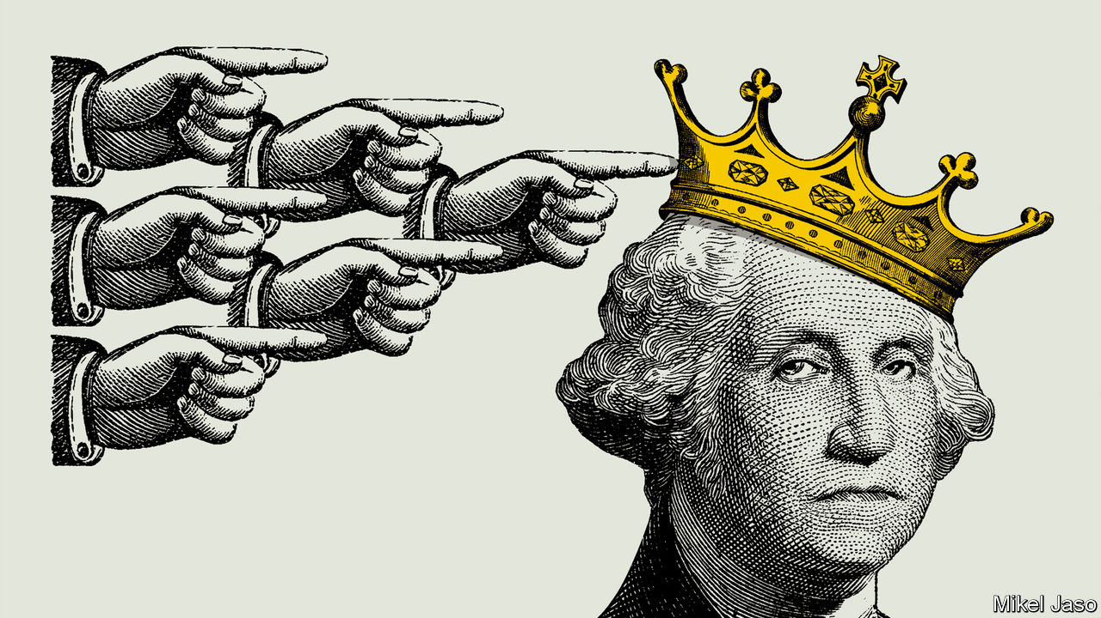

EVER SINCE the dollar cemented its role as the world’s dominant currency in the 1950s, it has been clear that America’s position as the sole financial superpower gives it extraordinary influence over other countries’ economic destinies. But it is only under President Donald Trump that America has used its powers routinely and to their full extent, by engaging in financial warfare. The results have been awe-inspiring and shocking. They have in turn prompted other countries to seek to break free of American financial hegemony.

In 2018 America’s Treasury put legal measures in place that prevented Rusal, a strategically important Russian aluminium firm, from freely accessing the dollar-based financial system—with devastating effect. Overnight it was unable to deal with many counterparties. Western clearing houses refused to settle its debt securities. The price of its bonds collapsed (the restrictions were later lifted). America now has over 30 active financial- and trade-sanctions programmes. On January 10th it announced measures that the treasury secretary, Steven Mnuchin, said would “cut off billions of dollars of support to the Iranian regime”. The State Department, meanwhile, said that Iraq could lose access to its government account at the Federal Reserve Bank of New York. That would restrict Iraq’s use of oil revenues, causing a cash crunch and flattening its economy.

America is uniquely well positioned to use financial warfare in the service of foreign policy. The dollar is used globally as a unit of account, store of value and medium of exchange. At least half of cross-border trade invoices are in dollars. That is five times America’s share of world goods imports, and three times its share of exports. The dollar is the preferred currency of central banks and capital markets, accounting for close to two-thirds of global securities issuance and foreign-exchange reserves.

The world’s financial rhythm is American: when interest rates move or risk appetite on Wall Street shifts, global markets respond. The world’s financial plumbing has Uncle Sam’s imprint on it, too. Most international transactions are ultimately cleared in dollars through New York by American “correspondent” banks. America has a tight grip on the main cross-border messaging system used by banks, SWIFT, whose members ping each other 30m times a day. Another part of the US-centric network is CHIPS, a clearing house that processes $1.5trn-worth of payments daily. America uses these systems to monitor activity. Denied access to this infrastructure, an organisation becomes isolated and, usually, financially crippled. Individuals and institutions across the planet are thus subject to American jurisdiction—and vulnerable to punishment.

America began to flex its financial muscles after the terrorist attacks of September 11th 2001. It imposed huge fines on foreign banks for money-laundering and sanctions-busting; in 2014 a $9bn penalty against BNP Paribas shook the French establishment. Mr Trump has taken the weaponisation of finance to a new level (see chart). He has used sanctions to throttle Iran, North Korea, Russia, Turkey (briefly), Venezuela and others. His arsenal also includes tariffs and legal assaults on companies, most strikingly Huawei, which Mr Trump accuses of spying for China. “Secondary” sanctions target other countries’ companies that trade with blacklisted states. After America pulled out of a nuclear deal with Iran in 2018, European firms fled Iran, even as the EU encouraged them to stay. SWIFT quickly fell into line when America threatened action if it did not cut off Iranian banks after the reimposition of sanctions in 2018.

Using the dollar to extend the reach of American law and policy fits Mr Trump’s “America first” credo. Other countries view it as an abuse of power. That includes adversaries such as China and Russia; Russia’s president, Vladimir Putin, talks of the dollar being used as a “political weapon”. And it includes allies, such as Britain and France, who worry that Mr Trump risks undermining America’s role as guarantor of orderliness in global commerce. It may eventually lead to the demise of America’s financial hegemony, as other countries seek to dethrone its mighty currency.

The new age of international monetary experimentation features the de-dollarisation of assets, trade workarounds using local currencies and swaps, and new bank-to-bank payment mechanisms and digital currencies. In June the Chinese and Russian presidents said they would expand settlement of bilateral trade in their own currencies. On the sidelines of a recent summit, leaders from Iran, Malaysia, Turkey and Qatar proposed using cryptocurrencies, national currencies, gold and barter for trade. Such activity marks an “inflection point”, says Tom Keatinge of RUSI, a think-tank. Countries that used merely to gripe about America’s financial might are now pushing back.

Russia has gone furthest. It has designated expendable entities to engage in commerce with countries America considers rogue, in order to avoid putting important banks and firms at risk. State-backed Promsvyazbank PJSC is used for trade in arms so as to shield bigger banks like Sberbank and VTB from the threat of sanctions.

Russia has also been busy de-dollarising parts of its financial system. Since 2013 its central bank has cut the dollar share of its foreign-exchange reserves from over 40% to 24%. Since 2018 the bank’s holdings of American Treasury debt have fallen from nearly $100bn to under $10bn. Russia’s finance ministry recently announced plans to lower the dollar share of its $125bn sovereign-wealth fund. “We aren’t aiming to ditch the dollar,” Mr Putin has said. “The dollar is ditching us.”

Elvira Nabiullina, Russia’s central-bank governor, says the move was partly motivated by American sanctions (which were imposed after Russia’s annexation of Crimea in 2014), but also by a desire to diversify currency risk. “I see a global shift in mood,” she says. “We are gradually moving towards a more multi-currency international monetary system.” Ms Nabiullina echoes Mark Carney, the governor of the Bank of England, who said in August that the dollar-centric system “won’t hold”.

Russia’s debt is being de-dollarised, too. New issuance is often in roubles or euros, and the government is exploring selling yuan-denominated bonds. Russian companies have shrunk their foreign debts by $260bn since 2014; of that, $200bn was dollar-denominated. Conversely, Russian firms and households retain a fondness for dollars when it comes to holding international assets: they have $80bn more than they did in 2014. Dmitry Dolgin of ING, a bank, finds this “puzzling”, but suspects it could be that the interest rates on dollar assets, higher than on euro equivalents, outweigh the perceived risk from sanctions.

## Dasvidaniya, dollar

ING expects 62% of Russia’s goods and services exports to have been settled in dollars in 2019, down from 80% in 2013. Its trade with China was almost all in dollars in 2013; now less than half is. Trade with India, much of it in the sanctions-sensitive defence sector, shifted from almost all dollars to almost all roubles over that period. One reason for this shift, say Russian officials, is that it speeds trade up, since dollar payments can be delayed for weeks as financial intermediaries run sanctions checks.

Energy and commodities firms are among Russia’s most active de-dollarisers. The greenback is the global benchmark currency for oil trading, and escaping its grip is hard. “The key thing to understand is that risk management, the entire derivatives complex, is in dollars,” explains the boss of a global energy firm. “So if you want to have risk management—as an oil trader, buyer or producer—you have to have contact with the dollar system.”

Nonetheless Rosneft, a state-backed producer that accounts for over 40% of Russia’s crude output, has denominated its tender contracts in euros. Surgutneftegas, another producer, still prices in dollars but has added a clause to contracts saying they can be switched to euros at its request—“a back-up plan in case Trump throws shit at the fan”, says a trader. Last March Gazprom priced a natural-gas shipment to western Europe in roubles for the first time. The cost of switching out of dollars is modest, says an executive at a global oil-trading firm: “an extra person in the finance department and a bit more currency risk.”

Will China follow the trail blazed by Russia? Mr Trump has exposed China’s profound vulnerability to the dollar-centric financial system. America’s ability to blacklist or hobble Chinese tech firms, such as Huawei, ultimately rests on punishing suppliers and other counterparties who do business with them through the dollar-based banking and payments system. An American legal case against a senior Huawei executive, who is fighting extradition from Canada, reportedly relies in part on evidence from an American-appointed overseer at HSBC, an Asia-centric bank run from London. In October America sanctioned eight cutting-edge Chinese tech firms for alleged human-rights abuses in Xinjiang province. The administration has threatened to block listings by Chinese firms in New York and restrict purchases by American investors of Chinese shares.

China’s first attempt to bypass the dollar was bungled. After the financial crisis in 2007-09 it promoted the international use of the yuan and pressed for it to become part of the IMF’s “Special Drawing Rights”, in effect receiving the fund’s imprimatur as a reserve currency. China set up currency swap deals with foreign central banks (it has done over 35). There was heady talk of the yuan challenging the dollar for the top spot by 2020. Then came a stockmarket panic in 2015 and the government clumsily tightened capital controls. The yuan’s share of global payment by value has stayed at about 2% for several years. Zhou Xiaochuan, a former governor of China’s central bank, has said that yuan internationalisation, which he promoted while in office, was “a premature baby”.

America’s display of financial firepower and new technologies are changing the calculus again. China has some of the building blocks to become more autonomous. It has its own domestic payments and settlement infrastructure, called CIPS. Launched in 2015, it has so far complemented SWIFT (which it uses for interbank messaging). It is tiny, processing less in 2018 than SWIFT does each day. But it simplifies cross-border payments in yuan, giving banks lots of nodes for settlements. Reports suggest that China, India and others may be exploring a jointly run SWIFT alternative.

## A will and a Huawei

Parts of the world’s consumer-finance system are coming under China’s sway thanks to its digital-platform firms, which have globalised faster than its conventional banks. Payments through Alibaba (and its affiliate Ant Financial) are accepted by merchants in 56 countries. The Alipay logo is, in some places, as common as Visa’s. In capital markets, in 2018 China introduced a yuan-denominated crude-oil futures contract on a Shanghai exchange. Known as the “petroyuan”, it is seen by some as a potential rival to the dollar in pricing oil. China has encouraged important firms listed in America to list their shares closer to home as well. On November 26th Alibaba, China’s most valuable company, which in 2014 floated in New York rather than in Hong Kong or Shanghai, completed a $13.4bn additional listing in Hong Kong (the funds were raised in Hong Kong dollars). “As a result of the continuous innovation and changes to the Hong Kong capital market, we are able to realise what we regrettably missed out on five years ago,” said Daniel Zhang, Alibaba’s chief executive.

China’s central bank is reported to be working on a new digital currency, though details are sparse. Some speculate that it wants to get a head-start on America in building whatever international system emerges for managing payments in central bank-issued digital currencies. It discussed creating a common cryptocurrency with other BRICS countries (Brazil, Russia, India and South Africa) at a recent summit. China may end up doing Bitcoin with an authoritarian twist: instead of anonymity it may want all data to be trackable and centrally stored.

That America’s geopolitical rivals want to escape the dollar’s dominance is no surprise. Perhaps more striking is that its allies are flirting with it, too. In her manifesto for 2019-24, Ursula von der Leyen, the new president of the European Commission, said: “I want to strengthen the international role of the euro.” Jean-Claude Juncker, her predecessor, has called the dollar’s dominance in European energy trade an “aberration” (when just 2% of imports come from America). The commission is working on a new action plan, part of which involves encouraging EU countries to eliminate “undue reference” to the dollar in payments and trade invoicing, according to a staffer.

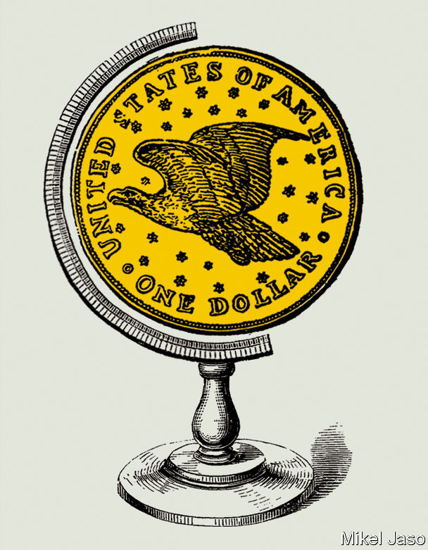

So far the EU’s main initiative has involved Iran. It has tried to create a way for its banks and firms to trade with it, while shielding them from America’s wrath. But Instex, a clearing house created for this purpose by Britain, France and Germany, with the commission’s support, is crude and limited. It is essentially a barter mechanism and does not cover oil sales (it is limited to non-sanctioned humanitarian trade). It was structured to allow firms to engage in commerce without resort to the dollar or SWIFT. But they have stayed away for fear of incurring secondary sanctions.

The stuttering performance of Instex reflects the sheer scope of America’s reach. As Adam M. Smith, a sanctions expert at Gibson Dunn, a law firm, points out, America can claim jurisdiction if a transaction has any American “nexus”, even if it is not denominated in dollars. This includes transactions that rely on banks under American jurisdiction, or where a foreign counterparty relies on American nationals to approve, facilitate or process the transaction, or where one party uses a back-end payment, accounting or email system that is stored on servers in America.

Despite this, some European officials remain optimistic. On November 29th six more EU states said they planned to join Instex. “It’s a ten-to-twenty-year thing, and hopefully not only covering Iran. You can’t undo decades of policy in a year,” says a French official. And, if Europe manages to reform the inner workings of the euro, its financial reach will expand. “We need to complete the project first: banking union, fiscal integration, genuine capital-markets union, and so on,” another French official says. European powers are likely to play a leading role in central-bank efforts to create a global electronic currency. Last year Mr Carney floated the idea of a network of central-bank digital monies that could serve as a global invoicing currency. If it happens America may not be invited.

## A haven above

The true test of any reserve currency is a financial crisis. Eswar Prasad of Cornell University, the author of “The Dollar Trap”, notes that the greenback benefits during times of turmoil. The 2007-09 crisis, which originated in America, paradoxically strengthened its status as a safe haven. When global trade, saving, borrowing and reserves are largely in one currency, these strengths are mutually reinforcing. No other capital market comes close to America’s for depth and liquidity, a key factor when choosing a currency for commerce.

Yet financial supremacy depends on a heady mix of economic clout, incumbency and legitimacy. And the martial approach that America has adopted threatens the dollar’s dominance, reckons Jeffrey Frankel of Harvard University. A former American treasury secretary agrees. In 2016, while still in office, Jack Lew told an audience in Washington: “It is a mistake to think that [sanctions] are low-cost. And if they make the business environment too complicated, or unpredictable, or if they excessively interfere with the flow of funds worldwide, financial transactions may begin to move outside of the United States entirely—which could threaten the central role of the US financial system globally, not to mention the effectiveness of our sanctions in the future.” As the Trump administration continues to use sanctions aggressively, efforts to circumvent them will accelerate. America does not have a monopoly on financial ingenuity.■

This article was downloaded by calibre from <https://www.economist.com/briefing/2020/01/18/americas-aggressive-use-of-sanctions-endangers-the-dollars-reign>

|  |  |  |  |
| --- | --- | --- | --- |
| Previous | Articles | Sections | Next |

|  |  |  |
| --- | --- | --- |
| Briefing | Sections | The Americas |

United States

The Democratic primary: The world intrudes

.

Retirement: Baby steps

.

America’s animals: City critters

.

The Department of Commerce: Weapon of choice

.

Immigration policy: Temporary toil

.

Lexington: The Senate’s coming test

.

|  |  |  |
| --- | --- | --- |
| Briefing | Sections | The Americas |

|  |  |  |  |
| --- | --- | --- | --- |
|  | Articles | Sections | Next |

#### The world intrudes

# The Democrats’ debate in Iowa covers foreign policy at last

His challengers agree that Donald Trump gets it wrong, but they express real differences with each other

Jan 16th 2020 | AMES, IOWA AND WASHINGTON, DC

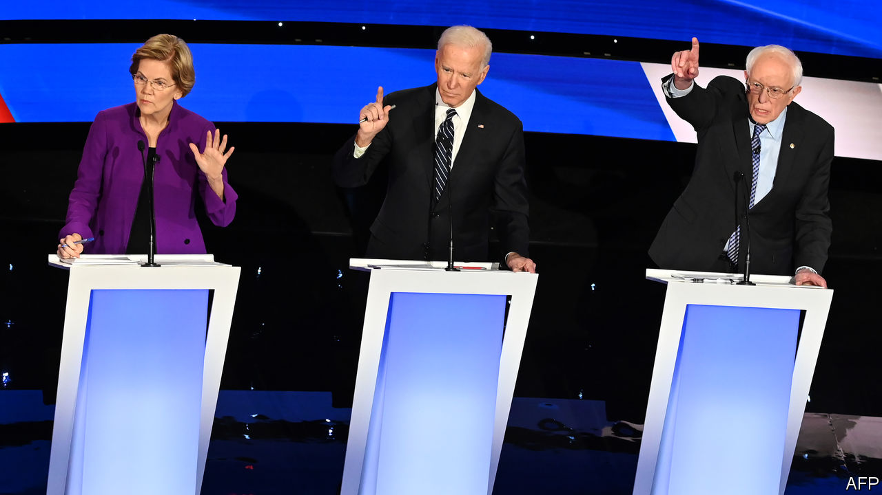

BEFORE LAUNCHING into a speech for the 30 or so Joe Biden-curious Iowans who had gathered in Ames on a frigid Wednesday evening in early January, John Kerry, the Democratic presidential nominee in 2004 and a secretary of state for Barack Obama, made sure to hug an old friend in the crowd: the gunner from his Swift Boat in Vietnam many decades ago. Soon after returning from that war as a wounded and decorated veteran, Mr Kerry had concluded that it was a pointless misadventure. In Iowa he worried that America was again on the brink of another disastrous war—this time with Iran.

President Donald Trump had ordered the killing of General Qassem Suleimani, perhaps the second-most-powerful man in Iran, eviscerating what little remained of the detente that Mr Kerry and Mr Obama had worked to establish through diplomatic channels. “We didn’t sit there publicly pissing and moaning and screaming about how bad they were and tweeting away and creating a storm,” Mr Kerry said.

This, Mr Kerry argued, is the reason to trust in Mr Biden, who, between his time as a senator and vice-president, has nearly half a century of experience in matters of foreign policy. More years, in other words, than Pete Buttigieg—another candidate vying to represent the moderate faction of the party—has had on Earth. His long experience is why Mr Biden thinks that foreign-policy debates will help him.

Unfortunately for him, the race has focused largely on domestic matters. Foreign affairs have been relegated to one-off speeches. None of the four leading candidates has published a specific China policy on their campaign websites, for instance. All mightily agree to disagree with Mr Trump’s impetuosity and self-imposed crises—whether by launching trade wars, leaving the Paris climate accord or by alternately taunting and serenading Kim Jong Un of North Korea. General Suleimani’s death has changed that. On January 14th the candidates had their final debate before the Iowa caucuses, with foreign policy dominating. It revealed big differences beneath their superficial agreement.

Of the major candidates, Mr Biden is most keen on restoring the pre-Trump status quo. Reassuring NATO allies, rejoining both the Paris accord and the Iran nuclear deal and pursuing arms-control treaties with Russia rank high among his priorities. He is the candidate most in line with the Washington foreign-policy establishment, often mocked as “the blob”. Critics to his left have suggested this is hardly a mark of good judgment. They point to Mr Biden’s vote to authorise the Iraq war in 2002—ressurecting the issue for the fourth primary season in two decades.

But Mr Biden is not in the liberal interventionist tradition of Hillary Clinton. He disagreed stridently with the secretary of state over the decision in 2011 to intervene in Libya. Though he would like to “end the forever wars in Afghanistan and the Middle East”, he is open, unlike some of his opponents, to leaving residual forces in Afghanistan. He would also like to increase arms sales to Ukraine.

Though voters may appreciate a return to the old ways, some breaks are more difficult to mend than others. The Paris accord would be simple to rejoin, but Iran might not be put back in the bag so easily. Great-power competition with China continues apace. Mr Trump’s norm-breaking around matters of trade—such as imposing tariffs on stretched national-security grounds—may embolden other countries to try the same tactics.

Both Bernie Sanders and Elizabeth Warren, the leading left-wing candidates, differ from the blob by framing foreign policy in the context of domestic projects. Mr Sanders sees international affairs in terms of a binary contest, between “a growing worldwide movement towards authoritarianism, oligarchy and kleptocracy” and his own egalitarian vision. For decades he has been a sharp critic of American interventions, particularly in Latin America.

Ms Warren views corruption as the wellspring of all problems, both domestic and foreign. Her analysis of global disorder, published in Foreign Affairs, blames both “endless wars” and the export of “a particular brand of capitalism, one that involved weak regulations, low taxes on the wealthy and policies favouring multinational corporations”, for America’s diminished standing in the world. In her view, reducing inequality can enhance stability internationally as well as at home.

Mr Sanders and Ms Warren are trying to overcome the somewhat artificial divide between foreign and domestic policy. This is sensible regarding competition with China—where infrastructure, education, research funding and industrial policy may matter more to long-term outcomes than any reshuffling of aircraft-carriers.

“It is easy to draw the contrast with the current president, who has no obvious plans other than dragging us closer and closer to war in the Middle East,” said Ms Warren, when asked about her vision of foreign affairs after an event in Mason City, Iowa. “We need a State Department that is fully staffed up, we need to use our economic tools, and we need to work with our allies.” Ms Warren’s published plan to rebuild the foreign service—which Mr Trump seems to have damaged for years to come—is thoughtful and detailed. She has hinted at an enthusiasm for using trade policy to extract concessions on issues such as the environment, labour standards and human rights. Both she and Mr Sanders may agree with Mr Trump in keeping tariffs on China, for instance, though for less haphazard and more principled reasons.

The Democratic candidates may keep in lockstep in their denunciations of Mr Trump’s foreign policy, but the differences between them are significant. And if Congress remains divided, their plans for America’s relationship with the rest of the world are more likely to be implemented than their domestic agendas, which tend to receive more attention.

Much foreign policy can be made by executive fiat. Overseas, adversaries and allies alike will find a change in the American presidency entails bumpier seesawing than ever before. “As Congress has become more and more dysfunctional, the presidency has taken more and more power,” says Daniel Drezner, a professor of international politics at Tufts University. “If you combine consolidated executive power with polarisation,” he adds, “it leads to schizophrenic foreign policy.” ■

[Sign up to receive Checks and Balance](https://www.economist.com/checksandbalance/), our new weekly newsletter on American politics

This article was downloaded by calibre from <https://www.economist.com/united-states/2020/01/16/the-democrats-debate-in-iowa-covers-foreign-policy-at-last>

|  |  |  |  |
| --- | --- | --- | --- |
|  | Articles | Sections | Next |

|  |  |  |  |
| --- | --- | --- | --- |
| Previous | Articles | Sections | Next |

#### Baby steps

# America’s pensions system is now less of a mess

But the country still has more cleaning up to do

Jan 16th 2020 |

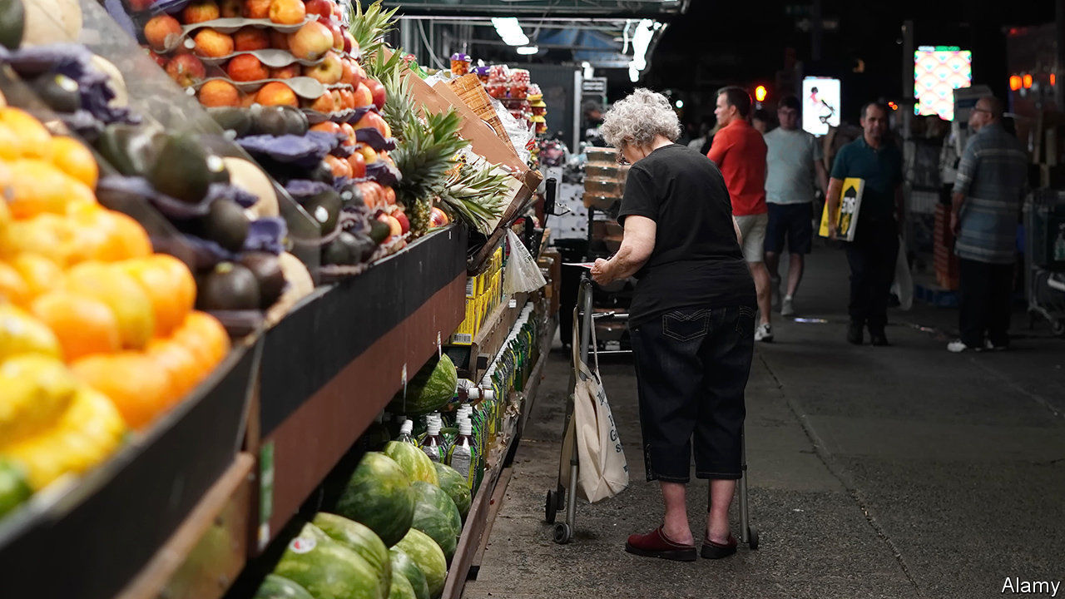

THE LATEST jobs report shows that the unemployment rate in America stayed at 3.5% in December, confirming that things are looking pretty good for workers right now. Less well known is that there are plans afoot to improve workers’ prospects once they have laid down their tools. Shortly before Christmas, America enacted its first big reform to the retirement system in over a decade. The Setting Every Community Up for Retirement Enhancement Act of 2019, better known as the SECURE Act, is a good start. But much more is needed.

Americans could certainly do with additional retirement security. The median balance held in retirement accounts is $60,000 per family, enough for only a pitiful income in old age. Yet by one estimate 40% of working-age Americans have no retirement-account savings at all, meaning that they will probably have to rely on Social Security (public pensions) in their dotage. That safety-net is thin. America’s rate of old-age poverty is one of the highest in the rich world (see chart).

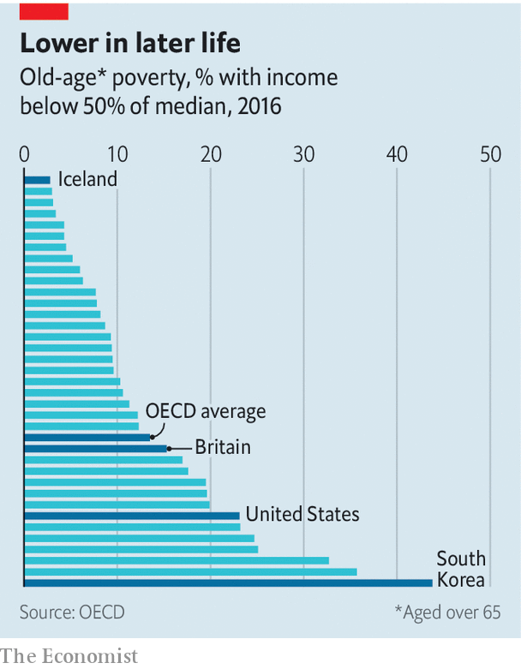

The new law’s many provisions may help turn things round. One of the most promising relates to the age at which people must start to withdraw cash from their retirement accounts. It will rise from 70.5 years to 72, meaning that workers who can afford to delay retirement will have more time to amass tax-favoured savings. That policy is expected to cost the federal government some $9bn over a decade. But the government will raise extra revenue by tightening the tax rules on inherited retirement accounts. The overall fiscal cost of the new act is likely to be tiny—perhaps one reason why it went through Congress with bipartisan support.

Economists are particularly intrigued by provisions in the new law governing income annuities, financial products which, once bought, provide preset monthly payments until the holders die. Despite their advantages, income annuities are oddly underused. Provisions in the SECURE Act, however, should encourage more firms to offer annuities. So long as employers choose a firm in good standing with regulators to provide the annuity, from now on they will be legally protected if the provider goes bust.

Finally, the new law may help encourage some Americans without a retirement-savings account to get one. A series of provisions should make it easier for small businesses to club together to provide retirement plans to their staff, point out J. Mark Iwry and David John of the Brookings Institution, a think-tank. Another part of the legislation offers financial incentives, in the form of tax credits, to firms which create retirement schemes for their staff and enroll them automatically.

America could go further. Many pensions experts argue that the single most effective reform would be if workers were to be automatically enrolled in retirement plans. Some countries have made bold changes. A few years ago Britain enacted a scheme along these lines, leading to a jump in the share of employees with a workplace pension of 36 percentage points, according to research from the Institute for Fiscal Studies, a British think-tank. If American politicians are serious about improving people’s prospects in retirement, tweaking around the edges will not be enough. ■

This article was downloaded by calibre from <https://www.economist.com/united-states/2020/01/18/americas-pensions-system-is-now-less-of-a-mess>

|  |  |  |  |
| --- | --- | --- | --- |
| Previous | Articles | Sections | Next |

|  |  |  |  |
| --- | --- | --- | --- |
| Previous | Articles | Sections | Next |

#### City critters

# Unpacking the rise of urban coyotes

Shifting patterns of global trade may explain the canine’s spread across America

Jan 16th 2020 | CHICAGO



THE ATTACKER sprang from the tall grass in a lakefront park, leaving a five-year-old victim terrified, blood streaming from his head. After the boywas taken to hospital, a hunt ensued. Helicopters, police and specialist trackers fanned across the Chicago neighbourhood. A man brought himself to hospital saying he, too, had been bitten. Two nearby schools were locked down for a day. Eventually a suspect—a brindle coyote with puppy-dog eyes—was apprehended behind a theatre.

The incident excited much of Chicago. Although coyote attacks on humans are rare, the animals have become an increasingly common part of urban American life. Once mostly found west of the Mississippi, they have spread east. Coyotes have settled in almost every urban area in the country, including New York City. There are few reliable estimates of the national population, but over 400,000 are hunted each year. Survivors roam an ever-larger territory.

In Chicago, coyote sightings have become routine, especially in the past decade. Stan Gehrt, a professor of wildlife ecology at Ohio State University, launched a study of the animals two decades ago after they began showing up in sizeable numbers. “Before then, not much research had been done into urban coyotes. We didn’t know what it meant,” he says. The population has soared. Depending on whether the count includes cubs, Mr Gehrt conservatively estimates that between 2,000 and 4,000 coyotes live in the city.

What lies behind this boom? The loss of deciduous forests and wolves (which hunted coyote) are long-term factors. Federal efforts to poison the animal reduced in the 1970s because of concerns over the dangers of releasing toxins haphazardly into the environment.

Mr Gehrt also points to a shift in global trade. Hunters and trappers continue to kill coyotes. A pelt can sell for as high as $70 to $100 to be used as trim or linings for winter coats, including Canada Goose jackets. But overall demand for American furs from Chinese, Russian and other European buyers has slumped in recent years, he says. With fur unfashionable, sales down and “trapping animals not as acceptable as before”, Mr Gehrt says rural areas have become “saturated” with the animal. Today, as cubs mature and seek their own territories, many have been pushed into cities.

Coyotes can be troublesome. They eat wandering pet cats and small dogs. But on balance they are benign. They mostly eat fruit and other wild species, including pests that flourish in cities, such as rats, rabbits, woodchucks, young Canada geese and the fawns of white-tailed deer. Keeping these populations in check is a welcome public service.

Predatory attacks on humans are rare. Just one American—a toddler snatched from her garden in Los Angeles in 1981—has been reported killed by a coyote in the past four decades. Public anxiety about the spread of a large predator is certainly understandable. But by comparison, dogs are a much greater menace. They kill some 50 people and send thousands to hospital a year in America. Deer, too, appear cute but cause traffic accidents that kill more than 200 Americans a year. Coyotes may look less docile, but they are linked less closely to death.

This article was downloaded by calibre from <https://www.economist.com/united-states/2020/01/18/unpacking-the-rise-of-urban-coyotes>

|  |  |  |  |
| --- | --- | --- | --- |
| Previous | Articles | Sections | Next |

|  |  |  |  |
| --- | --- | --- | --- |
| Previous | Articles | Sections | Next |

#### Weapon of choice

# Old export regulations get a new use

Donald Trump’s administration leverages rules from the Department of Commerce to confront Chinese firms

Jan 16th 2020 | WASHINGTON, DC

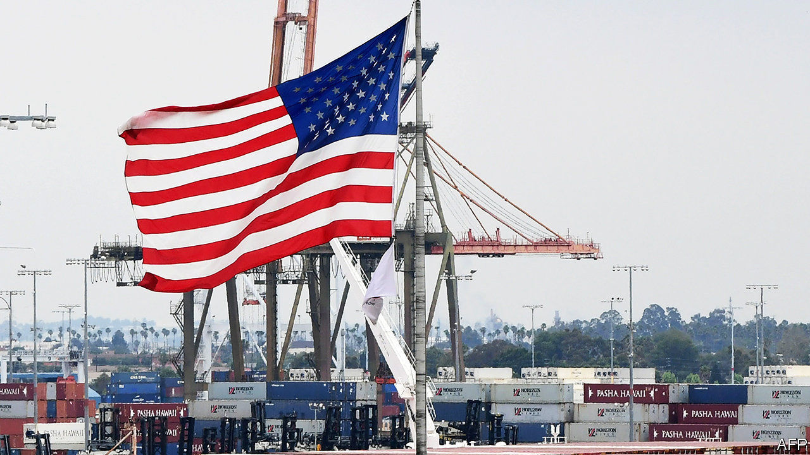

AN OBSCURE PART of the Department of Commerce called the Bureau of Industry and Security (BIS) is not used to grabbing the limelight. But lately it has had plenty of attention. That is thanks to its control of rules governing the flow of goods from and through America, called the Export Administration Regulations (EAR). Under Donald Trump, these rules are being transformed into a new weapon in the fight against Chinese technology. But changing them risks driving high-tech business out of America.

The traditional tools for attacking foreign companies are the economic sanctions available through the Department of the Treasury. Sanctions prevent the target firm from doing transactions in American dollars, essentially cutting them off from the global financial system. But Steven Mnuchin, the treasury secretary, is widely understood to be against that option for one of the main objects of America’s beef with China, the tech giant Huawei. That is possibly because shutting out Huawei could risk global network blackouts and great economic turmoil.

Mr Mnuchin’s resistance meant the Trump administration needed another option. It found BIS. The idea was to target Huawei through the “entity list”, first published in 1997 as a part of the EAR and designed to fight the proliferation of weapons of mass destruction. Back then it was understood that if the American government somehow became aware of a shipment bound for a dangerous regime it could invoke the EAR, place that regime on the entity list, and halt the components’ movement in its tracks.

The Trump administration’s first big EAR salvo came in May 2019, when it placed Huawei on the entity list, claiming it posed a threat to America’s national-security and foreign-policy interests. Huawei denies that it does. The listing prohibited the export of components from America to the company, and seemed to inhibit the export of American-made components from other countries to Huawei. After some initial confusion, companies worked out that they were in fact prohibited only from exporting components directly to Huawei from American soil.

Now the Department of Commerce is preparing new rules that would clamp down afresh on exports to Huawei. That is despite the fact that on January 15th the Trump administration signed a “phase one” trade deal with China—the latest demonstration that the many disagreements between the two countries do not scale up and down in tandem (see article).

Those rules would cut Huawei off from a greater proportion of American technology than at the moment, according to many people close to the process, removing the option of shipping American technology in from abroad. Companies such as Intel, which manufactures semiconductors, and Arm, which designs chips, would have to strip more American content out of their products, or stop shipping to Huawei.

The rules are still under discussion, but are expected to be published soon. Deeper controls on tech exports to the whole of China are also being considered. According to people familiar with the process the changes are driven not by Wilbur Ross, the commerce secretary, but by Earl Comstock, the department’s director of policy and deputy chief of staff. How and whether these new rules will go into effect is unclear. As with Huawei’s initial entity listing, they may be held back as ammunition in case phase-two negotiations stall, or used as leverage to keep them on track. American tech firms say that tightened export controls, especially the misfired first round, are misjudged. Instead of cutting Huawei off, American unilateralism forces Huawei to obtain non-American components from competitors. Other Chinese firms may do the same for fear of similar treatment. (Treasury sanctions do not come with this unintended consequence of helping non-American suppliers.)

This process may slow Huawei down, but lost revenue and commensurate gains by competitors could lead to a downward spiral for American firms that leads to lower relative spending on research and competitiveness. Newly flush with Huawei’s cash, European and East Asian suppliers could overtake American firms. At best, the industry expects the controls to force American firms’ operations offshore, into the hands of non-American suppliers. At worst, they risk scalping firms’ competitive advantage entirely.

The mission statement of the BIS takes these trade-offs into account. It promises not to impose “unreasonable restrictions on legitimate international commercial activity that is necessary for the health of US industry”. That is no simple task. If Washington and Beijing carry on along the path of technological “decoupling” then American industry will inevitably suffer (as will Chinese). Few organisations have greater power to determine the nature of that suffering than the Trump administration’s Department of Commerce. The entity list was not designed as a tool of geostrategic competition. But, increasingly, it is being turned into one.■

This article was downloaded by calibre from <https://www.economist.com/united-states/2020/01/18/old-export-regulations-get-a-new-use>

|  |  |  |  |
| --- | --- | --- | --- |
| Previous | Articles | Sections | Next |

|  |  |  |  |
| --- | --- | --- | --- |
| Previous | Articles | Sections | Next |

#### Well documented

# America’s guest-worker boom

Donald Trump’s administration is encouraging low-skilled Mexican migrants to come to America, legally

Jan 16th 2020 | LOS ANGELES

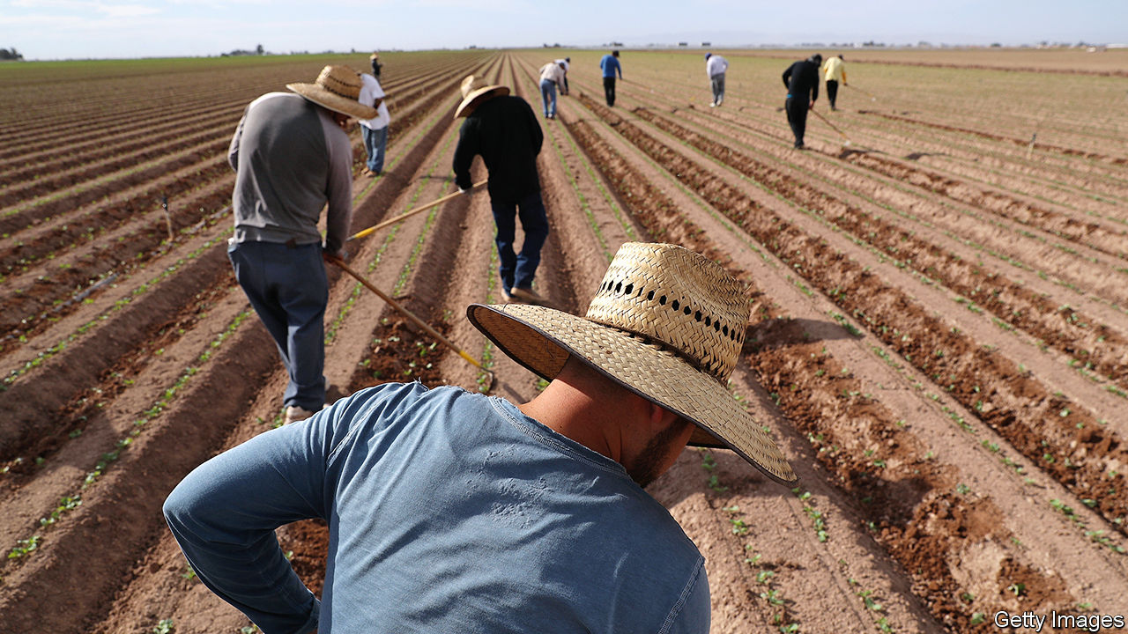

ALTHOUGH AMERICA’S immigration policy now seems dominated by a desire to seal the country’s southern border, Donald Trump’s administration has been surprisingly tolerant of a certain type of crossing. Those by legal, temporary migrants—or guest workers—in search of low-wage work have risen dramatically over the past decade.

The government granted 408,000 visas for guest workers in 2019, up from 103,000 in 2010. This growth began well before the start of Donald Trump’s term, but has recently come back into focus. If a proposed rule-change takes effect, guest workers could become an even larger source of labour in low-wage industries.

Part of this expansion stems from America’s strong economy. There are jobs available for people who want them. The problem is that many people do not. In industries such as agriculture, many employers say they cannot find workers willing or able to fill low-wage jobs.

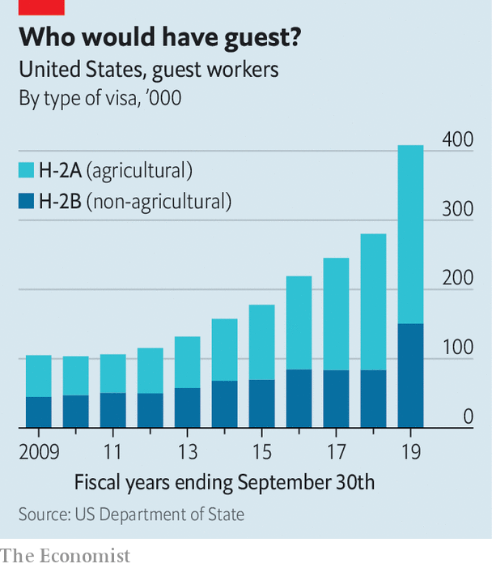

Guest workers fill this chasm. The programme offers two types of visa. Seasonal farm workers get the H-2A. There is no limit on their number, which has tripled in a decade (see chart). Non-farm workers get the H-2B. Their number is capped at 66,000 annually, but the administration has granted more H-2Bs every year.

To qualify for either visa, an employer must prove they cannot find an American to do the job. Once the Department of Labour has approved the request, the employer—usually a contractor—sends recruiters to find workers, usually in Mexico. Employers are in charge of applications, placement, transport and housing. They can refuse to renew a worker’s visa at will. Unlike most documented immigrants, guest workers do not pay Social Security, Medicare or unemployment taxes, making them cheaper to hire.

Employers say the process is too bureaucratic and expensive, though once they start hiring guest workers, they rarely stop. Labour advocates worry that it could undercut wages and is potentially exploitative, handing employers too much power. America also has a spotty record with guest workers. Between 1942 and 1964 the country granted 4.6m agricultural contracts, largely to Mexicans, as part of its bracero programme. Yet the man who ran it during the Kennedy and Johnson administrations later lambasted it as “legalised slavery”.

The issue remains fraught. But there have been signs of progress. In December a moderate bill passed the House of Representatives with bipartisan support, the first agricultural-labour reform bill to do so in more than three decades.

It would codify a rule-change proposed by the Department of Labour over the summer that would make the visa-application process easier, addressing some employers’ concerns and potentially expanding the programme further. It also would offer a path to legal status for potentially thousands of unauthorised immigrants. Those who have worked in agriculture for at least 180 days in the past two years could apply for “certified agricultural worker” status. Those who have worked longer could eventually apply for green cards.

The bill’s fate is less certain in the Republican-controlled Senate. The guest-worker programme is far from perfect. But a policy that encourages legal low-skilled migration and pleases both businesses and workers is certainly worth debating.■

This article was downloaded by calibre from <https://www.economist.com/united-states/2020/01/18/americas-guest-worker-boom>

|  |  |  |  |
| --- | --- | --- | --- |
| Previous | Articles | Sections | Next |

|  |  |  |  |
| --- | --- | --- | --- |
| Previous | Articles | Sections | Next |

#### Lexington

# The Senate’s coming test

Donald Trump’s acquittal is certain; how the constitutional system survives it is not

Jan 16th 2020 |

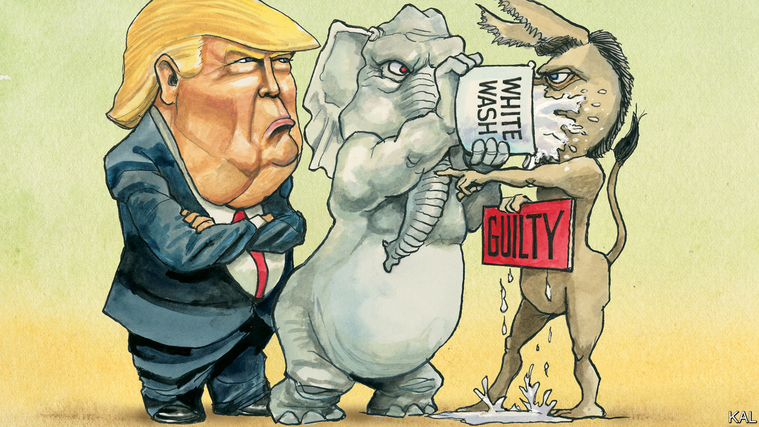

IF FACTS AND evidence still matter in American governance, the Senate will have no alternative but to take up the latest revelations of Donald Trump’s Ukrainian influence scheme when his impeachment trial begins next week. On the face of it, the clutch of notes and text messages released by House Democrats on January 14th appear to be as incriminating as anything levelled at Mr Trump’s presidency to date.

Stripped from an iPhone belonging to Lev Parnas, a Ukrainian-born businessman and Republican donor who has been indicted for political corruption, they suggest Mr Trump was thickly involved in the plot hatched by his lawyer, Rudy Giuliani, to shake down Ukraine’s newly elected government for political favours. In a letter sent last year to President Volodymyr Zelensky, requesting a meeting, Mr Giuliani stressed that Mr Trump had “knowledge and consent” regarding his activities in Ukraine. He also emphasised that he represented Mr Trump’s personal interests—“as a private citizen, not as president of the United States”. And in interviews on January 15th, Mr Parnas said the president was fully aware of his efforts in Ukraine.

This appears to contradict Mr Trump’s two main defences against the charge that he abused his office by suspending military aid to Ukraine in order to coerce Mr Zelensky into opening a spurious corruption investigation into Joe Biden. Mr Trump claims to have had no knowledge of the steps Mr Giuliani took to that effect in Ukraine. He also claims that the pressure he exerted on Mr Zelensky was motivated by his broader worry about corruption in Ukraine, and therefore was in America’s interest, not his own.

Other revelations in Mr Parnas’s trove are more lurid. They include texts from a previously unknown actor in the Trump-Giuliani scheme, a Republican congressional candidate called Robert Hyde, who appears to have been spying on America’s then-ambassador to Ukraine, Marie Yovanovitch, on Mr Parnas’s behalf. In exchanges with Mr Parnas early last year, Mr Hyde described the physical and electronic movements of Ms Yovanovitch, who had been identified by Mr Giuliani as an obstacle to his scheme: “She’s talked to three people. Her phone is off.” He also appeared to discuss the possibility of having her interfered with in some way. “That address I sent you checks out…they are willing to help if we/you would like a price…Guess you can do anything in the Ukraine with money,” wrote the Republican hopeful from Connecticut. “Can’t believe Trump hasn’t fired this bitch.” Mr Trump, who would later tell Mr Zelensky that the veteran diplomat was going to “go through some things”, fired her the next month.

Yet it is unlikely the Republican-controlled Senate will take much note of this apparently devastating evidence. Despite the administration’s efforts to stymie the impeachment probe run by House Democrats last year, there were already circumstantial indications that Mr Trump’s defence is as baseless as his allegations against Mr Biden. Even so, Mitch McConnell, with the backing of most of his 52 Republican colleagues, has said “there’s no chance” Mr Trump will be convicted. Though that might appear to make his conduct of the coming trial an irrelevance, the Senate leader has further made clear his unwillingness to weigh any evidence not attached to the narrow, because stymied, impeachment articles sent to him this week. If he gets his way—and there are currently only four quibbling Republican moderates tempted to resist—Mr Trump could be acquitted by the end of the month; or in time for his state-of-the-union message on February 4th.

This was predictable. Most Republican voters are behind Mr Trump for the same reasons that they have felt able to disregard the corruption and other abuses of the past three years. Their media outlets downplay or ignore the president’s misdeeds even as they accuse his accusers of the same or worse. Mr McConnell was therefore bound to do likewise. His refusal, thus far, to consider fresh evidence, including the handful of fresh testimonies Democrats want (starting with that of John Bolton, the former national security adviser) is merely an effort to downplay Mr Trump’s wrongdoing. Meanwhile he and other Republicans are blaming the Democrats for everything Mr Trump and they themselves stand accused of. The shakedown of Mr Zelensky was the sort of thing all presidents do; Mr Biden, in some unstated way, has done worse; the House inquiry was hopelessly biased; Nancy Pelosi’s brief effort to force Mr McConnell to relent was pure politics—so the impeachment is a charade! These mangled half-truths and partisan nonsenses are all the defence Mr Trump needs.

## Mitch against the Enlightenment

Even if predictable, this is unprecedented. Every previous presidential impeachment or near-impeachment (involving Andrew Johnson, Richard Nixon and Bill Clinton) was infected by partisanship. Yet, if Mr McConnell gets his way, this will be the first Senate trial conducted in head-on defiance of the principle of shared facts and evidence. The consequences would be graver even than the degrading of impeachment that would inevitably result. (Some Republicans are already muttering about impeaching Mr Trump’s next Democratic successor.) The Enlightenment tradition on which the American system depends—“of giving a damn about whether facts are facts”, as Frank Bowman, a pre-eminent impeachment scholar, puts it—would have suffered a jarring blow.

This is what the handful of moderate Republicans who might yet force Mr McConnell’s hand should consider to be at stake. They, namely Lamar Alexander of Tennessee, Susan Collins of Maine, Lisa Murkowski of Alaska and Mitt Romney of Utah, will have little bearing on Mr Trump’s future either way. There is nothing Mr Bolton could say to turn many Republicans against the president. Yet merely by standing for a weighing of the available facts, in sober respect for the truth, Mr Alexander and the rest would signify that disavowing them, however tempting, may also carry a cost.■

This article was downloaded by calibre from <https://www.economist.com/united-states/2020/01/16/the-senates-coming-test>

|  |  |  |  |
| --- | --- | --- | --- |
| Previous | Articles | Sections | Next |

|  |  |  |
| --- | --- | --- |
| United States | Sections | Asia |

The Americas

Haiti: Gourdean knot

.

Mexico: Out of left field

.

Bello: Argentina and the reality principle

.

|  |  |  |
| --- | --- | --- |
| United States | Sections | Asia |

|  |  |  |  |
| --- | --- | --- | --- |
|  | Articles | Sections | Next |

#### Gourdean knot

# Jovenel Moïse tries to govern Haiti without a parliament

Can the scandal-tainted president fix the country?

Jan 16th 2020 | PORT-AU-PRINCE

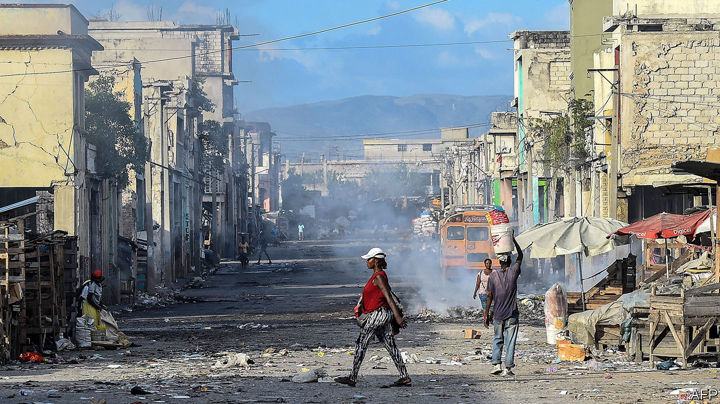

PETER CONFIDENCE lounges against a broken lamppost in a park in Petionville, a prosperous suburb of Port-au-Prince, Haiti’s capital, basking in the afternoon sun. As he rubs a tattooed St Peter on his neck he explains that Jovenel Moïse, Haiti’s president, is the only man strong enough to fix the country. Before he can finish, a passer-by selling food from a large metal pot that he lugs around interjects that the Americans should lock Mr Moïse up. Within seconds, a crowd assembles to discuss the state of the nation and the quality of its leader, nicknamed “Banana Man” because he once helped create a big banana plantation. The conversation pinballs between tirades and black humour.

Though such debate is a feature of Haitian life, the country’s parliament is silent. A new session should have begun on January 13th, the day after the tenth anniversary of a devastating earthquake. But a legislative election, due in October 2019, was never held. In the absence of a functioning legislature, the president will rule by decree. For a country with a history of brutal dictatorship, coups and dodgy elections, the prospect of one-man rule is ominous.

Even before it was dissolved, parliament was dysfunctional and its relationship with the president was broken. The 119-seat lower house was divided among 20-odd parties, which mostly represent the interests of local bigwigs. The 30-seat senate had 15. Mr Moïse, unable to form a majority, has named four prime ministers since 2017. One quit, one was felled by a no-confidence vote and two others never won parliamentary approval. Since March the government has operated without parliamentary authorisation. For the second year in a row, no budget was passed. Bureaucrats operate under the budget for 2017-18, unadjusted for inflation. The weakness of the gourde, Haiti’s currency, pushed up prices by 30% over the last two years.

Mr Moïse’s answer to these problems is a new constitution, which would give the president more power. He told The Economist that he would put it to a popular vote in 2020. A legislative election would follow.

But, as the Creole saying goes, “behind the mountains there are mountains.” The political crisis is one of Haiti’s many troubles, and makes all of them much harder to solve. More than half the population lives on less than the national poverty line of $2.41 a day. The share of Haitians with access to clean drinking water dropped to 52% in 2015 from 62% in 1990. Some 3.7m Haitians, a third of the population, face crisis-level food insecurity, according to an international measure known as the IPC. That is forecast to rise to 4.1m this year.

Rubble from the earthquake is still strewn across Port-au-Prince. The police, who are ill-trained, underfunded and corrupt, leave Haitians at the mercy of gangs that terrorise them. For months Haitians have endured peyi lok—shutdowns of roads, businesses and public services caused by street protests and gang activity.

Haiti’s current unrest began in July 2018, when the government ended fuel subsidies at the suggestion of the IMF. This caused prices to jump by 50%, triggering the resignation of Mr Moïse’s first prime minister. The government quickly reversed its decision, but protests soon resumed in response to allegations that top politicians, including Mr Moïse, had stolen millions of dollars through Petrocaribe, a scheme under which Venezuela accepted deferred payment for Haiti’s purchases of its oil. He denies the claim.

A report by a commission of Haiti’s senate said that politicians had misappropriated money from selling discounted oil. The government auditor affirmed the commission’s findings and accused state agencies of trying to thwart its inquiry. Even before the Petrocaribe allegations, Mr Moïse and parliament had taken steps to weaken the autonomy of the government’s financial-crimes unit. So far, no one has been held accountable for the Petrocaribe thefts.

Mr Moïse’s public standing is low for reasons besides the scandal. His election in 2016, when turnout was a record low of 21%, gave him a weak mandate. The National Human Rights Defence Network, an NGO, accused security forces of taking part in a massacre in 2018 in which at least 26 people died. Police have fired live ammunition at demonstrators. More than 200 people, including at least 44 police officers, have died during the protests.

Most Haitians expect no help from politicians. Standing on a dusty path that cuts through Canaan, a settlement of half-built cinder-block houses that sprang up on the outskirts of the capital after the earthquake, Dume Elinor shows off the school that he and other residents built. Daubed on its unfinished walls are semi-recognisable Disney cartoon characters. Inside are a few jerry-built desks. The school is only partially covered by an ill-fitting roof of wood and corrugated iron. Mr Elinor laughs and explains that no one knew how to do the job properly. Politicians only visit during elections, he says. “They leave us alone and we organise ourselves.”

But Haitians are beginning to demand more. The Petrocaribe scandal sparked the creation of Petro-Challengers, a movement that helped lead the protests. Its name was suggested by a Haitian videographer living in Canada, who tweeted a photo of himself blindfolded and holding a sign that read (in Creole) “Where is the Petrocaribe money?” Although the demonstrations dwindled at the end of 2019, the Petro-Challengers say they will resume protesting this year.

Politics is corrupt because Haitians learned to keep quiet under the dictatorship of François “Papa Doc” Duvalier and his son Jean-Claude (“Baby Doc”), who ruled from 1957 to 1986, says Velina Charlier. She is a leader of Nou Pap Domi (We Will Not Sleep), a group that emerged from Petro-Challengers. “Today, not only are people awake as to what’s happened, but they are daring to fight,” she says. Nou Pap Domi plans to begin a programme of “citizen education” to teach people how to vote and why they should do so. Ms Charlier hopes that people active in Petro-Challengers, many of whom were educated abroad, will become politicians themselves.

Mr Moïse thinks that he is the man to end “the predatory state”. He is negotiating with the opposition to form a national-unity government that would draft the new constitution with the help of a constituent assembly. Haiti wrote its last constitution in 1986-87 in similar circumstances, he points out. In the absence of a sitting parliament, a civilian-military government and a partly elected constituent assembly collaborated to draft the charter.

Mr Moïse’s 2020 deadline is realistic, he insists. The drafting and approval of the last constitution took “four months and 20 days”. In the meantime, he would combat “banditry” by strengthening the police and set up a food-distribution programme.

Haiti needs constitutional change and other institutional reforms. A new relationship between the executive and the legislature could prevent the sort of breakdown that is paralysing government. An independent electoral commission would help to guarantee the integrity of elections. The judiciary and the government’s anti-corruption unit are also in need of reform. Such changes will not improve wretched public services or lift living standards overnight, but they are a necessary step. Just holding fresh legislative elections under the current rules, as Haiti did five years ago, will accomplish nothing.

But many Haitians doubt that Mr Moïse is the right man to reform democracy. His talks with the opposition may be theatre and his timetable looks like fantasy. Some say his plan to change the constitution is itself unconstitutional. Even people who endorse the idea have called for him to resign. But there is no obvious alternative. The United States and the Organisation of American States support the president.

As the sun set over Port-au-Prince on the earthquake’s anniversary, two houngans (Vodou priests) and several mambos (priestesses) gathered in the Bureau National D’Ethnologie for a ceremony for the dead. The mambos chanted and struck spade-shaped fans against clay pots in common time while seated drummers beat polyrhythms with hands and sticks. Instead of producing rhythmic anarchy, the mambos’measured pulse combined with the drummers’ syncopation to mesmerising effect. That fusion of order and imagination sounded like the sort of beat a more hopeful Haiti could dance to. But its politicians are less skilled than its drummers.■

This article was downloaded by calibre from <https://www.economist.com/the-americas/2020/01/18/jovenel-moise-tries-to-govern-haiti-without-a-parliament>

|  |  |  |  |
| --- | --- | --- | --- |
|  | Articles | Sections | Next |

|  |  |  |  |
| --- | --- | --- | --- |
| Previous | Articles | Sections | Next |

#### Out of left field

# Baseball-mad Andrés Manuel López Obrador throws money at the game

Mexico’s penny-pinching president makes an exception for his favourite sport

Jan 16th 2020 | MEXICO CITY

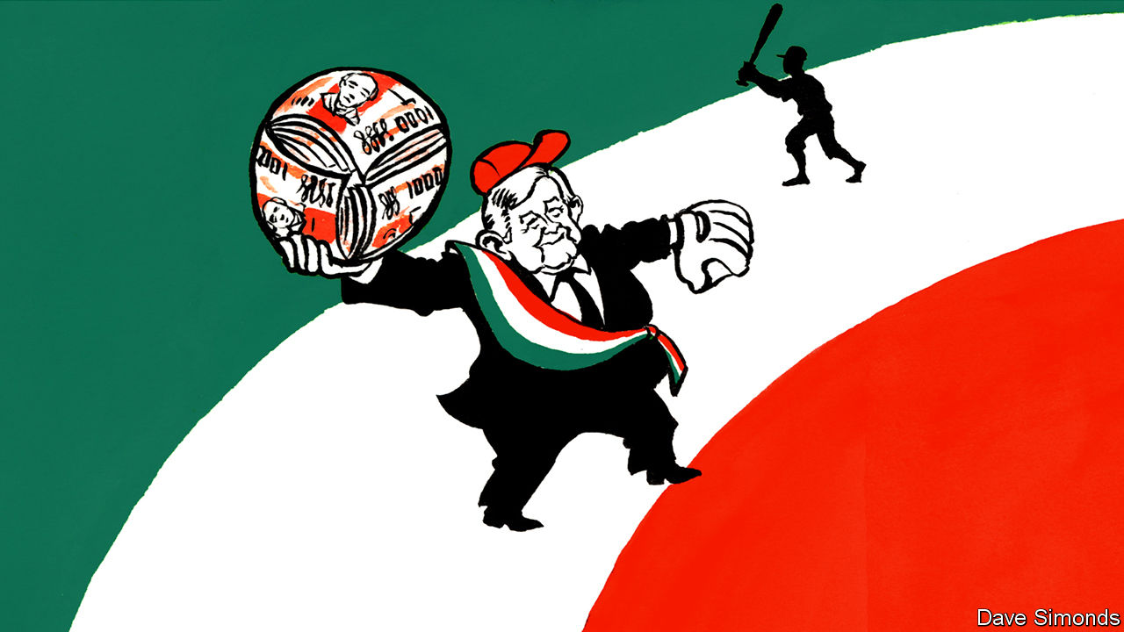

“TRAITOR. YOU ARE A TRAITOR.” That is how Eduardo Galeano, a leftist writer from Uruguay, greeted Che Guevara in Havana in the early 1960s. The Argentine’s crime had been to abandon Latin America’s favourite pastime, football, for North America’s. A Cuban newspaper had published a photo of him playing baseball. Guevara, who said it was “the first time someone calls me a traitor and keeps living”, learned to play in a Mexican prison while jailed with Fidel Castro in the 1950s.

He is not the only left-wing leader to have caught the baseball bug in Mexico. Andrés Manuel López Obrador, the country’s president, has been a fanatic since childhood. He won the election in 2018 by pledging to go to bat for the poor and vows to “strike out” Mexico’s “mafia of power”.

Under his programme of “republican austerity”, the government has slashed spending on everything from child care to medicines. Baseball is an exception. In March Mr López Obrador opened an Office for the Promotion and Development of Baseball. It got 350m pesos ($19m) to spot and nurture talent. Bureaucrats at non-baseball agencies were enraged.

Mexico’s constitution tells the government to “promote and stimulate” sport. It does not say which ones. Mr López Obrador has cut funding for Formula 1 and American-football events. Baseball, though, is “more than a sport. It is a fruitful passion that requires head, heart and character,” he said last year at the opening of a stadium in Mexico City. He became the first president in 72 years to throw an opening pitch.

Mr López Obrador wants to spread the game beyond its strongholds near the American border. He dreams that 50 Mexicans will be playing in major leagues abroad, a fourfold increase, by the time his term ends in 2024. He wants to combine Mexico’s two regional leagues into a single 26-team competition.

Baseball never caught on in Mexico as it did in Cuba and Venezuela. Mexican baseball’s best moments came before 1947, during the period when American leagues barred black players. Some played for Mexican teams. During the second world war Jorge Pasquel, the president of Mexico’s league, wangled draft deferments from the American government for American players heading to Mexico. That may have encouraged Mexico to continue a programme under which Mexican workers helped the war effort in the United States.

Thanks no doubt in part to Mr López Obrador’s fandom, attendance at Mexican Baseball League games rose by 30% last year. In April Mexico City will host regular-season Major League Baseball games for the first time since 2004. Mexico’s national team is one of six to qualify for this summer’s Olympic games in Tokyo.

Mr López Obrador, who is 66, says that had his army of scouts been around in his youth he would not have become a politician. But power has its perks. Hugo Chávez, a leftist (and left-handed pitcher) who governed Venezuela from 1999 to 2013, called the manager of Venezuela’s national team after each game to offer tips on tactics and selection. Mr López Obrador, who resists the trappings of power, may be tempted to ring up the Mexican manager.■

This article was downloaded by calibre from <https://www.economist.com/the-americas/2020/01/18/baseball-mad-andres-manuel-lopez-obrador-throws-money-at-the-game>

|  |  |  |  |
| --- | --- | --- | --- |
| Previous | Articles | Sections | Next |

|  |  |  |  |
| --- | --- | --- | --- |
| Previous | Articles | Sections | Next |

#### Bello

# Argentina’s new government gets to grips with the economy

The Peronists are fuzzy about their long-term plans

Jan 16th 2020 |



IT IS A MONTH now since Alberto Fernández took over from Mauricio Macri as Argentina’s president and, contrary to some forecasts, the sky over the Pampas has not yet fallen in. Having inherited a dire economic situation, including what Mr Fernández, a Peronist, called a “virtual default” on the country’s debts, his government has begun by doing more or less what he said it would. Adopting almost the opposite approach to its predecessor, it has laid out a tough fiscal policy and a loose monetary policy and has yet to say much about how it will handle the debt. Exchange and price controls, and the southern summer lull, have combined to buy the new team time. But will they use it wisely?

It was trying to buy time to reform a sick economy that got Mr Macri into trouble. A free-market conservative, he ran up debt to finance a gradual fiscal adjustment until investors took fright, prompting a run on the peso and forcing the government into the arms of the IMF. The economy slumped into recession, inflation surged to 54% last year and Mr Macri lost the presidential election. The new team’s first objective, according to Martin Guzmán, the economy minister, is “to halt the fall”.

They have swiftly pushed through an emergency package of mainly fiscal measures. These include tax increases on farm exports and travel abroad, and a six-month freeze of many prices, salaries and pensions. The impact on poorer Argentines has been softened with extra payments to them. According to Fundación Capital, a consultancy in Buenos Aires, the measures add up to a fiscal squeeze of around 1.5% of GDP. If fully implemented, they would balance the books before debt payments this year.

This has been offset by an opaque monetary policy. The central bank has said its intention is to maintain positive real interest rates and avoid “excessive” lending to the government. In practice the bank is driving interest rates towards negative territory and is “the printing press of the government”, as an economist who worked for a previous Peronist administration puts it. Officials think this monetary expansion will revive consumption and thus the economy. They are relying on price controls to blunt its inflationary impact. Critics reckon it will simply widen the gap between the official exchange rate of 60 pesos to the dollar and the free-market rate (at 77 this week). This will push up inflation.

Both Mr Fernández and his officials insist that Argentina wants to pay its debts (unlike in 2001, when Peronists cheered default) but that it needs more time to do so. That is broadly accepted by its creditors. An IMF mission is expected to visit Buenos Aires in the next few weeks. Mr Guzmán, a scholar of debt crises with no financial-market or government experience, says he wants a deal with the holders of $100bn of bonds by the end of March.

Time is of the essence. If the government moves quickly, the bonds will still be in the hands of institutional investors rather than litigious vulture funds, points out Héctor Torres, who was Argentina’s director on the IMF’s board. With the IMF itself, the government will probably seek a new standby agreement to stretch out the $43bn it is due to repay in 2022-23. It has eschewed drawing down $11bn outstanding from Mr Macri’s IMF loan. That is a mistake, argues Mr Torres, since the money might make it easier to reach a deal with the bondholders. It would be throwing good money after bad, reckons the new government team.

“We are navigating through a narrow passage,” according to Mr Guzmán. Missing is a chart for the other side of the corridor. Unless they are strictly temporary, the controls will create big distortions of the kind that built up under Cristina Fernández de Kirchner, the powerful vice-president, who held the top job from 2007 to 2015. The government has yet to link its emergency measures to a macroeconomic plan. That may be because Mr Fernández, a pragmatic moderate, must negotiate not just with creditors but also with his vice-president, a leftist populist.

His stance is thus ambiguous. On the one hand, he has rightly stressed that Argentina needs to boost its exports, and he has called for a national consensus on a long-term plan. On the other, in a reference to the IMF, he has lashed out at “recipes that have always failed”. In fact, they have always failed only in Argentina, which has long wanted to play by its own rules. “The world, unfortunately, is real,” as the writer Jorge Luis Borges put it. It is Mr Fernández’s task to persuade Argentines of that.

This article was downloaded by calibre from <https://www.economist.com/the-americas/2020/01/18/argentinas-new-government-gets-to-grips-with-the-economy>

|  |  |  |  |
| --- | --- | --- | --- |
| Previous | Articles | Sections | Next |

|  |  |  |
| --- | --- | --- |
| The Americas | Sections | China |

Asia

Banyan: The Taiwan consensus

.

Freedom of speech in Myanmar: Pen, sword and scales

.

Military reform in India: A major modern general

.

South Korea’s justice system: Going south

.

|  |  |  |
| --- | --- | --- |
| The Americas | Sections | China |

|  |  |  |  |
| --- | --- | --- | --- |
| Previous | Articles | Sections | Next |

#### Banyan

# What next for Taiwan after Tsai Ing-wen’s emphatic victory?

There is a clear consensus against China’s advocacy of “one country, two systems”

Jan 16th 2020 |

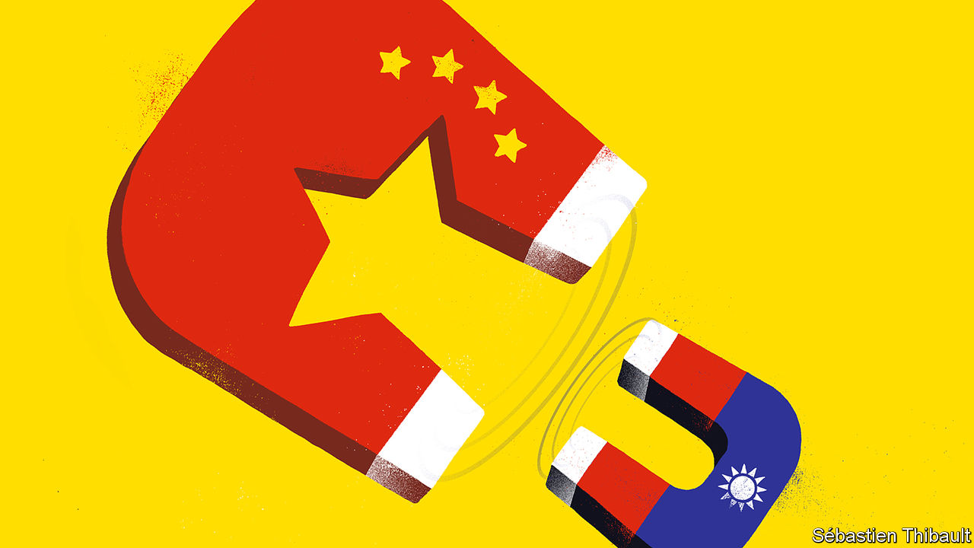

LAST AUTUMN, as China prepared to celebrate the 70th anniversary of the founding of the People’s Republic, a slogan of President Xi Jinping’s was strung up all over Beijing: “Don’t forget the original intention. Stick to the mission.” The mission was about national revival. As the Chinese Communist Party sees it, that involves restoring Taiwan to its rightful place as an undisputed part of the motherland.

And now Taiwan, which went to the polls on January 11th, has just responded—with a huge raspberry. The president, Tsai Ing-wen of the China-wary Democratic Progressive Party (DPP), was re-elected to another four-year term. Ms Tsai, soft-spoken and scandal-free, won in a landslide against her populist, often brash opponent, Han Kuo-yu of the China-friendly Kuomintang (KMT). For good measure, the DPP bucked predictions and hung on to control of the Legislative Yuan, the country’s parliament.

A year ago, following a DPP drubbing in municipal elections, it was not even clear that Ms Tsai would win her party’s nomination. Her dramatic turnaround is thanks to Mr Xi and his minion in Hong Kong, Carrie Lam. In a speech about Taiwan in early 2019, China’s dictator made clear that “one country, two systems”, the formula used to rule Hong Kong, was the model for Taiwan. When Ms Tsai claimed that Taiwanese rejected the model, even under the permanent threat of force, her approval ratings began to climb. They went higher still when Ms Lam, Hong Kong’s chief executive, pushed for a law allowing extradition to mainland China. That sparked a popular revolt over broken promises of autonomy and popular representation, allowing Ms Tsai to point out that since one country, two systems appeared dead in Hong Kong, it was absurd to consider it the prototype for Taiwan. Her country, meanwhile, has become an inspiration for Hong Kongers. Thousands of them flew to Taipei to follow the election and celebrate the outcome.

For now Ms Tsai’s star is high. Her diplomacy has been cannier than Mr Xi’s. She has quietly strengthened ties with Australia, Europe and Japan. Above all, she has bolstered support in America, Taiwan’s ultimate guarantor of security, by insisting that Taiwan will not destabilise things with fiery assertions of independence even as she refuses to acknowledge the goal of unification. Ties have rarely been better. Her reward: the sale last year of dozens of F-16 fighter jets.

Taiwan is also a rare winner from America’s trade war with China. The two giants’ tech divorce has given impetus to Ms Tsai’s attempts to “reshore” some of the Taiwanese tech industry’s huge investments in mainland China, to escape the threat of American tariffs. After years of sub-par growth, Taiwan’s economy is forecast to be one of East Asia’s better performers this year.

Yet things will surely get harder for Taiwan if America insists on a complete technological divorce from China. Taiwanese firms would be caught painfully in the middle. TSMC, the world’s biggest contract chipmaker, which provides components for American fighter jets, gets a fifth of its revenue from Chinese firms such as Huawei, a telecoms giant. Meanwhile, as exports to America grow, so Taiwan risks coming into President Donald Trump’s “America First” sights. Taiwan bans American pork because of a controversial feed additive promoting leanness. Some of the shine could quickly come off Ms Tsai’s victory.

Yet, for now, it is China and its traditional bases of support in Taiwan that are in a pickle. Chinese attempts to influence the election, from threats to disinformation campaigns, have backfired. Worse, after its electoral drubbing the KMT may launch into a debilitating civil war. Younger members blame the old guard for clinging too closely to the idea of reunification. They even want the party to abandon the “1992 consensus”, a diplomatic fudge hammered out between China and an earlier KMT government. It holds that there is only one China, even if both sides agree to disagree about what that means in practice.

Up-and-coming types now argue that the KMT pays a price for being seen as pro-China when there is, as one former legislator puts it, “a global anti-China wave”. Eric Huang, a lecturer and prominent member of the KMT’s younger generation, argues that it is time for the party to “put US-Taiwan relations ahead of relations across the Taiwan Strait”. Such a radical move would appal Mr Xi and those around him. Yet, as in Hong Kong, he appears to have no Plan B.

This article was downloaded by calibre from <https://www.economist.com/asia/2020/01/18/what-next-for-taiwan-after-tsai-ing-wens-emphatic-victory>

|  |  |  |  |
| --- | --- | --- | --- |
| Previous | Articles | Sections | Next |

|  |  |  |  |
| --- | --- | --- | --- |
| Previous | Articles | Sections | Next |

#### Pen, sword and scales

# Criticism of the army or government lands many Burmese in court

The army, meanwhile, spreads whatever falsehoods it likes

Jan 18th 2020 |

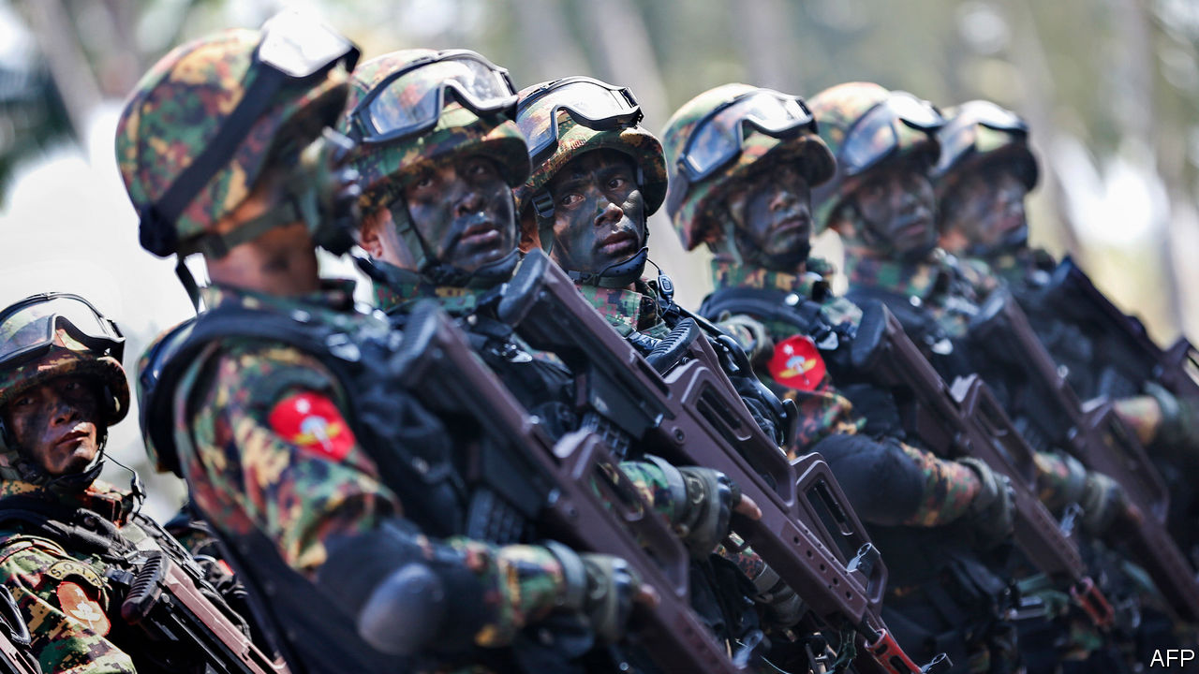

BURMESE GENERALS are not accustomed to criticism. During the long years of military rule, they tended to lock up anyone who crossed them. Even after they handed most authority back to a civilian government in 2016, they have continued to torment their critics—in the courts. Over the past four years the Tatmadaw, as the armed forces are known, has filed 47 lawsuits against nearly 100 individuals who have criticised it in the press or on social media. “We do not have lèse-majesté laws, but we seem to have lèse-militaire ones,” complains Mon Mon Myat, a journalist.

If anything, the army’s prickliness is growing. More than half of the 47 complaints were filed in 2019. In April the Tatmadaw sued two news outlets, Irrawaddy and Radio Free Asia, over their coverage of its clashes with one of Myanmar’s many ethnic militias. In June it sued three journalists for suggesting that it had seized land from farmers and suppressed the resulting protests. In August it filed a lawsuit against a pastor who had complained to Donald Trump, America’s president, about the army’s oppression of Christians. Last year it exhorted media outlets not to use the term “civil war” to refer to the various armed conflicts that rack the country, preferring instead “war of annihilation”. In 2017 it told reporters to call the people it is fighting in one such war “terrorists” rather than “militants” or “insurgents”.

Unfortunately, it is not just the army that is absurdly thin-skinned. Aung San Suu Kyi was one of the people the Tatmadaw detained for challenging military rule. But since she became the country’s de facto leader in 2016, at least ten people have been hauled into court for criticising her online, under a woolly and oppressive law on telecommunications.

All told, more than 250 people faced legal charges in 2019 for speaking out about the Tatmadaw, the government or ethnic tensions. Almost a third were prosecuted in criminal court for defamation, which is a civil offence in most Western countries but is punishable by up to three years in prison in Myanmar. Nearly a fifth were charged under the telecommunications law, which also provides for up to three years in prison for those “extorting, coercing, restraining wrongfully, defaming, disturbing, causing undue influence or threatening any person” on social media. “The problem has gotten worse with more arrests in recent months,” says Ye Wai Phyo Aung of Athan, a free-speech watchdog based in Yangon, the commercial capital.

The government has helped set up a body called the Myanmar Press Council to mediate disputes between journalists and officials, among other things. But one of its members, Myint Kyaw, says the government typically takes its complaints straight to the courts, sidestepping the council.

Ironically, it is the Tatmadaw itself which is one of the biggest sources of online falsehood in Myanmar. In 2018 executives at Facebook, which is extremely popular in Myanmar, said that the army had used it to mount a clandestine anti-Muslim hate campaign. Needless to say, none of those responsible was prosecuted. ■

This article was downloaded by calibre from <https://www.economist.com/asia/2020/01/18/criticism-of-the-army-or-government-lands-many-burmese-in-court>

|  |  |  |  |
| --- | --- | --- | --- |
| Previous | Articles | Sections | Next |

|  |  |  |  |
| --- | --- | --- | --- |
| Previous | Articles | Sections | Next |

#### A major modern general

# India’s armed forces get their biggest shake-up in decades

For the first time a single officer will be in charge of them all

Jan 18th 2020 |

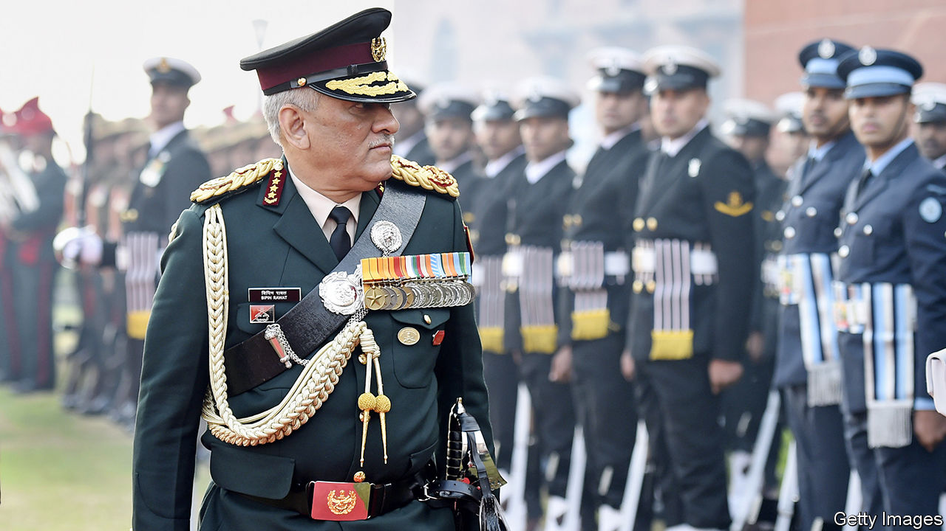

WHEN JAWAHARLAL NEHRU became the prime minister of India at independence in 1947, one of his first acts was to evict the country’s commander-in-chief, General Sir Rob Lockhart, from Flagstaff House, among the grandest mansions in Delhi. In a pointed gesture of civilian supremacy, Mr Nehru then moved in himself. A few years later he abolished the post of commander-in-chief entirely. The three coequal chiefs of the army, navy and air force have battled it out ever since, often quite heatedly.

That changed on January 1st when Bipin Rawat, the army chief (pictured), was handed a new uniform, a plush house and a newly minted job: Chief of Defence Staff (CDS). The creation of such a post had been mooted for decades, especially after the army and air force squabbled during a war against Pakistan in 1999. But there was resistance from civilians, who feared that a CDS might accrue too much authority, and from the air force, which saw it as a power grab by the already-dominant army.

Narendra Modi, the prime minister, swept those concerns aside. He has the largest parliamentary majority since 1984, a taste for grand gestures, and military threats on two fronts. Last year a terrorist attack in Kashmir resulted in an exchange of air strikes with Pakistan; relations have been fraught since. To the east, China’s defence budget is now triple India’s. New roads and railways into Tibet allow the People’s Liberation Army (PLA) to move troops to its disputed border with India quickly, while Indian forces are trapped in narrow valleys below. And reforms to the PLA mean that a single general would be in charge of all Chinese forces at the border, whereas the Indian command would be split between officers from different services.

The new CDS will not solve all these problems. Unlike his British counterpart, General Rawat will not in fact exercise any military command at all. He instead chairs a committee of the three service chiefs, who will still be able to go over his head to the defence minister. But he will have an office of over 60 people and influence over promotions and postings, giving him powerful levers to force the services to work together on everything from logistics to training—improving what military types call “jointness”.

More important, he has also been told to prepare the armed forces for theatre commands on the American or Chinese model. Under such a system, all forces in a given area, whatever their service, are under the command of a single officer. That idea has previously been anathema to the air force, in particular, which recoils from the idea that an army general might dictate how warplanes should be used.

The Indian armed forces are “at the cusp of a transformation”, says Anit Mukherjee, author of “The Absent Dialogue: Politicians, Bureaucrats and the Military in India”. But he warns that bureaucratic skirmishing from civilians and the services has neutered such efforts in the past. India’s lone joint command, in the Andaman and Nicobar Islands, is a largely failed experiment in inter-service harmony.

General Rawat’s promotion also raises questions about civil-military relations. Mr Modi has been accused of politicising the armed forces. In 2014, when he first became prime minister, he gave a ministerial post to V.K. Singh, a former army chief who had clashed with the previous government. During last year’s election campaign, Mr Modi’s Bharatiya Janata Party (BJP) displayed military images on campaign posters and publicised an event at which seven army veterans, including five retired generals, joined the party as the defence minister looked on approvingly. Another BJP leader, Yogi Adityanath, chief minister of Uttar Pradesh, described the Indian armed forces as “Modi’s army”. These episodes prompted over 150 senior veterans, including three former army chiefs, to write to the president to express their “alarm and disquiet”.

As army chief, General Rawat did little to allay these concerns. He “has often ventured into political and foreign-policy territory with his media statements, making many observers uncomfortable”, notes Sushant Singh, a former army officer who is now deputy editor of the Indian Express. In December, just days before becoming CDS, General Rawat provoked anger by criticising students protesting against a controversial citizenship bill.

His successor as army chief, General M.M. Naravane, struck a very different note in his first public remarks on January 12th. “As the army, we swear allegiance to the constitution of India,” he said. “Justice, liberty, equality and fraternity...should guide us.” The fact that those values were drawn from the constitution’s preamble, which has been read aloud at protests across the country, was not lost on anyone. ■

This article was downloaded by calibre from <https://www.economist.com/asia/2020/01/18/indias-armed-forces-get-their-biggest-shake-up-in-decades>

|  |  |  |  |
| --- | --- | --- | --- |
| Previous | Articles | Sections | Next |

|  |  |  |  |
| --- | --- | --- | --- |
| Previous | Articles | Sections | Next |

#### Going south

# South Korea’s president curbs the power of prosecutors

But is he doing it for the right reasons?

Jan 16th 2020 | SEOUL



JEJU, AN ISLAND off South Korea’s southern coast, is known for its hiking trails, temperate climate and the tough old women who dive off its cliffs for abalone, a delicacy popular with the glitterati in Seoul, the faraway capital. It is also popular with political leaders in search of a spot to sideline troublemakers. The rulers of the Joseon dynasty, for instance, used to send insubordinate aristocrats there to stop them from meddling in politics.

This week Park Chan-ho found himself reassigned to Jeju. Mr Park’s previous job was at the Supreme Prosecutor’s Office in Seoul, where he had been investigating allegations that the government had interfered in mayoral elections in the southern city of Ulsan in 2018. His colleague Han Dong-hoon, who had been leading an investigation into alleged nepotism and financial irregularities in the affairs of Cho Kuk, a former justice minister who resigned in the autumn, was moved to Busan, another traditional place of banishment.

The job moves, which were technically promotions, were part of an extensive reshuffle ordered by Mr Cho’s successor. Moon Jae-in, the president, denies that they are intended to punish the prosecutors or hinder investigations of his political allies. Mr Moon says that such personnel changes are common and that the probes the two men worked on could proceed unhindered with new prosecutors in charge. That may be true, but the reshuffle also fits in with Mr Moon’s quest to reduce the enormous power of prosecutors, one of his main pledges when he took office.

This week the second of two bills to reform prosecutions passed the National Assembly, after months of opposition protests and fisticuffs in the parliamentary chamber. Once the new laws take effect in the summer, prosecutors will lose some of their extensive powers to the police. A new agency comparable to Britain’s Serious Fraud Office will take over corruption investigations involving high-level officials and important business types.

Few doubt that the reforms are necessary. Most South Koreans do not trust prosecutors to do their jobs fairly. They think they are too soft on well-connected crooks and too harsh on people considered a threat to themselves or their political allies. This is especially worrying because the prosecution service has such sweeping authority. It has the exclusive right to issue indictments, and wide-ranging discretionary powers to start and end investigations, including command of its own investigative force (a job done by the police in most countries). It is also a tight-knit community, with many members drawn from the same schools and universities and moving easily between the prosecution, the justice ministry and the presidential palace. “The prosecution service is the only institution in South Korea that has so far escaped democratisation,” says Hannes Mosler of Berlin’s Free University. “It is essentially unchanged compared with the days of military dictatorship.” “Prosecutors have too much power and they have too often abused that power,” agrees Lim Ji-bong of Sogang University in Seoul.

By filling the top jobs at the prosecution service with political loyalists, Mr Moon this week followed a well-tested strategy that governments have used to try to harness that power and to insulate themselves from it. But though prosecutors have often lent a discreet helping hand to the government for part of a president’s term, most presidents have eventually found themselves at the receiving end of their appointees’ investigative powers. Lee Myung-bak and Park Geun-hye, Mr Moon’s predecessors, know this only too well. Under Mr Lee, a group of television producers had to fight a four-year libel suit because the agriculture minister objected to a programme they made about the risks of American beef imports. Under Ms Park, prosecutors barred a Japanese reporter from leaving the country while investigating him for defamation for a piece that speculated on Ms Park’s whereabouts during the tragic sinking of a ferry full of schoolchildren, when she inexplicably disappeared from public view. Both cases were eventually thrown out by higher courts. Both ex-presidents are now serving long prison sentences for corruption and abuse of power.

It is too early to tell whether Mr Moon’s reforms will break that cycle and turn the prosecution service into an agency that invites fewer attempts at political interference, including by Mr Moon himself. Mr Mosler reckons the new laws go some way towards curbing the agency’s excessive power. But they may also create new temptations for abusing it. Critics doubt, for instance, that there are sufficient safeguards to prevent the president from exerting undue influence over the new anti-corruption unit. Ending the predictable routine of first exploiting and then battling prosecutors will take a change of the political culture as well as the law. ■

This article was downloaded by calibre from <https://www.economist.com/asia/2020/01/18/south-koreas-president-curbs-the-power-of-prosecutors>

|  |  |  |  |
| --- | --- | --- | --- |
| Previous | Articles | Sections | Next |

|  |  |  |
| --- | --- | --- |
| Asia | Sections | Middle East and ... |

China

Impaired vision: Hope for myopes

.

Chaguan: The digital divide

.

We’re hiring a new China correspondent

.

|  |  |  |
| --- | --- | --- |
| Asia | Sections | Middle East and ... |

|  |  |  |  |
| --- | --- | --- | --- |
|  | Articles | Sections | Next |

#### Hope for myopes

# Over 70% of 12-14 year olds in China are short-sighted

Experts say they should get out more

Jan 16th 2020 | BEIJING

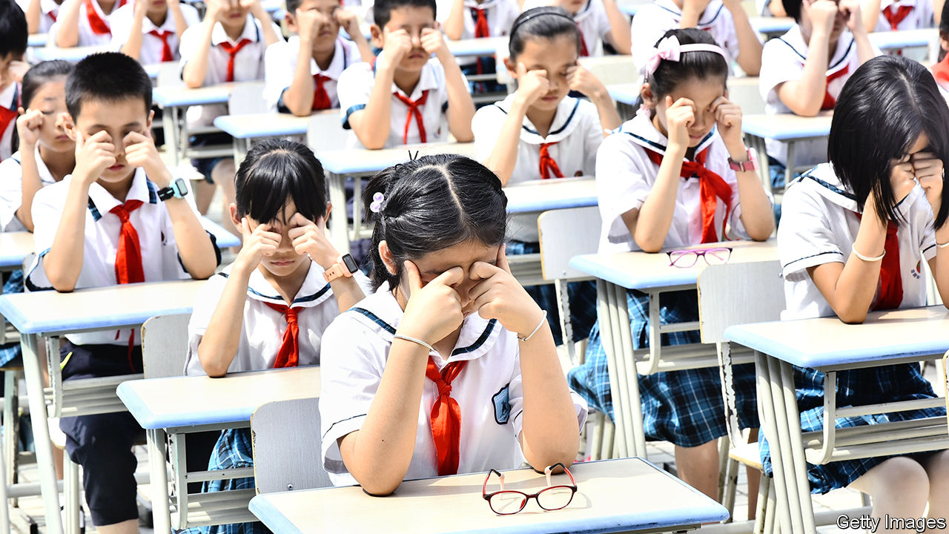

THE PHONE on Wang Xiaoying’s desk rings incessantly on a weekday morning. An optometrist in Shanghai, Ms Wang doubles as a part-time operator for China’s first publicly funded call centre providing information about myopia. It began operating on January 7th. Most callers are parents who worry about the deteriorating eyesight of their young offspring. “Make sure your child spends two hours outdoors each day!” Ms Wang often urges them. Another tip she offers is to avoid reading when supine. Trying to focus on an object held up by an unsteady arm is likely to strain the eyes, some experts believe.

The government reckons that more than 450m people in China, or at least one in three, are short-sighted (meaning that distant objects appear blurry). Globally just over one in five are. The prevalence of myopia among Chinese schoolchildren is even more alarming. In 2018 an official survey of 1m pupils found that among those aged between 12 and 14, 72% had myopia, up from 58% in 2010. Early onset of myopia is associated with a higher risk of eye diseases such as glaucoma, which can lead to blindness. In 2018 Xi Jinping, the president, declared the swelling ranks of young myopes a “big problem concerning the future of the country” which “must not carry on”.

The affliction’s spread in China is partly related to genes. Myopia is more common among East Asians than among white people. A study in 2016 found that just 19% of white 17-year-olds in Britain were short-sighted. But lifestyle plays a big role. A report by the World Health Organisation says the genetic contribution is “considered small”. To the extent that genes are involved, they “may determine susceptibility to environmental factors”. These are often a lack of outdoor activity and excessive “near work”, ie, too much time staring at close objects. The combination of an exam-crazed culture with the rapid spread of smartphones and computer-game technology explains much of China’s problem.

A paper in 2008 by a group of Australian researchers supports this idea. The study tracked hundreds of ethnic Chinese children in Sydney and Singapore. Whereas only 3% of the children in Sydney had become myopic by the age of seven, 29% had in homework-obsessed Singapore.

Officials fret about rising myopia not only because they care about people’s health. Legal Daily, a government-owned newspaper, recently suggested that China’s security could be compromised by its shortage of military recruits with normal eyesight. Last year China’s navy relaxed requirements for new pilots, no longer insisting on 20/20 vision.

The Communist Party is trying to reverse the trend. In 2018 it pledged to ensure that, by the end of this decade, less than 60% of 12- to 14-year-olds would be short-sighted. It also said the proportion of 15- to 17-year-olds with myopia should fall below 70% by then, down from 80% two years ago. Since 2018 periodic eye exams have been made compulsory at schools. Qiu Yu, a headmaster in Beijing, says his 1,800 pupils take eye tests twice a year. Headmasters whose pupils show a worsening trend in eyesight are summoned for “talks” by education officials, Mr Qiu explains—ie, a dressing down.

The party’s remedies include evidence-based as well as unorthodox prescriptions. Schools must ensure that students have at least an hour a day of outdoor activity (many experts believe sunlight helps prevent myopia or slow down its progression). Pupils in the first two years of primary school—a time of life when eyes are highly sensitive to strain—must not be given written homework. Those in the final year of primary school should receive at most one hour of it daily. Video-game makers must release fewer new products and devise ways of limiting the time children spend playing them. Schools and families must encourage children to avoid sweets and eat more fish. Experts agree that fish, which has high levels of omega-3 fatty acids, is good for eye health. Many doctors also recommend avoiding sugary foods, though why this helps is unclear.

More controversially, schools must ensure that pupils do “eye exercises” twice a day. These involve massaging the region around the eyes using the knuckles, with the thumbs placed on the temple (see picture). Mr Qiu, the headmaster, says that each set of exercises takes five minutes. The practice has its origins in traditional Chinese medicine. As with many remedies of such provenance, there is no sound evidence that it works.

The government could be doing more. Academics believe the proportion of pre-teens in China’s countryside who suffer from myopia may be five percentage points lower than in urban areas. That may be because they spend more time outdoors. But only one in seven rural schoolchildren who need glasses wear them, says a recent report by James Chen of Clearly, an international charity. A pair of cheap spectacles costs less than 50 yuan ($7). Yet many rural Chinese think that wearing glasses aggravates myopia. In fact, squinting without glasses puts more strain on the eyes, and may cause sight to worsen. Officials should try harder to discredit mistaken beliefs.

Yang Lili, a mother of a bespectacled 12-year-old in Beijing, is grateful that officials are belatedly paying attention to “the poison” of myopia. But they are “only scratching the surface, not solving the real problem”, she says. Ms Yang blames the entire culture of education. The fact remains that admission to the best universities involves intense cramming for a single exam. Schools may reduce homework. But parents “will continue to find private tutors and anything that gives their child an edge”. Another plan may be needed. ■

This article was downloaded by calibre from <https://www.economist.com/china/2020/01/18/over-70-of-12-14-year-olds-in-china-are-short-sighted>

|  |  |  |  |
| --- | --- | --- | --- |
|  | Articles | Sections | Next |

|  |  |  |  |
| --- | --- | --- | --- |
| Previous | Articles | Sections | Next |

#### The digital divide

# Different views of AI fuel distrust between China and America

The two countries talk past each other about its risks

Jan 16th 2020 |

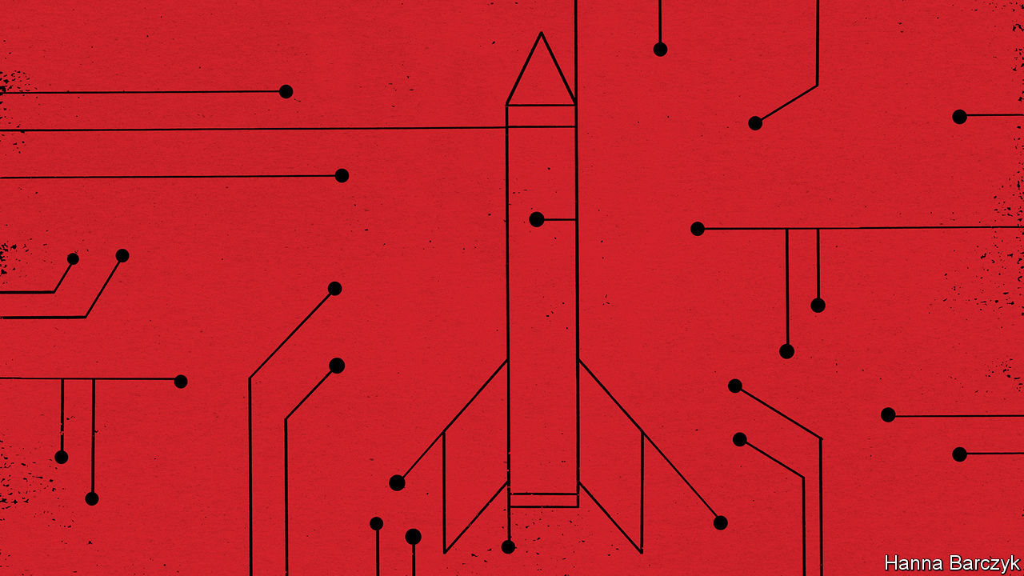

IN THE DEPTHS of the cold war, American and Soviet arms-control negotiators pulled off something remarkable: an agreement so grimly logical that their mutual distrust did not matter. The superpowers pledged to stop building new systems to defend their respective homelands against nuclear missiles. Their Anti-Ballistic Missile Treaty rested on a theory of mutual deterrence: the notion that the surest path to nuclear-armed co-existence lay in knowing that war would lead to catastrophe for both sides.

Today the rivalry between America and China is sliding into its own ice age of suspicion. Once again, new and unproved technologies—this time computer systems capable of performing superhuman tasks using machine learning and other forms of artificial intelligence (AI)—threaten to destabilise the global “strategic balance”, by seeming to offer ways to launch a knockout blow against a nuclear-armed adversary, without triggering an all-out war.

A report issued in November by America’s National Security Commission on Artificial Intelligence, a body created by Congress and chaired by Eric Schmidt, a former boss of Google, and Robert Work, who was deputy defence secretary from 2014-17, ponders how AI systems may reshape global balances of power, as dramatically as electricity changed warfare and society in the 19th century. Notably, it focuses on the ability of AI to “find the needle in the haystack”, by spotting patterns and anomalies in vast pools of data. In a medical setting AI can find tumours that radiologists miss. In a military context, it may one day find the stealthiest nuclear-armed submarines, wherever they lurk. The commission is blunt. Nuclear deterrence could be undermined if AI-equipped systems succeed in tracking and targeting previously invulnerable military assets. That in turn could increase incentives for states, in a crisis, to launch a devastating pre-emptive strike. China’s rise as an AI power represents the most complex strategic challenge that America faces, the commission adds, because the two rivals’ tech sectors are so entangled by commercial, academic and investment ties.

The good news is that China’s national-security establishment is also sobered by AI’s potential. Drawing on the example of arms-control talks during the cold war, Chinese officials and scholars have begun talking to Americans and Europeans about its dangers. With many government channels of communication suspended by the Trump administration, much of the jaw-jaw involves recently retired Americans meeting serving and former Chinese intelligence and military officers, diplomats and scholars. Chaguan was allowed to attend one such dialogue recently held in Beijing and Shanghai. The Americans were led by Mathew Burrows of the Atlantic Council, a Washington-based think-tank. His previous career in the CIA included preparing forecasts of global trends for incoming presidents. The Chinese organiser was Xiang Lanxin of the Graduate Institute of International and Development Studies in Geneva, who also heads the Shanghai-based Centre for One Belt, One Road and Eurasian Security.

Chinese views are not monolithic. Some officials sound gung-ho about AI as a path to prosperity and development, with few qualms about privacy or lost jobs. Still, other Chinese fret about AI that might put winning a war ahead of global stability, like some game-playing doomsday machine. Chinese officials have studied initiatives such as the “Digital Geneva Convention” drafted by Microsoft, a technology giant. This would require states to forswear cyber-attacks on such critical infrastructure as power grids, hospitals and international financial systems. AI would make it easier to locate and exploit vulnerabilities in these.

The bad news is that agreeing on rules for AI is even harder than wrangling over nuclear arsenals. One obstacle is physical. Warheads or missile defences can be counted by weapons inspectors. In contrast, rival powers cannot safely show off their most potent algorithms, or even describe AI capabilities in a verifiable way.

Other obstacles are philosophical. Seeking areas for co-operation, Chinese participants in the recent dialogue cited counter-terrorism. They suggested, for instance, that AI’s predictive powers might direct American and Chinese agents to shipping containers hiding drugs, or help police track extremists lurking among citizens returned from Syria, Iraq or other trouble-spots. Both sides readily agree on the need for co-operation in the search for smuggled fentanyl. But Western alarm bells quickly sound over China’s enthusiasm for algorithms trained to finger potential offenders before they break the law. Westerners worry especially about so-called “black box” algorithms, powerful systems that generate seemingly accurate results but whose reasoning is a mystery even to their designers. When machine learning uses past data to predict future actions, that prompts soul-searching about entrenching prejudice via algorithm. Last year a hearing in America’s Congress weighed the impact of facial-recognition technology on civil rights. Yet China shows few such qualms as it rolls out AI-powered surveillance systems that draw on data sets filled with past misdeeds and anti-social acts, or simple biases. Some use ethnic profiling, most notoriously in the western region of Xinjiang, where Muslim minorities are deemed prone to “mistaken thinking”.

## Don’t trust, can’t verify

Repeatedly, Chinese participants in the dialogue downplayed their country’s AI prowess. One said that China’s military applications were ten or 20 years behind America’s. “If I were America, I wouldn’t worry,” he chuckled. There were many calls for America to remain open to Chinese students and tech firms. “Generally speaking, China wants to learn from the United States, while the US sees China as a rival,” a Chinese official complained. To hawks in Washington such talk is a trick: an appeal to keep assisting China’s mastery of AI, and to forget the risks. Chinese AI experts might protest that they are damned if they seek co-operation with America, and damned if they do not. That, alas, is the logic of distrust. ■

This article was downloaded by calibre from <https://www.economist.com/china/2020/01/18/different-views-of-ai-fuel-distrust-between-china-and-america>

|  |  |  |  |
| --- | --- | --- | --- |
| Previous | Articles | Sections | Next |

|  |  |  |  |
| --- | --- | --- | --- |
| Previous | Articles | Sections | Next |

# We’re hiring a new China correspondent

An opportunity to join our editorial staff

Jan 18th 2020 |

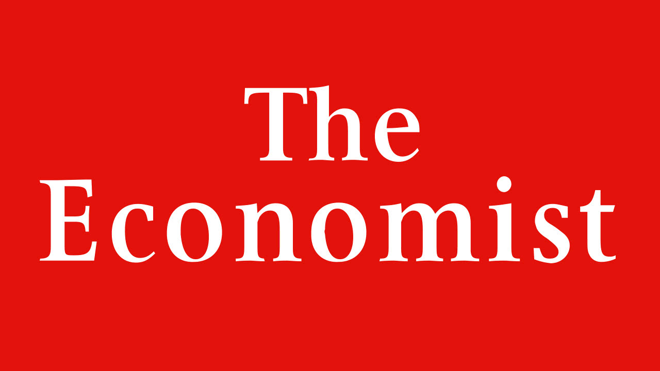

Journalist wanted: The Economist is hiring a new China correspondent to join our Beijing bureau. We’re looking for someone with a deep knowledge of China, excellent writing skills in English and a sharp analytical brain. Please send a CV and an unpublished 600-word article on any China-related topic to chinajob@economist.com by January 31st.

This article was downloaded by calibre from <https://www.economist.com/china/2020/01/18/were-hiring-a-new-china-correspondent>

|  |  |  |  |
| --- | --- | --- | --- |
| Previous | Articles | Sections | Next |

|  |  |  |
| --- | --- | --- |
| China | Sections | Europe |

Middle East and Africa

Iran: Regime on edge

.

Oman: What comes after Qaboos?

.

Ethiopia: It’s all in your head

.

A journey up the Congo river: Follow the bottle

.

|  |  |  |
| --- | --- | --- |
| China | Sections | Europe |

|  |  |  |  |
| --- | --- | --- | --- |
|  | Articles | Sections | Next |

#### Regime on edge

# Iran’s leaders risk being overwhelmed by crises they created

The regime is facing pressure at home and from abroad

Jan 16th 2020 |

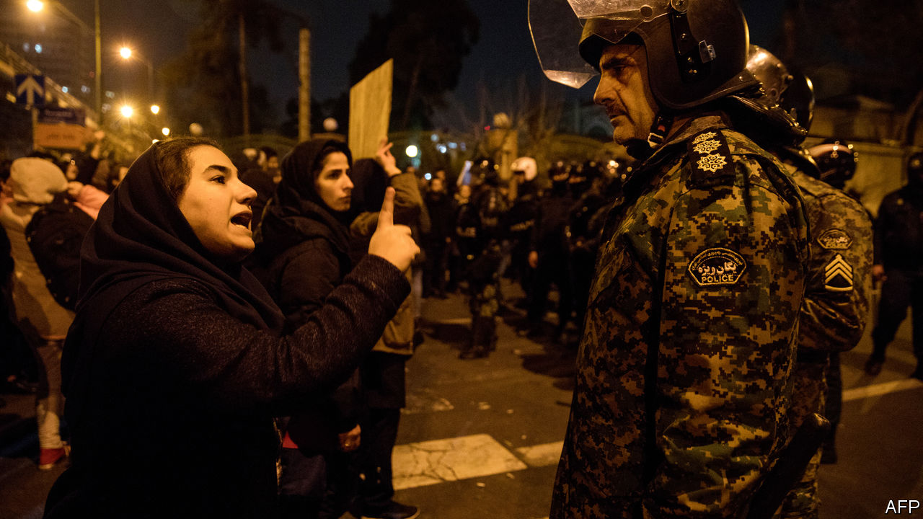

SO UPSET WERE they over the crash of a Ukrainian passenger jet that not one but two officials in Iran’s Islamic Revolutionary Guard Corps (IRGC), including its leader, said they wished they were dead. The IRGC, the regime’s Praetorian guard, shot down the plane by mistake over Tehran on January 8th, then tried to cover it up. The mea culpas came days later, after officials were caught in their lies. But the feelings of regret were short-lived. When thousands of Iranians took to the streets to voice their anger, the IRGC sent its bully boys to knock back the crowds; when the thumping failed to work, some opened fire.

Force has quelled previous protests, most recently in November, when the authorities killed hundreds of people. But the regime offers no solutions to the economic anxiety and political stagnation lying beneath all the anger. So it lunges from crisis to crisis, as the ranks of the discontented grow. Meanwhile pressure from abroad is rising. On January 14th Britain, France and Germany formally accused Iran of breaching an agreement, signed in 2015, to curb its nuclear programme. “We feel the system is on the brink,” says one protester.

In early January Iran had come together in national mourning after America’s assassination of Qassem Suleimani, its most prominent general, who was in charge of the IRGC’s foreign operations. But hours after the IRGC retaliated with missile strikes on American targets in Iraq, killing no one, its operatives in Tehran mistook the passenger jet taking off from the international airport for an incoming cruise missile. They shot it down, killing all 176 people on board. The dead included dozens of young Iranians going to study in Canada. For three days the Guards said a mechanical failure was to blame. Mourning on state television was muted. The official disregard contrasted with the huge funeral staged for General Suleimani.

The big protests in 2017 and 2019 started in provincial cities and featured mostly working-class Iranians. The latest unrest, by contrast, began in Tehran and has rippled outward. Students and middle-class Iranians have taken the lead. Some tore down portraits of General Suleimani and called for the downfall of the supreme leader, Ayatollah Ali Khamenei. Others mocked the IRGC’s attempt to deflect criticism by stirring up anti-American and anti-Israeli sentiment. At Shahid Beheshti University in Tehran, crowds refused to walk on giant American and Israeli flags that had been painted on the ground.

Prominent members of Iran’s nomenklatura have openly broken with the regime. Newspapers printed apologies for betraying their readers and promised to hold the authorities to account. “Officials who misled the media are guilty too,” tweeted Kian Abdollahi, editor-in-chief of the semi-official Tasnim news agency. “We are all ashamed before the people.” Gelare Jabbari, a television anchor, apologised “for lying to you on TV for 13 years”. Artists pulled out of festivals. The only female Iranian athlete to win an Olympic medal, Kimia Alizadeh, announced her defection.

The regime now rests on a loyalist rump, which seems to be weakening. Several conservative politicians, such as Ali Larijani, the speaker of parliament, have announced their retirement in recent months. The rest have engaged in a blame game with more pragmatic types, such as President Hassan Rouhani. Hardliners have called for his resignation. Mr Rouhani, in turn, says that IRGC leaders should be prosecuted. The authorities say they have detained several people, but seemingly no bigwigs. One person was reportedly arrested for posting a video of the missile hitting the plane online.

Unrelenting economic decline, hastened by American sanctions, gnaws at the credibility of the government’s pragmatists and hardliners alike. The IMF forecasts that GDP will shrink by 9.5% this year. Economists say Iran must sell 1m barrels of oil a day to stay afloat, but it has exported at best half of that in recent months. Starved of funds, capital expenditure has all but ground to a halt. Printing more rials might stimulate the economy, but would also boost inflation, which is running near 40% a year. The economy “is like a man in his 90s with ten diseases laid flat in hospital”, says an Iranian academic.

Many of the ailments can be traced back to President Donald Trump’s decision in 2018 to pull America out of a deal that curbed Iran’s nuclear programme in return for relief from sanctions. Mr Trump wants a new agreement that also curbs Iran’s missile programme and its regional meddling. “Let’s replace [the old deal] with the Trump deal,” adds Boris Johnson, Britain’s prime minister. Mr Rouhani has dismissed the idea and refuses to talk to Mr Trump. “Iran could have followed Mexico, which renegotiated NAFTA and benefited,” says an Iranian political scientist. “Even protracted negotiations might have kept Mr Trump in the nuclear deal and spared it sanctions.”

Instead the regime has challenged America and alienated the European signatories to the deal by lifting all limits on its production of enriched uranium, which can be used for nuclear energy or, if concentrated enough, a bomb. Its actions pushed Britain, France and Germany to invoke the deal’s dispute mechanism on January 14th—which could ultimately spell the end of it. America may have played a role in the decision. According to the Washington Post, Mr Trump threatened to impose a 25% tariff on European car imports if the three countries refused to act.

For Iran, the status quo is untenable. But with his nuclear deal in tatters, his brother in prison (on charges of corruption) and his presidency ending next year, Mr Rouhani looks like a lame duck. Some Iranians believe the IRGC stands a better chance of changing Iran. Its strength has grown over the past decade, along with its role in the economy; it might be better placed to challenge clerical rule and make up with America. But a coup seems unlikely. The IRGC, now sullied, remains in the grip of the clergy. Each unit, from platoon upwards, has a clerical commissioner who vets promotions and reports directly to Mr Khamenei. The religious indoctrination of recruits has increased.

For his part, Mr Khamenei has not apologised for the plane crash, perhaps fearing it would show weakness. On January 17th he is due to lead Friday prayers in Tehran for the first time in eight years. Expect his message to be uncompromising. He is likely to endorse the IRGC and warn that protesters will be treated as traitors.

Mr Khamenei may count on outlasting Mr Trump, who faces an election in November. In the meantime, he will rely on the IRGC and the clergy to smother dissent. The Council of Guardians, an appointed group of clerics and Islamic jurists, has barred 90 MPs, nearly a third of the parliament, from running for re-election next month. Most are moderates. In the words of one Iranian analyst, Iran’s clerics learnt from the shah’s downfall in the Islamic revolution of 1979 that a regime weakens itself when it starts to reform. ■

This article was downloaded by calibre from <https://www.economist.com/middle-east-and-africa/2020/01/16/irans-leaders-risk-being-overwhelmed-by-crises-they-created>

|  |  |  |  |
| --- | --- | --- | --- |
|  | Articles | Sections | Next |

|  |  |  |  |
| --- | --- | --- | --- |
| Previous | Articles | Sections | Next |

#### What comes after Qaboos?

# The new sultan of Oman hopes to lead as well as the last one

But he will face plenty of challenges

Jan 16th 2020 |



SULTAN QABOOS of Oman left little to chance. Long before he died he sealed two envelopes containing the name of his chosen successor—and a back-up, just in case. Hours after his death was announced on January 10th, relatives gathered to open the envelope. Everyone suspected the candidate would be one of his cousins. Which one was a surprise: not Asad bin Tariq, who had been elevated to deputy prime minister in 2017, but Haitham, a longtime diplomat. Still, the succession went off without a hitch. The new sultan swore an oath and pledged to continue the policies of the man who built the modern Omani state.

Sultan Qaboos seized power from his father, with British help, in 1970, when he was 29. The older man ruled as a recluse. When he was deposed Oman had just three schools and 10km of paved roads. Sultan Qaboos changed all that. Though it is not as oil-rich as its neighbours, in 2010 Oman was ranked by the UN as the country that had developed most over the previous 40 years, ahead even of China. The Sultan also charted an independent foreign policy: fond of Britain, willing to host Israeli prime ministers, but also happy to meet Iranian ayatollahs and Chinese businessmen.

Many of those foreigners descended on Muscat this week to pay their respects. Britain sent both Prince Charles and Boris Johnson, the prime minister, a remarkable show of affinity for a faraway state (Oman is the one Gulf country where Britain, not America, is primus inter pares). That relationship remains on solid ground with Sultan Haitham, an Oxford graduate.

Indeed, little is likely to change in Oman’s foreign affairs. Sultan Qaboos charted the course, but many Omanis are now proud of a policy that has kept them out of the region’s myriad fights and made their country a trusted mediator. In his first speech as sultan, Haitham pledged to adhere to his predecessor’s principles. “We’re on the Indian Ocean, not only the Gulf. We look out as well as in,” says an adviser to the late sultan.

Still, a few questions linger. One is how Sultan Haitham will manage relations with President Donald Trump. Sultan Qaboos is said to have been upset by the president’s decision to withdraw from the nuclear deal with Iran, which grew out of secret talks in Muscat. Mr Trump sent only a middling delegation to his funeral, led by the energy secretary. But the new sultan will be familiar with the Americans from his days as a diplomat, when he helped negotiate agreements that allow America to use Omani airfields and position military kit in the sultanate. If Mr Trump decides to pursue his own deal with Iran, he may ask for help.

Other Gulf states, meanwhile, may see an opportunity to meddle. Saudi Arabia and the United Arab Emirates (UAE) resented Sultan Qaboos’s neutrality in the war in Yemen, his refusal to join the blockade of Qatar and his ties to Iran. In recent years Omani officials and foreign diplomats have worried that the country could find itself subjected to the same treatment as Qatar. When Britain held a military exercise on Oman’s Indian Ocean coast in 2018, diplomats described it as a message to the UAE, a sign that Oman had powerful friends.

Wealthier neighbours could try to put pressure on the new sultan more subtly—by dangling the prospect of needed investment. Oman pumps 1m barrels of oil a day, about a quarter of the UAE’s output. That small stream still accounts for more than 70% of government revenues. Last year the state had to raid its sovereign-wealth fund to finance the deficit. The World Bank puts youth unemployment at a staggering 49%. Inward foreign direct investment is growing, but is still largely concentrated in oil and gas.

Sultan Haitham has little economic nous and is not known for his managerial savvy. The ministry of culture, which he ran, was seen as dysfunctional. Oman-watchers fear he lacks energy and hope he will delegate to younger officials. “There’s a new generation of leaders coming up,” says a diplomat. “They understand that things need to be upgraded a bit.” ■

This article was downloaded by calibre from <https://www.economist.com/middle-east-and-africa/2020/01/18/the-new-sultan-of-oman-hopes-to-lead-as-well-as-the-last-one>

|  |  |  |  |
| --- | --- | --- | --- |
| Previous | Articles | Sections | Next |

|  |  |  |  |
| --- | --- | --- | --- |
| Previous | Articles | Sections | Next |

#### It’s all in your head

# Ethiopia embraces the power of positive thinking

But reframing poverty as a state of mind may not solve it

Jan 16th 2020 | ADDIS ABABA

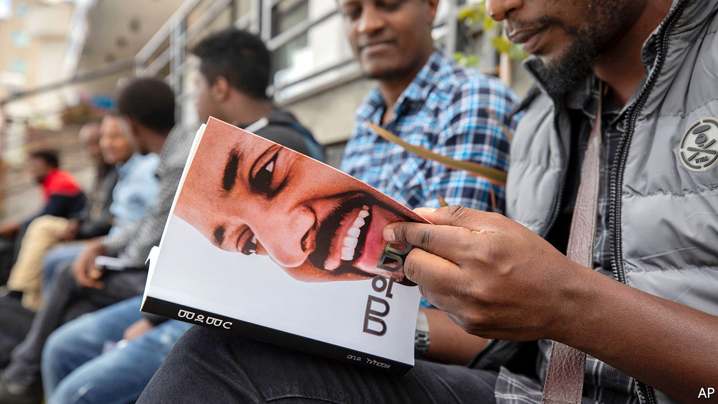

“I USED TO have pimples and everything. And I have big ears in case you haven’t noticed,” laughs Ebba Tesfaye, now fresh-faced and snappily dressed, in the lobby of a swanky hotel. Rattling through his life story—bullying, drugs, redemption—he pauses only to glad-hand a passing celebrity before rushing to the set of his new TV show.

Ebba T, as he is known, is among the most prominent of a rising generation of motivational speakers and life coaches in Addis Ababa, Ethiopia’s capital. Their rags-to-riches parables offer hope to legions of frustrated Ethiopians. A few, like Ebba, have found fame on the airwaves. Some are YouTube gurus. A handful write books, while others start consultancies. All preach a message of individual uplift in a country burdened by poverty and ethnic divisions.

Such positive thinking has a growing market. Translated versions of self-help bibles, such as “Releasing Your Potential” and “You Can Win”, fill the capital’s ubiquitous mobile bookstands. “Psychology books are so popular,” says Abraham Atalele, a young street vendor who switched from hawking clothes to books after reading “The Art of Self-Management”.

Self-help ideas have also reached the upper echelons of government. Abiy Ahmed, the prime minister, counts Mehret Debebe, a psychiatrist and popular TV host, as an adviser. Mehret, who argues that poverty is at root an attitude problem, was one of the first to turn positive thinking into big business by launching a series of conventions shortly after Abiy took office in 2018. “Most people learned about motivational speaking from Dr Mehret,” says Henok Begashaw, who sends out inspirational memes to his more than 100,000 subscribers on Telegram, a messaging app.

Yet the chief peddler of positivity is Abiy himself. “I believe we can realise the prosperity of Ethiopia in the coming ten years,” he has said. “The only problem is our thinking.” Last year he published a book called “Medemer” (pictured) which blames negative thinking for many of Ethiopia’s problems. Shortly after becoming prime minister he gave televised “trainings” to generals and cabinet ministers, during which he argued that “attitude problems” were holding the country back. Government initiatives, such as weekly cleaning days and a nationwide tree-planting project, are part of the solution. “A mind that doesn’t see a good thing will not create a good thing,” he said when asked to explain the flowers arranged along the road to the airport in Addis Ababa.

Not everyone is convinced. Self-help, with its focus on personal salvation, is often associated with Pentecostalism—and is thus regarded warily by traditionalists in the Ethiopian Orthodox Church. “Most Ethiopians believe loving yourself is selfish,” says Ebba T. And the stress on individual bootstrapping offends some in a ruling party with Marxist roots. “I’d rather rely on a structural analysis of poverty than a psychological one,” sniffs an intellectual close to the government.

But Abiy appears unfazed. At the end of last year he turned the ruling coalition, the Ethiopian People’s Revolutionary Democratic Front, into a single party—which he tellingly named the Prosperity Party.

This article was downloaded by calibre from <https://www.economist.com/middle-east-and-africa/2020/01/18/ethiopia-embraces-the-power-of-positive-thinking>

|  |  |  |  |
| --- | --- | --- | --- |
| Previous | Articles | Sections | Next |

|  |  |  |  |
| --- | --- | --- | --- |
| Previous | Articles | Sections | Next |

#### Follow the bottle

# How to get beer around Congo, a country with hardly any roads

A journey up the Congo river

Jan 16th 2020 | MBANDAKA

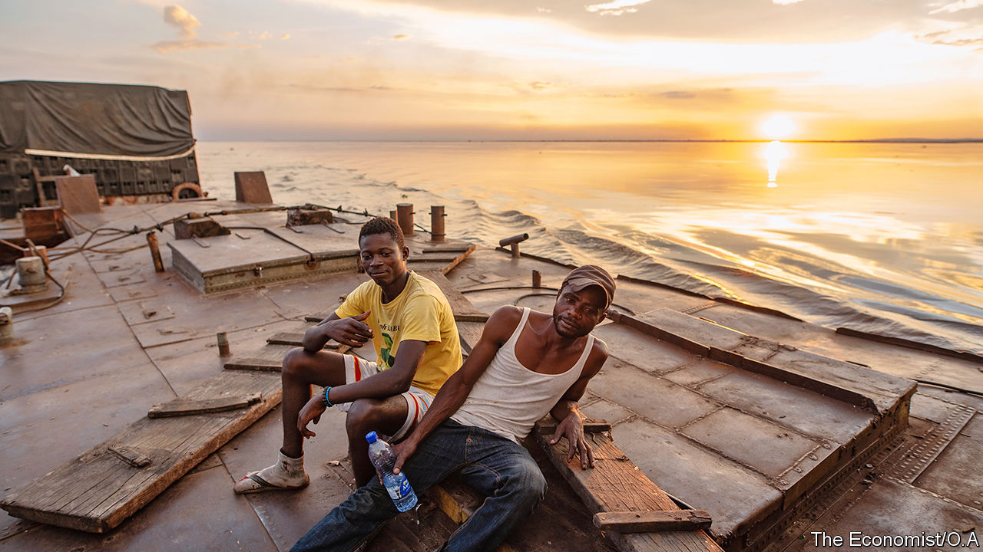

THE BARGE, weighed down by half a million bottles of beer, pulls out into the middle of the Congo river. At its tip, breezy rumba music drifts out of a small radio and a group of young men sit around grumbling about the hardships of life on board. “We stay on this boat until death,” claims one sailor (pictured, right). In reality, the crew spends a total of only six months on the barge a year—although the risk of it sinking is not trivial. Laden with beer belonging to Bracongo, a brewery, the boat is travelling from Kinshasa, the capital of the Democratic Republic of Congo, to the city of Bandundu, 387km (240 miles) upstream.

Omar Barcat, the barge’s owner, has been running a fleet of five cargo ships for 20 years. He predicts that various apparatchiks, some wielding Kalashnikovs, will intercept the boat at several points along the river. They will try to extort payoffs that amount to around $500. Unruly sailors are another problem. Far away from their bosses back in the capital, they are sometimes tempted to stop off in villages and visit friends. Occasionally they drink beers they claim have exploded or broken (which can lead to worse misdemeanours). “But they know that if anyone is caught doing that he will immediately be fired,” he says.

Much is at stake for Mr Barcat and for Bracongo. The brewery, owned by Castel, a French firm that operates across Africa, has been competing with Bralima, owned by the Dutch company Heineken, for customers in Congo for 70 years. Both breweries have been around since colonial times; unlike most foodstuffs in Congo, beer is local. And yet the difficulty for both companies is getting bottles from the factory to the bar.

Congo is not an easy country to get around. China has three metres of road per citizen; Congo has three centimetres. Only four out of 26 provincial capitals have roads that reach Kinshasa. Some villages are so isolated that they still use a currency that was abolished in 1997. It is no surprise that, in the east, the government has little control and the people in power are those with guns. Millions have fled the violence there over the past 20 years.

For most people the only way to travel long distances is to go on boats that ply the Congo river and its tributaries. All the beers that reach the country’s dense, forested interior will have been shipped up the river. The journey on Mr Barcat’s boat will take a week. If the roads in Congo were made of tarmac instead of undulating mud and sand, then the beers would reach Bandundu in less than a day. But the rusting carcasses of overturned vehicles languishing in ditches serve as a reminder of what can happen if that journey is attempted by a lorry with a heavy load.

In 2019 Bracongo had the edge over its competitor: it provided 53% of beers in the country, compared with 47% from Bralima, according to the brewery’s own statistics. In Kinshasa the two companies race to load up trucks each morning. “We try hard to get everything out by 7.30am. Bralima’s lorries leave between 7.30am and 8am,” says Teddy Junior Mena, head of Bracongo’s distribution. “And we are also trying to get a beer to every last village in Congo,” he adds.

Indeed, despite the country’s abysmal infrastructure, beer gets everywhere. Like the rumba music which is blasted from fuzzy speakers at every run-down bar, it is one of the few things Congolese can rely on. To understand how one brewery gets its wares to thirsty customers, your correspondent embarked on a series of voyages.

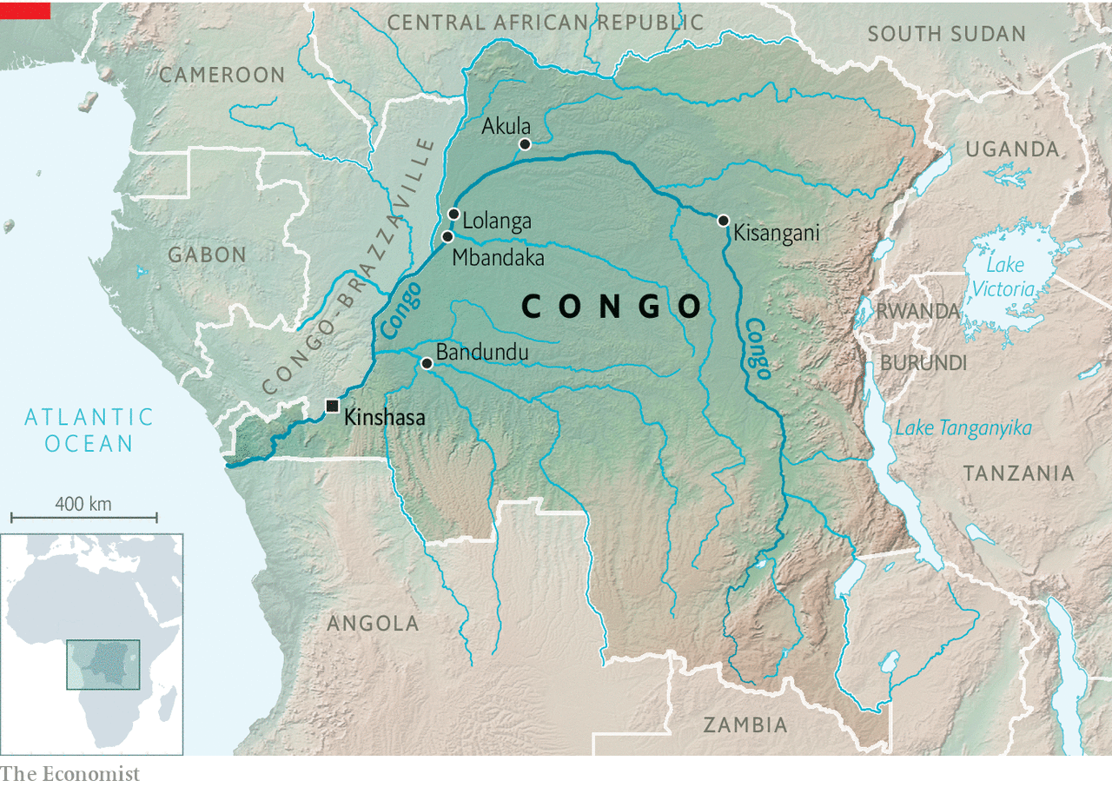

The Congo river traces a huge arc across the country from the south-east, through the city of Kisangani, past Kinshasa and out into the Atlantic Ocean (see map). It is both the second-longest river in Africa and the deepest. If its roaring water mass was turned into energy through hydroelectric dams, it could light up most of the continent.

## King Leopold’s ghost

For centuries the river has served as a trade route—for better and for worse. King Leopold II of Belgium, who ran Congo as his personal fief from 1885 to 1908, forced armies of villagers to harvest ivory, tap rubber and load these precious commodities onto boats. Wives were held hostage to ensure that their husbands submitted to forced labour. Those who did not work hard enough were killed or dismembered. Countless villagers hid deep in the forest to avoid enslavement. Fishing and subsistence farming collapsed. Deaths from starvation and disease soared; births plunged, since so many couples were separated. By one very rough estimate, Congo’s population fell by half, from 20m to 10m, between 1880 and 1920.

Leopold’s misrule attracted global condemnation. In 1908 the Belgian government prised Congo from his grip and ruled it somewhat less atrociously until 1960, when it became independent. Mobutu Sese Seko, a military despot, re-christened the country “Zaire” in 1971. In Kongo, a local language, this means “the river that swallows all rivers”. The name changed back when Mobutu was overthrown in 1997.

Today the river is a source of pride. Photos of fishermen in canoes on the river are stamped across the country’s banknotes. Just after setting out, Mr Barcat’s barge passes a man sitting astride four floating tree trunks, bound together with rope. Using a single oar, he guides his vessel towards the port where he will try to sell the wood. He has probably travelled from Mbandaka, a city in the heart of the Congo basin rainforest, some 586km upstream. If so, he will have spent two weeks punting down a wide stretch of murky water that is home to hundreds of crocodiles.

After a week Mr Barcat’s barge reaches Bandundu. From here, as in Mbandaka, smaller vessels carry the beers to tiny villages on the banks of the river. At the port in Mbandaka, Christine, a 40-year-old bar owner, picks up 70 crates of beer from the Bracongo depot. She travels to the city twice a month on one of these smaller vessels to collect beers for her bar and to sell to other bartenders. The trips are tough: she has to sleep out on deck in the rain and the muggy heat. “We are exposed to all the elements,” she sighs.

The second, spluttering wooden boat, which along with Christine and her beers carries around 150 people, 60 sacks of charcoal, palm oil, peanuts, two charred cobras (a regional delicacy) and a mournful-looking chicken, finally sets off, after a five-hour delay, at 9pm. Rumba music hums from several battery-powered radios. Modified Chinese generators power the boat. Fiston, a member of the crew in his early 20s, explains that there are five generators so the boat will not have to stop when one or two inevitably conk out. Indeed, a few hours into the journey, the first so-called engine splutters and dies.

It is not the only sign that this vessel is not entirely river-worthy. Fiston’s list of passengers, presented to the official at the harbour, has only 15 names on it. If the boat goes down and more than 15 people survive, he will have no problems with those in charge. Creative accounting like this makes it almost impossible to know how many people die in the river each year.

Soon after the boat starts off, the smell of marijuana wafts down from the upper deck, nicknamed “The United States”, because “it’s as high as you can go in life”, a passenger explains. Below, people huddle around smoky stoves and share saucepans of rice and stew. Old men nestle down for the night under their coats. Passengers step over them to get to the toilet, which is a hole in the deck and a bucket of river water.

In one of the four cabins available to passengers, your correspondent’s bed is a sagging foam mattress supported by slabs of plywood with a grubby mosquito net hanging over it. Sleep is elusive: the generator is so loud that it is hard to doze off.

The next morning bleary-eyed passengers shuffle, one by one, to the back of the boat, clutching toothbrushes. A woman fries dough balls and sells plastic cups of sugary tea for breakfast. An argument breaks out between the captain and a couple of young men. A group of boys on the United States deck lean over to get a better view of the ruckus. Angel, a peanut vendor, wags one of her fingers and shouts something in Lingala, a local language. Suddenly everyone cheers. A drunk man blows a whistle. “One of the boys was winding up the driver,” Christine explains. “But that woman put him in his place.”

## Ça sent la bière, Dieu qu’on est bien

Your correspondent gets off, grateful for dry land, at a village called Lolanga. Christine will continue on the boat for three more days, to its final stop, a larger village called Akula. It is less than 350km—about as far as New York is from Washington, DC, a journey of around four hours in a car. Each round trip takes Christine just over a week. She dreads it, but knows that her bar will not survive without beer.

Christine’s travails are passed on to her customers. Her beers cost a third more than those in Kinshasa, at $1.80. She has to factor in her $60 boat ticket and the money she pays a friend to run her bar when she is away. Her profits are slim. She does not make enough money to save, she says, but enough to survive.

For many Congolese, potent home-brews offer better value for money than factory-made beer. Old ladies produce buckets of fizzing moonshine in the backs of their houses. One drink, called Mbandule, or “turn your mind upside-down”, is made from a fermented cereal crop and is particularly popular in the east, or with those seeking cheap oblivion. A glass costs just 30 cents.

Beer is a status symbol, observes Mr Mena, like owning a mobile phone. The two often go together, he laughs: “Nowadays people drink a beer with their phone in one hand.” Rumba musicians, too, are sponsored by different beer companies; when Werrason, a famous one, switched sponsor from Bracongo to Bralima in 2005, he prompted gasping headlines.

Partly as a result, beer sales in Congo do not reflect the state of the economy, which shrank by 1.5% in 2019. According to Bracongo people are drinking more beer than ever before. “Even we don’t understand it sometimes. This dry season [April to August] we have some of the biggest figures ever,” says Mr Mena.

Since 2010 Bracongo has started to promote different kinds of beers to different slices of the population. Those without jobs inevitably pick the cheapest in the market: small bottles of the weakest brew called Beaufort. Young people tend to go for lighter lagers, says Florent Muteba, head of Bracongo’s commercial analysis. Farmers and street vendors seem to like malty dark ales. Clever, aspirational marketing and Herculean logistics help explain why the company manages to sell alcohol even when people are getting poorer. (Its addictive qualities probably help, too.)

On the journey back to Mbandaka, this time on a wooden canoe which threatens to capsize as a priest and his friends get on board, your correspondent stops in a tiny riverside village. Here a woman complains that the nearest pharmacy is a three-hour boat trip away. Getting antibiotics quickly is impossible, but getting beer is not—just next door to her an old man, Garus, sells large, warm bottles of dark ale. Fishermen pool their day’s earnings to buy them. There is no electricity, but Garus turns his straw-roofed house into a bar at night, using torches to light it. He too pumps rumba music out of a battery-powered radio. “People here drink beer to forget their worries, to de-stress,” he explains.

Mr Barcat would be out of business if Congo had proper roads. Politicians keep promising to build them, but somehow never do. Mr Barcat jokes that he will be able to retire comfortably; his barges also take the empty bottles back to Kinshasa on the return journey, so he makes money both ways. The river will remain Congo’s main artery for years to come. And poor people will continue to club together to buy one of the few colonial relics that nearly everyone loves: clear, refreshing, temporarily worry-dispelling beer. ■

This article was downloaded by calibre from <https://www.economist.com/middle-east-and-africa/2020/01/16/how-to-get-beer-around-congo-a-country-with-hardly-any-roads>

|  |  |  |  |
| --- | --- | --- | --- |
| Previous | Articles | Sections | Next |

|  |  |  |
| --- | --- | --- |
| Middle East and ... | Sections | Britain |

Europe

Russia: The transition begins

.

Milan thrives while Italy stagnates: The angel of the north

.

European industrial policy: L’industrie, c’est moi

.

France and the Sahel: A small Afghanistan

.

Language wars: Colonic irritation

.

Charlemagne: Geopolitics starts at home

.

|  |  |  |
| --- | --- | --- |
| Middle East and ... | Sections | Britain |

|  |  |  |  |
| --- | --- | --- | --- |
|  | Articles | Sections | Next |

#### Guess why?

# Putin proposes a rewrite of Russia’s constitution

Term limits are for the little people

Jan 16th 2020 | MOSCOW

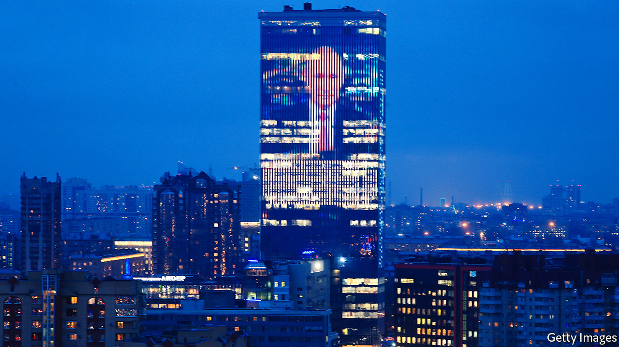

THAT VLADIMIR PUTIN would try to retain power after his current presidential term expires in 2024 was never in much doubt. Ageing autocrats rarely leave office voluntarily, particularly if their rule has been tainted by war, repression and graft. The only questions were how Mr Putin would get round the term-limits imposed by the constitution and what this might mean for his anxious entourage.

On January 15th Mr Putin launched a “transition” aimed at ensuring his continuing role as Russia’s national leader. In his state-of-the-union speech he proposed sweeping changes to the constitution and laid plans that could give him a new role within a transformed political system. Within hours the government led by Dmitry Medvedev, Russia’s subservient prime minister, resigned. This was, as he put it, “to give our president the ability to make any necessary decisions.”

He was promptly replaced by Mikhail Mishustin, a hitherto obscure technocrat who had run Russia’s tax service. The reshuffle was not explicitly linked to the proposed constitutional changes. But it added a sense of drama and indicated to the confused Russian public that significant changes are afoot.

In reality, swapping one technocrat for another makes little difference. “All members of the ruling elite, starting from a certain level, look alike and are interchangeable,” says Ekaterina Schulmann, a political scientist. But the unpopular Mr Medvedev had become a liability. That does not mean he is gone for good. For now, he has been made deputy head of the security council, a powerful body that acts as a de facto politburo. He could even emerge as Russia’s new president in 2024, thanks to his combination of weakness and loyalty.

Russians have seen this ballet before. In 2011 Mr Putin announced he would return to the Kremlin after sitting out one term as prime minister, swapping jobs with Mr Medvedev, who filled in as president between 2008 and 2012. Some people were so offended by this trickery that they took to the streets. This time, Mr Putin’s announcement was met with indifference. Alexei Navalny, the main opposition leader, tweeted: “How dumb are all those who said Putin would leave in 2024.”

One reason for the muted reaction is that Mr Putin’s manoeuvre is intentionally obscure. He said nothing about his own future role, except to indicate that the “transition” has started. Although the details of his plan are unclear, it could elevate him above any elected job and formalise his role as a monarch in all but name.

To ensure no rival emerges, he suggested curbing the powers of a future president and limiting him or her to two terms (by removing the existing qualifier “consecutive”). Mr Putin also suggested expanding the powers of the Duma (parliament), dominated by his own United Russia party. Kirill Rogov, an analyst, notes that in a rigged electoral system more power for the Duma means more power for the dominant political party.

This led some observers to suggest that Mr Putin is contemplating the role of the leader of the ruling party, speaker of parliament or prime minister. He has good reason to avoid these options, however. United Russia, dubbed the party of “thieves and crooks” by Mr Navalny, is so unpopular among Russia’s voters that many of its functionaries preferred to run as independents in recent local elections.

A more likely scenario is that Mr Putin beefs up the State Council, an advisory body he set up in 2000 and which includes regional governors as well as the speakers of the Duma and the upper chamber of parliament. Mr Putin now proposes giving it executive powers. He also said he would extend the powers of regional governors. An empowered State Council, with Mr Putin as its head, could resemble a Soviet-era Central Committee of the Communist Party, where regional first secretaries were both powerful and loyal to the general secretary. To seal Russia off from the world, a revised constitution would also reduce the sway of international court rulings and conventions over Russian law.

Mr Putin’s plan demonstrates his personal power, but the manner and the timing of his announcement hint at underlying vulnerabilities. Last summer’s protests in Moscow were sparked by the Kremlin’s refusal to register any independent candidates for local elections. Mr Navalny inflicted hefty losses on the ruling party in the capital by urging his supporters to vote tactically against it. Mr Putin’s popularity ratings have been steadily sliding.

This may explain his haste in announcing the changes to the constitution. Parliamentary elections are due next year, and the fear of more street protests and political losses mean the Kremlin would rather lock in its changes under the current Duma. Still, Russia is far from safe from upheaval. Mr Putin may continue to rule in some form or other after 2024, but he cannot extinguish the feelings of injustice and discontent that make it so dangerous for him ever to leave the presidency. ■

This article was downloaded by calibre from <https://www.economist.com/europe/2020/01/18/putin-proposes-a-rewrite-of-russias-constitution>

|  |  |  |  |
| --- | --- | --- | --- |
|  | Articles | Sections | Next |

|  |  |  |  |
| --- | --- | --- | --- |
| Previous | Articles | Sections | Next |

#### The angel of the north

# Italy’s second city shows up the rest of the country

Once dismissed for its dullness, Milan is booming

Jan 18th 2020 | MILAN

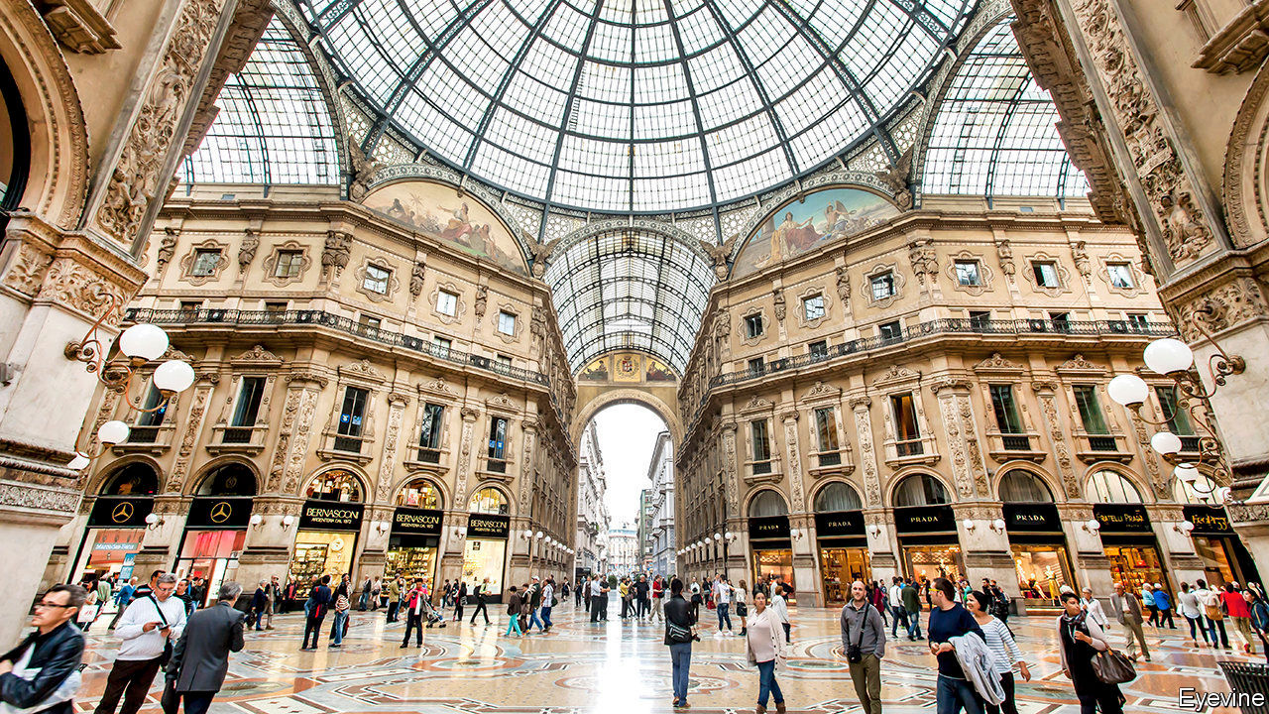

MARIATERESA GIUSSANI lives in Seregno, 28km (17 miles) outside Milan, and drives to work in the central fashion district where the company she owns, which markets school uniforms, has its offices. “Ten years ago I would leave at 7.15am to avoid the traffic,” she says. “Now, I have to be out by 6.15am. If I leave ten minutes later, it’s nose-to-tail all the way.”

Ms Giussani’s altered morning schedule is among the myriad side effects of a boom that has set Milan apart from the rest of Italy, still struggling to recover from the financial crisis of a decade ago, and at best plodding along on the edge of recession.

“The city is on an enormous upswing,” says James Bradburne, the Canadian-born director of Milan’s most renowned art museum, the Pinacoteca di Brera. Between 2014 and 2018, according to the regional bosses’ federation, Assolombarda, Milan’s output grew by 9.7%—more than twice the national rate. Property prices have leapt. Stories abound of out-of-towners paying €400 ($446) a week to rent a single room, residents offered 50% more than they paid for properties bought four years earlier and luxury-goods firms paying €1m a year or more for an outlet in the Galleria Vittorio Emanuele II, which links La Scala theatre to the cathedral square.

Central Milan exudes a mix of ostentatious wealth and sophisticated design. And not just the centre: Porta Genova, a once-rundown quarter, today hosts an accountancy multinational, Deloitte; a fashion house, Armani; and a museum of world cultures in a converted factory with a restaurant that boasts three Michelin stars. New skyscrapers dot the skyline and the prosperity they reflect has coincided with a cultural revival. Mr Bradburne has revitalised the Brera with an innovative range of programmes, aimed at everyone from children to Alzheimer’s sufferers.

What happened? Most Milanese cite the catalytic effects of hosting the 2015 World Expo. Giuseppe Sala, a businessman, was put in charge of the project and is widely credited with its success. Now the city’s centre-left mayor, he modestly attributes much of Milan’s progress to property developments launched under a centre-right predecessor, Gabriele Albertini. But, he says, Expo did play an important role: it restored to the Milanese a sense of pride in their city, long dismissed as grey, architecturally and figuratively. “And it showed off its strong points to the world.” Tourism has exploded. The annual number of visitors to Milan has soared from 6m to more than 10m since the Expo.

The mayor acknowledges that what some are calling the Milanese miracle has generated problems. The biggest, he thinks, is environmental. He has banned the most polluting vehicles from 70% of the city, offered incentives for the replacement of boilers and plans to make the city’s entire bus fleet electric. The boom has also created a division between flashily rich districts and poor ones: Pope Francis pointedly made his first stop in Milan a deprived area with a big immigrant population. Mr Sala says investors have already committed a further €12bn-13bn to property development in the city, and that much of it will go to the periphery and to providing reasonably priced accommodation.

Milan’s next appearance on the world stage will be as co-host of the 2026 Winter Olympics along with ritzy Cortina d’Ampezzo. It seems unlikely that glitz will gave way to grit any time soon. If only the rest of Italy could do anything like as well. ■

This article was downloaded by calibre from <https://www.economist.com/europe/2020/01/18/italys-second-city-shows-up-the-rest-of-the-country>

|  |  |  |  |
| --- | --- | --- | --- |
| Previous | Articles | Sections | Next |

|  |  |  |  |
| --- | --- | --- | --- |
| Previous | Articles | Sections | Next |

#### L’industrie, c’est eux

# Europe is rediscovering its penchant for statist intervention

As China and America prop up national champions, a new dirigisme is brewing in Europe

Jan 16th 2020 | PARIS, BERLIN AND BRUSSELS

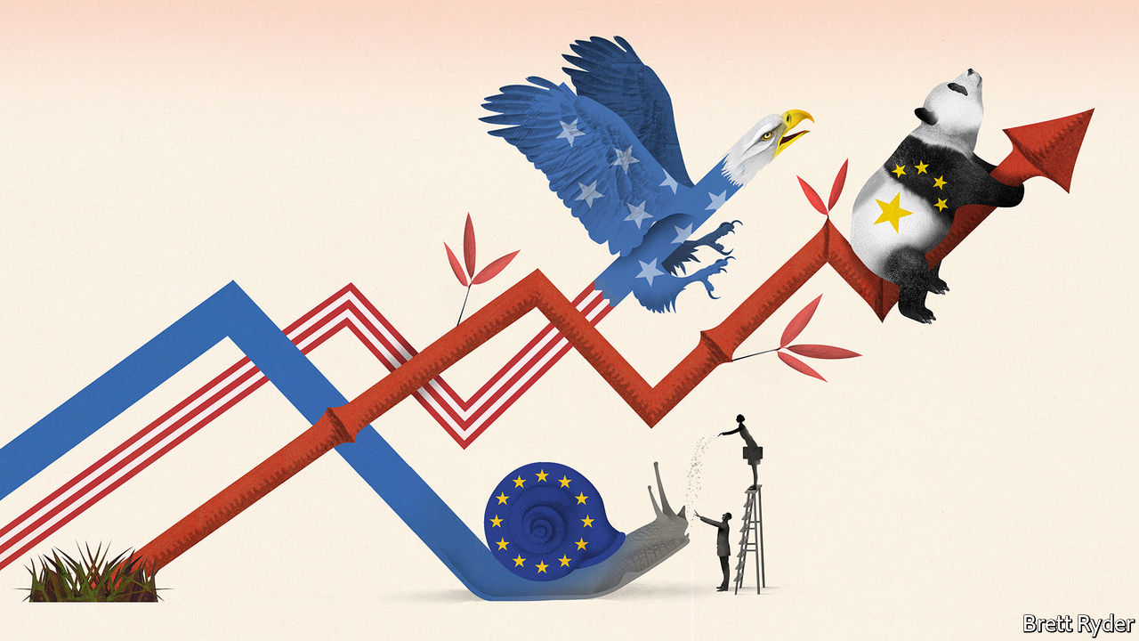

DESPITE ITS reputation as a place where politicians like to meddle in all aspects of the economy, Europe is often standoffish when it comes to championing industry. Some politicians, notably in Paris, do think of themselves as behind-the-scenes business titans. But the default EU position is for trade and investment to be open, exposing firms to global competition. Robust antitrust enforcement hobbles potential monopolists. Most important, “state-aid” rules enforced from Brussels prevent national governments mollycoddling favoured firms with tax breaks or subsidies, unlike nearly everywhere else.

Until now. A consensus has emerged in Europe that the open approach is not working. The continent, it is argued, has missed the boat on tech, which is dominated by America. China has protected and promoted its firms to the point where they can take on European rivals. Exciting breakthroughs in fields from quantum computing to next-generation cars seem to be happening everywhere else. Could policy tools used by its rivals nudge European industry back into the big leagues?

Many hope so. The upshot is a new approach, one that would have been unthinkable a few years back. On one hand, Europe is pursuing a watered-down protectionism reminiscent of President Donald Trump’s America First method. On the other hand, it is espousing statist policies invented in 17th-century France—and updated in contemporary China—which seek to pick winners and throw taxpayers’ money at them.

Start with the growing protectionist tinge. European firms are still to face competition—but on new terms. A hotch-potch of policies, some of them in gestation for years, seeks to put limits on unencumbered free trade. Their aim is to level a playing field which Europeans perceive has been tilted by others in their favour. “We need to be less naive,” has become a refrain in policymaking circles.

What draws the policies together is their intention to punish firms from countries not playing by what Europe thinks ought to be global norms. Ursula von der Leyen, the new European Commission president, has promised to enact a carbon border tax, to penalise imports from countries with looser environmental regulation than Europe. And if European firms are not allowed to get state aid from their own governments, some are advocating restrictions on the European operations of foreign firms (ie, China’s) that receive state support.

European firms would also get a leg-up when bidding for public contracts at home. New rules will, in effect, penalise firms from countries that fail to give reciprocal access to European companies—most notably China. Guidelines to screen foreign investments will soon come into force, matching a long-standing (and tougher) American scheme. Those will shield some European firms from takeovers that politicians deem undesirable.

Beyond hobbling foreign firms, Europe is also finding new ways to support its own. Last month the commission approved a request by seven governments, including France and Germany, to spend €3.2bn on a public-private partnership for building batteries. What would once have been a clear case of state aid was, in fact, greeted with enthusiasm in Brussels. European governments are intending to kick-start the creation of up to 25 battery plants, to service the automotive sector better.

Several more such “Important Projects of Common European Interest” have been approved or are in the works; commission experts have indicated which “strategic value chains” are likely to be looked on favourably for future state largesse. Predictably, European officials are talking about the need for an “Airbus of batteries”, another for 5G telephony, artificial intelligence and so on.

Unlike previous EU projects that funded scientific research, money is now being invested alongside companies. Officials insist they are not a way to prop up unviable companies, merely to spread risk that companies cannot shoulder on their own. Many schemes are designed to help meet ambitious climate-change targets (Europe wants to be carbon-neutral by 2050).

Some industrialists are hoping for a further boost: the relaxation of antitrust rules. Margrethe Vestager, recently reappointed as competition supremo, last month indicated a review of the merger-approval process. Her blocking in February 2019 of a planned merger of the railway arms of Siemens and Alstom, two industrial groups, riled their respective governments in Germany and France. Few think the proposed antitrust changes will be so radical as to make a difference to the biggest tie-ups. But there are hints the commission could be a touch more amenable in future.

## Teutonic turnaround

Why the shift? Beyond the perceived loss of ground to China and America and the assumption that is because Europe is too laissez-faire, politicians sense a continent-wide disenchantment with markets in the aftermath of the financial crisis—and thus more tolerance for political intervention. Britain’s forthcoming exit from the EU has also marginalised a voice that would once have looked askance at dirigiste ploys.

But the main reason is a change in approach in Germany. France has always lobbied in favour of public grands projets and looser competition rules. For just as long, Germany has lobbied for its ordoliberal approach, which dictates that the state establishes rules for the market economy and then lets firms do their thing (Ludwig Erhard, who oversaw West Germany’s economic miracle in the 1950s as economy minister, compared the involvement of the state in the economy to a football referee).

This has stung Germany of late: Chinese firms that used to buy machines from the Mittelstand are now competing with it. A domestic solar industry based on German technology was crushed by Chinese subsidies and lower standards. Now it fears that being left behind on artificial intelligence and batteries will hobble the prospects of its car champions.

The dirigiste swing is far from settled policy in Berlin. The torchbearer for the new approach is Peter Altmaier, the economy minister. Last year he went even further than France, for example suggesting a public fund that could be used to acquire stakes in certain companies at risk of foreign takeover. The plan was panned even within his own party—it is said that the minister drafted much of the proposal himself, so unimpressed were his aides by the idea. It has since been rolled back.

But the German shift, even if incomplete, has swung the pendulum in France’s direction. How far will become clearer in March, when Mrs von der Leyen is to unveil a new “industrial strategy” for Europe. Politicians devising blueprints for business has a decidedly five-year-plan-ish ring to it. But bringing some order to how Europe thinks about industry is overdue. Past exercises in this vein have been usually excuses to recycle bromides about the importance of skills, supply chains and small businesses. Expect a more substantial shift in policy this time. ■

This article was downloaded by calibre from <https://www.economist.com/europe/2020/01/18/europe-is-rediscovering-its-penchant-for-statist-intervention>

|  |  |  |  |
| --- | --- | --- | --- |
| Previous | Articles | Sections | Next |

|  |  |  |  |
| --- | --- | --- | --- |
| Previous | Articles | Sections | Next |

#### A small Afghanistan

# France weighs up its thankless mission fighting jihadists in Africa

African governments want French help, but not all Africans agree

Jan 18th 2020 | PARIS

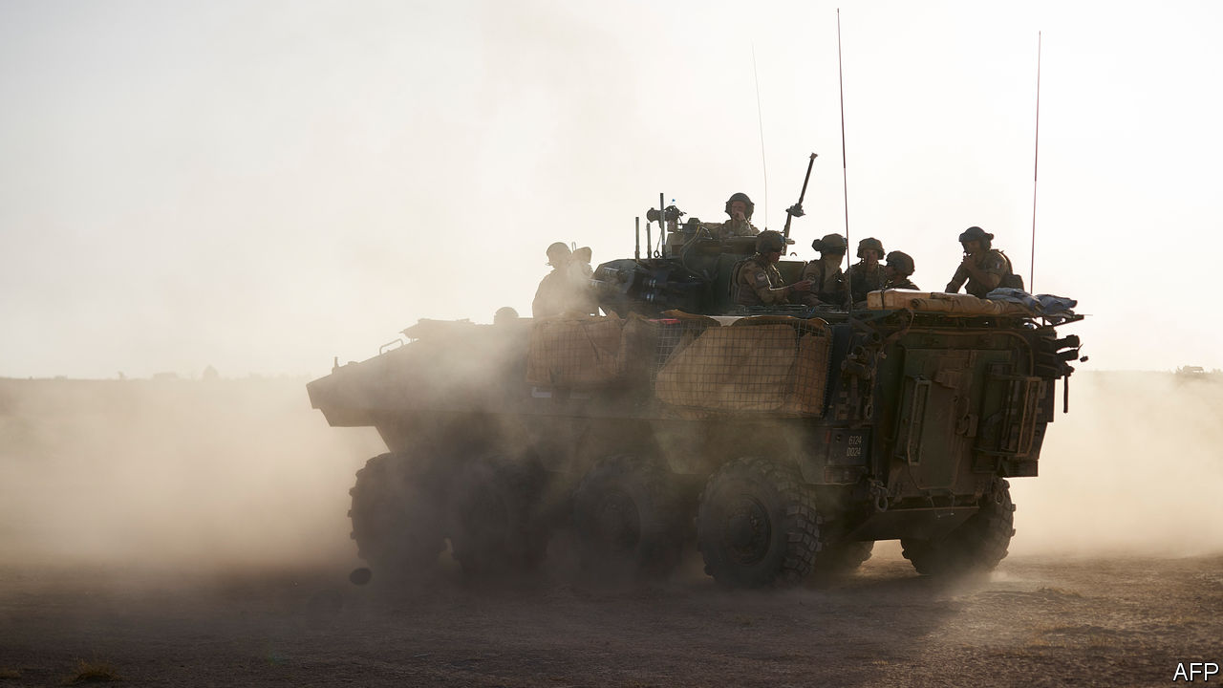

AFTER NIGHTFALL on a moonless evening last November, three French combat helicopters, backed by fighter jets, took off from military bases deep in the African Sahel. Their mission was to support a French commando operation on the ground, tracking terrorists in pickup trucks and motorbikes in the Liptako region of Mali. Flying in tight formation and close to the ground in total darkness, two of the helicopters collided. Thirteen French soldiers, the youngest aged 22, were killed.

The deaths shook France. They also revived questions about what exactly the country is doing in this vast semi-arid belt south of the Sahara desert. On January 13th, at a summit he hosted in the French south-western town of Pau with the leaders of five Sahel countries, President Emmanuel Macron tried to provide an answer. France is there to bring “security and stability”, he declared, and nothing else. “If at any time an African state asks the French army not to be there any longer,” Mr Macron said irritably, “we’ll leave.”

The paradoxes and agonies of the French operation, known as “Barkhane”, have been brutally exposed by these deaths, as well as those of (many more) troops from other African countries. In early January 89 soldiers from Niger died in a jihadist ambush of a military post in Chinagodrar, near the border with Mali. This followed a separate attack on a military base in Niger, at Inates, that killed 71 soldiers. The borderlands between Niger, Burkina Faso and Mali have become a zone of chronic instability, trafficking and jihadist activity. This has thrived in the Sahel following the collapse of Islamic State in Syria and Iraq, and Libya’s descent into chaos. France, says Marc-Antoine Pérouse de Montclos, author of a new book on France in the Sahel, has been dragged into what he calls “mission impossible”.

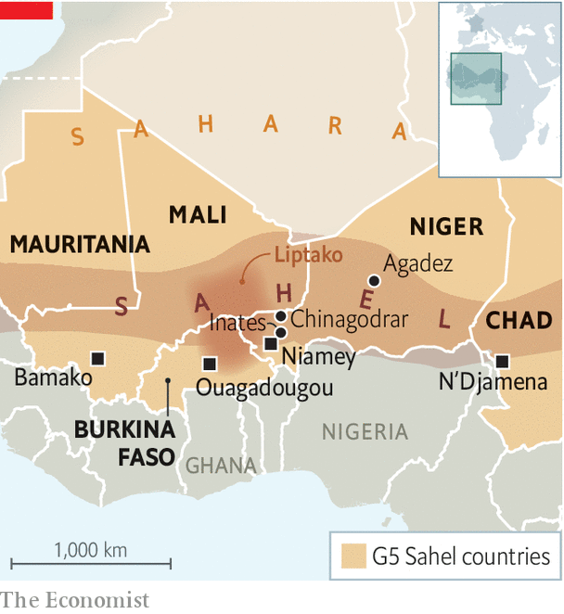

It was President François Hollande who originally dispatched French troops to Mali back in 2013 in order to beat back a jihadist incursion. This was not supposed to be a permanent operation. Yet, seven years on, France still has 4,500 troops there. In theory they help train and work alongside a joint force of 5,000 from Burkina Faso, Chad, Mali, Mauritania and Niger, known as the G5 Sahel. But these forces—Chad’s apart—are not considered to be up to the job. There is also a United Nations peacekeeping force in Mali some 15,000 strong.

Mr Macron, who belongs to a generation that has never known Africa under French colonial rule, took office in 2017 keen to take a less paternalistic approach than his predecessors did. He has forged links with non-Francophone countries, including Nigeria and Ghana, promised to give back African art works from Paris, and spoken of the “crimes of colonisation”. Mr Macron considers the French anti-jihadist operation in the Sahel to be “absolutely essential” in the struggle against terrorism, which France feels is a burden it is carrying on others’ behalf.

So it is with evident frustration that Mr Macron now also finds himself the target of a hostile anti-France campaign in the region. Protesters in the Malian capital of Bamako, and in neighbouring Niger, have demanded that French troops should leave. Critics accuse France of propping up autocrats. Some political leaders, meanwhile, are lukewarm about France’s effort.

Amid the charges and countercharges, the purpose of this week’s summit in Pau, says a French official, was “clarification”. Mr Macron declared in December, while at the NATO summit in London, that he “cannot and will not” keep French soldiers on the ground in the Sahel as long as there is ambiguity about whether they are welcome. In Pau he secured from the leaders of the five Sahel countries a formal affirmation of their “wish that the French military engagement in the Sahel should continue”.

Yet France finds itself increasingly alone. It has some limited help from the British, Danes, Estonians and Germans. And it is trying to help build up local capacity. Its real partner, though, is America, which runs its own counter-terrorism activities in the region, including an air and drone base in Agadez, in the desert in central Niger, and another surveillance facility in the north. Now the Pentagon is considering scaling back its operations. “We are stuck,” says François Heisbourg of the Foundation for Strategic Research, “We’re in exactly the sort of place we wouldn’t want to be; it’s a small Afghanistan.” ■

This article was downloaded by calibre from <https://www.economist.com/europe/2020/01/18/france-weighs-up-its-thankless-mission-fighting-jihadists-in-africa>

|  |  |  |  |
| --- | --- | --- | --- |
| Previous | Articles | Sections | Next |

|  |  |  |  |
| --- | --- | --- | --- |
| Previous | Articles | Sections | Next |

#### Colonic irritation

# The hopeless struggle to make German gender-neutral

The German language is unsuited to modern sensitivities

Jan 18th 2020 | BERLIN

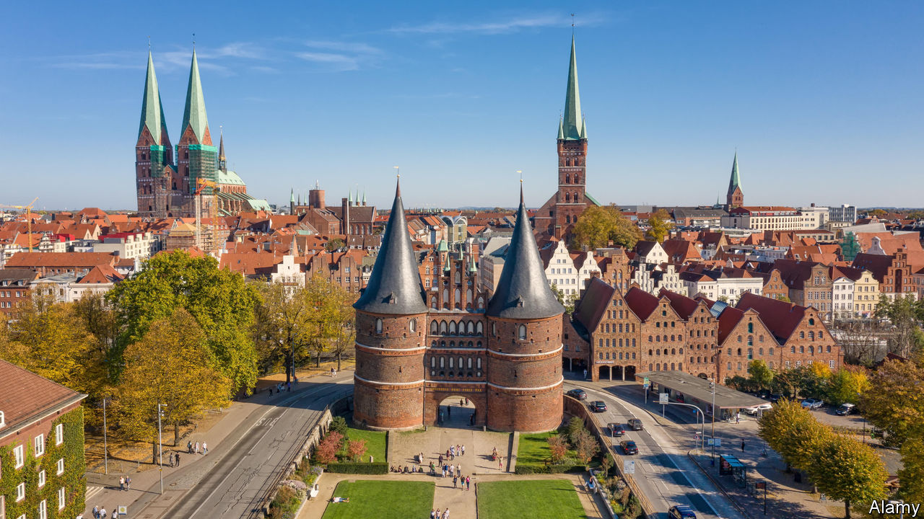

“IN GERMAN, A young lady has no sex, while a turnip has,” grumbled Mark Twain in his essay “The Awful German Language”. The rules governing gender in German are indeed baffling: why die Rübe (feminine) but das Mädchen (neuter)? Yet they are as nothing next to the complexities of importing modern gender sensitivities into a language plainly unsuited to them.

In German, plural nouns for people typically take the masculine form, and professions are usually gendered. So teachers address mixed groups of pupils as (masculine) Schüler, and whereas Helmut Kohl was Bundeskanzler (masculine), Angela Merkel is the Bundeskanzlerin (feminine). In a non-binary age some find such usage old-fashioned. Studies find that children often link generic plural terms (eg, Schüler) with the male sex.

This month the northern city of Lübeck decreed that official communications must use gender-neutral language. Formulations that avoid gendered terms are preferred; otherwise nouns should be given the feminine ending, set off by a colon to indicate neutrality. Locals thus become Lübecker:innen (Lübeckerinnen are “women from Lübeck”; Lübecker means “men (or a man) from Lübeck”). Traditionalists are aghast; one group has vowed to pay the legal fees of municipal staff who break the new rule. But institutions across the German-speaking world are moving in this direction.

The structure of German makes it especially prone to such disputes, says Christine Günther, a linguist at the University of Siegen. English has its own problems (see Books &amp; Arts), but nouns are genderless and job words neutral, bar the odd exception like “waitress”. In Germany, solutions usually involve awkwardly interrupting a word with an asterisk or underscore; Lübeck officials think the colon is easier to read. A glottal stop is used when speaking.

In 2018 the Council for German Orthography was asked to rule on the gender asterisk but said such matters should not be settled in a top-down fashion. Now partisans of Germany’s culture wars are storming the pitch of their defenceless language: third-gender theorists battling reactionaries over punctuation.

This article was downloaded by calibre from <https://www.economist.com/europe/2020/01/18/the-hopeless-struggle-to-make-german-gender-neutral>

|  |  |  |  |
| --- | --- | --- | --- |
| Previous | Articles | Sections | Next |

|  |  |  |  |
| --- | --- | --- | --- |
| Previous | Articles | Sections | Next |

#### Charlemagne

# For Europe, geopolitics starts at home

Talks over admitting Albania and North Macedonia to the EU have been bungled

Jan 18th 2020 |

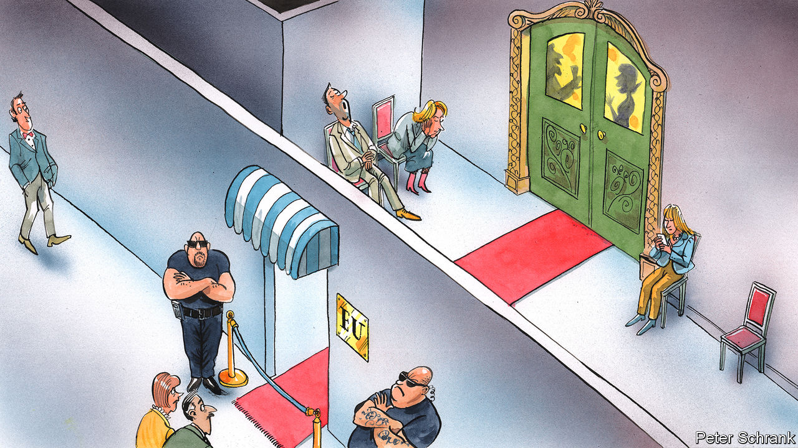

ENLARGEMENT HAS always been a fraught topic for the EU. In the 1960s Charles de Gaulle made Harold Macmillan weep when the French president thwarted Britain’s attempts to join what was then the Common Market. (“I wanted to put my hand on his shoulder and say to him, as in the Edith Piaf song, ‘ne pleurez pas, milord’,” recalled de Gaulle.) The “big bang” accession of 2004, when ten countries largely from central and eastern Europe joined, was supposed to be a unification of Europe. But it led to new fractures between east and west. Diplomats become undiplomatic about Romania and Bulgaria, which joined in 2007, grumbling that their enthusiasm for corruption dimmed only slowly after they joined the club. The proposed accession of Albania and North Macedonia is proving once again that enlargement can be enraging.

Emmanuel Macron, the French president, blocked their path last year—with the support of the Netherlands and Denmark when it came to Albania—demanding that the EU must instead first overhaul its rules on joining the bloc. That was a “historic mistake” in the words of Jean-Claude Juncker, the outgoing European Commission president. Now the attempts to sweep up the damage from Mr Macron’s hand-grenade have begun in earnest. The commission, under new management and determined to pursue a “geopolitical” strategy, will by the end of the month unveil reforms to the accession process designed to placate the French president and his allies. A summit some time in the spring will clear up the mess and agree on new accession rules. By May it will be all smiles in Zagreb, where the 27 EU members meet their neighbours from the western Balkans for another conference. Or so goes the plan.

What compromise Brussels cobbles together will have ramifications far beyond the fate of two small Balkan nations. Between them, the duo have a population roughly equal to Slovakia’s and the GDP of Cyprus. Yet the EU’s response will show whether the bloc is capable of becoming a coherent geopolitical actor, something which its leaders—especially in the core national capitals—are desperate to achieve. If Brussels fails to act strategically in its own backyard, how can it do so globally?

Mr Macron and co were right to criticise the EU’s enlargement process. A feeling lurks among some member-states that the process is a slippery slope. Countries unready for membership, such as Romania and Bulgaria, were levered in under pressure from national capitals. France is calling for “reversibility”, whereby prospective members can have privileges revoked if they fall behind on their pledges—an idea the commission likes. Although Albania and North Macedonia have taken huge strides, reports into their progress contain eye-bulging caveats about corruption and press freedom, which the commission has waved away. “It’s politics versus reality,” huffs one sceptical diplomat. Most countries, however, are calling on opponents to turn a blind eye, like revellers in a provincial nightclub trying to persuade a bouncer to let in their mates even though they are wearing trainers.

Albania and North Macedonia are more likely to end up in the cloakroom than on the dance floor. Starting accession negotiations is very different from completing them, and there is little prospect of fully-fledged membership soon. Indeed the EU accession programme has evolved into a holding pen for awkward neighbours, rather than a genuine path to joining. Whereas some countries see this as a feature, France sees this as a bug, with accession used at the expense of other foreign-policy tools. The membership process with Serbia began a decade ago. Turkey’s started in 1987. Most EU leaders are happy to spin the line to voters that accession exists in name only for some countries.

Enlargement is a geopolitical issue for the EU, not just a domestic one. The perils of botching accession policy are best seen in Turkey, which has drifted out of Europe’s sphere of influence. Now, on topics such as Syria and migration, Ankara has more control over Europe’s destiny than Brussels and little willingness to listen to officials who misled it. A meeting in Moscow this month between Russia and Turkey to discuss a ceasefire in Libya was a potent image of Europe’s failure to boss its own backyard.

## A tricky way out

Brussels needs to come up with a ladder for opponents of enlargement to climb down. A compromise regularly floated but opposed vociferously by Germany, among others, would be to allow North Macedonia under the velvet rope into the EU’s waiting room, while keeping Albania firmly out. Such a sacrifice might placate opponents of enlargement in the short term, but the implicit message that a majority-Muslim state is unwelcome in the EU is one that would shape the bloc for far longer. Albania would join Kosovo, Bosnia and Turkey in the club of spurned Muslim countries.

The EU’s influence in the region is at stake. North Macedonia changed its name. Albania has made good on pledges to crack down on bent judges. Accession talks were the quid pro quo. Failing to live up to promises will strengthen regional rivals, such as Russia and Turkey, or prompt countries to embrace distant potential friends, such as China. “They never say the EU is crap, they say: ‘It’s great, but they are lying to you’,” notes an EU official. In the case of Albania and North Macedonia, they were right.

The EU has a chance to undo the damage. Whether Mr Macron and allies back down is another matter. Spending years wrangling over the rules of joining the club would only weaken it. North Macedonia heads to the polls in April. The government’s pitch to voters has been that it is making progress in its EU talks. Come the summit in Zagreb, a less Europe-friendly government may be in power in Skopje. European leaders such as Mr Macron want the bloc to start punching its weight on the international stage. Solving the enlargement debate would be a sign that the EU is prepared to put geopolitics first. But Europeans who yearn for such an outcome will doubtless have to wait—like the North Macedonians. ■

This article was downloaded by calibre from <https://www.economist.com/europe/2020/01/18/for-europe-geopolitics-starts-at-home>

|  |  |  |  |
| --- | --- | --- | --- |
| Previous | Articles | Sections | Next |

|  |  |  |
| --- | --- | --- |
| Europe | Sections | International |

Britain

The Atlantic alliance: Declarations of independence

.

Barbershops: Cut-throat competition

.

Criminal justice: What’s going wrong here?

.

Northern Ireland: The word was God

.

Airlines: Keeping Flybe aloft

.

Tax and benefits: The sausage-roll bonus

.

Bagehot: Harry, Meghan and Marx

.

|  |  |  |
| --- | --- | --- |
| Europe | Sections | International |

|  |  |  |  |
| --- | --- | --- | --- |
|  | Articles | Sections | Next |

#### Anglo-American relations

# Johnson, Trump and the future of the Atlantic alliance

Britain turns away from its oldest ally on several fronts

Jan 16th 2020 |

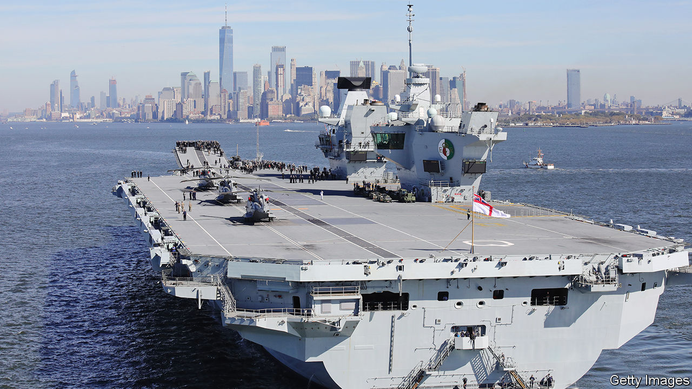

BRITAIN HAS often been ridiculed as America’s poodle. This week Boris Johnson appeared to stay in character. On January 14th Britain, with France and Germany, invoked a dispute-resolution mechanism in response to Iranian steps away from the Joint Comprehensive Plan of Action (JCPOA), the multinational nuclear deal signed in 2015 and abandoned by America in 2018. “Let’s work together to replace the JCPOA and get the Trump deal instead,” said Mr Johnson.

The prime minister is not the first leader to propose rebranding as a salve to the presidential ego. But his sycophancy was sweetener to a snub: Britain is spurning President Donald Trump’s increasingly strident demands to reimpose sanctions on Iran, siding with European allies over America. And that is not the only place where Anglo-American trust is fraying.

On January 12th Ben Wallace, Britain’s defence secretary, questioned America’s reliability as a partner: “I worry if the United States withdraws from its leadership around the world…the assumptions of 2010 that we were always going to be part of a US coalition is really just not where we are going to be.” That would expose gaping holes in Britain’s forces, warned Mr Wallace. “We are very dependent on American air cover and American intelligence, surveillance and reconnaissance assets. We need to diversify our assets.”

The minister’s “remarkable candour” is a “big moment”, says Michael Clarke, a former director of the Royal United Services Institute, a think-tank. “You won’t find that thought in any government defence or foreign-policy document of the last 70 years.” Mr Wallace’s intervention comes as the Ministry of Defence is preparing the most significant strategic defence and security review (SDSR) for a generation. The last three reviews—in 1998, 2010 and 2015—acknowledged that Britain would be unlikely to fight on its own; they assumed that America was the probable partner.

Why is Britain going wobbly now? One former defence official suggests that Mr Wallace is launching a pre-emptive attack on those in the Conservative Party and the Treasury who would like the country to buy its arms off-the-shelf from America, rather than making them at home. Britain’s current (and risky) plan is to develop its own next-generation warplane, Tempest, rather than accept a junior position in an American project. Mr Trump’s disdain for allies is another factor, and there is a strategic difference, too. “We fear Russia most, while the US most fears China,” says a British diplomat. Referring to wars in which America and Britain fought without the other, he suggests that “the prospect for another Vietnam/Grenada or Falklands/Sierra Leone may be increasing.”

The divergence over China burst into public view this week when Mr Johnson indicated that he would break with America on the question of whether to allow kit made by Huawei, a Chinese tech giant, to be used in fifth-generation (5G) mobile-phone networks. Huawei’s products are both cheaper and more advanced than those from its chief competitors—Nokia, a Finnish firm, and Ericsson, a Swedish one—but America worries that they could be used by Chinese spies to snoop on electronic communications or even sabotage networks remotely.

## Breaking up would be expensive to do

A decision is due by the end of the month, but it seems likely that Britain will rebuff American entreaties. British spooks are convinced that the danger posed by Chinese kit can be managed by confining Huawei to less-sensitive parts of the network, and by tearing down and inspecting its gear before approving it. Threats to cut off intelligence are seen as a bluff. Britain is, behind America, the second-most-capable member of the Five Eyes, an electronic-spying pact with roots in the second world war and which includes Canada, Australia and New Zealand. But that pact also indicates just how hard it would be for Britain to loosen its transatlantic bonds.

Ever since the second world war, Britain’s military forces, nuclear capabilities and intelligence agencies have been deeply entwined with those of America. The Royal Navy’s new aircraft-carrier (pictured on the previous page visiting New York) will embark on its first mission next year with American jets on board. Britain’s nuclear-tipped Trident missiles are drawn from a common pool in the state of Georgia. And even beyond the Five Eyes, British and American spies are joined at the hip; in 2015 the Pentagon’s intelligence agency appointed a Royal Air Force officer as its deputy director. How such intimacy would play out in a crisis is unclear: warplanes aboard an aircraft-carrier cannot easily recuse themselves from action.

The SDSR will also have to confront the forbidding financial implications of acting without America, not least in the two areas where Mr Wallace pointed to the greatest dependence: intelligence, surveillance and reconnaissance (ISR, in the jargon, meaning spying on things, mostly from planes and satellites) and air cover. Advanced spy satellites cost billions and the space budget is stretched: Britain plans to splash out up to £5bn to reduce its dependence on American GPS satellites, having been kicked out of Europe’s Galileo programme. “Britain can only afford very specific and niche capabilities,” says Bleddyn Bowen of the University of Leicester. Mr Bowen says that Britain’s lone spy satellite, Carbonite-2, is “very experimental”. A planned constellation of small radar satellites—Project Oberon—would have to be procured in large numbers to provide meaningful coverage.

Home-grown air cover would also come with a hefty bill. The British Army, halved in size since the Falklands war of 1982, seeks to be able to deploy the whole of a combat division (40,000 or so troops). But a lack of air-defences means that fielding anything above a brigade (5,000 troops) without American support would leave troops dangerously exposed to enemy warplanes and missiles.

If Britain is to pull away from America, the obvious place to turn to is Europe. Brexit will shut Britain out of EU defence schemes, but it may still have a role. The idea of “strategic autonomy”, a more independent European foreign and security policy, has become a rallying cry on the continent and several countries are keen to keep Britain involved. “The British must be a partner on European defence,” insisted Emmanuel Macron, France’s president, in an interview with The Economist in November. Yet the closer Britain clings to Europe, the less likely it is to get a generous trade deal from America. That, as Mr Johnson is finding, is the problem faced by a small power stuck between two great powers.■

This article was downloaded by calibre from <https://www.economist.com/britain/2020/01/18/johnson-trump-and-the-future-of-the-atlantic-alliance>

|  |  |  |  |
| --- | --- | --- | --- |
|  | Articles | Sections | Next |

|  |  |  |  |
| --- | --- | --- | --- |
| Previous | Articles | Sections | Next |

#### Turkish delight

# Why Turkish barbers are taking over Britain’s high streets

Last year, 675 new barbers’ salons opened, making them the fastest-growing independent sector

Jan 16th 2020 | MELKSHAM

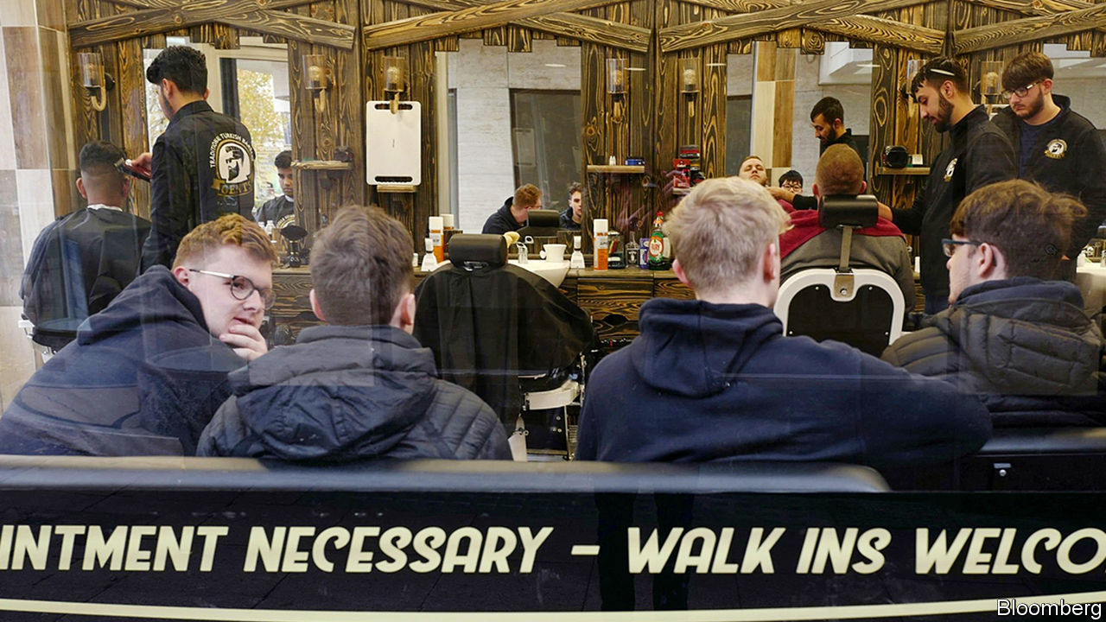

MELKSHAM, A SLEEPY town in Wiltshire, is not generally thought to sit at the apex of gentlemen’s fashion. Yet a stroll down its high street reveals a tonsorial revolution deep in the heart of Britain. A coincidence of economic, cultural and political factors has transformed Britain’s barbershops, once the preserve of staid men demanding a uniform “short back and sides”.

Inspired by “Peaky Blinders”, a BBC period crime drama, there is a vogue for complex hairdos—in particular, harshly shaved backs and sides topped with a pompadour-style quiff. Combined with the persistent popularity of beards, which look suave rather than shaggy only if properly maintained, this has fuelled the growing market in male grooming.

Richard Davies, an economist, and formerly this newspaper’s economics editor, regards the boom as the masculine equivalent of the “lipstick effect”, whereby in periods of economic uncertainty women forgo luxury items for cheaper, eye-catching goods. “We have very weak wage growth. People can’t afford a house or a new car, and are falling back on pampering themselves with a small treat.” Rising demand and falling rents have led to an invasion of the high street by men armed with clippers and razors. Last year, 675 new barbers’ salons opened, ranking the business as the fastest-growing independent sector.

Many of them are Turkish. Thanks to a barbering tradition natural to a hirsute region, and a more liberal visa regime than Middle Eastern countries, Turkish barbers have established a potent brand in Britain.

At Moredon Turkish Barbers in Swindon, Mustafa Can explains their success. “People like that it’s traditional, that we burn the hairs out of the ears and nose, that we use a cut-throat razor and a hot towel.” Barbering comes naturally to Turks, says Mr Can: as a boy, he combined his schoolwork with training in the trade. But although all barbers from the region tend to call themselves Turkish to benefit from the power of the brand, success has brought competition from farther afield, and with it echoes of regional tensions.

“A lot of Kurdish are freedom fighters, they like the gun,” says Ramzi Mawloud, an Iraqi in Swindon. “So when…they see that I’m making money, without any respect, they open a shop next door.” Aziz Buyukertas, a Turk operating in Melksham, says, “Kurdish barbers are going everywhere, some of them are taking the piss. Every town there are three, four, five of them.” Mr Can warns of newcomers’ suspect scissoring. “They don’t have a clue. They are going to burn your ears or cut your skin.” Fresh locations, he says, are drying up. “I google other places and see that they have one already. There is nowhere left to go.”

Competition is forcing British barbers to change their practices. “The Turks keep us on our toes,” laments Gary Hatto, who has a chain of barbershops. “Turks are willing to work seven days a week and you’ve got to admire a man who does that…we’ve started trying to do that now.” But Mr Hatto is unlikely to be put off by intensifying competition. Four years ago, he was jailed for biting a rival barber. ■

This article was downloaded by calibre from <https://www.economist.com/britain/2020/01/18/why-turkish-barbers-are-taking-over-britains-high-streets>

|  |  |  |  |
| --- | --- | --- | --- |
| Previous | Articles | Sections | Next |

|  |  |  |  |
| --- | --- | --- | --- |
| Previous | Articles | Sections | Next |

#### What’s going wrong here?

# Britain’s 20,000 new cops won’t get the justice ministry celebrating

Courts and prisons have coped with cuts thanks to falling prosecution rates

Jan 16th 2020 |

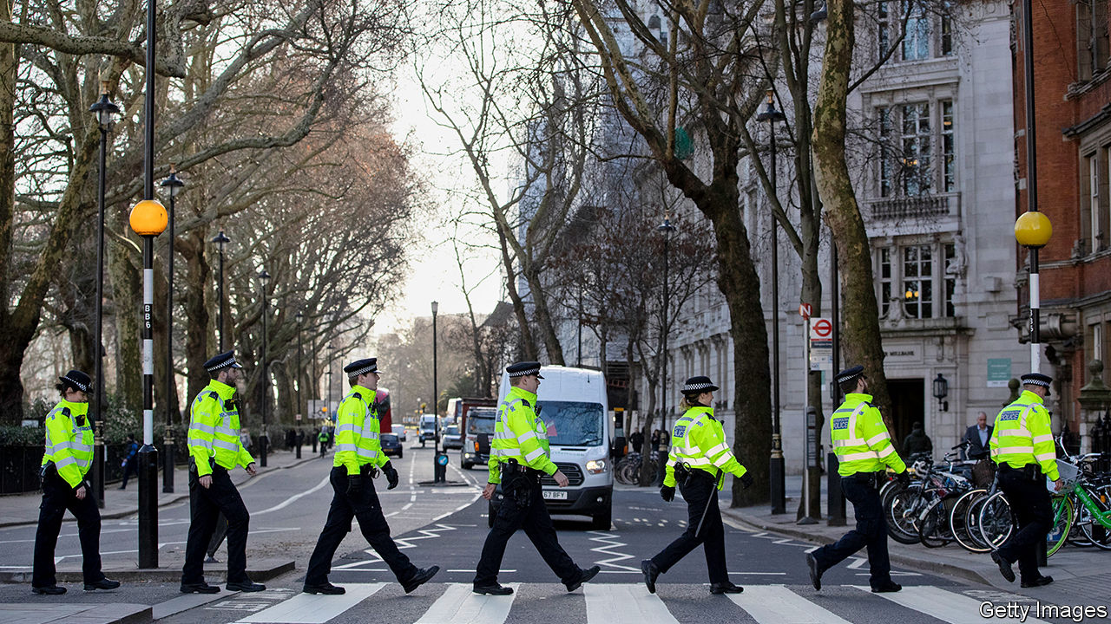

COPS SPEND much of their time driving around on routine patrols or rummaging through files at the nick. But a series of gritty job adverts for London’s Metropolitan Police instead emphasise the thrill of the chase. Policemen bash down doors and clip handcuffs on ruffians. Blue lights strobe and officers don riot gear. “Do something real,” the voice-over implores. As if they were squaddies going off to fight, their training ends with a passing-out parade.

The 43 police forces in England and Wales have been starved of new blood for a decade. As successive governments cut spending, forces froze recruitment; the number of cops fell by 14%. But rising rates of violent crime forced a rethink. Boris Johnson spent last year’s election campaign promising to hire 20,000 new officers. Chief constables are chipper.

Yet the prime minister’s benevolence might cause him an unexpected headache. The rest of the criminal-justice system suffered even deeper pruning than the police. The Crown Prosecution Service, for instance, had its budget cut by about a third. The number of prison officers fell by 26% between 2010 and 2014, before a new recruitment campaign. It helped, though, that the number of suspects charged by the police also fell, from about 700,000 in 2013 to fewer than 500,000 last year. Courts and prisons struggled, but at least they had fewer suspects to try and lags to house.

That is now likely to change. In the long run, more bobbies might depress crime rates, but in the short term they are likely to charge more suspects. As police numbers have declined, so the number of people being charged and prosecuted has fallen, even though violent crime has risen. An increase in police numbers will presumably have the opposite effect.

The knock-on consequences could be hard to manage. Courts, and eventually prisons, will be busier. “All you’re doing is putting pressure at the start of the pipeline,” says Sir Tom Winsor, chief inspector of constabulary. This is why one ex-cabinet minister reckons the recruitment drive is “the worst thing that could happen” for the rest of the criminal-justice system.

England’s tatty criminal courts do not look ready for the influx. Despite the fall in the number of prosecutions, waiting times are growing, thanks to court closures and the complexity of wading through heaps of evidence from mobile phones. On average, offenders are being sentenced in crown courts 524 days after committing their offence, a rise of about a third since 2010.

Prisons are even less prepared. The remaining warders are having a tough time keeping order. Last year, the prisons watchdog found “too many” jails were “plagued by drugs, violence [and] appalling living conditions”. The number of assaults by prisoners on staff and other inmates has more than doubled in the past five years, as has the number attempting to harm themselves. On January 9th a terrorist attack took place inside a prison, when a convicted jihadist is alleged to have attacked a guard. All of this has happened while prisoner numbers have been falling; they are down by 6% from their peak in 2011. If charging rates had not dropped, “the prison system would have broken,” says the ex-minister. Mr Johnson’s pledge to beef up sentences for violent prisoners and terrorists will only add to the strain.

Mr Johnson might simply bung the courts and prisons some more cash. He has promised a commission to improve the effectiveness of the system; it seems sure to recommend more investment. But that would take time: cuts are quicker than finding and training recruits to replace lost expertise. In the meantime, more cops may not mean more justice. ■

This article was downloaded by calibre from <https://www.economist.com/britain/2020/01/18/britains-20000-new-cops-wont-get-the-justice-ministry-celebrating>

|  |  |  |  |
| --- | --- | --- | --- |
| Previous | Articles | Sections | Next |

|  |  |  |  |
| --- | --- | --- | --- |
| Previous | Articles | Sections | Next |

#### Northern Ireland

# How Ulster Scots and the Irish language got Northern Ireland’s government back

Language is replacing religion as a marker of sectarian affiliation

Jan 18th 2020 |

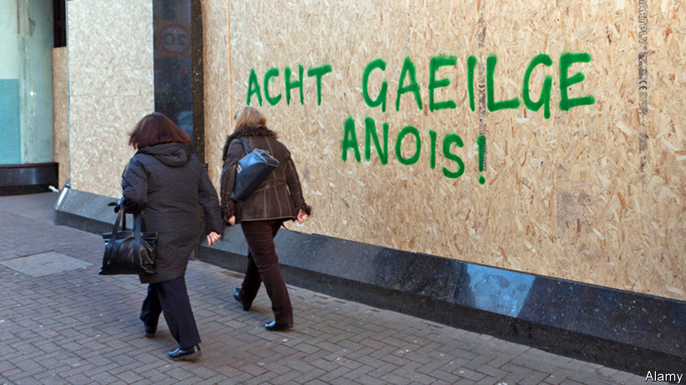

BACK IN ACTION after a lapse of three years, Northern Ireland’s shaky government rests on a compromise so ingenious that it would impress a medieval theologian trained to argue over angels and pinheads. But the latest political bargain, dreamed up by mandarins in London and Dublin, pertains not to religion but to language. It neatly finesses the most emotive recent dispute between the Democratic Unionist Party (DUP), backed by most Protestants, and Sinn Fein, the party which gets most votes from people of Catholic background. The dispute is over official support for Irish and Ulster-Scots, a form of speech which has become identified with the Protestant cause.

The new salience of languages in daily use among only a small minority of people is a reflection of how much Northern Ireland has changed in 50 years of inter-communal contention. Religious fault-lines haven’t gone away: thanks to the de facto segregation of education and housing, Protestants and Catholics live separately and learn separately.

But even in Northern Ireland, religion is on the decline. According to a poll in 2017 by ARK, a social-policy research group, 30% of people went to church at least once a week, compared with 44% in 1998. Sinn Fein suffers only a small electoral cost from pursuing policies over abortion and gay rights that clash with Catholic teaching. DUP leaders hew to a social-conservative line closer to the group’s ultra-Protestant roots but not all their supporters agree.

While DUP voters are divided over gay marriage, which became legal this week, they are virtually unanimous in their suspicion of the Irish language, according to Jonathan Tonge, a politics professor at Liverpool University who monitors opinion in Northern Ireland. This, he maintains, shows how “old theological divides have disappeared and languages have achieved totemic significance.”

The DUP had said it could accept legal support for Irish only as part of a broader measure which also boosted the language and heritage of its own Protestant supporters; Sinn Fein insisted there must be a stand-alone Irish Language Act, upholding the right to receive public services, speak in court and parliament and interact with officialdom in the Celtic tongue.

Under the compromise, there will be one commissioner tasked with enhancing “the use of the Irish language by public authorities” and another whose job is to “enhance and develop the language, arts and literature associated with the Ulster-Scots and Ulster-British tradition”. With Jesuitical subtlety, it was agreed that change would be introduced in a series of separate amendments to the Northern Ireland Act of 1998, which implements the region’s peace settlement. So the DUP can say the nationalists have failed to get a new law, while Sinn Fein can claim that help for Irish is not being treated as equivalent to the promotion of Ulster Scots.

Hardly anybody in Northern Ireland actually uses these languages regularly. The last census, in 2011, found that more people gave Lithuanian as their main language (0.36%) than Irish (0.24%). But using a more generous yardstick, a government survey in 2018 found that 15% of the population claimed some Irish.

Still, the language has proved a convenient marker for young, secular Republicans whose grievances are social and economic rather than religious and who link their cause to feminism and gay rights. The campaign is based on “intersectionality”, insists Conchur O’Muadaigh, a youth organiser, using a term that refers to multiple and interdependent types of disadvantage.

The boost for Ulster Scots, similarly, will be cheered by the good number of people in the northern strip of Ireland (by no means all of whom are Protestant) who grew up speaking broadish Scots at home but felt they had to talk posh in public. Now they don’t have to any more—or, as they would prefer to put it, they dinnae hae tae ony mair. ■

This article was downloaded by calibre from <https://www.economist.com/britain/2020/01/18/how-ulster-scots-and-the-irish-language-got-northern-irelands-government-back>

|  |  |  |  |
| --- | --- | --- | --- |
| Previous | Articles | Sections | Next |

|  |  |  |  |
| --- | --- | --- | --- |
| Previous | Articles | Sections | Next |

#### Airlines

# Keeping Flybe aloft

The bail-out of a struggling airline sends out a troubling message

Jan 16th 2020 |



“GOBSMACKING”, is how a competitor described the government’s announcement on January 14th that it would bail out Flybe, a struggling airline. It’s not just competitors, but also taxpayers, who might be worried by this decision.

Flybe was grounded by a strategy of concentrating on less busy and less profitable routes, which turned out to be, unsurprisingly, unprofitable. The firm was acquired last year by a consortium including Virgin Atlantic, for just £2.8m ($3.6m). Despite that, a year later the firm was once again at death’s door.

Rather than let it crash, the government has allowed it to defer payment of its bill for Air Passenger Duty (APD)—a tax paid by flyers and collected by airlines—for an unspecified period, boosting its cashflow by up to around £100m. Willie Walsh, the chief executive of International Airlines Group (IAG), which owns British Airways, called this “a blatant misuse of public funds”. IAG has complained to the European Commission that the deal might breach state-aid rules.

While trade unions have been quick to welcome the government’s support, IAG’s anger is widely shared among its peers. Airlines complain that APD is charged at a much higher rate in Britain than elsewhere in Europe. A cut now seems likely in the budget in March, which would benefit the whole sector but do little to mitigate the anger at Flybe’s special treatment.

The government argues that the deal is not about protecting a single airline. It was, after all, prepared to let the much larger Thomas Cook fail in summer 2019. The decision, it says, is about a commitment to keeping distant places connected to the rest of Britain—“levelling up”, in the lingo of the Johnsonian Treasury. Flybe is the main operator at many smaller and more isolated airports. According to Cirium, a travel-data company, Flybe operates 95% of all scheduled services from Southampton and almost 80% from Belfast City airport and Exeter. The government says that its collapse would have put these airports at risk. When Thomas Cook failed, its slots at Gatwick and several other major airports were quickly snapped up. Demand for slots at Exeter or Southampton may not be so brisk; and in any case the short-term disruption would have been high.

Boris Johnson reportedly described himself as a “Brexity Hezza” at a recent cabinet meeting, invoking the memory of Michael Heseltine, a Tory minister of the 1980s and 1990s known for his enthusiasm for economic intervention in deprived areas. The government’s talk of “levelling up” growth across the regions and the expected coming splurge on infrastructure certainly point to a Heseltinian flavour to Mr Johnson’s domestic agenda.

The Flybe bail-out, however, is reminiscent not of the 1980s and 1990s but of the 1970s, when the government regularly propped up failing companies with soft loans. During the election campaign Mr Johnson argued that leaving the European Union would give Britain the freedom to establish its own, more lenient, set of rules on state aid. If the Flybe case is an illustration of what they might look like, then it is a worrying one. ■

This article was downloaded by calibre from <https://www.economist.com/britain/2020/01/16/keeping-flybe-aloft>

|  |  |  |  |
| --- | --- | --- | --- |
| Previous | Articles | Sections | Next |

|  |  |  |  |
| --- | --- | --- | --- |
| Previous | Articles | Sections | Next |

#### Tax and benefits

# Greggs and the vegan sausage roll bonus

Why bakers are taxed more than bankers

Jan 18th 2020 |

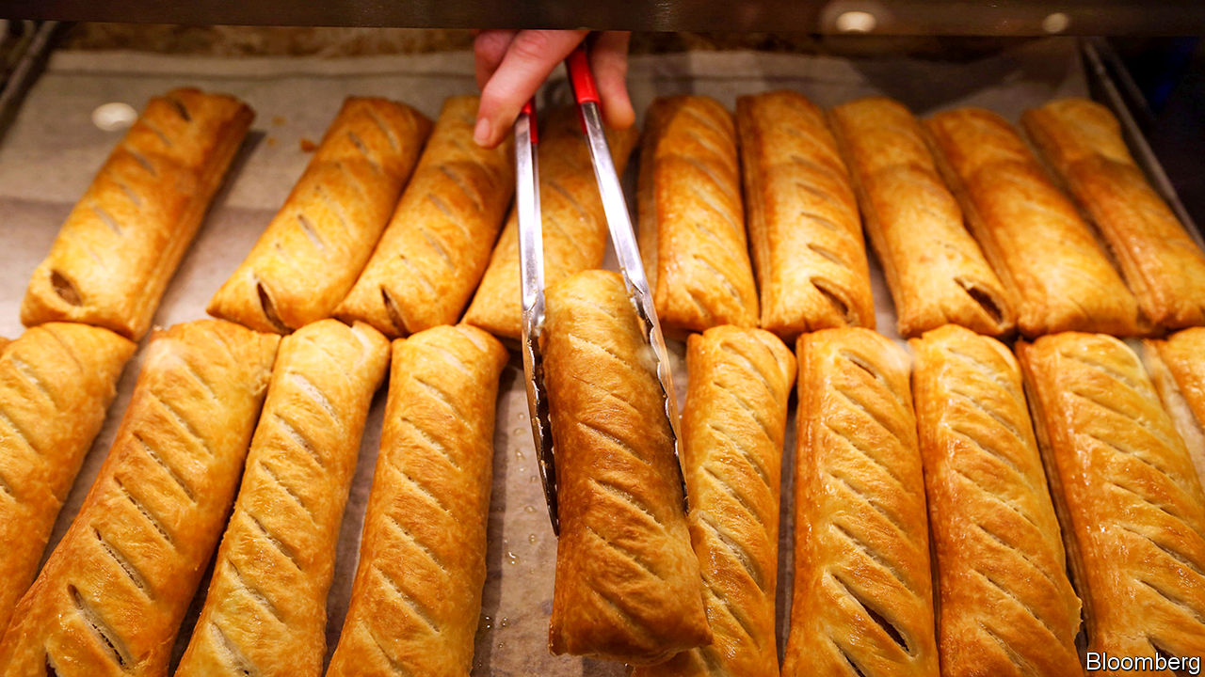

BONUS SEASON is usually associated more with bankers than bakers, but this year Greggs, a high-street purveyor of bread, buns and the like, gave its staff a special one-off payment of £7m ($9m). It has been a good year for the chain, which saw like-for-like sales rise by over 9% partially driven by the high-profile launch of its new vegan sausage roll; and the management decided that, as well as rewarding shareholders, the company would give employees an extra £300 in their January pay packet.

But the impact of the company’s generosity on those pay packets will be much reduced by the taxman. Greggs’ employees will face implicit marginal tax rates of up to 75%. A banker receiving £1m would, by contrast, be taxed at 47% (the top tax rate plus national insurance).

The quirks of Britain’s tax-and-benefits system explain the disparity. Most of Greggs’ 23,000 workers earn between £7.50 and £9 an hour and many work part-time. To make ends meet many of them rely on government help through universal credit, a new benefit which is being rolled out across Britain, and which low-paid people as well as the unemployed can claim.

Universal credit was supposed to show the Conservative Party’s compassionate side. It was hoped that it would both be easier to administer than the previous mishmash of six separate payments and provide a greater incentive to work. But between 2010 and 2015, as austerity bit, it was repeatedly pared. The result is a fairly miserly benefit that imposes startlingly high implicit tax rates on low-paid workers.

For a Greggs worker earning around £13,000 a year—less than half the national average—income tax at 20% and national-insurance contributions at 12% will swallow up £96, taking the bonus down to £204. That will then be subject to the universal credit taper rate of 63%, reducing their monthly benefit top-up by £128.52. In effect the bonus will be taxed at a marginal rate of 75%, and the worker will end up seeing £75 of the £300.

In recent years the government has made a big noise about raising the personal allowance, on which no income tax is charged, from £6,475 in 2010 to £12,500 in the current tax year. But “taking the lowest paid out of tax”, as the Tories like to put it, is harder than it seems. A Greggs worker on, say, £10,000 will indeed pay no income tax on their bonus, but after national-insurance deductions and the universal-credit taper they will still be facing an implicit marginal tax rate of around 67% on their £300. Depending on where they live, the bonus might also lead to reductions in council-tax benefit, further increasing the implicit tax rate.

The government is rightly keen that poorer people should work rather than sponge off the welfare system. An implicit marginal tax rate of 75% does not encourage them to do so.

This article was downloaded by calibre from <https://www.economist.com/britain/2020/01/18/greggs-and-the-vegan-sausage-roll-bonus>

|  |  |  |  |
| --- | --- | --- | --- |
| Previous | Articles | Sections | Next |

|  |  |  |  |
| --- | --- | --- | --- |
| Previous | Articles | Sections | Next |

#### Bagehot

# Harry, Meghan and Marx

Brand Sussex represents the biggest threat to the monarchy so far

Jan 16th 2020 |

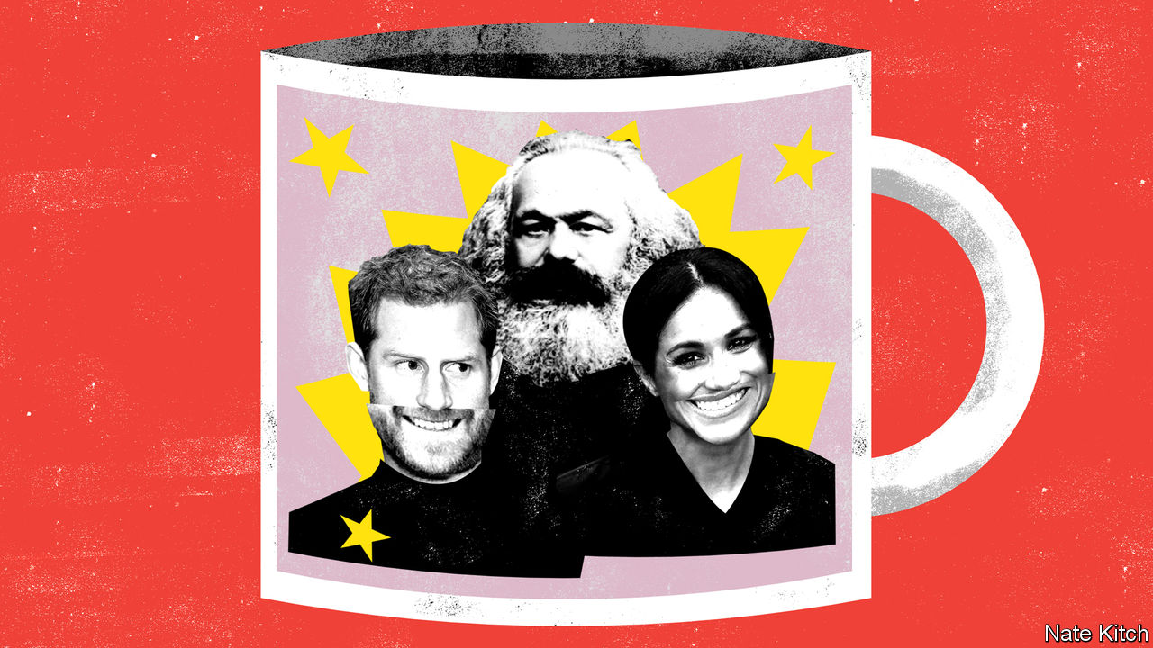

MARX PREDICTED that capitalism would destroy every remnant of feudalism. It would tear asunder “the motley feudal ties that bound man to his ‘natural superiors’”, in the words of “The Communist Manifesto”. It would drown ecstasies of religious fervour and chivalric enthusiasm in the “icy water of egotistical calculation”. And it would subject every national institution to the revolutionary logic of the global market.

So far the British monarchy, one of the last vestiges of the country’s feudal system, has proved a splendid refutation of Marxism. The Crown has survived both the high-noon of Victorian capitalism and the revival of market orthodoxy after 1979. In “The English Constitution”, Walter Bagehot explained why: far from undermining capitalism, the monarchy, in its British form, reinforced it, acting as glue in a society divided into antagonistic classes and distracting the masses from the real sources of power. It injected pageantry, romance, mystery and drama into the lives of British people, mitigating the dreary business of being a cog in the wheels of capitalism.

But the Duke and Duchess of Sussex may be about to prove Marx right. They represent the most profound danger to the monarchy’s settlement with modernity since Bagehot wielded his pen. Previous threats have been mere individuals—Edward VIII, Princess Diana and, most recently, Prince Andrew. The current one is an entire economic system. In stepping down as “senior royals” while pronouncing that they “value the freedom to make a professional income” the Duke and Duchess threaten to unleash the spirit of capitalism on the very core of the monarchy.

This is not the first time the Windsors have experimented with capitalism. Princess Diana referred to the royal family as “the firm” because it was so businesslike in its approach to monarchy. Prince Charles sells over £200m ($260m) a year worth of organic food under his Duchy brand. But until now the firm has treated capitalism as a servant of feudalism. Prince Charles gives the profits from his Duchy brand to charity, and misses no opportunity to preach the superior values of the “old world” to this venal age, denouncing intensive farming methods and modern architecture, while telling off business people for putting profit before principle.

The Sussexes are doing something new. They are embracing capitalism in its rawest, most modern form: global rather than national, virtual rather than solid, driven, by its ineluctable logic, constantly to produce new fads and fashions.

This type of capitalism is the inverse of feudalism. In a feudal society you are bound to your followers by mutual bonds of obligation. In 21st-century capitalism you accumulate followers in order to monetise them. In a feudal society you are bound to plots of land: Harry is the Duke of Sussex while his elder brother is the Duke of Cambridge. In a 21st-century-capitalist society you are propelled around the world in pursuit of the latest marketing opportunity. It is only fitting that the principal agent of the current debacle, Meghan Markle, is the product of an entertainment business that has done more than any other industry to fulfil Marx’s prediction that “all that is sacred” would be “profaned” and “all that is solid” would “melt into air”.

The Sussexes are determined to turn themselves into a global brand. Their first move after they announced that they were stepping down from many of their royal duties was to unveil the name of their brand, Sussex Royal, which sounds a bit like a potato but will soon start to glitter with Hollywood stardust. They started working on their new website in September, according to coding logs, and trademarked the Sussex Royal logo, for use on hundreds of items ranging from socks to counselling services, in December. They have hired a branding agency called Article whose clients include the children’s channel Nickelodeon, the fashion house Diane von Furstenberg and the Toronto Maple Leafs ice-hockey team. They are exploring the possibilities of forging a relationship with Disney, an entertainment company that knows a thing or two about monetising princes and princesses.

Various branding experts have pronounced that Harry and Meghan have “a ready-made brand” that could earn them as much as £500m in their first year. InfluencerMarketingHub, a website, points out that, with 10m Instagram followers, they could expect $34,000 for a sponsored post. SEMrush, a Boston-based marketing analytics firm, says that Ms Markle’s “search volume” is nearly three times Beyoncé’s.

Already Harry and Meghan are rewriting the rules of royalty, so that they can behave as celebrities rather than as public servants. They are planning to abandon the system of royal reporting, whereby royals put up with journalists chosen by the papers, who share their material with the rest of the press. Harry and Meghan intend to back out of that, in favour of choosing their preferred media toadies—though since it appears that they want to continue to receive money from Prince Charles, the older generation has a certain amount of leverage. Negotiations are under way. The Palace held a “crisis summit” on January 13th to try to work out a peace treaty between the Crown and the Sussexes. Ms Markle, who is in Canada, did not attend, leaving Harry to defend the Sussexes’ corner against his grandmother, father and brother.

Branding experts purr that Harry and Meghan have an interest in preserving the integrity of their brand. But the logic of 21st-century capitalism is against a peaceful settlement. They will need more than Prince Harry’s inheritance, which is estimated at £20m-30m, to keep up with the global super-rich. Ensuring that their brand remains hot and providing their “distribution channels” with “content” will require them to extract more and more value from the monarchy—perhaps including revelations about racism and sexism at the heart of the royal family. The daylight that Walter Bagehot said should not be let in upon the magic of monarchy is as nothing to the glare of 21st-century capitalism. ■

This article was downloaded by calibre from <https://www.economist.com/britain/2020/01/16/harry-meghan-and-marx>

|  |  |  |  |
| --- | --- | --- | --- |
| Previous | Articles | Sections | Next |

|  |  |  |
| --- | --- | --- |
| Britain | Sections | Special report |

International

Road safety: Crunch time

.

Road markings: You might as well do the white line

.

|  |  |  |
| --- | --- | --- |
| Britain | Sections | Special report |

|  |  |  |  |
| --- | --- | --- | --- |
|  | Articles | Sections | Next |

#### Crunch time

# Globally, roads are deadlier than HIV or murder

The tragedy is that this is so easy to change

Jan 16th 2020 | BANGKOK

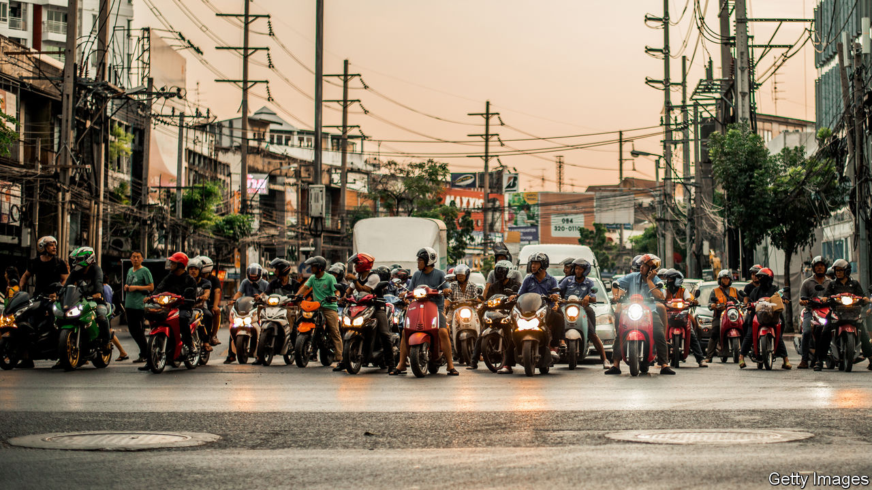

A YEAR AGO Nungroothai Tantasirin’s daughter, Hataipat, was hit by a motorbike while crossing the road near Bangkok. Soon after she died of her injuries. Ms Nungroothai threw herself into campaigning for a pedestrian bridge and took the bike rider to court, winning a hefty financial settlement. But nothing brings back a lost daughter—and reminders of the tragedy are everywhere. Recently, the school where Ms Nungroothai teaches returned from holidays. One child turned up with a head wound from a crash. Another teacher was off sick, having been struck by a motorbike while walking along the side of the road.

Thais know that their roads are dangerous. Local journalists cover tragedies like the death of Hataipat Tantasirin and diligently report the carnage that occurs around New Year’s Eve and Songkran, the Thai new year. According to official statistics, 19,930 people perished from injuries sustained on Thailand’s roads in 2018, including 837 in Bangkok. The country’s annual road-death rate is almost double the global average and more than seven times the rate in nearby Singapore, a wealthy financial hub. What is less well known is how easy it would be to change this.

Globally, road accidents kill more people every year than malaria or HIV/AIDS. Spencer James and other researchers at the Institute for Health Metrics and Evaluation (IHME) in America put the death toll in 2017 at 1.24m. According to IHME, the overall number of deaths has been more or less static since the turn of the century. But that disguises a lot of movement up and down in individual countries.

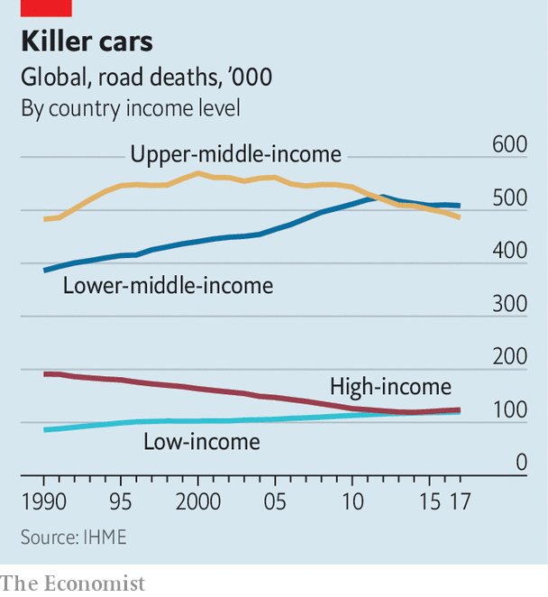

In many poor countries, especially African ones, road accidents are killing more people (see chart). Those countries have swelling, young populations, a fast-growing fleet of cars and motorbikes, and a limited supply of trauma surgeons. It is impossible to know for sure because official statistics are so inadequate, but deaths are thought to have risen by 40% since 1990 in countries that the World Bank defines as low-income, such as Afghanistan. In many rich countries, by contrast, roads that were pretty safe are becoming even safer. In Estonia and Ireland, the number of deaths has fallen by about two-thirds since the late 1990s.

The most important and intriguing changes are taking place in middle-income countries, such as Thailand. These contain most of the world’s people and have some of the most dangerous roads. They also tend to be close to an inflection point. In China and South Africa deaths have been falling since about 2000, according to IHME—though crashes still claim about a quarter of a million Chinese lives each year. In India deaths peaked in 2012. It is possible that the Philippines reached a peak four years ago. In Kenya and Nigeria deaths are still rising.

Roads in middle-income countries often change quickly, in ways that make them both safer and more dangerous. On the outskirts of Bangkok, Somchart Ninkled oversees a small group of volunteer ambulance drivers and “body snatchers”, as they are grimly known. These men are called to diverse emergencies, often involving snakes, which they grab with their bare hands. They also scrape at least one person off the roads every night. Crashes are getting worse, they say, as motorbikes become more powerful and roads grow smoother and faster. On the plus side, more people seem to be wearing helmets. And the police have at least put a stop to the local road races that were once common.

Rob McInerney, head of the International Road Assessment Programme, a charity, says that countries tend to go through three phases. They begin with poor, slow roads. As they grow wealthier, they pave the roads. Traffic moves faster, which pushes up the death rate (from Australia to Zambia, the physical law is the same: to calculate an object’s kinetic energy, you multiply half its mass by the square of its speed). In the third phase, countries act to make their roads safer. The trick is to reach the third stage sooner, by focusing earlier and more closely on fatal accidents.

How to do that? The answer is probably not education and training, says Soames Job of the World Bank. Some studies suggest that training drivers makes them more dangerous; perhaps they become cockier. Besides, routinely wearing helmets and seat-belts, obeying speed limits and avoiding drink-driving—all things that save lives—are not advanced skills. They are practices which people know they should follow but often don’t. Dangerous driving is not a fixed cultural trait, as some imagine. People respond to incentives, such as traffic laws that are actually enforced.

In Thailand motorbike helmets are compulsory. In Bangkok 85% of drivers and 55% of pillion riders wear them, according to roadside surveys. That is better than in the past, and much better than the national average. Perhaps urbanites follow the rules because they can afford helmets, or value their brains more highly—evidence from India suggests that university graduates are more likely to wear helmets. But in all probability Bangkok residents wear helmets because they fear being stopped and fined if they do not. Rittporn Yomram, a motorbike taxi driver in Bangkok, says that many passengers hesitate to wear helmets—unless they see a cop.

The police can also reduce speeding and drink-driving, if people truly fear the consequences of being caught. Thailand’s cops wrote almost 12m tickets in 2018; unfortunately, due to poor record-keeping, only 12% of them were paid. Major-general Eakkarak Limsanggas of the Royal Thai Police has cracked down on drink-driving by setting up roadblocks around Bangkok. He thinks this had an effect, although the penalties are less harsh than in many countries. But it was not long before politicians started calling, arguing that the roadblocks were harming the night-time economy and telling him to lighten up.

Countries can make their roads safer even if they are unable or unwilling to make drivers behave better. Many poor and middle-income countries have built concrete medians, especially in and around cities. These prevent head-on crashes—generally the most lethal kind—and give pedestrians a small safe zone halfway across a road. Development banks and groups such as the Millennium Challenge Corporation now insist that the roads they pay for are built to high safety standards.

Roundabouts, chicanes and road humps all reduce speeds and save lives. One study, by academics at the University of KwaZulu-Natal in South Africa, found that the number of pedestrian injuries in two districts of Durban fell from 659 in the two years before speed bumps were built to 519 in the two years after. The number of deaths fell more sharply, from 24 to eight. Mr McInerney points out that fast four-lane roads are still being built through villages in many countries. But in Peru and elsewhere, local people have responded by building illegal speed bumps.

In Bangkok, the road where Hataipat Tantasirin was hit by a motorbike has a new pedestrian footbridge. That will save lives, if people use it. The body snatchers report that they are often called to accidents where pedestrians have been hit by cars or motorbikes directly under footbridges. Apparently, they use them for shade. ■

This article was downloaded by calibre from <https://www.economist.com/international/2020/01/16/globally-roads-are-deadlier-than-hiv-or-murder>

|  |  |  |  |
| --- | --- | --- | --- |
|  | Articles | Sections | Next |

|  |  |  |  |
| --- | --- | --- | --- |
| Previous | Articles | Sections | Next |

#### You might as well do the white line

# Painting lines on roads saves lives

Simple things can reduce deaths in traffic accidents

Jan 16th 2020 |



FIFTEEN MINUTES into Alfred Hitchcock’s film “North by Northwest”, Roger Thornhill, the character played by Cary Grant, has a heap of problems. Having been mistaken for another man, he has been kidnapped by two armed thugs and driven out of New York City. The thugs have poured a large bourbon into him and put him behind the wheel of a car, which they have aimed over the edge of a cliff. Thornhill has another problem which heightens the drama. The road’s edge is unmarked.

When “North by Northwest” was released, in 1959, most American roads lacked painted edge lines. Even the centre lines shown in that film were not yet standardised. Could simply painting lines on roads have saved hundreds of thousands of Americans?

In their book “Reducing Global Road Traffic Tragedies”, Gerald Balcar and Bo Elfving argue that it did. The first American centre line appeared near Detroit in 1911; the man responsible for it claimed a leaky milk van leaving a white streak inspired him. Over the next few decades, road engineers began to favour yellow centre lines, which were made reflective by adding glass beads to paint. But edge lines remained rare outside cities.

What changed that were studies from the 1950s showing that painted edge lines cut road accidents, especially fatal ones. In the early 1970s Potters Industries (which made the glass beads, and employed Mr Balcar) calculated that driving on a rural road at night was six times deadlier than driving on an urban road during the day. Cars were running off the roads largely because drivers could not detect their edges.

As edge lines and marked intersections proliferated, and Americans started wearing seat-belts, the road-death rate began to fall. The car chase in the 1968 film “Bullitt” takes place on impeccably engineered roads, with centre lines and edge lines, energy-absorbing crash barriers and soft, obstacle-free road margins. To make such roads deadly, you need muscle cars, insane speeds, a shotgun and a strategically placed petrol station.

This article was downloaded by calibre from <https://www.economist.com/international/2020/01/18/painting-lines-on-roads-saves-lives>

|  |  |  |  |
| --- | --- | --- | --- |
| Previous | Articles | Sections | Next |

|  |  |  |
| --- | --- | --- |
| International | Sections | Business |

Special report

Housing: No place like home

.

A history: Building up

.

Supply: In my back yard

.

Housing finance: Whack-a-mole

.

Better off renting?: Money down the drain, right?

.

Home ownership: End of an era

.

Housing for the poor: A roof of one’s own

.

The future: Rebuilding

.

|  |  |  |
| --- | --- | --- |
| International | Sections | Business |

|  |  |  |  |
| --- | --- | --- | --- |
|  | Articles | Sections | Next |

#### Housing

# Housing is at the root of many of the rich world’s problems

Since the second world war, governments across the rich world have made three big mistakes, says Callum Williams

Jan 16th 2020 |

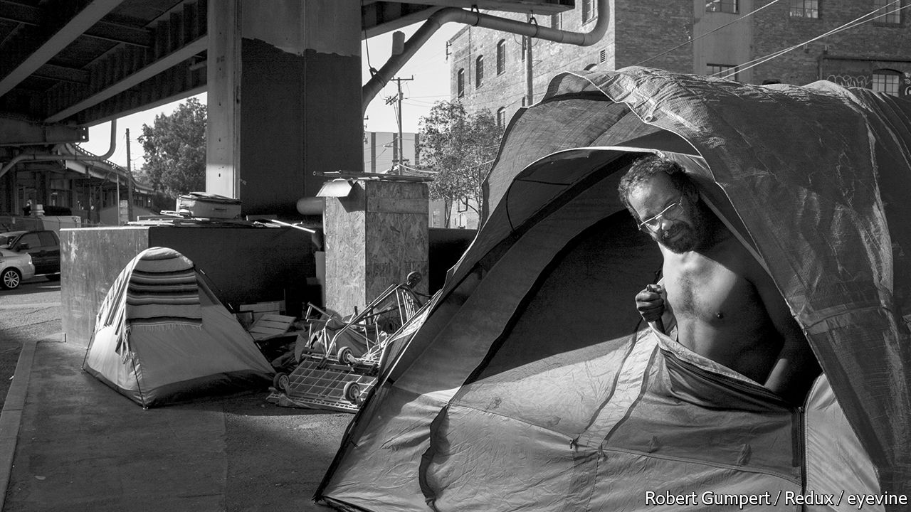

THE FINANCIAL crisis of 2008-10 illustrated the immense dangers of a mismanaged housing market. In America during the early to mid-2000s irresponsible, sometimes illegal, mortgage lending led many households to accumulate more debt than they could sustain. Between 2000 and 2007 America’s household debt rose from 104% of household income to 144%. House prices rose by 50% in real terms. The ensuing wave of defaults led to a global recession and nearly brought down the financial system.

From the 1960s to the 2000s a quarter of recessions in the rich world were associated with steep declines in house prices. Recessions associated with credit crunches and house-price busts were deeper and lasted longer than other recessions did. Yet the damage caused by poorly managed housing markets goes much deeper than financial crises and recessions, as harmful as they are. In rich countries, and especially in the English-speaking world, housing is too expensive, damaging the economy and poisoning politics. And it is becoming ever more so: from their post-crisis low, global real house prices have since risen by 15%, taking them well past their pre-crisis peak.

Traditionally politicians like it when house prices rise. People feel richer and therefore borrow and spend more, giving the economy a nice boost, they think. When everyone is feeling good about their financial situation, incumbent politicians have a higher chance of re-election.

But there is another side. Costly housing is unambiguously bad for the rich world’s growing population of renters, forcing them to trim spending on other goods and services. And an economic policy which relies on homebuyers taking on large debts is not sustainable. In the short term, finds a study by the IMF, rising household debt boosts economic growth and employment. But households then need to rein in spending to repay their loans, so in three to five years, those effects are reversed: growth becomes slower than it would have been otherwise, and the odds of a financial crisis increase.

Malfunctioning housing markets also hit the supply side of the economy. The rich world’s most productive cities do not build enough new houses, constraining their growth and making them more expensive than they would otherwise be. People who would like to move to London, San Francisco or Sydney cannot afford to do so. Since productivity and wages are much higher in cities than outside, that reduces overall GDP.

So it is bad news that, in recent decades, the rich world has got worse at building new homes. A recent paper by Kyle Herkenhoff, Lee Ohanian and Edward Prescott argues that in America this process has “slowed interstate migration, reduced factor reallocation, and depressed output and productivity relative to historical trends”. Constraints on urban growth also make it harder to reduce carbon-dioxide emissions, since big cities are the most efficient built forms. In America there are more building restrictions in places which have lower emissions per household.

Housing is also a big reason why many people across the rich world feel that the economy does not work for them. Whereas baby-boomers tend to own big, expensive houses, youngsters must increasingly rent somewhere cramped with their friends, fomenting millennials’ resentment of their elders. Thomas Piketty, an economist, has claimed that in recent decades the return to capital has exceeded what is paid to labour in the form of wages, raising inequality. But others have critiqued Mr Piketty’s findings, pointing out that what truly explains the rise in the capital share is growing returns on housing.

Other research, meanwhile, has found that housing is behind some of the biggest political shocks of recent years. Housing markets and populism are closely linked. Britons living in areas where house prices are stagnant were more likely to vote for Brexit in 2016, and French people for the far-right National Front in the presidential elections of 2017, according to research from Ben Ansell of Oxford University and David Adler of the European University Institute. Political disputes sparked the protests in Hong Kong, but the outrageous cost of accommodation in the city-state has added economic fuel to the political flames.

This special report will argue that since the second world war, governments across the rich world have made three big mistakes. They have made it too difficult to build the accommodation that their populations require; they have created unwise economic incentives for households to funnel more money into the housing market; and they have failed to design a regulatory infrastructure to constrain housing bubbles.

Happily, they are at last starting to recognise the damage caused by these policies. In Britain the government now openly says that the housing market is “broken”. Scott Morrison, Australia’s prime minister, has pledged to make housing more affordable. Canada’s recent election was fought partly on who would do more to rein in the country’s spiralling housing costs. Carrie Lam, Hong Kong’s chief executive, has put housing front and centre in her response to the protesters.

They need to learn from places where the housing market broadly works—and those places do exist. As this report shows, flexible planning systems, appropriate taxation and financial regulation can turn housing into a force for social and economic stability. Singapore’s public-housing system helps improve social inclusion; mortgage finance in Germany helped the country avoid the worst of the 2008-10 crisis; Switzerland’s planning system goes a long way to explaining why populism has so far not taken off there. Governments across the world need to act decisively, and without delay. Nothing less than the world’s economic and political stability is at stake. ■

This article was downloaded by calibre from <https://www.economist.com/special-report/2020/01/18/housing-is-at-the-root-of-many-of-the-rich-worlds-problems>

|  |  |  |  |
| --- | --- | --- | --- |
|  | Articles | Sections | Next |

|  |  |  |  |
| --- | --- | --- | --- |
| Previous | Articles | Sections | Next |

#### A history

# How housing became the world’s biggest asset class

It is only a recent phenomenon

Jan 16th 2020 |

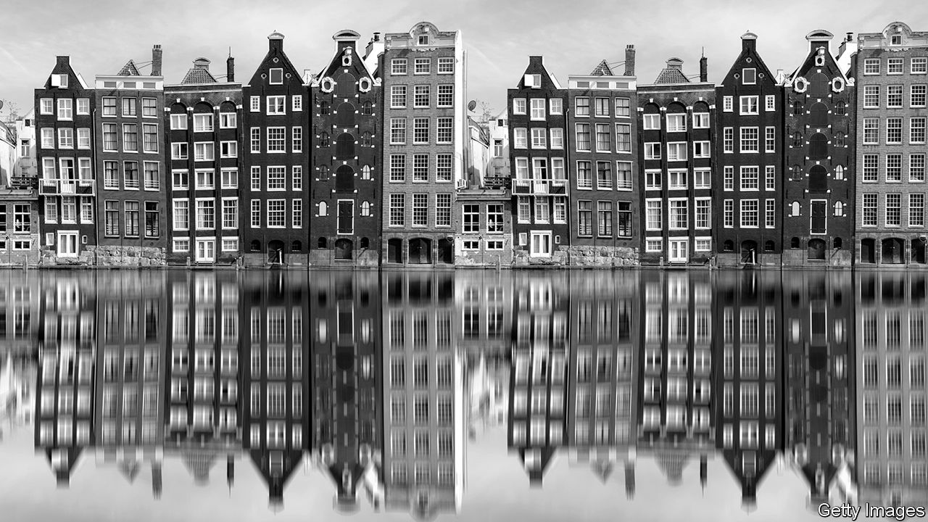

IN 1762 BENJAMIN FRANKLIN set sail from England to Philadelphia after several years away. On his arrival he was shocked by what he saw. “The Expence of Living is greatly advanc’d in my Absence,” he wrote to a friend. Housing, he thought, had become particularly expensive. “Rent of old Houses, and Value of Lands…are trebled in the last Six Years,” he complained.

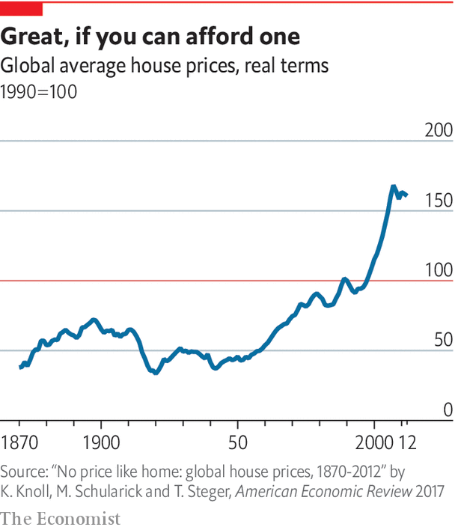

If Franklin were alive today, he would be furious. Over the past 70 years housing has undergone a remarkable transformation. Until the mid-20th century house prices across the rich world were fairly stable (see chart). From then on, however, they boomed both relative to the price of other goods and services and relative to incomes. Rents went up, too. The Joint Centre for Housing Studies of Harvard University finds that the median American rent payment rose 61% in real terms between 1960 and 2016 while the median renter’s income grew by 5%. In the 18th century farmland was the world’s single-biggest asset class. In the 19th century the factories used to power the Industrial Revolution took the number-one spot. Now it is housing (see chart, below).

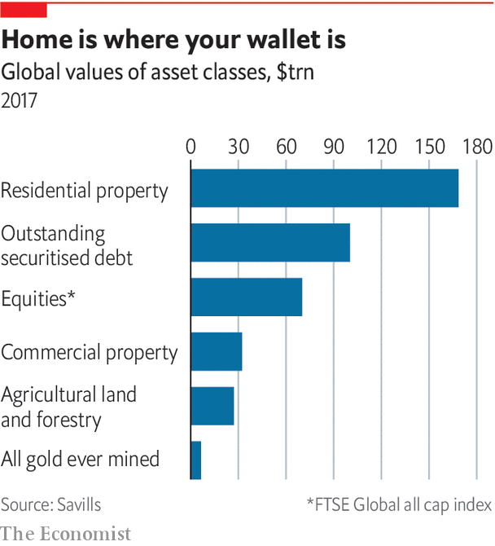

In capitalism’s early days house prices did see short-term booms and busts: 17th-century Amsterdam experienced a few housing bubbles, as did 19th-century America. Three main factors, however, explained long-term price stability. First, mortgage markets were poorly developed. Second, rapid improvements in transport meant that people could live farther away from their place of work, increasing the amount of economically useful land. Third, there was not much land regulation, meaning that housebuilders could build when they wanted and in the way that suited them. “For most of US history,” say Edward Glaeser of Harvard University and Joseph Gyourko of the University of Pennsylvania, “local economic booms were matched by local building booms.”

After the second world war, however, housing markets underwent a revolution. Governments across the rich world decided that they had to do more to care for their citizens—both as a thank-you for the sacrifices and to ward off the communist threat.

To this end, they vowed to boost home-ownership. A country of owner-occupiers, the thinking went, would be financially stable. People could draw down on equity in their house when they hit retirement or if they found themselves in difficulty. In the late 1940s and the 1950s manifestos of Western political parties became more likely to identify home ownership as a policy goal, according to research by Sebastian Kohl of the Max Planck Institute for the Study of Societies. Over time, the notion that owneroccupation was superior to renting became common, even apparently self-evident.

Policies to promote owner-occupation proliferated. In America the Veterans Administration made mortgages with no down-payment available to veterans in the mid-1940s. Canada established the Central Mortgage and Housing Corporation for returning war veterans. In 1950 the Japanese government established the Government Housing Loan Corporation to provide low-interest, fixed-rate mortgages. Changes to international financial regulations also encouraged banks to issue mortgages.

In a research paper Òscar Jordà, Alan Taylor and Moritz Schularick describe the second half of the 20th century as “the great mortgaging”. In 1940-2000 mortgage credit as a share of GDP across the rich world more than doubled. More people clambered onto the “housing ladder”. America’s home-ownership rate rose from around 45% to 70%; Britain’s went from 30% to 70%.

In previous centuries, a rise in demand for housing did not translate into structurally higher house prices. What had changed in the second half of the 20th century? One factor was transport speeds, which continued to improve but more slowly: trains and cars got only a bit better. So instead of moving farther and farther out to find accommodation, more people needed to look for somewhere to live closer to work. Land prices rose, and that fed into costlier housing.

## The price of preservation

In the 1950s and 1960s governments constructed large amounts of public housing, in part to rebuild their cities after the devastation of the second world war. Yet at the same time many of them tightened land regulation, gradually constraining private builders. In the 1940s and 1950s, for instance, Britain passed legislation to prevent urban sprawl. It provided for “green belts”, areas encircling cities where permission to build would be hard to obtain. Around the same time cities elsewhere, including Sydney and Christchurch, explored similar plans. From the 1960s American builders, too, began to have serious difficulty obtaining approval for building new homes.

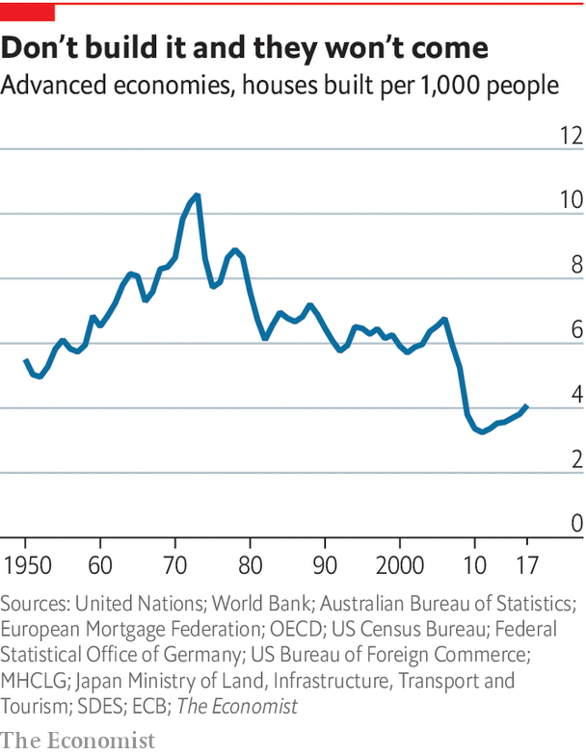

According to calculations by The Economist, the rate of housing construction in the rich world is half what it was in the 1960s (see chart). It has become particularly hard to build in high-demand areas. Manhattan saw permission given to 13,000 new housing units in 1960 alone, whereas for the whole of the 1990s only 21,000 new units were approved. A recent paper from Knut Are Aastveit, Bruno Albuquerque and André Anundsen finds that American housing “supply elasticities”—ie, the extent to which construction responds to higher demand—have fallen since the pre-crisis housing boom.

Why did the rich world turn against new construction? The post-war rise in home ownership may have had something to do with it. In 2001 William Fischel of Dartmouth College proposed his “homevoter hypothesis”. The thinking runs that owner-occupiers have an incentive to resist development in their local area, since doing so helps preserve the value of their property. As home ownership rises, therefore, housing construction might be expected to fall.

Research supports that idea. One paper studies a ballot in 1988 in San Diego, finding that precincts with a larger share of homeowners had more votes cast in favour of growth controls. Another finds that parts of New York City with high home-ownership rates were more likely to implement measures which made development more difficult. There is little doubt that the rich world is a less friendly place to build than it once was. But to what extent is land regulation responsible for today’s sky-high prices? ■

This article was downloaded by calibre from <https://www.economist.com/special-report/2020/01/16/how-housing-became-the-worlds-biggest-asset-class>

|  |  |  |  |
| --- | --- | --- | --- |
| Previous | Articles | Sections | Next |

|  |  |  |  |
| --- | --- | --- | --- |
| Previous | Articles | Sections | Next |

#### Supply

# Politicians are finally doing something about housing shortages

But will it reduce housing costs?

Jan 16th 2020 |

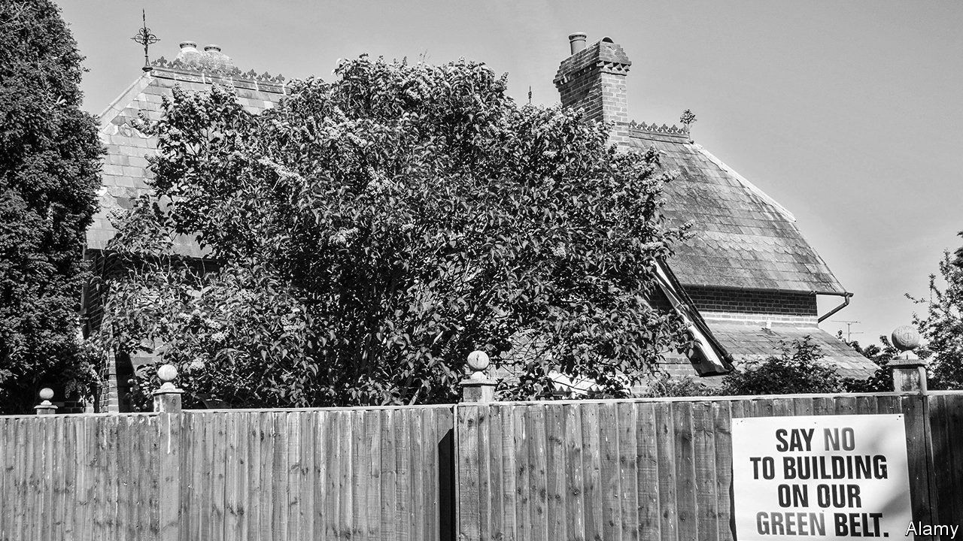

TO GET A sense of why London has such expensive housing, visit Tottenham Hale. You might expect that, next to an Underground station where central London is accessible within 15 minutes, there would be plenty of houses. In fact, there is a car wash. The land on which the car wash sits is officially classified as “green belt” land, which means that building houses on it is almost impossible. Across just five big cities in England there are over 47,000 hectares (about 116,000 acres) of similar land, which is not particularly green, is close to train stations with a good service to their centres, and yet cannot be built on. That is enough space for over 2.5m new homes at average densities.

For decades the green belt was sacred. The British public imagine it, wrongly, as idyllic pasture where horses drink from streams. Politicians dared not talk about it. This is now changing. “It is time to burst the myth that the green belt is green,” Siobhain McDonagh, a Labour MP, argued last year, “and start using the non-green sites for the homes that our children so desperately need.” A cross-party group of MPs called upon the government to loosen planning in parts of the green belt. Ministers say that they are looking seriously at the issue.

Britain is not the only place where change is afoot. In 2017 Germany reformed its urban-planning law and lifted barriers to densification. Consultants to the government in Auckland detect a genuine interest in boosting housing supply. In Canada, the Ontario government is streamlining the planning process in order to increase housebuilding. In October California pushed through a broad zoning-reform bill. After decades of NIMBYism, there is clearly a backlash, led by millennials unable to afford a house. Many politicians now realise there could be political mileage in building more houses. Some activists have even coined an acronym—YIMBY, “Yes In My Back Yard”.

Many of those activists argue that overtight land regulation is the root cause of high house prices. To get a sense of the argument, compare Singapore with Hong Kong. Singapore has a fairly elastic planning system. The government owns most of the land. When house-price growth is too strong or the population is rising quickly, the state can release extra land faster than a barman at the Raffles hotel can mix a Singapore sling. In Hong Kong, by contrast, the supply of developable land is controlled by a small clique of oligarchs. What will buy you a cramped bedsit in Hong Kong will buy you a decent-sized pad in Singapore.

It is a similar story in America. The part of the country with the most elastic housing supply, Pine Bluff, a midsized city in Arkansas, has an average house price of $90,000. The cost of a house in one of the most restrictive parts, San Luis Obispo in California, is $725,000, even though building costs across America do not vary much. Common land-use regulations across America include zoning rules which allow only single-family houses and prevent the construction of apartments (94% of residential land in San Jose is zoned in this way, for instance). Since 1950 ordinances which establish exclusive zones, so that homes are not allowed in commercial areas, have become more popular.

Academic research supports the circumstantial evidence. Christian Hilber of the London School of Economics and Wouter Vermuelen of CPB Netherlands Bureau for Economic Policy Analysis found that if south-east England (the wealthiest and most regulated region) had been as open to new construction as the north-east (the least regulated), house prices in the south-east would have been 25% lower in 2008. Edward Glaeser of Harvard University finds similar results for parts of America.

## A big refurbishment

Yet what a few years ago was an almost universally accepted view among housing economists—that housing is so costly because there is not enough construction—has come under attack, in particular from Ian Mulheirn of the Tony Blair Institute, a think-tank. Members of this vanguard argue that the obsession with supply restrictions misses a more important cause of high house prices: global financial markets. As interest rates have fallen across the rich world, people can take out bigger mortgages and keep their monthly repayments at a manageable level. Landlords are willing to pay more for a house to rent out, because yields on other assets have fallen.

Some evidence seems to back up the view that economists’ obsession with housing supply is misguided. In the 2000s both Ireland and Spain experienced soaring house prices, even as construction took off. A recent blogpost from researchers at the Bank of England found that most of the rise in British house prices since 2000 was down to cheaper borrowing.

In fact, both causes are important. The loosening in global financial conditions since 2000 has certainly pushed up house prices—as have low unemployment, high immigration and the rise of platforms such as Airbnb, which divert home ownership away from ordinary people. Prices have not risen because building has suddenly became vastly more difficult.

At the same time, however, the long-term rise in house prices is largely down to constrained supply. And if builders struggle to erect new dwellings quickly, a given increase in demand is largely channelled into price rises. Giovanni Favara of the Federal Reserve Board and Jean Imbs of the Paris School of Economics find that, though looser finance has led to higher house prices, that was true “to a lesser extent in areas with elastic housing supply, where the housing stock increases instead”.

Even the most ardent demand-siders agree that building more would reduce housing costs. In policy terms, that matters. Governments have more control over the domestic planning system than they do over global financial conditions. Those who manage their land better are rewarded with more stable housing markets.

## Game of zones

Broadly speaking, three types of planning systems exist across the rich world: discretion-based; autocratic; and rules-based. The first type is commonly found in Commonwealth countries. Local residents have plenty of power to stop development plans, and they frequently do. It may be no coincidence that those countries have in recent decades seen the fastest growth in house prices, says Paul Cheshire of the London School of Economics. Parts of America follow similar rules. In San Francisco every permit is appealable and, since very few large-scale projects match existing building and planning codes, delays are common.

Autocratic planning systems do a better job of boosting housing supply. Russia has raised its annual rate of housebuilding from 400,000 a year in the early 2000s to over 1m. Singaporeans who protest against development are routinely ignored, says one with a house located near Tengah forest, some of which will soon be razed to make way for apartment blocks.

The third group—rules-based planning systems—are commonly found in European countries such as France and Germany. If developers tick all the boxes then construction is permitted, even if local residents object. These systems have generally done a better job of delivering housing. Since the 1950s Germany has built twice the number of houses as Britain, despite having only a slightly higher population.

As well as planning rules, the tax system matters. Switzerland demonstrates this well. It has a decent claim to be the world’s most democratic country, reliant as it is on referendums to decide all sorts of issues. (In 2018 it held ten national referendums, on everything from whether or not to penalise farmers who dehorn their livestock to whether or not insurance companies should be allowed to hire private detectives.) Local governments are unusually powerful. Yet NIMBYish residents appear to hold little sway. Each year Switzerland builds twice as many houses as America on a per-person basis.

To explain this apparent paradox, a paper by Mr Hilber and Olivier Schöni of Laval University points to the Swiss tax system. In countries such as Britain, though many taxes are levied at the local level, the proceeds are redistributed across the country. Local governments therefore see little economic benefit from allowing home construction, even as they must cope with the disruption. As a result they are unlikely to try too hard to override the NIMBYs.

By contrast, in Switzerland local taxes stay where they are levied, so local governments have a fiscal incentive to allow development. The process for acquiring planning permission can be slow, explains Melk Nigg, an architect in Zug, a canton close to Zurich which has the joint-highest rate of housing construction in Switzerland. But it is predictable. In the past century Swiss house prices have risen by less than those in any other rich country.

Can such policies be adopted elsewhere, especially in English-speaking countries? It is largely a question of politics. Right-leaning parties in particular recognise that, since homeowners are widely perceived to be more likely to vote for conservatives, unless they can create a new generation of owner-occupiers they will eventually be voted out of office. As the rate of home ownership falls, owner-occupiers lose political power relative to renters, meaning that liberalising planning policy has a lower political cost. And as more people come to see the urgent necessity of cutting carbon-dioxide emissions, support may grow for a new generation of houses with more efficient heating and insulation.

Nonetheless YIMBYs must tread a fine line. On the one hand, only a long-lasting construction boom has any chance of noticeably improving housing affordability. On the other hand, building on that scale would create much controversy, because of the disruption and because neighbourhoods would change. The continued rise of the YIMBYs is far from assured. ■

This article was downloaded by calibre from <https://www.economist.com/special-report/2020/01/16/politicians-are-finally-doing-something-about-housing-shortages>

|  |  |  |  |
| --- | --- | --- | --- |
| Previous | Articles | Sections | Next |

|  |  |  |  |
| --- | --- | --- | --- |
| Previous | Articles | Sections | Next |

#### Housing finance

# A decade on from the housing crash, new risks are emerging

Shadow banks originate around half America’s mortgages

Jan 16th 2020 |



DURING THE broadcast of the 39th Super Bowl in 2005, there was an advert for mortgages from a firm called Ameriquest. “Don’t judge too quickly,” ran the slogan. “We won’t.” Ameriquest also sponsored the half-time show, where Paul McCartney opened with “Drive My Car”. Two years later and the firm was no more, part of the wider crisis in the mortgage market which prompted a global recession and nearly caused the financial system to collapse.

Eleven years after that, at the 50th Super Bowl, a similar advert appeared for a different lender, Rocket Mortgage. A magician, a cyclist and even a toddler try to use the app to apply for home financing. “Push button, get mortgage,” the slogan read. By the Super Bowl in 2018 Rocket said it was the country’s largest mortgage lender, leading some Americans to wonder whether any lessons had been learned at all from the global crash.

Certainly the regulatory system for banks has been transformed. In the 2000s most financial regulation was “microprudential”, focusing on the soundness of individual banks. Now “macroprudential” regulation is the norm. The idea is to ensure that the financial system as a whole can withstand nasty surprises. “Macropru” is useful in a world of low interest rates. When borrowing is cheap, households can bid up house prices to unsustainable levels. But since raising interest rates does not square with the needs of the broader economy, targeted measures are required.

Since the early 2000s the number of rich countries using macro-prudential policies has doubled. In Britain not more than 15% of new mortgage lending can be for houses worth more than 4.5 times the borrower’s income. Singapore and parts of Canada now restrict purchases by foreigners.

All this can put the brakes on rapid credit growth. For high-risk borrowers, getting a mortgage is harder than it was, which is one reason why home ownership among the young has fallen. Banks have scaled back their mortgage operations. “The mortgage business… has experienced increasingly lower returns as new regulations add both sizeable costs and higher capital requirements,” wrote Jamie Dimon, the boss of JPMorgan Chase, in 2016.

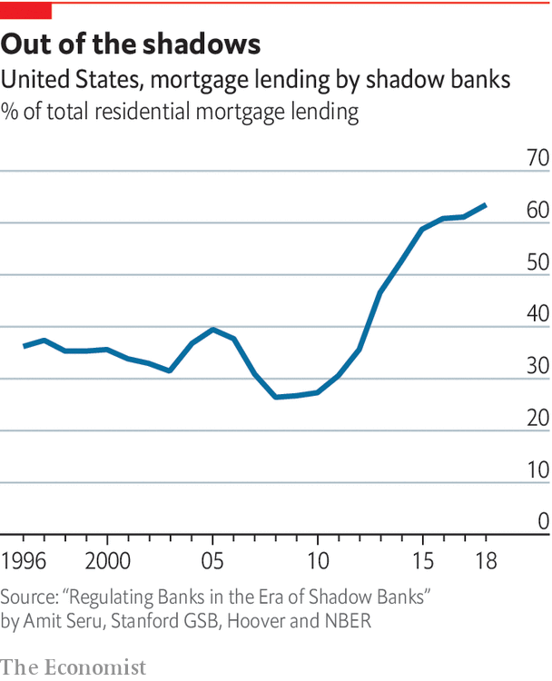

But new risks are emerging. In recent years non-bank mortgage lenders (a group of non-deposit-taking lenders that includes Quicken Loans, which offers Rocket Mortgage) have proliferated. They now originate around half of America’s mortgages (see chart). A growing number of economists argue that regulators need to keep a closer eye on these firms.

Many non-bank mortgage lenders are seizing market share because they offer genuinely useful products. Safe Rate, based in Chicago, offers a new type of mortgage. When local house prices decline, so do borrowers’ monthly mortgage repayments. The benefit for the borrowers is that they save money and are less likely to default. The advantage for investors is that, by preventing foreclosures, more mortgages will be kept going and it is less likely that house prices across a region will spiral downwards.

Some non-banks, however, exist purely as a means to get around strict bank regulations. In America non-banks are more loosely regulated and supervised than traditional banks. One paper found that an increasing regulatory burden accounted for some 60% of non-bank growth in 2007-15. (In countries like Britain the difference in regulatory burdens between banks and non-banks appears smaller and the growth in their lending is lower.)

Mortgage credit in America is not rising as fast as it was in the early 2000s. According to official data, only a small share of Quicken’s loan-book is in trouble. Yet many non-banks remain highly reliant on short-term funding from traditional banks, so if wholesale markets froze again, many Americans would quickly lose access to mortgage finance. Rather than keeping mortgages on their balance-sheets, non-banks tend to sell them on—not the best incentive to be ultra-cautious, says Amit Seru of the Stanford Graduate School of Business. Non-banks also seem particularly likely to serve less creditworthy borrowers. Until regulators start properly grappling with non-bank lenders, the job of regulating America’s mortgage market will be only half-done. ■

This article was downloaded by calibre from <https://www.economist.com/special-report/2020/01/16/a-decade-on-from-the-housing-crash-new-risks-are-emerging>

|  |  |  |  |
| --- | --- | --- | --- |
| Previous | Articles | Sections | Next |

|  |  |  |  |
| --- | --- | --- | --- |
| Previous | Articles | Sections | Next |

#### Better off renting?

# Owner-occupation is not always a better deal than renting

Each year American owner-occupiers pay around $200bn in maintenance costs on their homes

Jan 16th 2020 |

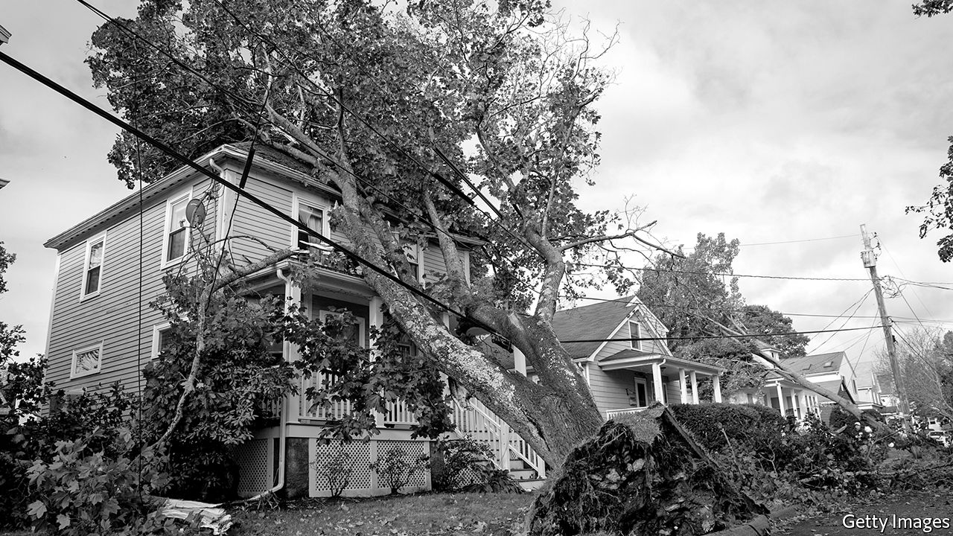

THE QUESTION hardly seems worth asking. Is it a better deal to rent a house or to buy one? Buying a house is a wise investment for the future, the argument goes, whereas renting one amounts to little more than throwing money down the drain. A closer look at the economics, however, shows that this view may be mistaken.

For one thing, renters often devote a smaller share of their income to rent than owner-occupiers devote to repayments of mortgage interest (in both cases, this is money handed over to someone else and never seen again). Whether one is cheaper than the other depends in part on interest rates. In the early 1990s, when interest rates were higher than they are today, the average ratio of mortgage-interest repayments to income was higher than the rent-to-income ratio in many countries.

That calculation nonetheless underestimates the cost of owner-occupation. Whether a home-owner is paying off a mortgage or not, they face a number of costs that renters do not, points out Ian Mulheirn of the Tony Blair Institute, a think-tank. For instance, a residential-property transaction in an OECD country incurs a median bill of about 8% of the value of the house (transaction costs for renting tend to be trivial).

Owner-occupiers must also account for wear and tear. Each year in America they pay around $200bn in maintenance and improvement costs (about 1% of the value of the houses in their possession). Home ownership also carries opportunity costs. In recent decades housing has proven to be a good investment; that may well continue. But capital locked up in a house could have made an even higher return if invested elsewhere.

What happens when you factor all this in? Take the example of the British housing market. In the run-up to the financial crisis of 2008-10, rapid increases in house prices and rising interest rates meant the user cost of owning actually rose well above rents. But over the long run the two tenures have cost about as much as each other. This is as economic theory would predict. Renting a home, and buying the right not to have to rent a home, are economically equivalent actions.

This article was downloaded by calibre from <https://www.economist.com/special-report/2020/01/18/owner-occupation-is-not-always-a-better-deal-than-renting>

|  |  |  |  |
| --- | --- | --- | --- |
| Previous | Articles | Sections | Next |

|  |  |  |  |
| --- | --- | --- | --- |
| Previous | Articles | Sections | Next |

#### Home ownership

# Home ownership is in decline

That is not a big cause for concern

Jan 16th 2020 |

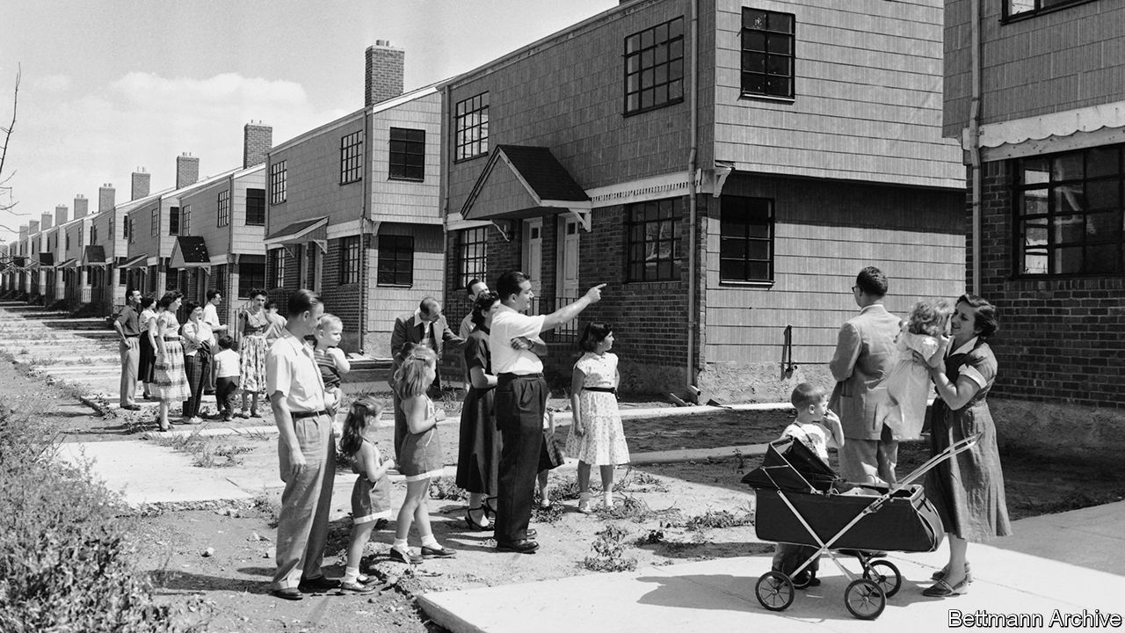

MORE THAN nine in ten Singaporeans are homeowners, a higher rate than in any other rich country. And what a nice place it is to live. The city-state is rich, stable and has virtually no crime. The streets are clean.

Singapore seems to confirm what conservatives have long believed: that home ownership makes for richer, happier folk. Lee Kuan Yew, its first prime minister, was a big fan, arguing that it gave ordinary people “a stake in the country and its future”. Margaret Thatcher’s “right-to-buy” programme in the 1980s, allowing Britons in social housing to buy their property at knock-down prices, is said to have been influenced by the Singapore model.

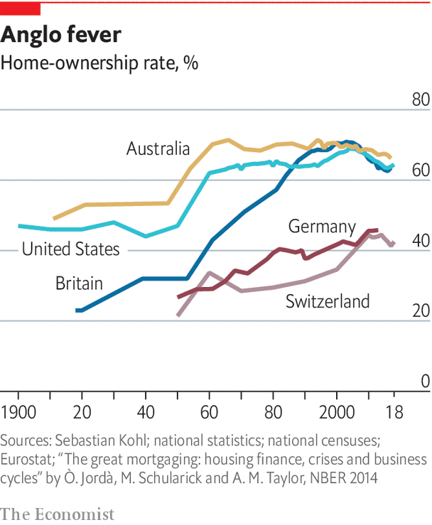

It might be seen as worrying, then, that for the first time in a century home ownership in the rich world is in decline (see chart). Yet having more renters might not be such a bad thing.

For most of the past millennium, the only people with a good claim to be homeowners were landed gentry and farmers who worked the fields. Then, from the mid-20th century onwards, home ownership was democratised. A combination of rising household incomes and government policies helped more people get onto the property ladder. In most countries home ownership peaked around the year 2000.

America has some of the most generous fiscal incentives to become a home-owner. Official estimates suggest that the government forgoes over $200bn a year (over 1% of GDP) subsidising homeowners through the tax code, with policies including a tax deduction on mortgage interest and not taxing the income homeowners implicitly earn by avoiding paying rent. Mark Zandi of Moody’s Analytics adds that subsidies to mortgages provided by Fannie Mae and Freddie Mac—two government-sponsored enterprises that support much of the country’s mortgage finance—and the Department of Housing and Urban Development amount to a further $9bn or so a year.

America is especially generous, but schemes to boost home ownership are common. Most rich countries do not charge capital-gains tax on the sale of an owner-occupied house. Inheritance-tax regimes routinely make exemptions for housing. Many countries subsidise mortgages and down-payments. Yet for all this, the factors pushing home ownership down are now stronger.

One possibility is that younger folk may be less interested in home ownership. After all, many millennials desire “asset-light” lives in which they rent cars, music and clothes, rather than owning them. Why not housing too?

The private sector has spotted an opportunity. Silicon Valley types are bullish on “co-living”, where people rent a dwelling and share common spaces such as kitchens, washing facilities and gyms. Hmlet, a co-living firm, is expanding in home-ownership-obsessed Singapore. Sharing a kitchen might sometimes be annoying, but Hmlet’s properties are well kitted out.

The attraction of co-living is, however, exaggerated. The majority of people would still prefer to be homeowners. Surveys from America suggest that the share of people who think that home ownership represents a good investment is growing.

Economic factors may be a bigger cause of the decline in home ownership. With weak earnings growth since the crisis, young folk have struggled to accumulate savings for a down-payment. Tighter regulation of mortgage markets since the financial crisis has made it tougher for first-time buyers to acquire finance. Baby-boomers, looking for a return on their savings, are pushing aside prospective first-time buyers and becoming landlords. As millennials have taken on more student debt, buying a home has become trickier.

How low could the home-ownership rate go? It seems unlikely that rates in the English-speaking world will ever approach Germany’s (with a rate of just 44%) or Switzerland (40%). Home-ownership rates are the product of history and culture. Countries with a history of weak real house-price growth—Germany and Switzerland fit the bill—have lower owner-occupation, because fewer people see buying a house as a worthwhile investment. Densely built places also tend to have lower home ownership. People are generally less keen on owning a flat in a high-rise block than they are in a detached house (55% of Germans live in apartments, a high rate by international standards).

Politicians across the rich world bemoan the emergence of Generation Rent. “American home ownership rate in Q2 2016 was 62.9%—lowest rate in 51 yrs,” tweeted Donald Trump when he was campaigning for president. “WE will bring back the ‘American Dream!’ ” Boris Johnson, Britain’s prime minister, seems equally concerned about his country’s falling rate of owner-occupation.

But lower home ownership need not be a cause for concern. For one thing, owning a home is not necessarily the route to riches that many people believe it to be (see article). The evidence that home ownership is good for society is, in fact, fairly weak. There are many counter-examples to Singapore. Romania probably has the world’s highest home-ownership rate, at 96%, but it has its fair share of social problems. Switzerland, at the other end of the scale, nonetheless has low crime and high social trust.

Academic studies offer only weak support for the idea of promoting home ownership. One paper suggests that owner-occupiers have better-tended gardens. But if nice shrubbery were a goal of public policy, it might be a better use of public money to subsidise wheelbarrows and trowels. Another study in America found that homeowners’ children were far more likely to graduate from high school—even after controlling for parents’ earnings. Researchers have struggled to discern which way the causality runs, however: does home ownership make good parents, or do good parents become homeowners?

Other evidence, meanwhile, finds that home ownership carries costs. The stresses of paying back a big mortgage are real. And the mad dash in the 1990s and 2000s to create “property-owning democracies” ended with the global financial system on its knees.

Home ownership does subtler sorts of economic damage, too. Indebted homebuyers are 30% less likely to become entrepreneurs, according to one study. Responsibility for a large mortgage debt may make people loth to take on further risk. When the home- ownership rate in an American state has risen, a sharp rise in unemployment has followed, according to David Blanchflower of Dartmouth College and Andrew Oswald of Warwick University. Homeowners are less willing to move to find work.

As the rented sector has grown in size, and as Generation Rent becomes a more powerful constituency, governments are putting more effort into improving the sector. One increasingly popular measure is rent control. London’s mayor, Sadiq Khan, has advocated restricting rent rises in the capital. Berlin’s legislators recently voted to freeze rents for five years. Paris reintroduced rent controls last year, having scrapped them in 2017. Such interventions are misplaced. Rent control generally dissuades investment in new construction, the last thing many of these cities needs.

More promising than rent control, however, is a move towards improving tenancies. Many politicians in English-speaking countries have Germany in mind. There, renting is not seen as a second-class tenure. It is fairly secure: the average tenancy lasts for 11-12 years, compared with 2-3 years in Britain. Some 3m Germans are members of tenants’ organisations, which can bargain on their behalf with landlords (the mascot at one association in Munich is dressed like Superman and calls himself the “Rentstopper”).

Emulating the German experience will be tricky. In Germany landlords treat tenants well not just to be nice, but because they have an incentive to do so. In recent decades Germany has seen little house-price appreciation. Since making money through capital gains is difficult, German landlords’ best hope of getting a decent return is through keeping their tenants in place for as long as possible. Only if house prices in other countries were more stable would their landlords start to behave in this way, too.

Still, governments can make some reforms. Britain has abolished letting fees, a murky system of charges slapped on by estate agents using a methodology that renters and landlords rarely understood. Spain is moving to give renters longer tenancies as standard. New Zealand is passing rules to ensure that certain basic standards for rental accommodation are met.

Perhaps the most promising development, however, is growing private investment in the rental sector. Since 2010 global institutional investment in residential property has more than doubled in real terms, not only because investors are looking for yield in a low-rate world but also because the number of potential customers is rising. Across America the share of the rental sector owned and operated by companies is rising, according to research by Hyojung Lee of Virginia Tech. By one estimate, the annual number of homes in New York City bought by professional investors has doubled in a decade.

An expansion of corporate housing will raise average standards in the rental sector. Big firms may be more professional than mom-and-pop landlords, and may also benefit from economies of scale which allow them to provide better-quality accommodation at lower prices. “Build-to-rent” apartment blocks often include goodies such as gyms and free Uber rides with the rent.

That said, corporate landlords have a more transactional relationship with their tenants. A study of Atlanta, Georgia, published by the Federal Reserve Bank of Atlanta in 2016, found that large corporate owners of single-family rentals were 8% more likely than small landlords to file eviction notices. To help the poorest or most vulnerable members of society with their housing needs, governments may need to do more. ■

This article was downloaded by calibre from <https://www.economist.com/special-report/2020/01/18/home-ownership-is-in-decline>

|  |  |  |  |
| --- | --- | --- | --- |
| Previous | Articles | Sections | Next |

|  |  |  |  |
| --- | --- | --- | --- |
| Previous | Articles | Sections | Next |

#### Housing for the poor

# Governments are rethinking the provision of public housing

Is it better to give people money or build them houses?

Jan 16th 2020 |



IN THE PAST ten years the homeless population in Los Angeles has risen by 50%. In New York it is 60% up over the same period. San Francisco is widely thought to have America’s worst homelessness problem. Just metres from the headquarters of Twitter and Uber, people lie in the street, stupefied, or defecate in front of the passing traffic. The term “housing crisis” is bandied about too readily. But it is an apt way of describing what is happening in America’s most prosperous cities.

It does not have to be this way. Tokyo is as much a global city as San Francisco, yet you can go days without seeing a single person living on the streets. The inhabitants of Zug, a short drive from Zurich, are as rich as the local Kirschtorte. Astonishing wealth, a waterside location and lots of high-tech firms mean that Zug bears more than a passing resemblance to San Francisco. But in Zug there is practically no rough sleeping.

Homelessness is the extreme manifestation of a problem that governments have tried to tackle for decades. At any one time, at least some people struggle to afford decent housing on private markets. Governments have spent vast sums trying to help the poor into housing and improving conditions. Yet they are failing in their objectives. This is prompting a rethink.

Governments began intervening heavily in housing markets following the second world war. They promised to build millions of homes themselves, which they would then rent to their constituents at below-market rates. In America the Housing Act of 1949 authorised the construction of over 130,000 units of public housing a year for six years. In 1950-70 Britain built some 3m units of social housing, and over the same period West Germany put up even more. The Japanese government was equally enthusiastic.

The boom ended as governments triumphantly declared that the housing shortage had been solved. At the same time fewer people wanted to live in big blocks of homogeneous flats, especially poor-quality ones: the dash for volume had often caused governments to cut corners. A gas explosion at the Ronan Point block in London in 1968 marked a turning-point in attitudes to public housing in Britain. In the mid-1970s Pruitt-Igoe, an infamous project in St Louis, Missouri, was demolished. Around this time, economists started to think differently about the best way to provide welfare.

Rather than build houses for the poor, many argued, why not give them the money they would need to buy housing on the open market? Recipients of cash payments could then choose the sort of accommodation that suited them best. Others contended that the private sector would deliver superior housing to what the state could provide. Cash benefits also promised to be better targeted at the poor: withdrawing a monthly housing payment to someone who suddenly becomes well off is easier than kicking them out of their home.

## Who is it helping?

What followed was a shift from supply-side to demand-side measures. In the early 1970s Britain started to wind down its programme of social-housing construction, but in its place gave money to poor tenants. France did something similar in the latter part of the decade. In Germany from the late 1980s, housing assets owned by municipalities were transferred to for-profit owners. In America between 1977 and 1997, the number of households receiving housing vouchers increased from 162,000 to over 1.4m.

Though economists generally prefer cash benefits over the in-kind sort, a growing number are starting to argue that providing cash assistance for housing has not proven to be as effective as expected. Giving people money increases their purchasing power. In a normal market, the increase in effective demand leads suppliers to respond accordingly. Yet the supply of housing in many cities is inelastic: when demand for housing rises, extra supply does not necessarily follow. Instead, the price of housing—which, for most poor people, is rent—goes up.

In many cases, therefore, housing benefits help landlords as much as the poor. Some research in England has found that half of the gains from housing benefits accrue to landlords. A paper from 2006 looking at France concludes that a one-euro rise in housing benefits raises rents by 80 cents.

Kanye West reportedly built prototypes of houses inspired by a planet in “Star Wars”

If governments respond to rising rents by increasing housing benefits, costs can quickly spiral. Over the long run, cash payments for housing can even cost the government more than providing housing directly (though this is difficult to calculate reliably). Meanwhile, it is not clear whether the private sector is able to fill the gap when the state stops building houses itself. If not, then overall new housing supply falls, making it more expensive for everyone.

Faced with growing numbers of people unable to afford housing, there are stirrings of a global movement back towards direct provision. Last year Kanye West, a rapper, reportedly built prototypes of dome-shaped houses inspired by Tatooine, a planet in “Star Wars”, which were to be used as low-income dwellings (though after a fight with local residents, the prototypes appear to have been demolished).

Housing co-operatives are also becoming more popular. A short drive from Zug a group called “mehr als wohnen” opened “Hunziker Areal”, a housing complex, in 2014. Rents in its apartment blocks are generally far lower than the local average. Residents have a say in how the community is run. There are bikes in a “mobility station” for people to borrow and residents can tend a vegetable patch. It is a world away from what many Americans or Britons think when they hear the term “public housing”.

Governments have bigger plans. In 2018 Britain built more public housing than in any year since 1992. The South Korean government aims to increase the share of public-rental housing from 7% of the total stock to 9% by 2022. In Germany in 2018-19 the government set aside some €5bn ($5.6bn) to promote the construction of public housing.

The best way to make housing more affordable would be to make the supply more responsive to increases in demand. A big underlying reason why homelessness in Tokyo is so low is that housing is reasonably affordable. Meanwhile, Zug builds more than twice as many homes per person as San Francisco. Research suggests that a 10% fall in rents in a high-cost city such as New York results in an 8% decline in the number of homeless residents. Until governments keep overall housing costs under control, the rest is tinkering. ■

This article was downloaded by calibre from <https://www.economist.com/special-report/2020/01/18/governments-are-rethinking-the-provision-of-public-housing>

|  |  |  |  |
| --- | --- | --- | --- |
| Previous | Articles | Sections | Next |

|  |  |  |  |
| --- | --- | --- | --- |
| Previous | Articles | Sections | Next |

#### The future

# What is the future of the rich world’s housing markets?

It is plausible that house prices could persistently rise faster than incomes

Jan 16th 2020 |

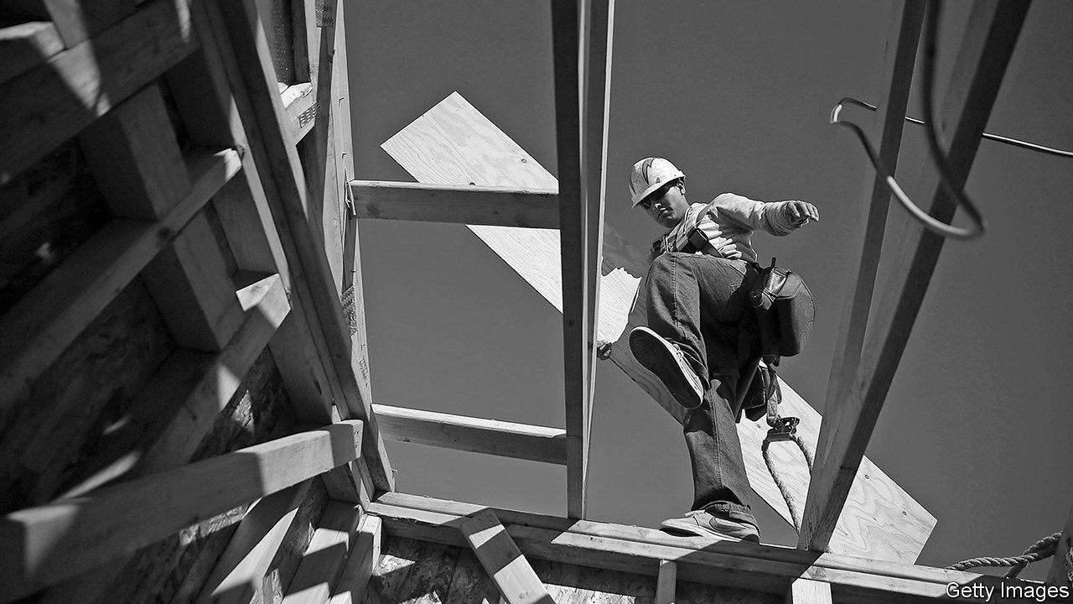

MOORE’S LAW states, roughly, that computing power doubles every two years. Time and again experts predicted its demise—surely, they reasoned, computers cannot continue getting exponentially more powerful. Yet it held for at least half a century.

More people are starting to wonder whether housing may have its own version of Moore’s law. Over the past 70 years global house prices have more than quadrupled in real terms. They are far beyond their pre-crisis peak. It may seem mad, but a paper from David Miles, formerly of the Bank of England’s monetary-policy committee, and James Sefton of Imperial College London finds that “in many countries it is plausible that house prices could now persistently rise faster than incomes”. A growing population and rising incomes increase demand for housing, which runs up against a fixed supply of land in areas where the good jobs are, and limits to improvements in transport speeds.

As this report has argued, high property prices are associated with less economic dynamism and more financial instability. But although Messrs Miles and Sefton say that ever-pricier property is “plausible”, they do not say it is inevitable. To keep housing costs down in the long term, governments need to get three things right.

The first is better regulation of housing finance. Switzerland comes close to treating home-ownership and renting equivalently in its tax system, meaning that people are not encouraged to funnel capital into the housing market. More countries should follow that example. President Donald Trump’s tax reform of 2017, which limited mortgage-interest deductions, is a step in the right direction.

More radical reforms could be considered. German mortgage-lenders embrace an unusual appraisal technique. When assessing the value of a house, they rarely refer to market price; instead they consider “mortgage-lending value”, an assessment of the probable price of a house over the economic cycle. A report from the Bank for International Settlements, a club of central banks, suggests that by discounting short-term price fluctuations, this valuation technique can stop bubbles from forming. Lenders in America once embraced the technique, points out Ed Pinto of the American Enterprise Institute, a think-tank, yet after the second world war it fell out of fashion.

The second group of reforms concerns transport. Until the mid-20th century, house prices were stable in part because the cost and ease with which people could get around improved roughly as quickly as economic growth. As getting from A to B became ever quicker, it increased the amount of developable land at an economy’s disposal. But after the second world war improvements in transport slowed, meaning that more and more people were fighting over the same amount of space. That caused house prices to rise.

More recently, commuting times into the rich world’s biggest cities have, if anything, been lengthening, raising the premium of living near or in city centres. A better train and road network, then, would allow more people to live farther afield. Driverless cars could also reduce the hassle of moving around. (And when video-conferencing is fully reliable, more people may be willing to live miles away from their office and call in for meetings.)

The third set of reforms concerns planning. This report has argued that governments are finally waking up to the fact that there is a structural undersupply of housing. They could learn from best practice internationally. Devolving taxes to the regional or local level, the norm in Switzerland, gives local governments a stronger incentive to allow development.

Cheaper housing would make politics less volatile

France has followed the Swiss example in increasing pressure on local governments to raise revenue from property taxes, “which can in turn lead to efforts to stimulate land development”, according to the OECD. Abolishing single-family-home zoning, which prevents densification, is another good option—and something Minneapolis did last year. Boosting the construction of public housing is also welcome. Singapore, where 80% of residents live in government-built flats, is in some respects the model to copy. The state regularly renovates the buildings and, more controversially, promotes mixing of different sorts of people, to help prevent the emergence of ghettos.

## Rome wasn’t built in a day

The gains from allowing more building would be enormous. According to one paper American GDP could be around 10% higher if there were plentiful new construction in just New York, San Francisco and San Jose. Cheaper housing would also make politics less volatile: a growing body of research shows that support for populist parties is particularly likely in countries where people cannot afford to move to the big cities, and are thus trapped in “leftbehind” places.

Some housing experts are sceptical about whether any democratic society would ever countenance such a building surge. They are too pessimistic. In Japan a series of reforms in the early-to-mid-2000s loosened the planning system, allowing applications to be processed more quickly and giving residents more discretion over how to use their land. Tokyo’s rate of housing construction has risen by 30% since the reform; in 2013-17 Tokyo put up as many houses as the whole of England. Tokyo is a more jumbled city than most rich ones, but current zoning laws ensure that it is not quite as higgledy-piggledy as, say, Houston. In inflation-adjusted terms, house prices in the Japanese capital are 9% lower than they were in 2000, while in London they are 144% higher.

Ordinary people need to change their attitudes, too. In the West many almost instinctively oppose development, either because of the inconvenience associated with it or because they dislike the very idea of housing companies making profits. Better compensating people affected by housing construction would help win over more residents. Governments could also do more to explain why a shortage of housing is bad news for everybody, rather than celebrating whenever house prices go up. Bold action is needed. Until it is taken, housing will continue to weaken the foundations of the modern world. ■

This article was downloaded by calibre from <https://www.economist.com/special-report/2020/01/16/what-is-the-future-of-the-rich-worlds-housing-markets>

|  |  |  |  |
| --- | --- | --- | --- |
| Previous | Articles | Sections | Next |

|  |  |  |
| --- | --- | --- |
| Special report | Sections | Finance and ... |

Business

The World Economic Forum: A tour of the Magic Mountain

.

Bartleby: The drugs don’t work

.

Pharmaceuticals: Cheap shots

.

Aston Martin Lagonda: Driving nowhere fast

.

Schumpeter: Blowin’ in the wind

.

|  |  |  |
| --- | --- | --- |
| Special report | Sections | Finance and ... |

|  |  |  |  |
| --- | --- | --- | --- |
|  | Articles | Sections | Next |

#### A tour of the Magic Mountain

# Can the World Economic Forum keep its mojo?

The organisation behind Davos faces a conflicted identity, increased competition and uncertain succession

Jan 16th 2020 | GENEVA

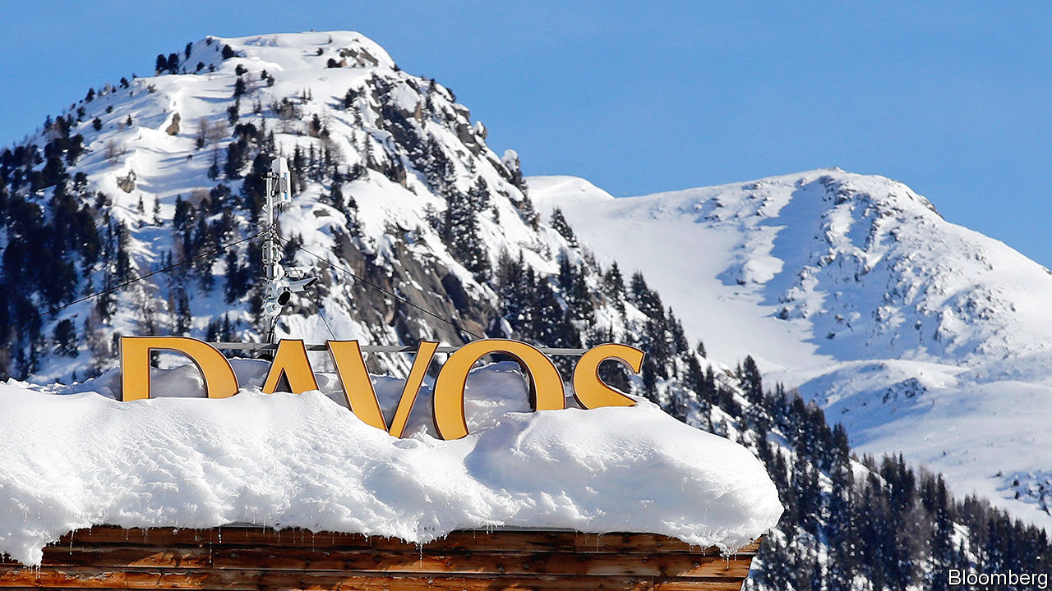

IN 1971 A precocious German academic—at 32 years old, the holder of five degrees in engineering and economics—hosted a conference. The setting was the newly opened congress centre in the Swiss resort of Davos, best known for its tuberculosis sanatoriums and as the backdrop for Thomas Mann’s “The Magic Mountain”. Klaus Schwab wanted to use the symposium to make European businesses think more about stakeholders beyond those who own their shares, and to expose them to American management methods. The fees paid by the 450 who came generated a profit of SFr25,000 ($75,000 in today’s money), which Mr Schwab used to endow the European Management Forum.

Renamed the World Economic Forum (WEF) in 1987, its signature annual event has become the ultimate A-list bash for plutocrats. It attracts nearly 3,000 business folk, politicians, take-me-seriously celebrities and journalists hoping to taste the zeitgeist. Visitors, some unable to get passes to the main venue, crowd panels and parties in hotels or on the “fringe”, a growing unofficial Davos on the town’s main drag. (The Economist sends journalists to the Forum and our parent company receives revenue from organising events for clients in Davos during the meeting.)

At 81, Mr Schwab remains the ringmaster, and on January 21st he will open the 50th annual gathering. Amid all the über-networking, another raft of “multi-stakeholder” initiatives will be launched, including a “one trillion trees” reforestation project. Star turns will include President Donald Trump, back after skipping 2019, and Greta Thunberg, who will be joined by a pack of other teenage activists, invited to help the conference “look to the future”. None of the WEF’s imitators, which put on Davos-wannabe events from Aspen to Boao, has matched the WEF in its ability to bring together public- and private-sector power-brokers, says Sir Martin Sorrell, former boss of WPP, an advertising giant, who now runs S4 Capital, a media firm.

Mr Schwab likes to say the WEF is “committed to improving the state of the world”. Not everyone sees it that way. To many NGOs its commitment is to globalist elites, peddling an agenda that exacerbates inequality. Anti-WEF rallies are being held across Switzerland this week and next.

More surprising, critics can be found on Mr Schwab’s side of the barriers. “He vacillates between genuinely wanting to bring global peace and prosperity, and simply wanting to be close to money and power,” says a Davos regular. The same can be said of his creation. In interviews with The Economist Davos devotees and WEF collaborators praised its convening clout, in the Alps and through its pioneering network of regional summits, including a “Summer Davos” in China. But they noted that world-changing ambition can lose out to a fear of upsetting the corporate and political leaders whose presence makes Davos a hit. The WEF’s evolution from convener of policymakers to shaper of policy is raising eyebrows. And almost all those interviewed wondered if the WEF’s allure will persist when Mr Schwab no longer leads it.

The WEF has plenty to commend it. Mr Schwab’s genius, says an ex-colleague, is to have developed it into “a sort of UN for public-private discourse and co-operation, an alternative forum in a world of broken global governance”. Mr Schwab points to GAVI, a global vaccination alliance launched at Davos 20 years ago, as an example of a successful public-private partnership to which the WEF “played midwife”.

Politicians like Davos because CEOs are there. Tony Blair came to pitch Britain to business and Binyamin Netanyahu to plug Israel as a tech hub. It is a lower-stakes setting to forge intergovernmental deals. After UN climate talks collapsed in 2009, leaders relaxed in Davos and laid the foundations for what became the Paris agreement, says Adrienne Sörbom, co-author of a book about the WEF.

Bosses, for their part, relish rubbing shoulders with world leaders and being in the room for historic set-pieces—like Nelson Mandela’s address in 1992, before his election as South Africa’s president—or in the building for historic compromises, such as that on Gaza reached by Israeli and Palestinian leaders in 1994.

Everyone loves the WEF’s networking efficiency. Those who come can get a lot done in a few days, saving thousands of air miles. Conveniently, Davos is not too hard to get to but remote enough that once there, you are stuck: no dipping in for an hour, then scooting across London or New York for lunch with your lawyer.

This has proved a winning formula financially, too. The WEF is a non-profit foundation. Some 42% of its revenue, which has grown steadily to SFr345m ($356m) in the last financial year, goes on its 800 employees, including those at its campus by Lake Geneva. It enjoys a special status, similar to that conferred on the Red Cross, which means that the Swiss state picks up part of its security costs (which are considerable, given its clientele). Much of the rest is spent on “activities”, including Davos. The remainder goes either into the foundation’s capital or its strategic reserves, which are just shy of SFr300m. Beyond that, disclosure is scant: the WEF’s public filings in Geneva’s corporate registry contain little except skeletal extracts of board minutes and announcements of director appointments and resignations.

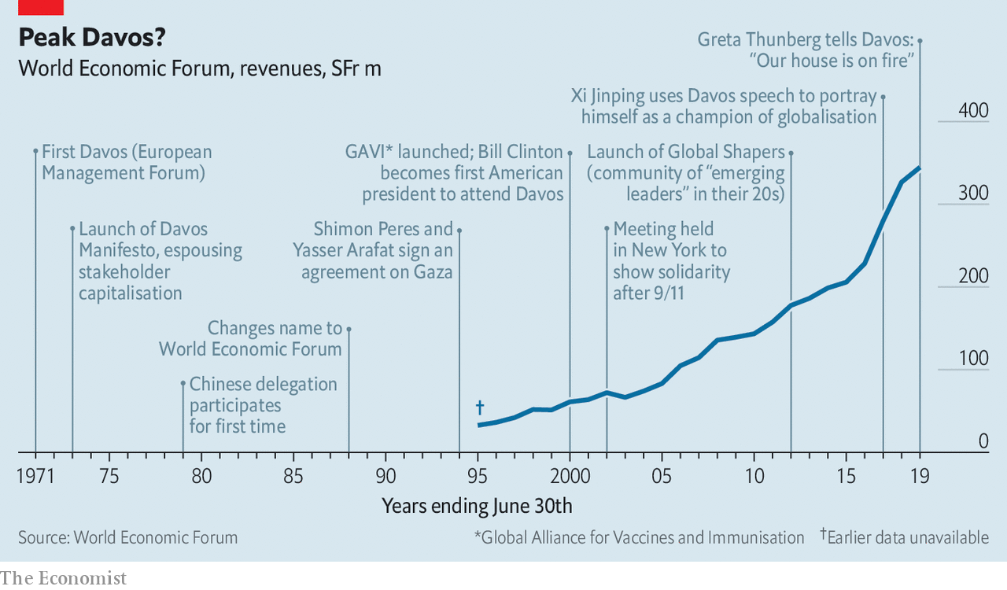

In its early years the WEF held a 50% stake in an events firm that put on Davos. This stake was later sold. At times newspaper reports have questioned mixing potential profit-making with charitable status. An official Swiss examination of the WEF found no impropriety. The WEF and Mr Schwab say he has never received any financial benefit related to the Forum, other than his salary. Since 1995 Davos has been produced by PublicisLive, part of Publicis Groupe. The French giant’s ex-boss (and now supervisory-board chairman), Maurice Lévy, is a former WEF board member. The contract is “the jewel in the crown” of Publicis’s events business, says a former insider. WPP had long coveted the assignment, which covers shaping the programme, building sets, overseeing accommodation and the like. But, says Sir Martin, “we never got near it.” The contract’s value is not disclosed. The former insider says margins have at times passed 30%. Publicis says the contract does not allow net margins to “surpass a very modest threshold”. The current contract ends in 2022, when, the WEF says, it will go out to tender.

## Pay for playground

The money for all this comes largely from annual fees from “members”, paying SFr25,000 a year, and three tiers of “partners”, mostly big companies, starting at SFr120,000. For SFr600,000 apiece the 120 or so top-tier (“strategic”) partners get, among other perks, up to five Davos passes and a better shot at slots on panels.

Cash from firms lets the WEF invite academics, activists and other less monied types to Davos free of charge—but elicits criticisms of punch-pulling. Mark Malloch-Brown, former deputy head of the UN (and, briefly, of the WEF), says it has been hobbled by anxiety not to offend corporate partners: “It sees itself as a catalyst, but in reality it is often more cautious than the UN,” when it comes to policy reform. The WEF says “plenty” of its initiatives challenge short-term corporate interests.

Mr Schwab has taken flak for going soft on politicians, too. When Mr Trump first swept into Davos in 2018, his host praised his “strong” leadership. Given Mr Schwab’s professed concern over climate change, “You would think he might have found a way to call out the guy who trashed the Paris agreement,” says a former WEF executive.

Mr Schwab insists the WEF has found the right balance between being a friend to elites and a firebrand, and has always encouraged “dissident voices”. Ralph Nader, a consumer-rights activist, addressed Davos in 1976. The WEF increased the number of NGO invitees after the first big wave of anti-globalisation protests in the early 2000s.

Another concern is over the WEF’s remit. Keen to be more than a meeting place, it began to launch its own year-round initiatives. It now has around 100 of these. The “fourth industrial revolution”, WEF-speak for digitisation’s impact on society, boasts its own campus in San Francisco. Mr Schwab has long held out hope of winning a Nobel prize for his work on this concept and stakeholder capitalism, to add to his honorary British knighthood, 17 honorary doctorates and a pile of national medals.

Mr Schwab says that most of the initiatives have been successful. Few, though, are regarded as leading-edge. Peter Bakker, president of the World Business Council for Sustainable Development, and former boss of TNT, a logistics group, says the WEF is not where big ideas are cooked up, so much as a venue to “mainstream and amplify” existing ones. One expert calls some of the WEF’s research “ersatz thinking”. The WEF points to its Global Gender Gap Report as an example of groundbreaking research.

A few past collaborators claim that in straining to prove its relevance, the WEF has occasionally hijacked other people’s ventures. One who got a taste of this accuses it of “using its convening power to insinuate itself into the group and take the lead” without the necessary skills. He cites the Water Resources Group (WRG), a project launched in Davos to improve water management in poor places, which, he says, lost oomph after the WEF took charge. Some NGOs now think twice before teaming up with it.

The WEF rejects this characterisation. It says it was invited into the WRG and that a Harvard report in 2017 described it as a case study for public-private collaboration. But a recent strategy shift could be read as an admission that running initiatives is not its forte. From now on the WEF will, says Mr Schwab, focus on “connecting dots” between other people’s projects or act as a broker. Dominic Waughray of the WEF’s Centre for Global Public Goods points to health and environment projects where it has already done this. For one on plastic pollution, the WEF brought Coca-Cola and Nestlé into a state-led initiative promoted by Britain and Canada.

As it nears its half-century, the WEF faces three challenges. The first is competition. It once stood pretty much alone. Now it has to hustle for corporate attention with the likes of TED, the Milken Institute and Bloomberg’s formidable events arm, which puts on the New Economy Forum in China. In time, they could rival Davos’s lustre.

This is especially likely—the second challenge—if the WEF is perceived as a remnant of a bygone era. Mr Schwab points out that it was an early champion of stakeholder capitalism, which is in the ascendant. That may be so. But in many eyes Davos is the apotheosis of global capitalism, which is on the back foot.

Then there is what Mr Schwab’s CEO chums call key-man risk. He is feisty (if lugubrious) and shows no sign of bowing out. But he cannot go on for ever. He once said: “The Forum has been...built around one person, which can be a problem.” Several deputies have been groomed, only to leave or be pushed out. José María Figueres, an ex-president of Costa Rica, quit as WEF’s chief executive in 2004 after failing to disclose consulting fees. Mr Schwab says a “contingency” plan is in place, but offers no details; some continue to speculate that his son Olivier, the WEF’s head of operations, might one day play a bigger role. Keeping corporate and political bosses coming may get harder after the professor hangs up his skis—even if he leaves the world’s mightiest Rolodex behind.■

This article was downloaded by calibre from <https://www.economist.com/business/2020/01/16/can-the-world-economic-forum-keep-its-mojo>

|  |  |  |  |
| --- | --- | --- | --- |
|  | Articles | Sections | Next |

|  |  |  |  |
| --- | --- | --- | --- |
| Previous | Articles | Sections | Next |

#### Bartleby

# The wider effects of America’s opioid epidemic

The drugs don’t work

Jan 16th 2020 |

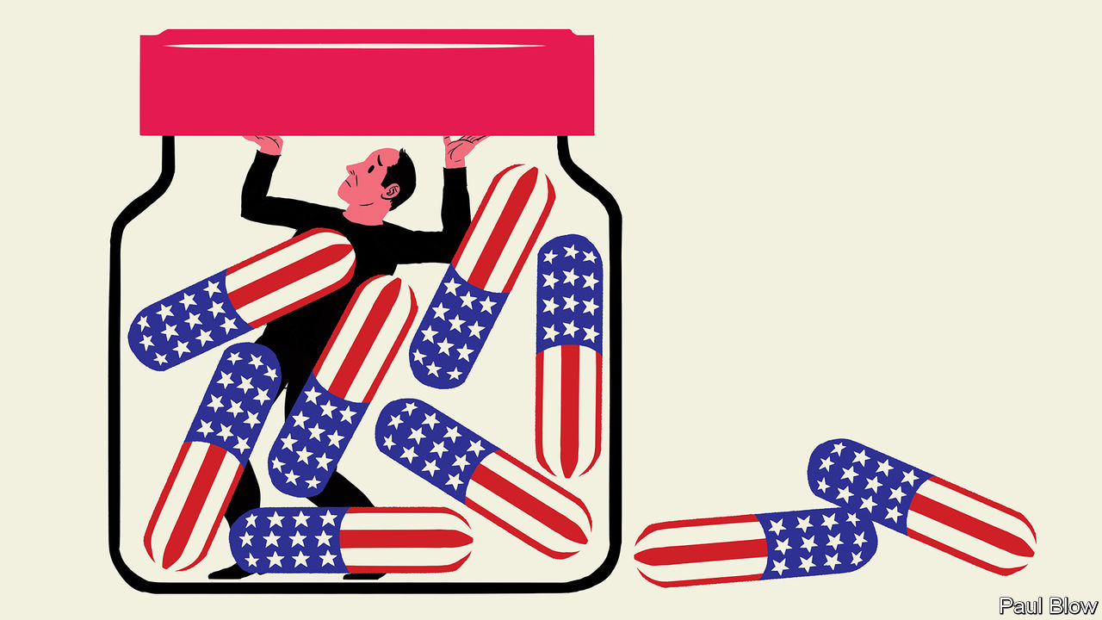

THE IMPACT of the opioid epidemic in America is staggering. Work by Anne Case and Angus Deaton of Princeton University has indicated that overprescription of pain-relieving drugs was a big factor in the increase in mortality among middle-aged whites that has occurred since 2000. The Council of Economic Advisers has estimated that, in 2018, the costs of opioid addiction (including the value of lives lost) were $696bn, or 3.4% of GDP.

Slowly but surely, more details are emerging. In 2017 Alan Krueger, also of Princeton, showed* that labour-force participation had fallen in American counties where more opioid pain medication had been prescribed. Now a new paper** by three academics from the University of North Carolina explores the impact of the epidemic on firms and business investment.

As with Krueger’s research, the focus is on the labour market. The authors examine the change in the rate of opioid prescriptions in individual counties between 2002-06 and 2006-10, and compare it with changes in employment five years later (between 2007-11 and 2011-15).

The delay is an attempt to get round the problem of separating correlation and causation. People who are unemployed may opt for the solace of opioids. But the authors reasonably assume that “opioid prescriptions written by doctors are independent of economic conditions five years later.” Furthermore, some doctors are much more likely to prescribe pain medication than others. Patients of doctors who prescribe more opioids are 5.8% less likely to be employed five years later.

What the academics find is that higher prescription rates are associated not just with a decline in employment but in the sales growth of firms sited in the worst affected areas. Sales are 1.7% lower for firms in the 75th percentile opioid counties than those in the 25th percentile. Businesses struggle, the authors suggest, because they cannot find the right workers. In addition, companies respond to the shortage of workers by investing more in information technology, substituting capital for labour.

Clearly, myriad factors affect growth rates, employment, investment and opioid use. The researchers therefore try to exclude alternative explanations for their findings. They check whether the results are robust by dropping some counties, such as those with the worst economic performance and those associated with “pill mills”—clinics identified by the Drug Enforcement Administration as having excessive prescription rates. To ensure results are not distorted by the types of firm being examined, they test the sample excluding manufacturing companies and firms with high exposure to Chinese imports. The impact of opioids on employment remains the same.

When it comes to employees, the authors include only workers aged between 18 and 60 (to exclude those about to retire) and those who have not previously been prescribed opioids. And they also examine emergency-room prescriptions—visits to the ER involve urgent cases and doctors are randomly assigned, reducing the chance that the results are driven by intentional drug-seeking behaviour. Increases in ER prescriptions are also associated with falls in employment and slower firm growth.

The clear negative impact of opioid abuse has significant implications. First, it shows the difficulties faced by economists when forecasting variables such as labour-force participation rates. Anyone constructing a model in the late 1990s could not reasonably have anticipated the opioid epidemic.

Second, the epidemic presents a strong argument for government intervention. It arose from a market failure: doctors were free to prescribe opioids and patients were free to take them. Neither group seems to have anticipated the addictive effects.

The authorities have reacted, with 25 states passing laws to regulate opioids use, starting with Massachusetts in 2016. Since 2017 the increase in deaths from opioid abuse seems to have halted. The academics also find some evidence of positive share-price gains for companies based in those states that passed regulations. Business doesn’t just need skilled employees; it needs workers who are free from addiction.

* “Where Have All the Workers Gone? An Inquiry into the Decline of the US Labor Force Participation Rate”  
** “The Impact of the Opioid Crisis on Firm Value and Investment”, by Paige Ouimet, Elena Simintzi and Kailei Ye

This article was downloaded by calibre from <https://www.economist.com/business/2020/01/18/the-wider-effects-of-americas-opioid-epidemic>

|  |  |  |  |
| --- | --- | --- | --- |
| Previous | Articles | Sections | Next |

|  |  |  |  |
| --- | --- | --- | --- |
| Previous | Articles | Sections | Next |

#### Cheap shots

# EQRX wants to make high-end medicines less costly

A Boston-based biotech startup thinks it has found a lucrative third way between high-margin branded drugs and high-volume generics

Jan 18th 2020 | BOSTON

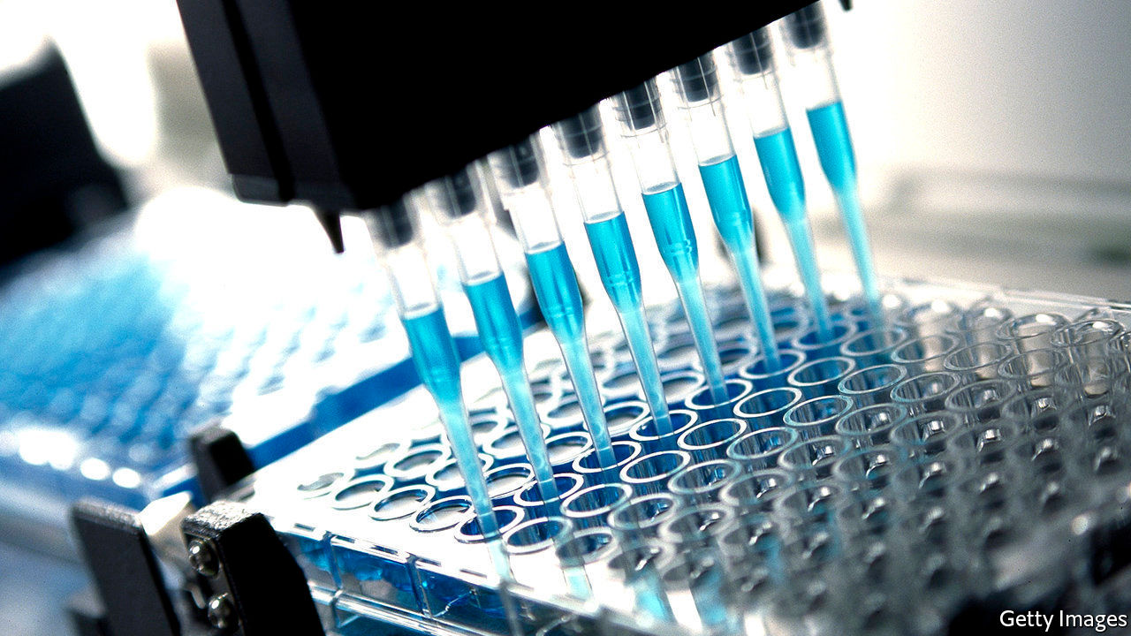

A BIOTECH STARTUP wants to make me-too versions of existing drugs. So far, so familiar. Except that EQRx, a firm based in Boston, aims to launch ten high-end medicines, including for cancer, in ten years—quite a feat by the industry’s sluggish standards. More unusual, it wants to charge a third of the price of rival treatments, maybe less. On January 12th it announced $200m in funding from investors that included Alphabet’s venture arm and Andreessen Horowitz, a famed Silicon Valley finance firm, which gushed that EQRx promised to “reimagine how medicines are created, tested and commercialised”.

The company wants to re-engineer Big Pharma’s business model, as Amazon has done for retail or SpaceX for rocketry. It will ruthlessly outsource where necessary. More ambitiously, it wants to trim the direct costs of drug development down from the ache-inducing industry average of $375m per drug—or, some estimate, closer to $1.4bn if you count the cost of failures. Melanie Nallicheri, EQRx’s president, thinks the firm can cut failure rates from 90% to 40%. To do this, EQRx will use “precision medicine” in drugmaking. Clever software will screen molecules for their healing potential, and tests of promising compounds will be confined to patients whose variant of a disease can be pinpointed using a biological signature.

Historically, clinical trials were not too fussy about the participants they accepted. This has changed as firms try to tailor drugs to those most likely to respond to them. The new approach allows for smaller and cheaper trials, accelerating drug development. Xalkori (crizotinib), a treatment for lung cancer with particular genetic mutations, took only four years to approve.

That did not stop Pfizer, its producer, from charging a lot for it. America’s health-care system, with its layers of intermediaries, is riddled with incentives to keep prices high. Wholesalers earn a mark-up on drugs. Health insurers and employers use pharmacy-benefit managers to negotiate drug prices on their behalf. These intermediaries may obtain a rebate, and then keep some of it. As a result, branded drugs may be only slightly cheaper to the middlemen than alternatives. At the same time, even insured patients can end up having to pay a sizeable chunk of the list price.

Steve Pearson of the Institute for Clinical and Economic Review, which examines how drugs’ prices stack up against their clinical value, says the rebate system in particular has often snuffed out efforts to compete on cost. Slightly cheaper drugs known as biosimilars, popular in Europe, have made limited headway in America. EQRx will need to offer drugs at prices that are too low for the system to ignore.

The deep-pocketed venture capitalists see promise in EQRx’s third way, between expensive branded medicines and cheap generics. If this is to work, EQRx must become pretty big, pretty fast, so that higher volumes offset lower margins. Industry insiders are sceptical; developing drugs is harder than developing software, they note. Even harder, especially if the firm went public, may be resisting shareholders’ calls to charge as much for them as the distorted market will bear.■

This article was downloaded by calibre from <https://www.economist.com/business/2020/01/18/eqrx-wants-to-make-high-end-medicines-less-costly>

|  |  |  |  |
| --- | --- | --- | --- |
| Previous | Articles | Sections | Next |

|  |  |  |  |
| --- | --- | --- | --- |
| Previous | Articles | Sections | Next |

#### Driving nowhere fast

# Aston Martin is stuck in idle

An attempt to emulate Ferrari’s roaring success has not worked as planned

Jan 16th 2020 |

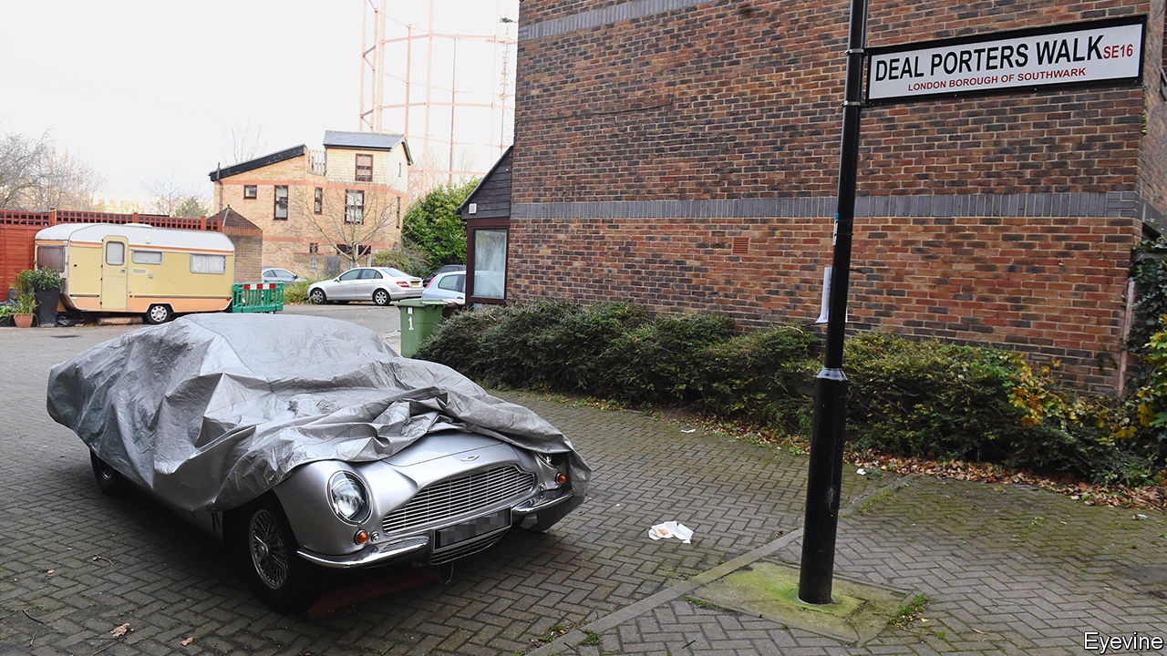

FEW ASTON MARTIN owners dare push their sports cars to the edge of losing grip in a fast corner. The same cannot be said of shareholders in Aston Martin Lagonda (AML), which owns the prestige brand. An ill-judged initial public offering in 2018, predicated on rapid growth, has the company careening.

The IPO was an attempt to emulate the success of Ferrari, which floated in 2015. (The chairman of Exor, which has a significant stake in Ferrari, also sits on the board of The Economist’s parent company.) The Italian supercar-maker enjoys 25% operating margins, closer to what LVMH makes on its Louis Vuitton handbags than what Daimler gets for Mercedes cars. Ferrari’s share price has trebled since going public. AML’s, by contrast, has plunged by three-quarters. Its market value now stands at just £1.1bn ($1.4bn). After turning an operating profit in 2017 and 2018, in November it reported a loss for the first nine months of last year. On January 7th the company issued its second profit warning since July.

AML is selling far fewer cars than it hoped—20% fewer relative to early forecasts for 2019, when around 5,800 actually rolled off the production line. The goal of making 14,000 cars a year by 2023 looks fanciful. Attempts to meet it, by investing in new models, have left AML with net debts of around £900m. Wary bond investors are demanding coupons as high as 15% to refinance £100m about to come due. Aston Martin has pasted its logo on helicopters and blocks of flats. But if Max Warburton of Bernstein, an equity-research firm, is correct in his heretical suggestion that perhaps the brand is not that strong after all, such non-auto ventures may flop.

Aston’s legacy of losing money is as rich as that of making fast and glamorous cars. In its 106 years James Bond’s wheels of choice have endured seven bankruptcies. This time investors bet on AML thanks to a credible leader—Andy Palmer, a shrewd industry executive—and a plausible plan to expand its range of vehicles. It has already launched three new GT cars, suited to long, comfy journeys. Next year it plans to unveil a mid-engined car, the Valhalla, to take on Ferrari, better-known for such machines. And it has taken 1,800 orders for its SUV, the DBX, following in the tyretracks of Bentley, Rolls-Royce and Lamborghini.

Even if all these AML offerings prove wildly successful, they may not bring in enough cash to ensure a succession of new models needed to keep wealthy petrolheads coming back to the brand. Philippe Houchois of Jefferies, a bank, reckons that if AML sells 5,000 of the cars that start at £158,000 at a 15% margin, that would only bring in enough cash to cover £100m in annual interest on its debts. The overall market for sports cars is not growing fast and Evercore ISI, a broker, points out that rivals’ SUVs have eaten into sales of their other cars. AML can expect the same.

Mr Houchois reckons that AML needs £400m-500m to tackle its debts and invest in its future. The firm says it is “reviewing its funding requirements”. Lawrence Stroll, a Canadian billionaire who co-owns a Formula 1 team, is said to be ready to inject £200m into the business. Apparent interest by Geely, a Chinese carmaker that also owns Volvo, Lotus and 10% of Daimler, pushed AML’s shares up this month. But any rescuer, should one come forth, risks looking like an Aston Martin buyer—stuck owning a fast-depreciating trophy asset. ■

This article was downloaded by calibre from <https://www.economist.com/business/2020/01/18/aston-martin-is-stuck-in-idle>

|  |  |  |  |
| --- | --- | --- | --- |
| Previous | Articles | Sections | Next |

|  |  |  |  |
| --- | --- | --- | --- |
| Previous | Articles | Sections | Next |

#### Schumpeter

# Big Oil has a do-or-die decade ahead because of climate change

Blowin’ in the wind

Jan 18th 2020 |

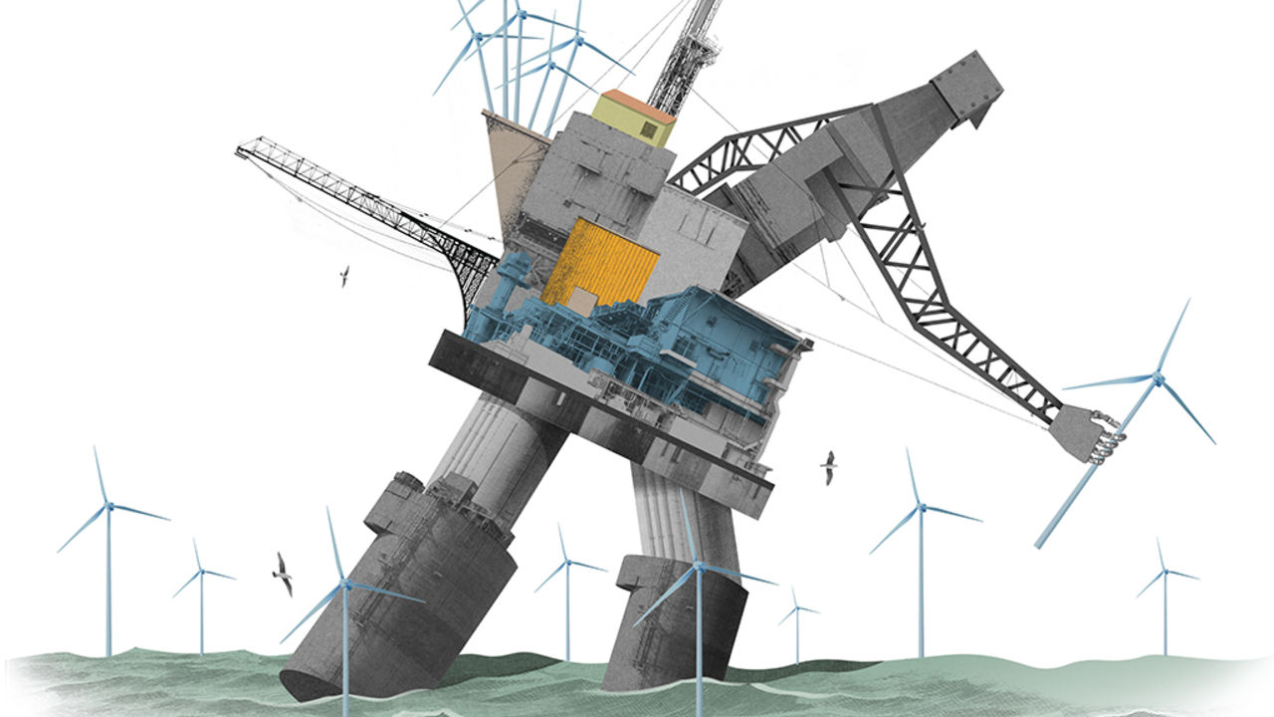

AS REVOLUTIONARY SLOGANS go, it hardly had the resonance of ¡No pasarán! But when Repsol, a Spanish oil company, said in December it would reduce the net carbon footprint of everything it produces to zero within 30 years, it marked the most powerful pledge so far by a big oil firm to cast off some of the vestiges of a fossil past in favour of a windy and sunny future.

Many will scoff. Oil companies are, after all, widely regarded as the villains of the climate crisis. Repsol is a relatively puny producer; its vow may simply be a gambit to woo investors keen on “sustainability”. Yet it deserves a pat on the back. Without the oil industry’s balance-sheets and project-management skills, it is hard to imagine the world building anything like enough wind farms, solar parks and other forms of clean energy to stop catastrophic global warming. The question is no longer “whether” Big Oil has a big role to play in averting the climate crisis. It is “when”.

Ask oil executives about timing, though, and most hum and haw. They face a dilemma. Though the world needs them to throw their weight behind clean energy, their oil-and-gas businesses have traditionally generated higher returns. Yet forecasting returns is complex—and becoming more so. As well as project risk, it involves assessing the attitude of investors, governments and consumers towards climate uncertainties. To cynics, all the climate-friendly noises amount to little in practice, since few people are ready to make carbon-cutting sacrifices that would force oil firms’ hand. But noises are sometimes followed by action. Should they be this time, the 2020s may be do-or-die for the oil industry.

In energy, a lot can happen in ten years. The 2010s saw oil markets transformed by American shale. In Europe renewable energy prompted something almost as wrenching for a different sort of energy firm—utilities. Faced with an existential threat from wind and solar, fossil-fuel power producers such as Germany’s E.ON and RWE tore themselves apart, redesigned their businesses, and emerged cleaner and stronger. Southern European firms like Spain’s Iberdrola and Italy’s Enel took renewables worldwide. Last year total shareholder returns from the reinvigorated European utilities left the oil-and-gas industry in the dust.

Big Oil looks like the European utilities of a decade ago: potentially in for a seismic shock, and in denial. Some giants, like ExxonMobil and Chevron in America, continue to bet most heavily on oil, believing demand for petrol will remain strong for the foreseeable future. Others, among them Europe’s supermajors, Royal Dutch Shell, Total and BP, increasingly favour natural gas, and see low-carbon (though not necessarily zero-carbon) power generation as a way to prop up their business model as more cars and other things begin to run on electricity.

A few dabble in renewable energy, especially in Europe. But of a whopping $80bn or so of capital expenditure by Europe’s seven biggest listed energy firms last year, only 7.4%—less than $1bn each on average—went to clean energy. In order to meet the goals of the Paris agreement to keep global warming below 2°C, the ratio of dirty energy to the clean sort will need to be turned upside down. On January 14th UBS, a bank, calculated that capital spending on renewable energy, power grids and batteries will need to rise globally to $1.2trn a year on average from now until 2050, more than double the $500bn spent each year on oil and gas. To help fund that, it reckons that oil-and-gas companies will need to divert $10trn of investments away from fossil fuels over the same period.

That sounds unthinkable. For now, oil executives show no appetite for such a radical change of direction. If anything, they are working their oil-and-gas assets harder, to skim the profits and hand them to shareholders while they still can. Oil, they say, generates double-digit returns on capital employed. Clean energy, mere single digits.

They may be overstating the case. First, as the Boston Consulting Group points out, no big industry performed worse for shareholders in the second half of the 2010s than oil and gas. Second, the Oxford Institute for Energy Studies (OIES), a think-tank, says climate-concerned investors are already pushing up oil companies’ cost of capital for long-term projects, crimping returns. Third, with their vast balance-sheets, and skill in building and managing complex endeavours over decades, they could dramatically scale up offshore wind and similar businesses, bolstering profitability.

Furthermore, Big Oil has ways to make other high-risk, high-reward bets on clean energy. One is through venture capital. The OIES calculates that of 200 recent investments by the oil majors, 70 have been in clean-energy ventures, such as electric-vehicle charging networks. They have generally been small for now. But BP reportedly plans to build five $1bn-plus “unicorns” over the next five years with an aim of providing more energy with lower emissions. Another way is to back research and development in potentially groundbreaking technologies such as high-altitude wind energy, whose generating efficiency promises equally lofty profits.

## BlackRock and the black stuff

Even as the majors diversify, supplying oil and gas will be the bedrock of their business for decades. Larry Fink, boss of BlackRock, the world’s largest asset manager, acknowledged this in a letter to global chief executives on January 14th, even as he predicted that climate change would cause a significant shift in capital toward sustainable investing (see article).

Yet excuses for prevarication are growing thinner. As Peter Parry of Bain, a consultancy, puts it, it has become “something of a myth” that oil is a high-return industry. As national climate commitments grow more stringent, governments may go on the warpath. UBS argues that it may be necessary for governments to “ban” the $10trn of oil-and-gas investments to reach net zero emissions by 2050. It is not only Repsol that feels which way the breeze is blowing. It need not be an ill wind. ■

This article was downloaded by calibre from <https://www.economist.com/business/2020/01/18/big-oil-has-a-do-or-die-decade-ahead-because-of-climate-change>

|  |  |  |  |
| --- | --- | --- | --- |
| Previous | Articles | Sections | Next |

|  |  |  |
| --- | --- | --- |
| Business | Sections | Science and ... |

Finance and economics

Emerging markets: Not just a first-world problem

.

Buttonwood: The semaphore of semis

.

Oil prices: Crude calculus

.

Sustainable investing: Green giant

.

US-China trade: Between the lines

.

Free exchange: Prometheus undirected

.

|  |  |  |
| --- | --- | --- |
| Business | Sections | Science and ... |

|  |  |  |  |
| --- | --- | --- | --- |
|  | Articles | Sections | Next |

#### Not just a first-world problem

# Emerging economies are experiencing a prolonged productivity slowdown

They seem doomed to lag behind rich countries for longer than had been hoped

Jan 16th 2020 | HONG KONG

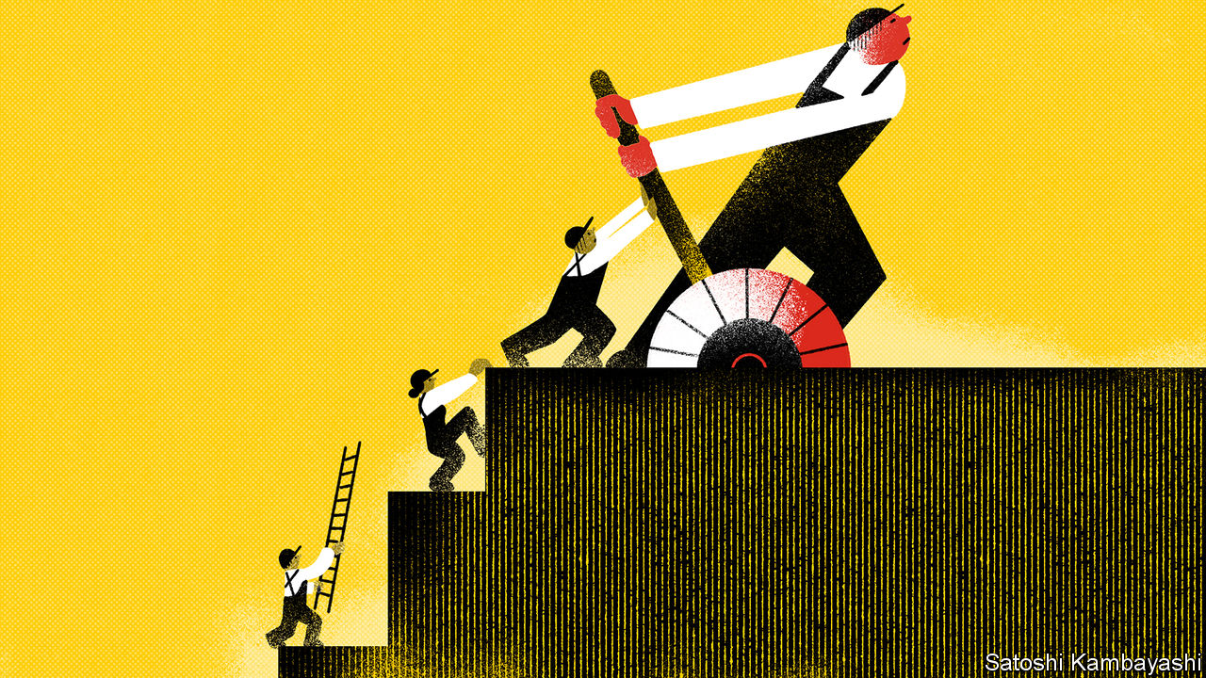

HOW DO MODERN innovations stack up with those of the past? Some economists, such as Robert Gordon of Northwestern University, argue that driverless cars, 3D printers and so on pale into insignificance compared with the fruits of previous industrial revolutions, such as mass production (see Free exchange). That, they think, explains a prolonged productivity slowdown in America and other rich economies that the financial crisis deepened.

But what about everywhere else? Developing countries are, by definition, some distance from the technological frontier. One consolation of their position is the vast backlog of past innovations that remain for them to exploit more fully. Their growth depends more on imitation than innovation. A country where most people still ride scooters does not have to worry if the next Tesla fails to arrive on schedule.

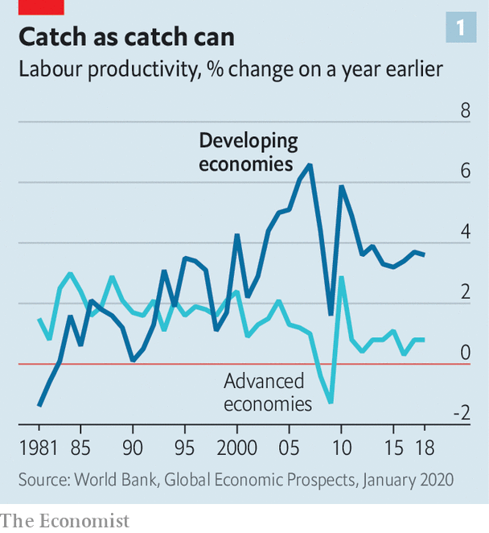

And yet they too have suffered a productivity let-down. According to a new World Bank report, the slowdown is the “steepest, longest and broadest yet”, based on data going back four decades (see chart 1). The GDP per worker of developing economies is almost 14% lower than it would have been had productivity not lost momentum.

The Institute of International Finance, a think-tank, believes that emerging markets now suffer from a variant of the “secular stagnation” that haunts the rich world. Oxford Economics, a consultancy, argues that emerging markets have lost both volatility and vigour, consigning them to “grating stability”. Capital Economics, another consultancy, predicts that in the coming decade, “the widespread emerging-market catch-up growth of the past two decades will come to an end”. In most of the emerging markets it tracks, GDP per person grew less quickly last year than in America. Imitation is supposed to be easier than innovation. But even as leading economies are finding it harder to break a path, many of their followers have lost their way entirely.

How did this happen? When they look at the rich world, some economists worry that big firms have it too easy. Without stiff competition, they have little incentive to innovate or invest. But when they look at the poor world, some worry that big firms now have it too hard. In a survey of over 15,000 companies, the World Bank shows that large firms in poor countries tend to be more productive and more likely to export than their smaller rivals. In the past, these firms have been important conduits for improved know-how and technologies acquired from partners and rivals abroad and passed on to suppliers and imitators at home. But the “routes to technology transfer are narrowing”, the bank points out, thanks to rising protectionism and the halt in the expansion of global value chains.

A lack of technology transfer is only part of the problem, however. Half of the slowdown in labour-productivity growth in recent years reflects not a failure to imitate but a failure to accumulate: weak investment has left labour with too little capital to work with. This shortfall in investment explains all the productivity slowdown in South Asia, the Middle East and north Africa, and two-thirds of that in Europe and Central Asia. That is a serious problem, but also a reassuringly conventional one. Insofar as low capital spending stems from a lack of credit or confidence, it is easy enough to imagine a reversal once financial wounds heal and animal spirits revive.

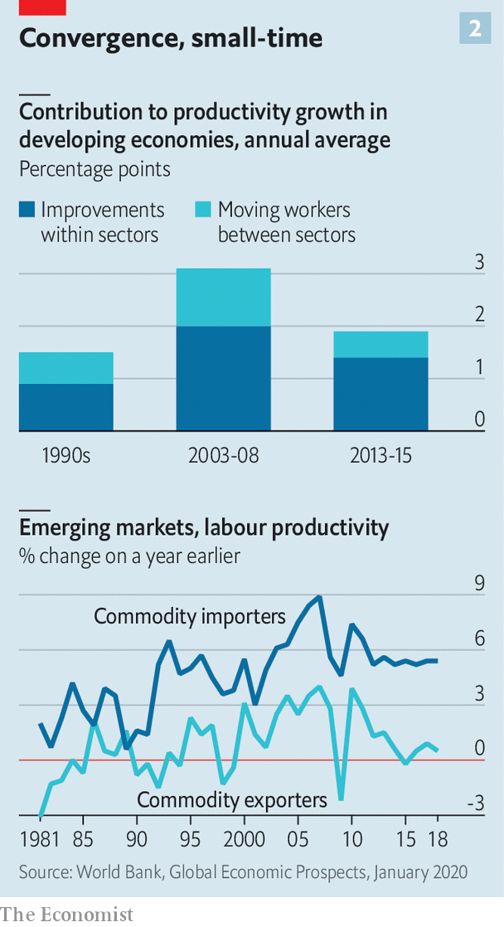

Reluctance to mobilise capital has been matched by labour’s sluggishness in moving. In any country, some parts of the economy (such as manufacturing) are more productive than others (such as agriculture). But this gap is unusually large in developing countries, where the modern and the medieval often coexist. In principle, therefore, emerging economies have much to gain from moving workers between sectors, even if productivity within each sector does not improve. In the typical developing country, this movement contributed about 1.1 percentage points to growth in the years before the global financial crisis. That contribution has dropped to just 0.5 points in more recent years (see chart 2). In Latin America and the Middle East, the contribution was negative: workers moved the wrong way, to where they were less productive.

Perhaps the simplest explanation for the productivity bust lies in the boom that preceded it. For five extraordinary years, punctuated by the global financial crisis, China enjoyed exceptional growth that pulled commodity-exporters behind it. That very success left the Asian giant with less room for further catch-up growth, contributing to its inevitable slowdown. Its growth has also become more self-contained and less commodity-intensive.

The changing pace and pattern of China’s growth proved a disaster for the many developing economies that export commodities, especially in Latin America and the Middle East. Their productivity growth has collapsed. But in other developing economies, claims of secular stagnation and the end of catch-up growth seem exaggerated. Their productivity growth is close to its 25-year average and still comfortably above that of the rich world. It is slow only in comparison with a handful of years before and after the global financial crisis.

In a World Bank publication 25 years ago Lant Pritchett, now at Oxford University, emphasised that catch-up growth was historically quite rare. Yes, imitation should be easier than innovation (and returns to investment should be high where capital is scarce). But other factors often got in the way. After all, if poor countries reliably grew faster than rich ones, there would not be so many poor countries still around. The “dominant feature” of modern economic history was not convergence between rich and poor countries, wrote Mr Pritchett, but “divergence, big time”.

The past decade, for all its disappointments, has bucked that historical trend, if less impressively than the decade before it. For emerging economies, the 2010s were a let-down. But they were still the second-best decade of the past 50 years.■

This article was downloaded by calibre from <https://www.economist.com/finance-and-economics/2020/01/18/emerging-economies-are-experiencing-a-prolonged-productivity-slowdown>

|  |  |  |  |
| --- | --- | --- | --- |
|  | Articles | Sections | Next |

|  |  |  |  |
| --- | --- | --- | --- |
| Previous | Articles | Sections | Next |

#### Buttonwood

# What the semiconductor industry tells us about the world economy

Blessed are the chipmakers

Jan 16th 2020 |

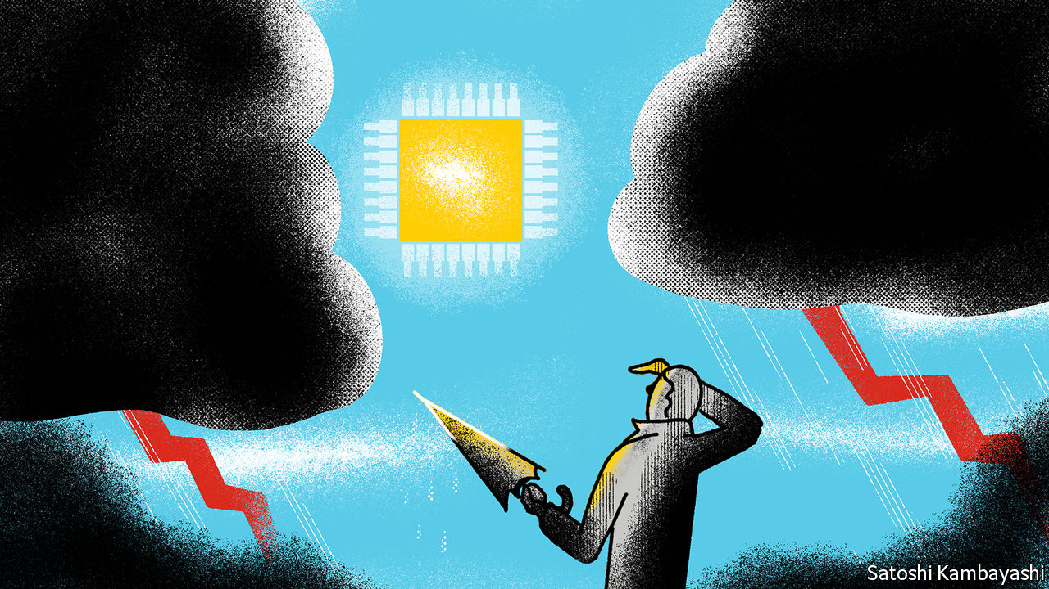

THE SETTING for Robert Harris’s thriller, “Enigma”, is wartime Britain, where everything is rationed except for the rain. It follows Tom Jericho, a young prodigy stationed at Bletchley Park, the real-life centre of code-breaking operations, who is part of a team of cryptologists trying to break the code used by Germany’s armed forces. The work has frustration built in. Any progress can be undone if the enemy changes the code—which he will if he suspects that it has been cracked.

The novel comes to mind when considering the mysteries of shifts in the economic cycle and market reactions. The mood has clearly changed for the better since the middle of last year. Fears of recession have receded. Global equity prices have rallied. Bond yields have perked up. A truce in the trade war, however fragile, has helped. But the improvement in mood coincided with signs of life in Asia’s manufacturing hubs.

The key to these coded messages is the semiconductor industry. Cars, smartphones, gadgets and cloud-computing servers rely on components, notably memory chips, that are disproportionately made in emerging Asia. The mood-sensitive parts of aggregate demand—capital spending by firms and non-essential purchases by consumers—have microchips in there somewhere. The chip industry itself has savage mini-cycles. When it turns down, it is a sign of trouble ahead in the world economy. When it perks up, as it has done recently, there is reason to be more optimistic.

The cost structure of the chip business is central to this enigma. A semiconductor fabrication plant, or fab, costs billions of dollars to build. A sudden jump in orders, such as occurred in 2017, is met with increased capacity. But when demand falls, the fabs just keep producing. They are highly automated with few staff, so running costs are low. Continuous output makes sense but leads to occasional gluts and sagging prices, as happened through most of last year. Stocks become bloated. When demand picks up again, as it did late last year, stocks are drawn down and prices begin to stabilise.

Until quite recently the industry’s rhythms, and the tautness or slackness of Asia’s supply chains in general, were dictated by the two- or three-year life-cycle of smartphones. Export orders for Taiwanese electronics, for instance, tended to spike whenever a new Apple or Galaxy handset was launched. But the smartphone market is now saturated. Consumers find that an old model works almost as well as a newer one—and this might still be the case even when the new 5G generation of phones reaches the market. What drives growth in demand now is cloud computing, electrification of cars, wearable gadgetry and gaming, says Shawn Kim of Morgan Stanley. The cloud is a particular force. As firms ramp up capital spending of all kinds, that in turn spurs investment in cloud capacity, where business-related software lives.

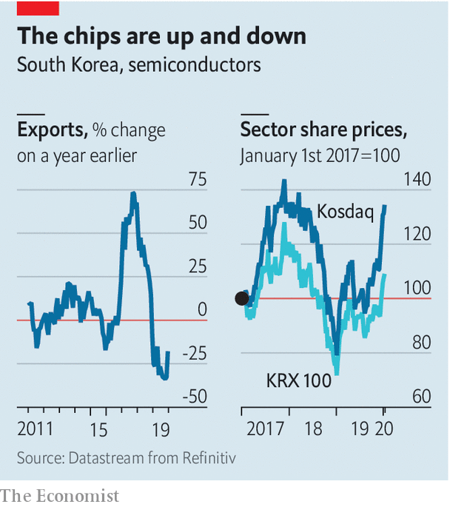

What signals should market cryptologists be looking at? One measure is exports of semiconductors from South Korea, says Alicia Garcia-Herrero, chief economist for Asia at Natixis, an investment bank, who is based in Hong Kong. South Korea is pivotal to Asia’s supply chain, she says, and its shipments of semiconductors help predict exports in the region more generally. After a brutal 2019 the trend has bottomed out and is turning (see chart). Another signal is the financial health of big Asian chip companies, such as Samsung and SK Hynix. Those averse to digging deep into financial statements could simply monitor industry share prices. Or they could look for inflection points in the price of DRAM, a type of memory chip used to store data on servers and computers.

Technology’s share of global GDP will continue to grow. In principle, then, these signals will become even more closely watched. But other forces are at work. China has designs to be self-sufficient in electronic components, a goal made more urgent by the trade-tech wars. The short-term effect is to give a boost to Asia’s tech industry. But in the longer term, firms might find themselves displaced by Chinese rivals, at least in China’s own market.

To the extent that China succeeds, it will devalue the signals that arrive from the more open parts of emerging Asia. Market-watchers will come to feel the same frustration felt by Mr Harris’s fictional codebreakers at Bletchley. The codes keep changing. For now, though, the message from Asia is that the sun is peeking through the clouds—or, at least, that it has stopped raining.

This article was downloaded by calibre from <https://www.economist.com/finance-and-economics/2020/01/18/what-the-semiconductor-industry-tells-us-about-the-world-economy>

|  |  |  |  |
| --- | --- | --- | --- |
| Previous | Articles | Sections | Next |

|  |  |  |  |
| --- | --- | --- | --- |
| Previous | Articles | Sections | Next |

#### Crude calculus

# Oil markets shrug off tension in the Middle East

After a brief jump to over $70 a barrel, the price of Brent crude has subsided again

Jan 16th 2020 | ABU DHABI

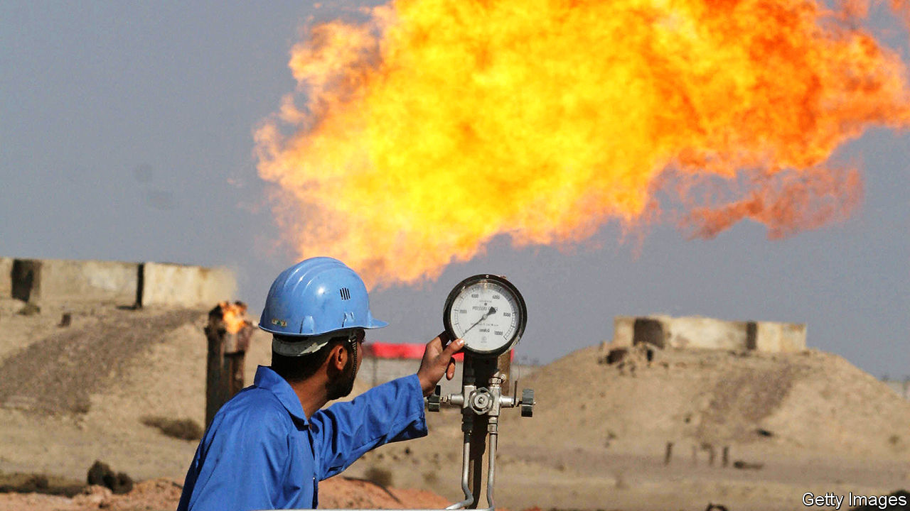

IT HAS BEEN a busy start to the year for the oil industry in the Middle East. The chief executives of Saudi Aramco, ExxonMobil and Total were among those who gathered on January 13th in Dhahran, in Saudi Arabia, for the International Petroleum Technology Conference. On January 11th Abu Dhabi, in the United Arab Emirates, welcomed energy ministers and executives for its Sustainability Week. They had plenty to talk about: a few days earlier, the region had looked close to war.

America killed Qassem Suleimani, one of Iran’s top commanders, in Iraq on January 3rd. Iran bombed an American base in Iraq in retaliation on January 8th. That strike killed no Americans and the threat of war has receded for now, but further conflict seems likely. Oil markets, however, are unbothered. After a brief jump to over $70 a barrel, the price of Brent crude subsided to $64 on January 13th, lower than before Suleimani’s death. On January 14th oil traders were preoccupied not by fears of violence, but by crude inventories and news of a trade deal between China and America.

Oil producers in the Middle East are adjusting to a new normal. Geopolitics threatens to disrupt crude production, but the broader oil market is unconcerned. The threat to oil infrastructure is real. Iran and its proxies may continue to attack pipelines, tankers and processing facilities, as they did last year. “We have squeezed Iran with these sanctions and they have no way out,” says a former senior American military official, who expects further violence. Iraq, which has become the second-largest producer in the Organisation of the Petroleum Exporting Countries (OPEC), might also see a sudden drop in output. President Donald Trump has threatened sanctions if Iraqi lawmakers make good on their vote this month to push out American forces.

Meanwhile America’s role in protecting the region’s oil infrastructure looks uncertain. “We are independent, and we do not need Middle East oil,” Mr Trump declared on January 8th. That is not strictly true. In October America imported 741,000 barrels a day of crude oil and petroleum products from Gulf producers. Because oil is a globally traded commodity, its price at a pump in Rhode Island is still linked to policy in Riyadh. Even so, America is far less dependent on imports than it used to be, with monthly imports falling by about 40% from a peak in 2006. Last September America exported more oil than it imported. And Mr Trump does not seem particularly interested in going to war over oil.

In September, after strikes blamed on Iran knocked out more than half of Saudi Arabia’s output, America sent more troops to the region but declined to stage a counter-attack. The Suleimani strike, after the killing of an Iraqi-American blamed on Iranian proxies, made clear that Mr Trump would respond to the deaths of Americans. The same is not true for an attack on oil infrastructure. Mr Trump has suggested that America’s allies in NATO should do more to protect oil interests in the region. Forty years ago Jimmy Carter laid out what would become known as the Carter Doctrine: America would act to protect its energy interests abroad. In 2020 Mr Trump seems disinclined to hold that line.

Oil markets are staying calm partly because buyers and sellers seem to be discounting the possibility that Iran will close the Strait of Hormuz, through which around 20% of the world’s oil passes. They are also reassured by Saudi Arabia’s speedy recovery from September’s attacks. The next month Saudi Aramco showed off a vast command centre within its headquarters to The Economist, emphasising its capacity to respond nimbly to any problems. Saudi Arabia has invested in new security measures, too. New supplies from America, Brazil, Guyana and Norway have also helped contain the price of crude. This year geopolitical risk may make oil operations in the Middle East harder, without making oil much more expensive. ■

This article was downloaded by calibre from <https://www.economist.com/finance-and-economics/2020/01/18/oil-markets-shrug-off-tension-in-the-middle-east>

|  |  |  |  |
| --- | --- | --- | --- |
| Previous | Articles | Sections | Next |

|  |  |  |  |
| --- | --- | --- | --- |
| Previous | Articles | Sections | Next |

#### Green giant

# BlackRock says it wants to do more for the climate

The proof will be in its investment and shareholder-voting strategies

Jan 16th 2020 |

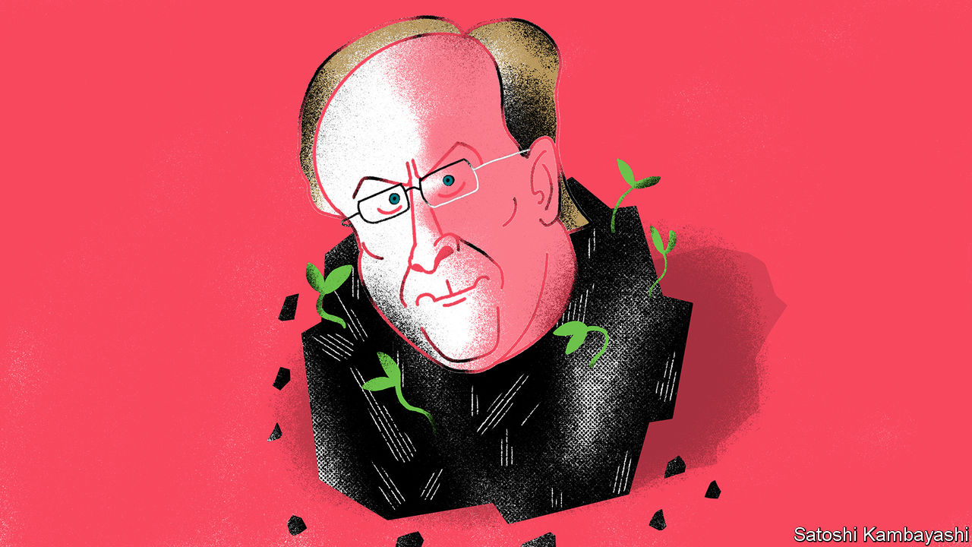

“I BELIEVE WE are on the edge of a fundamental reshaping of finance,” wrote Larry Fink, the boss of BlackRock, the planet’s biggest fund manager, in an open letter on January 14th. His annual missives, addressed to clients and the bosses of companies in which BlackRock invests, are widely read. This year’s, which argues that climate change is a big investment risk that could cause market havoc sooner than most expect, was no exception.

The letter also said what BlackRock, which has $7.43trn in assets under management, plans to do. First, it will demand greater disclosure from all firms on their carbon emissions and climate risks. Because BlackRock has huge clout, this will make a difference. Second, it will double its offering of sustainable funds to 150. The aim is that BlackRock’s sustainable assets will rise from $90bn to $1trn within a decade. Finally, it has pledged to change how it runs its actively managed portfolios, which account for 27% of its total assets. It will dispose of public securities issued by any firm that makes over a quarter of its revenue from thermal coal—the type used to generate electricity.

The direct impact will be limited: the pledged coal divestments, for example, are less than 0.1% of BlackRock’s assets. The indirect impacts may be larger, as firms are prodded to improve disclosure and the share of assets run under green mandates rises. Part of Mr Fink’s motivation is self-interest. Climate change is the biggest concern of BlackRock’s clients, he says. Even as a price war in passive fund management rages, demand for green investment funds is soaring. And BlackRock will integrate climate analysis into Aladdin, a risk-management system that it sells to many other financial firms.

Mr Fink’s professions of greenery did not come out of the blue. In 2018 his letter, entitled “A sense of purpose”, said that firms should do more than create shareholder value. But they imply big changes for BlackRock. In 2019 it opposed 93% of shareholder resolutions in America urging companies to become greener, compared with an industry average of 56%, according to Morningstar, a research firm. It only recently joined Climate Action 100+, a coalition of asset managers that presses big polluters to clean up.

So is the letter so much greenwash? A good test is whether BlackRock’s active and passive funds vote against the expansion plans of fossil-fuel firms they invest in. These imply big increases in carbon emissions, says Mark Campanale of Carbon Tracker, a think-tank. Over to you, Larry. ■

This article was downloaded by calibre from <https://www.economist.com/finance-and-economics/2020/01/16/blackrock-says-it-wants-to-do-more-for-the-climate>

|  |  |  |  |
| --- | --- | --- | --- |
| Previous | Articles | Sections | Next |

|  |  |  |  |
| --- | --- | --- | --- |
| Previous | Articles | Sections | Next |

#### Between the lines

# America and China sign a trade deal

But it will be an uneasy truce

Jan 16th 2020 | SHANGHAI AND WASHINGTON, DC

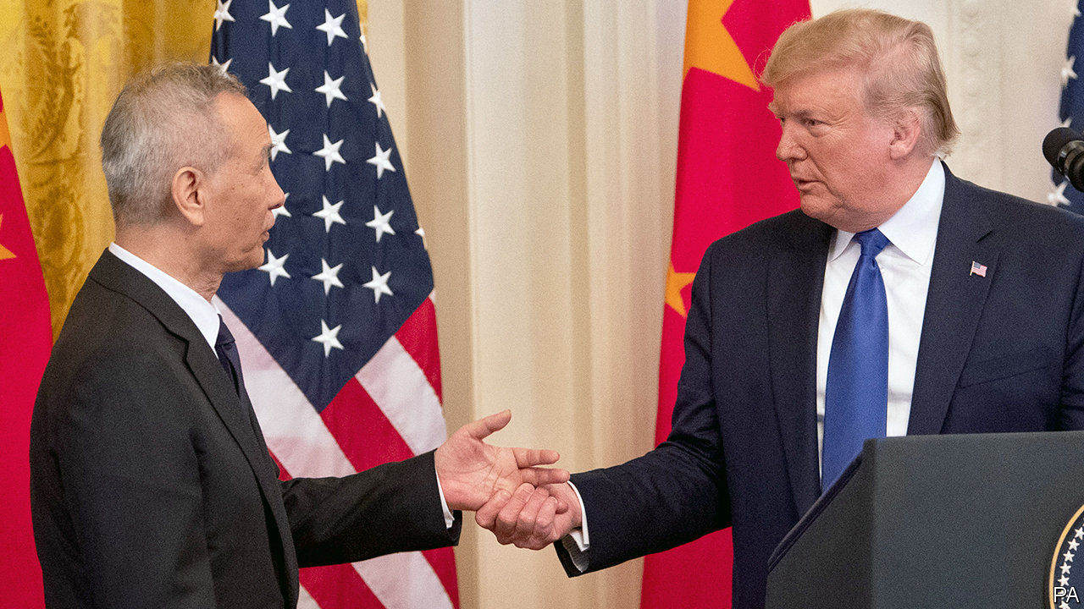

WITH HIS habit of announcing trade deals only for them to dissolve within weeks, President Donald Trump is a standing reminder that talk is cheap. But on January 15th he signed a phase one trade agreement with China alongside Liu He, the Chinese vice-premier, and published its contents for the world to see. The 86 pages set out the terms of a new economic relationship between these two giants. Alongside some welcome measures, there are some howlers—and glaring omissions.

Throughout the whole, however, runs a common pattern. Clauses that are in reality concessions wrung from the Chinese are often written in such a way that they formally apply to both sides—but with subclauses specifying the actions that the Chinese are to take. For example, pledges to protect trade secrets are accompanied by new processes by which American companies can complain about breaches.

The deal also addresses several long-standing American complaints about China’s foot-dragging. China pledged that approvals of agricultural biotechnology products will take less than two years. The deal sets deadlines for China to consider licence applications by MasterCard and Visa. And China will lower bureaucratic barriers to imports of American dairy, pork and beef.

As many a weary trade negotiator can attest, China has a history of reneging on promises. But this deal comes with a novel dispute-settlement mechanism. After a speedy consultation, either party may find fault with the other. (History suggests that the Americans are more likely to feel aggrieved.) If a solution cannot be reached, the accuser can unilaterally impose penalties. The accused cannot retaliate, short of pulling out of the deal altogether.

It is possible that this mechanism will force China to address American grievances. But it may also cause new problems. It hands huge discretion to Robert Lighthizer, the United States Trade Representative (USTR). Take China’s ever-contentious yuan regime. On January 13th, in a sign of thawing relations, the American Treasury removed China from its list of currency manipulators. But if at some point China is put back on the list, the USTR would now seem to have virtually unchecked power to slap tariffs on it.

Further problems may be caused by China’s pledge to buy an extra $200bn of American goods and services over the next two years, on top of a baseline of $187bn in purchases in 2017. That is intended to satisfy Mr Trump’s main desire: to close America’s trade deficit with China. But making it happen will probably require China’s government to direct Chinese companies to buy lots of American goods. Both countries will become more reliant on each other, which neither wants. And their other trading partners might be squeezed out.

The Americans do not seem overly concerned. Mr Lighthizer is keen to move on to implementation, saying that, as the first deal of its kind, “we have to make sure that it works”. The coming months will demonstrate whether the two countries can establish a friendlier dialogue, and whether their relationship can survive America’s more aggressive use of security-related export and investment restrictions.

The deal is far from a reset. As Mr Lighthizer noted, China’s cyber-intrusions and industrial subsidies still rankle with America. Chinese media, meanwhile, laid out an argument that may become more familiar: if American export restrictions prevent China from fulfilling its purchase commitments, the fault will lie with America.

A truly grand pact between the two countries is some way off—and indeed, may never arrive. But this modest trade agreement shows how much the status quo has changed. Tariffs on hundreds of billions of dollars’ worth of imports into both countries remain in place, with an ever-present threat of more. This is not trade peace, but rather a trade truce—and a tense one at that. ■

This article was downloaded by calibre from <https://www.economist.com/finance-and-economics/2020/01/16/america-and-china-sign-a-trade-deal>

|  |  |  |  |
| --- | --- | --- | --- |
| Previous | Articles | Sections | Next |

|  |  |  |  |
| --- | --- | --- | --- |
| Previous | Articles | Sections | Next |

#### Free exchange

# Economists explore the consequences of steering technological progress

Global warming and AI raise questions about how to manage innovation

Jan 16th 2020 |

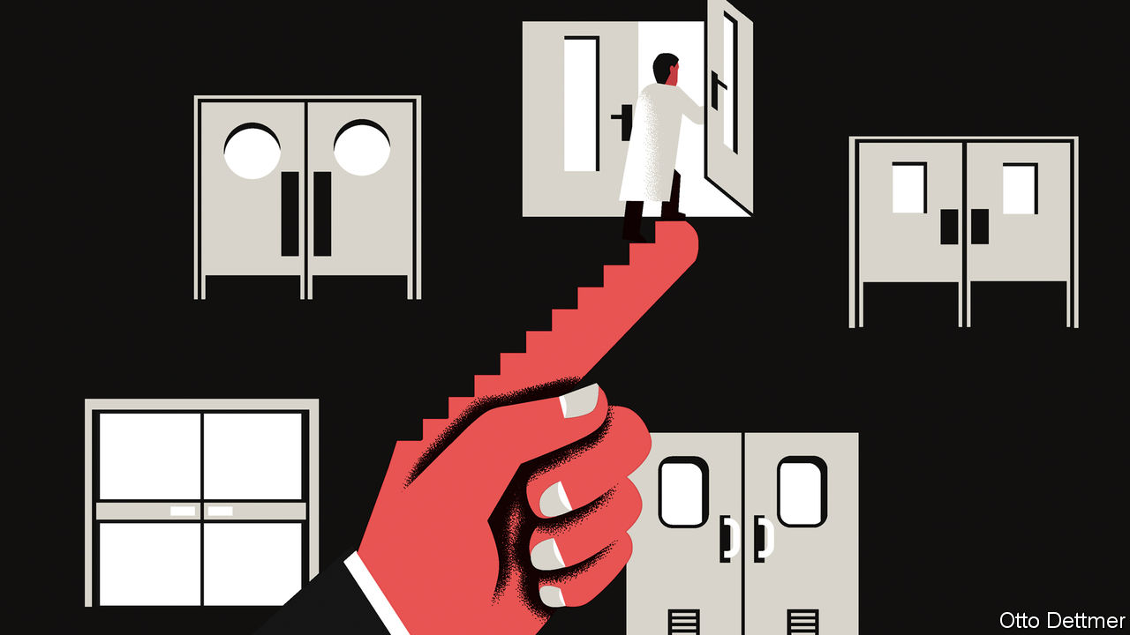

SINCE THE ancient Greeks, at least, people have recognised that civilisational progress tends to create havoc as well as opportunity. Economists have had little time for such concerns. To them, technological progress is the wellspring of long-run growth, and the only interesting question is how best to coax more innovation out of the system. But in the face of looming social challenges, from climate change to inequality, some are now asking whether, when it comes to innovation, what sort is as relevant as how much.

Early models of growth did not explain technological progress at all, treating it rather like manna from heaven. In the 1980s some economists worked to build endogenous-growth models that said where innovation came from. They explained it as the consequence of investment in research and development, increases in the stock of human capital, or the (temporary) extra profits that can be reaped by firms with new technologies. Other economists have focused more on data than on theory. “Who Becomes an Inventor in America? The Importance of Exposure to Innovation”, a paper published in 2018 in the Quarterly Journal of Economics, identifies factors that seem to encourage young people to become innovators. Children who grow up where innovation rates are high, for instance, are more likely to become inventors themselves.

Research has also made clear, however, that technological discovery is not linear, but veers about depending on economic conditions. Some economic historians reckon that early industrialisation was motivated by a desire to replace scarce resources, such as skilled labour, with abundant ones, such as unskilled labour and coal. Early inventors were not simply discovering nature’s truths one by one, in other words, but trying to solve specific problems. Work on such technological bias blossomed in the 1990s as economists sought to explain why the wage premium earned by college graduates kept rising even as the supply of graduates increased. The answer, some reckoned, was that technological change in the 20th century was “skill-biased”, boosting the productivity of workers with degrees, but not of others.

In a paper published in 2001, Daron Acemoglu of the Massachusetts Institute of Technology collected these strands in a model of “directed technical change”. Technological progress, he suggested, is influenced by the relative scarcity of factors such as labour and capital; by how easily one factor can be substituted for another; and by the path of past innovation. Research on a particular technology may reduce the cost of developing complementary innovations in future. Directed technical change is fascinating to contemplate because it allows for alternative technological futures: worlds in which firms wring every efficiency from Zeppelins and pneumatic tubes, rather than from internal-combustion engines and Twitter. If the direction of progress is not set in stone, policy choices could lead an economy down one technological path rather than another. That raises an immediate question: if innovation can be steered, should it be, and if so, how?

Since 2000, published work on directed technical change has focused largely on environmental challenges. Path dependence means that research on fossil-fuel technologies can often be more fertile than research on cleaner alternatives. There are more experts in the relevant disciplines, better-funded research labs and an established complementary economic infrastructure. Efficient decarbonisation might thus require subsidies for clean-energy research, as well as a carbon price. Indeed, efforts to slow global warming represent a massive attempt to realise one technological future—a zero-carbon version—rather than another.

Why stop there? Some futurists, and a few economists, worry that rapid progress in artificial intelligence could lead to mass displacement of labour and social crisis. But in a recent paper Anton Korinek of the University of Virginia notes that not all uses of AI are alike. Clever machines could indeed replace human workers—or might instead be engineered to assist human labour: to help people navigate complicated processes or take difficult decisions. Private firms, focused on their bottom lines rather than the potential knock-on effects of their investment decisions, might be indifferent between the two approaches in the absence of a government nudge, just as polluting firms tend not to worry about the social costs of environmental harm unless made to do so by governments. In a working paper co-written with Joseph Stiglitz, a Nobel laureate in economics, Mr Korinek concludes that directing technical change to favour labour-assisting rather than labour-displacing forms of AI could be a second-best way to manage progress, if governments cannot sufficiently redistribute the gains from automation from winners to losers. This may sound far-fetched, but policy proposals such as Bill Gates’s suggestion that robots should be taxed to slow the pace of automation represent steps toward a more micromanaged technological future.

## Oh, the humanity

Environmental policies aside, such steps seem premature. A more sophisticated view of technological progress is to be welcomed. But economics lacks the tools, at least for now, to judge which technological path is preferable. The world is too complex to allow economists to compare hypothetical technological futures: to know whether a Zeppelin-based society would operate more efficiently overall than a car-based one. Economists cannot know what surprises lie down one innovation path rather than another.

And questions of technology are not solely, or even mostly, about efficiency. Many are ethical. Innovations with overwhelming productivity advantages could prove devastating to social trust or equity. In the face of radical technological change—in AI, robotics and genetic engineering—societies will inevitably argue over which technological paths should be explored. Economists’ views belong in these conversations—provided they are crafted with humility and care. ■

This article was downloaded by calibre from <https://www.economist.com/finance-and-economics/2020/01/18/economists-explore-the-consequences-of-steering-technological-progress>

|  |  |  |  |
| --- | --- | --- | --- |
| Previous | Articles | Sections | Next |

|  |  |  |
| --- | --- | --- |
| Finance and ... | Sections | Books and arts |

Science and technology

Emerging diseases: The seventh crown

.

Bioengineering: Robots that come alive

.

Palaeontology: What really killed the dinosaurs?

.

|  |  |  |
| --- | --- | --- |
| Finance and ... | Sections | Books and arts |

|  |  |  |  |
| --- | --- | --- | --- |
| Previous | Articles | Sections | Next |

#### Emerging diseases

# A new human coronavirus has appeared in China

So far, only one person has died. But more than 40 are ill

Jan 16th 2020 |

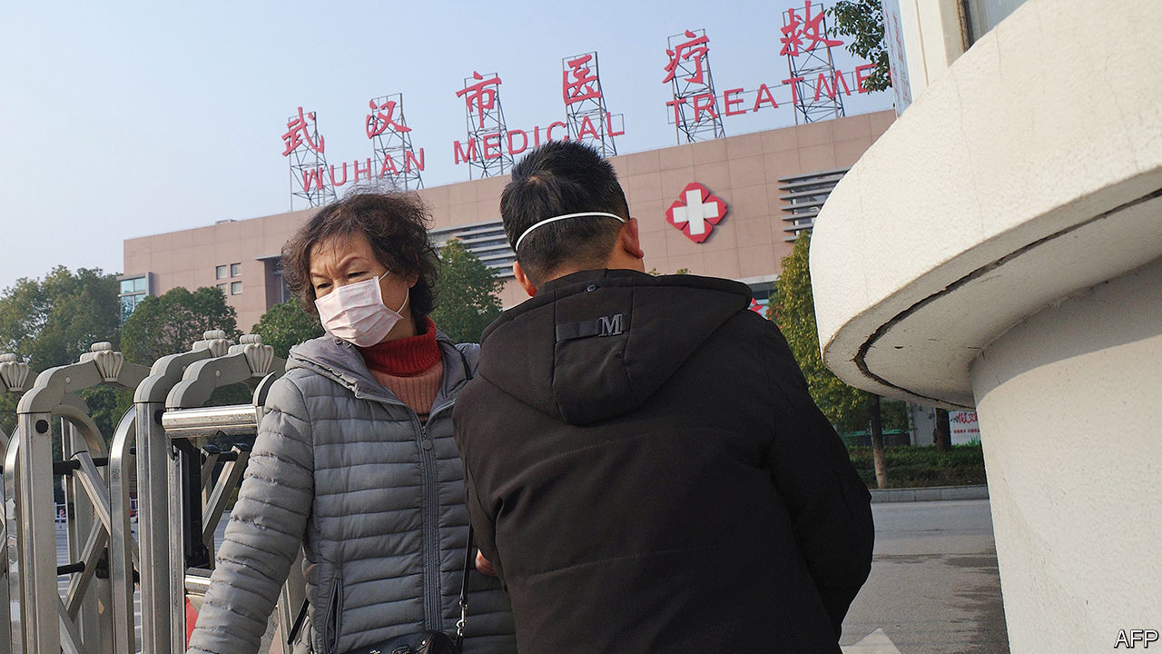

BEFORE 2003 few outside the field of respiratory medicine would have heard the term “coronavirus”. Then came SARS—severe acute respiratory syndrome—and suddenly the word became familiar. SARS caused a medical panic. It was an unknown illness with a mortality rate of about 10% and there was a brief period when, having escaped from China, where it first appeared, and surfaced in places as far distant as Canada, it seemed to have the potential to cause a global epidemic.

Thankfully, SARS was contained, and now seems to have disappeared in the wild. But the bogeyman status of coronaviruses has not diminished. Hence the mini-panic when a new one began infecting people in Wuhan, the capital of Hubei province, in China. As The Economist went to press 42 patients had been confirmed as being ill with the new virus, one of whom had died.

The virus’s symptoms of fever and pneumonia are similar to those of several other infections, so it was not clear to start with what was happening. The person now believed to have been the first patient developed symptoms on December 8th. The most recent case in China presented on January 2nd. On January 8th, however, a Chinese visitor arriving in Thailand from Wuhan was also found to be feverish, and on January 13th her illness was confirmed as being caused by the new virus.

Once China’s health authorities realised what was going on, they acted fast. On January 1st they shut down a market that seemed to be a common factor between the patients. By January 7th they had isolated the new pathogen, showing that it was a coronavirus. And on January 12th they published the new virus’s genetic sequence, enabling doctors in other countries to check for possible cases.

Coronaviruses, so called because they vaguely resemble monarchical crowns when examined under an electron microscope, are a widespread group that infect many species of mammal and bird. The two human examples known of before 2003 both cause colds, but are not regarded as life-threatening. A diligent search after the emergence of SARS discovered two others that had been circulating, previously unnoticed, in the human population. Then, in 2012, a sixth human coronavirus was discovered and shown to be responsible for newly described symptoms now called Middle East respiratory syndrome (MERS) that kill about a third of those infected. The agent responsible for the outbreak in Wuhan, which has yet to be named formally, appears to be the seventh.

What is not yet clear is whether the Wuhan virus can, like the other six, spread directly from person to person. Novel human viruses are usually pathogens established in another animal that have jumped the species barrier. To be successful, though, they must also have mutated sufficiently to pass between members of their new host. The virus responsible for SARS, for example, came from bats, via civets, before infecting people. That responsible for MERS came from camels. Which species harboured the Wuhan virus remains unknown. The initial suspicion—hope, almost—was that each of those infected picked the virus up independently from whichever animal reservoir harbours it, rather than from another human being. The now-closed market being a common factor in infections has encouraged this belief, as has the failure of China’s health authorities to find signs of infection in those who had been in contact with patients.

Given the lack of new cases, it looks possible that even if person-to-person transmission has happened, the swift response to the new infection has nipped things in the bud. That is encouraging, as is the fact that the traveller to Thailand was detected by equipment installed for the purpose at Bangkok airport. This picked up her elevated body temperature and alerted the authorities. In a world where a virus could be halfway around the planet before medical science has got its boots on, that is something to be grateful for.■

This article was downloaded by calibre from <https://www.economist.com/science-and-technology/2020/01/18/a-new-human-coronavirus-has-appeared-in-china>

|  |  |  |  |
| --- | --- | --- | --- |
| Previous | Articles | Sections | Next |

|  |  |  |  |
| --- | --- | --- | --- |
| Previous | Articles | Sections | Next |

#### Biological robots

# A research team builds robots from living cells

They can do simple tasks, and one day might reproduce themselves

Jan 16th 2020 |



ROBOTS COME in all shapes and sizes. Some are humanoid. Others resemble animals. Many are just a jumble of arms slaving away on a production line. But one thing all robots have in common is that they are mechanical, not biological devices. They are built from materials like metal and plastic, and stuffed with electronics. No more, though—for a group of researchers in America have worked out how to use unmodified biological cells to create new sorts of organisms that might do a variety of jobs, and might even be made to reproduce themselves.

There are several ways to tinker with living organisms. Selective breeding and, more recently, genetic engineering permit the production of novel plants and animals for agriculture and horticulture, and as pets. Souped-up bugs for industrial processes can also be made in these ways. Researchers are working, too, on growing isolated animal organs for testing drugs and eventually, perhaps, for transplant surgery.

What Joshua Bongard of the University of Vermont and Michael Levin of Tufts University in Massachusetts have come up with is different. As they report in the Proceedings of the National Academy of Sciences, they and their colleagues have designed organic robots from their cellular components, and then set about realising those designs by joining together specific types of stem cells taken from a well-studied species of African frog, Xenopus laevis. The result (pictured) is close to matching the biological definition of an organism, in that it is capable of behaving autonomously and contains cell types that are specialised to perform different roles.

Though only a millimetre or so across, the artificial organisms Dr Bongard and Dr Levin have invented, which they call xenobots, can move and perform simple tasks, such as pushing pellets along in a dish. That may not sound much, but the process could, they reckon, be scaled up and made to do useful things. Bots derived from a person’s own cells might, for instance, be injected into the bloodstream to remove plaque from artery walls or to identify cancer. More generally, swarms of them could be built to seek out and digest toxic waste in the environment, including microscopic bits of plastic in the sea.

To design their bots Dr Bongard and Dr Levin employed a computer program called an evolutionary algorithm. This worked by creating virtual representations of thousands of arrangements of cells that might achieve a particular task. It then tested those arrangements, using what is known about the biophysics of Xenopus cells, for suitability to perform the task in question, picked the most promising versions to form the basis for thousands more cellular arrangements, and then repeated the process until something properly fit for purpose emerged. That done, it was merely a matter of building the pattern which the algorithm had arrived at out of actual Xenopus cells, using microsurgical techniques to shape groups of cells in the way the pattern dictated.

The demonstration bots Dr Bongard and Dr Levin have made use two types of stem cell. Some are so-called pluripotent cells taken from early-stage embryos. These embryonic cells retain wide powers to turn into other cell types. The others are cardiac progenitor cells, a more specialised type of stem cell already destined to generate heart muscle.

Placed in a dish, bots made in this way were able to propel themselves along the dish surface via contractions of the heart-muscle cells within them. Besides pushing single pellets, groups of bots put into a dish together were able to work collectively, moving around in circles and gathering the pellets into neat piles.

Exactly how that happens is not yet clear. “It is possible”, says Dr Bongard, “that the cells are signalling to one another in a way we’re not aware of.” That possibility, and many other questions, will be the subject of further research. The team are also trying to work out how cells can be motivated to build complex, functioning bodies. Such knowledge, says Dr Levin, would be immensely useful in regenerative medicine, which seeks to repair organs and build body parts for transplant.

## Go forth and multiply?

For xenobots to have a practical future, though, someone will have to find a less fiddly way of making them. At present, it takes a microsurgeon hours to handcraft each individual bot, peering down a microscope and using tiny tweezers to do so. One way the process might be automated is by employing three-dimensional printing to build up the necessary layers of cells.

The new organisms could also do with upgrading in certain ways. At present, for example, they have short lives—a couple of weeks at most. This is because they do not have any apparatus for feeding themselves. In one sense that is a good thing, for it soothes fears about safety. If a bot should escape it would expire at the end of its allotted time and, being made simply of frog cells, would be biodegradable and non-toxic. But because longer-lived bots would be more useful, the researchers are looking at ways to extend their creations’ lives.

A more controversial suggestion is to equip xenobots with reproductive systems—perhaps as simple as allowing them to divide themselves in two, in the way that flatworms can. This would help any application that required a swarm of the critters. It might also, though, raise concerns about escapees establishing themselves in the wild. All this, says Dr Bongard, means it will be necessary to work with policymakers to decide how the production of future life forms, as useful as they might be, might be regulated. ■

This article was downloaded by calibre from <https://www.economist.com/science-and-technology/2020/01/18/a-research-team-builds-robots-from-living-cells>

|  |  |  |  |
| --- | --- | --- | --- |
| Previous | Articles | Sections | Next |

|  |  |  |  |
| --- | --- | --- | --- |
| Previous | Articles | Sections | Next |

#### Palaeontology

# What really killed the dinosaurs?

Lingering doubts about the cause of a mass extinction are put to rest

Jan 18th 2020 |



ONE THING about the prehistoric past which almost everybody thinks they know is that the dinosaurs (those, at least, that did not belong to the group of animals now known as birds) were wiped out more or less instantaneously by a collision between Earth and a very large space rock. The crater from that collision was discovered decades ago in southern Mexico. The effects of the giant waves created by the impact can be seen in places like Hell’s Creek, near Bowman, North Dakota, where marine creatures were swept far inland. And modelling suggests the planet would have been a pretty uncomfortable place for quite some time afterwards, with ejecta suspended in the atmosphere blotting out the sun, and acid rain changing the chemical composition of the oceans.

And yet... a small group of holdouts paint a different picture. Yes, they say, Earth was indeed hit by an asteroid or comet some 66m years ago at the end of the Cretaceous period. But that was either a coincidence or the straw that broke the planet’s ecological back. For the rocks also show that a series of huge volcanic eruptions was happening at the time in what is now India. Toxic and climate-changing gases from these eruptions, they suggest, were the underlying cause of the mass extinction that did for the dinosaurs—a point of view backed up by the fact that two earlier mass extinctions, those at the ends of the Permian and Triassic periods, coincided with similar eruptions while showing no sign of an asteroid strike. Conversely, several other large bolides are known to have arrived at various times in the past without accompanying extinctions.

A paper just published in Science, by Pincelli Hull of Yale University and her colleagues, casts further light on the matter. It shows that though the Deccan Traps eruptions, as this period of volcanism is known, went on over the course of around 1m years, they did most of their atmospheric damage about 200,000 years before the dinosaurs disappeared. So it was indeed, the team conclude, the impact that caused the extinction, not the volcanoes.

Dr Hull and her associates gathered data from hundreds of sources. These included analyses of fossil leaves, soil, mollusc shells, foraminifera (a type of shell-growing amoeba) and general marine sediments. Such sources record palaeotemperatures in several different ways. One is through the ratio in shells between two isotopes of oxygen. This ratio varies with ambient temperature in a predictable manner. A second is the ratio of magnesium to calcium in foraminifera shells. A third, called TEX86, relies on the composition of the membranes of a group of single-celled organisms called Archaea. And so on.

By combining all of these data the researchers show pretty conclusively that the temperature rose by about 2°C between 400,000 and 200,000 years before the mass extinction. It then fell gradually back over the subsequent 200,000 years to its previous level. They interpret this temperature spike as a consequence of global warming brought about by carbon dioxide released in the Deccan Traps eruptions. This would also have coincided with the rise and decline of other nasties, such as sulphur dioxide, which the Deccan volcanism pumped into the atmosphere. By the time of the mass extinction, in other words, it looks as though things atmospheric had returned to normal. It therefore seems unlikely that the Deccan Traps were responsible for the extinction. Rather, it was the asteroid wot done it.■

This article was downloaded by calibre from <https://www.economist.com/science-and-technology/2020/01/18/what-really-killed-the-dinosaurs>

|  |  |  |  |
| --- | --- | --- | --- |
| Previous | Articles | Sections | Next |

|  |  |  |
| --- | --- | --- |
| Science and ... | Sections | Economic and ... |

Books and arts

Conflict and culture: Pictures at an exhibition

.

American politics: Original sin

.

The second world war: Freedom fighters

.

Chinese fiction: Beneath the waves

.

Johnson: Who do they think they are?

.

|  |  |  |
| --- | --- | --- |
| Science and ... | Sections | Economic and ... |

|  |  |  |  |
| --- | --- | --- | --- |
|  | Articles | Sections | Next |

#### Pictures at an exhibition

# As violence spreads across Mali, artists in the capital resist

“It is our duty to create something beautiful every day,” reckons Seydou Camara, a photographer

Jan 16th 2020 | BAMAKO

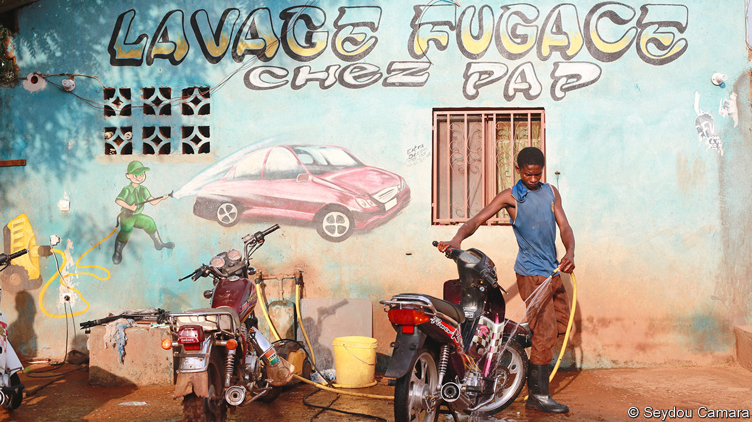

ONCE A WEEK Seydou Camara leads several dozen photography students around Bamako, Mali’s sprawling capital. Most of them do not have equipment of their own, but that does not deter them. They troop through the sunburned streets, past countless motorbikes, vegetable-sellers and fabric-dealers, passing round a few old cameras between them as they walk. “We want to teach them how to tell their city’s stories,” says Mr Camara.

As vast swathes of the country are tormented by men with guns and machetes, Mr Camara’s free classes have become a small act of resistance. The wiry street photographer is determined to help sow the seeds of a new generation of artists who can prosper when the fighting stops. “I believe it is our duty to create something beautiful every day,” he says.

His country’s cultural history is unusually rich. In medieval times west African civilisation blossomed in territory along the banks of the Niger river that was to become modern Mali. In the 13th century, while Europe burned heretics, books were a status symbol in the Malian empire. Scholars and nobles collected many thousands of manuscripts and turned the cities of Timbuktu, Gao and Djenné into repositories of the world’s knowledge.

Since independence from France in 1960 Bamako—meaning “crocodile river” in the local Bambara tongue—has undergone a fresh renaissance. Its position at the crossroads between the arid Sahel region and the luxuriant Gulf of Guinea has made it a melting pot for artists and musicians from across west Africa. Legendary performers have emerged from the city. In the late 20th century Ali Farka Touré and Toumani Diabaté cemented Bamako’s status as a musical powerhouse with their desert blues. Malick Sidibé and Adama Kouyaté pioneered African photography, capturing the exuberance of a generation throwing off the shackles of colonialism.

Today, the city’s cultural scene is under threat. In 2012 rebels and jihadists swept out of the Sahara and captured the northern half of the country. The militants enforced an extremist Wahhabi ideology, looted libraries and damaged the ancient mud-brick mosques of Timbuktu. In 2013, after the gunmen began to advance on Bamako, thousands of French and Chadian soldiers intervened and drove them back into the desert. Over the past seven years, the jihadists have regrouped and set different ethnic groups against each other. Attacks and ethnic pogroms have once more spread from the remote north to within a few hundred miles of the capital.

Apart from a handful of incidents, Bamako itself has so far been largely unscathed by the violence. Unless the Malian armed forces disintegrate, or the French and United Nations contingents that are still stationed in the country are withdrawn, it will remain safe for the foreseeable future. Physically safe, at least; the conflict has already had a devastating impact on artistic life in the city. Take Mr Camara. Ten years ago, his future looked bright. A series of pictures he shot of the lives of his country’s albino population earned international praise. Collectors and foreign newspapers were keen on his intimate portrayals of urban life (see above).

Recently, tourists—and buyers—have become scarce; dealers of African art tend to skip Bamako in favour of Lagos, Nairobi or Dakar. Mr Camara and many of his peers are struggling to make ends meet. “It has become very difficult for us,” says Kadia Sogobo, a 24-year-old photographer. “Our heritage and our culture are under threat.” Mercedes Vilardell, who acquires African art for Tate Modern in London, says Malian artists do not have the same resources as South Africans or Nigerians to advertise their work internationally. Since “people are now too scared to come here”, she laments, “it just isn’t seen.”

For all the turmoil, life goes on in Bamako. The street bars still hum with the rhythms of Tuareg rock, Congolese rumba and Nigerian Afrobeats. Locals boast that, apart from Lagos, their city has the best nightlife on the continent. The embattled government has made a political statement simply by carrying on as normal. In December 2019 it oversaw the opening of Bamako Encounters, a biannual photography festival that has become one of Africa’s biggest. Photographers and artists came from all over the continent to tell African stories in dozens of small galleries. Regular visitors reckoned fewer people were attending than in the past, but given that the event had previously been cancelled altogether because of fears over security, staging it was a show of defiance. At the opening, speakers talked about the need to fight terror with culture and beauty.

For Mr Camara the festival is particularly important. His work was first noticed there in 2009, and he knows how valuable the exposure it brings can be for his students. Without such attention, he worries that Mali’s image will increasingly be defined not by its people, but by the Western journalists who have arrived to report on the bloodshed. “All they see is our misery,” he says. “They don’t see our happiness. No one can portray us better than ourselves.”

He cannot travel across his country as he once did. Yet, for him, Bamako itself is filled with hidden tales and significance. He says the cliffs surrounding the city have a metaphorical meaning that helps define its inhabitants. “On one side of us are the cliffs of power,” he says gesturing towards the president’s hilltop palace. “On the other, you have the cliffs of knowledge, where the university is. In between, the people of the Niger welcome all.” ■

This article was downloaded by calibre from <https://www.economist.com/books-and-arts/2020/01/18/as-violence-spreads-across-mali-artists-in-the-capital-resist>

|  |  |  |  |
| --- | --- | --- | --- |
|  | Articles | Sections | Next |

|  |  |  |  |
| --- | --- | --- | --- |
| Previous | Articles | Sections | Next |

#### Original sin

# How to fix the design flaws in American democracy

Lee Drutman spies a way out of the “doom loop” of partisan dysfunction

Jan 18th 2020 |

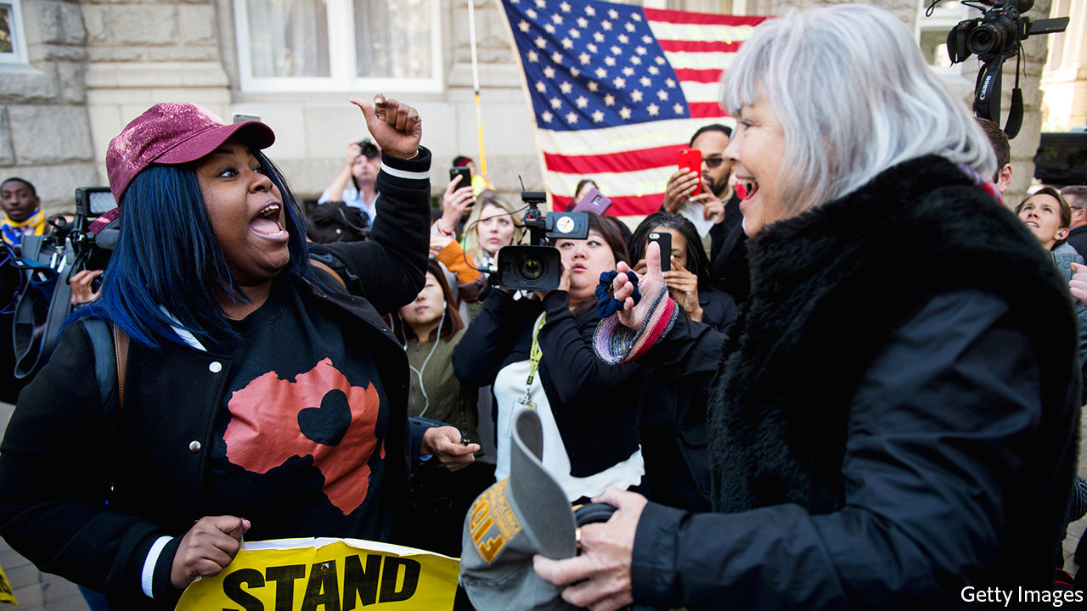

Breaking the Two-Party Doom Loop. By Lee Drutman. Oxford University Press; 272 pages; $27.95 and £18.99.

PERHAPS THE only point of universal agreement in American politics is that it is in a bad way. Impeachment of a sitting president—among the most solemn tasks a Congress can take up—has predictably disintegrated into partisan cacophony. Legislators seldom pass laws. Supreme Court vacancies trigger all-consuming contests over the soul of the nation. Ask about the cause, however, and the accord dissolves in a mess of accusations: against socialist Democrats, racist Republicans, censorious Silicon Valley or nativist Fox News.

But what if the problem is instead inherent in American democracy itself—in design flaws that encourage Manichaean polarisation and inhibit repairs? That is the convincing thesis offered by Lee Drutman, a political scientist, for present-day levels of partisanship that rival those preceding the civil war. When the country’s founding fathers unthinkingly imported the British system of first-past-the-post elections, which tends to produce two large parties since third-party votes often seem wasted, they “greased the slide into Red America versus Blue America”.

It seems odd to suggest that this 230-year-old arrangement is responsible for a deterioration in the past few decades. But, Mr Drutman argues, for much of that time the flaw was merely latent. Though Democrats and Republicans have dominated politics since the days of Abraham Lincoln, two other, shadow parties used to exist: conservative Democrats in the South and liberal Republicans in the cities. Both species are now almost extinct—killed off in culture wars over race and identity that began in the 1960s. Since then, the natural bifurcating tendency of American democracy has become dangerously pronounced.

Winner-takes-all politics means voters have limited choices. When one or other big party predominates—as is now the case in most state and local races—there is no real choice at all. Meanwhile, closed primaries allow ideological outliers, such as Donald Trump, to take over national parties. Politicians follow the incentives this system creates—towards fiercer partisanship and an increasing willingness to bend the rules and trample norms by, among other things, gerrymandering districts and refusing to vote on a Supreme Court nominee. These days, 97% of votes in Congress are entirely partisan. Control of only one state legislature (Minnesota’s) is split between the parties. The capacity for self-correction looks limited. Mr Drutman’s “doom loop” seems to be self-perpetuating.

The remedies he advocates are more far-reaching than the usual bromides about “putting country above party” or bipartisan hobnobbing in Washington. Instead, he aims to break the duopolistic stranglehold and stimulate the emergence of new parties. The mechanism for achieving that is simple: America, he says, could blunt the drift to the extremes by instituting ranked-choice voting. Because they would covet second preferences as well as top ones, candidates would be warier of the sort of negative campaigning that can repel moderates. Already the state of Maine and several American cities have such systems. Another idea is to elect multiple representatives from enlarged districts—leading to mild proportional representation and making gerrymandering much harder. Not only should this produce more moderate candidates for Congress; it might mean that four to six distinct parties would have to govern in coalition, and thus relearn the lost art of compromise.

Unlike those reforms, fixing the oddest quirk of the American political system—the election of the president via a lopsided electoral college—would require amending the constitution. Though this seems impossible now, large-scale electoral reform has happened before, in America and elsewhere. Until the 17th Amendment went into effect in 1919, following protests by the Populist Party, Americans did not directly elect their senators. Frustrated citizens in New Zealand rejected the first-past-the-post system in the early 1990s, adopting a ranked-choice method instead.

At times, Mr Drutman rhapsodises about multiparty democracy as if it were a panacea for all America’s ills. It would, he thinks, combat not only polarisation, but also low turnout, inequality and demagoguery. Yet the force of his argument, rigorous and limpidly expressed, is almost irresistible. He emerges as one of the keenest observers of America’s political pathologies—if only because he questions what others take for granted. Tracing the arc of the doom loop, he also spies a way out. ■

[Sign up to receive Checks and Balance](https://www.economist.com/checksandbalance/), our new weekly newsletter on American politics

This article was downloaded by calibre from <https://www.economist.com/books-and-arts/2020/01/18/how-to-fix-the-design-flaws-in-american-democracy>

|  |  |  |  |
| --- | --- | --- | --- |
| Previous | Articles | Sections | Next |

|  |  |  |  |
| --- | --- | --- | --- |
| Previous | Articles | Sections | Next |

#### The second world war

# The heroic women partisans of Turin

They fought for Italy’s freedom, and for their rights

Jan 16th 2020 |

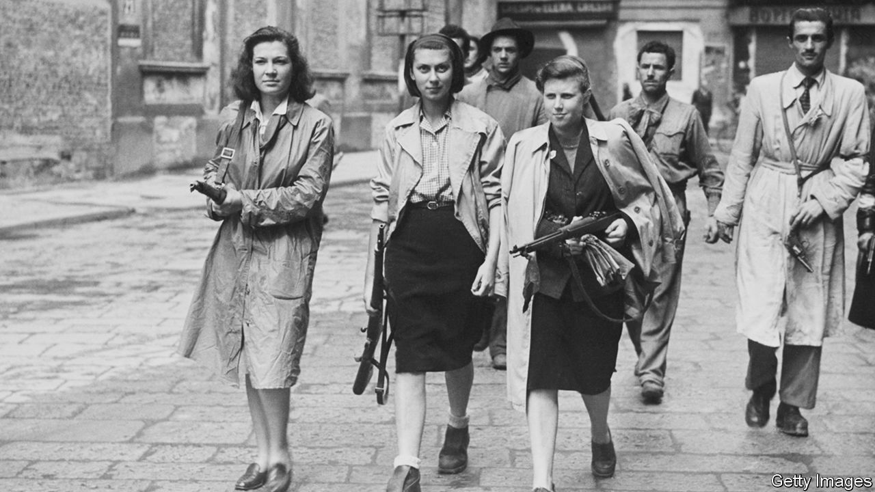

A House in the Mountains. By Caroline Moorehead. Harper; 415 pages; $29.99. Chatto &amp; Windus; £20.

THEY CAME, Caroline Moorehead writes, in red sweaters and red scarves. Some were old, others virtually children. They sang resistance songs and knelt among the tombstones as the coffins of their friends passed by. Even after fascists came to arrest them, others returned and tidied the flowers on the graves. Over 2,000 women honoured three of their comrades, murdered by thugs in Turin. One victim, Rosa Ghizzone, was pregnant when she was shot.

The defiance at the graveyard, and the preceding horror, is a single vignette from a heroic, horrific struggle. Between Italy’s capitulation to the Allies in September 1943 and the arrival of American troops 19 months later, the people of Turin engaged in a brutal civil war. In scenes repeated across northern Italy, fascist loyalists and their German backers grappled with people like Ghizzone—partisans and others who were desperate for a future free from Nazism. Like Ghizzone, about 80,000 would not live to see it.

In “A House in the Mountains”, the moving finale of a quartet of books on resistance to fascism, Ms Moorehead focuses on four other female partisans: Ada, Bianca, Silvia and Frida. Each, in her way, exemplified women’s central role in the fight for liberty. Ada Gobetti, the eldest, was an organiser. She hosted meetings and hiked across the Alps to see supporters in France. A comrade said she had “the physical and moral strength of 10,000 fighters”. Frida Malan was a staffetta, a young woman who did everything from carrying messages to arranging getaways. She and her friends rushed around on bicycles, hiding banned leaflets under salad and celery sticks.

As Ms Moorehead makes clear, this work was not only about national liberation. Her heroines knew they had a chance to grab equal rights for women. That, too, was never easy. Quite apart from fascist ideology—which cast them as docile wives and mothers—they faced chauvinism from male colleagues. After meeting Gobetti, one mocked the “revolutionary ideas our Ada has put in her head”. For their part the Allies, who were pushing up the peninsula after landing in the south, often patronised the Italians as too apathetic to be really useful. They feared communist sympathies among the resistance.

Meanwhile Italian fascist militiamen, grenades strapped to their belts, looked for suspects to torture. The Germans were at least as bad. In one massacre, a lieutenant drank a bottle of cognac before shooting 54 prisoners. Ms Moorehead conveys the terror with understated power; she is equally good at conjuring the blurred morality of civil conflict. Malan escaped a firing squad because a fascist soldier took pity—her brother had once saved his fiancée from execution by the resistance.

Many partisans fled to the mountains north of Turin, and Ms Moorehead evokes the valleys and wild flowers in technicolour detail. This was a place where peasants thought raw snails could combat rickets, and bread was hung from ceilings to harden, then broken with hammers and softened in milk. The partisans delighted in all this: amid round-ups and reprisals, Ms Moorehead writes, Gobetti noticed “meadows dotted with yellow and violet and the briars covered in white flowers”. The mountains helped these remarkable women retain their humanity, even as they battled for their country and their rights. ■

This article was downloaded by calibre from <https://www.economist.com/books-and-arts/2020/01/18/the-heroic-women-partisans-of-turin>

|  |  |  |  |
| --- | --- | --- | --- |
| Previous | Articles | Sections | Next |

|  |  |  |  |
| --- | --- | --- | --- |
| Previous | Articles | Sections | Next |

#### Beneath the waves

# Loneliness and longing in Beijing

“Braised Pork”, a debut novel by An Yu, follows a young widow’s uncanny quest

Jan 16th 2020 |



Braised Pork. By An Yu. Harvill Secker; 240 pages; £13.99. To be published in America in April by Grove Press; $25.

IN LITERATURE, AS in other fields, China’s opening to the world has helped blur the boundaries between homegrown culture and diaspora life. Rather than decide irrevocably between East and West, younger figures such as the author and film-maker Xiaolu Guo—who writes in both Chinese and English—may move between continents and mine material from every place they land. “Braised Pork” is the debut of a Beijing-raised, Paris-based writer who has also studied in New York. It reads, however, not as a slice of expat—or exile—fiction, but as a contemporary Chinese novel that happens to have been written in English.

As other contemporary Chinese authors have before her, An Yu (born in 1992) evokes the loneliness of a young woman in a newly affluent society that has discarded not only “feudal ways of thinking” but the spiritual ballast of the past. Widowed at an early age, Wu Jia Jia, her unmoored heroine, embarks on a dreamlike search for an inner realm of meaning that eludes her among the shopping malls and wine bars of upscale Beijing.

Jia Jia finds her wealthy older husband Chen Hang—who married her to possess “the finest, most tasteful accessory”—drowned in the bath, bizarrely crouched in an attitude of prayer. Ms Yu studs her story with hallucinatory images and episodes that interrupt its otherwise realistic flow. The uncanny drawing her husband left of a fish with a human head triggers Jia Jia’s quest. A painter, she starts to depict marine scenes that suck her into a “world of water” where everyday identity disintegrates. Both frightening and consoling, this oceanic kingdom promises the “balance between mystery and simplicity” that she craves in art and life.

Other characters—her new bartender boyfriend, his scholarly parents, her own father and aunt—drift through a narrative in which memory has broken into fragments and “The past seemed to have become merely what remained.” Jia Jia’s fond recollections of braised pork, a favourite family dish, hint at her longing for a vanished intimacy. Her widow’s journey follows images of the tantalising “fish man” to Tibet, which, as often in Chinese writing, is imagined as a heartland of esoteric wisdom. There, “at the edge of the world”, an old sculptor divulges secrets of a watery domain “where there are no barriers”. In Tibet, Jia Jia glimpses the fate of her long-dead mother, another lonely seeker.

Ms Yu chooses not to pin down the significance of her aquatic dreamscape. In the contradictory manner of occult images, it may represent both limitless freedom and an escape from the big-city curse of isolation. Her novel has a cool, poised elegance that only adds to its enigmatic allure. All mysteries aside, it also suggests that the fallout from China’s “one-child policy” still moulds the emotional terrain of many younger artists. ■

This article was downloaded by calibre from <https://www.economist.com/books-and-arts/2020/01/16/loneliness-and-longing-in-beijing>

|  |  |  |  |
| --- | --- | --- | --- |
| Previous | Articles | Sections | Next |

|  |  |  |  |
| --- | --- | --- | --- |
| Previous | Articles | Sections | Next |

#### Johnson

# Who do they think they are?

The battle over the singular use of “they” has been waged for centuries

Jan 16th 2020 |



GRAMMAR HAS rarely produced as much public acrimony as in the battle over pronouns being waged around the world. In one skirmish in 2015, the University of Tennessee offered guidance on referring to non-binary students on its website, only for political blowback to lead to a legislative ban on spending public money to support non-traditional pronouns. Jordan Peterson, a controversial Canadian academic, has refused to use invented pronouns or “they” in relation to people who identify as neither male nor female. Many fulminating commentators spy political correctness running amok yet again.

Into the breach comes a useful corrective in the form of Dennis Baron’s well-timed new book, “What’s Your Pronoun?” Mr Baron is a linguist at the University of Illinois, and a longtime scholar of a curious gap in the English language. For centuries, people have wrestled with the fact that there is no uncontroversial pronoun to refer to a subject of unknown, indeterminate or mixed gender.

Singular they, in sentences such as “Everyone loves their mother”, has been derided as incorrect for a long time. Mr Baron tracks the first such ruling to a 16th-century Latin grammar, which declared the masculine the more honourable gender that, where necessary, encompasses the feminine. In the 18th and 19th centuries, this view made its way into English grammars: when referring to a generic person, you should say “Everyone loves his mother.”

But there were wide holes in this argument. Proponents of the rule treated it as a simple matter of grammatical agreement: everyone is grammatically singular, so requires a singular pronoun. They is plural and won’t do. To real sticklers for agreement, however, pronouns must tally in both number and gender. Generic they is wrong by number, but generic he is wrong by gender.

Nonetheless, “he includes she” was in textbooks, and so, for a time, proto-feminists tried to take advantage where they could. Laws saying that each person should pay “his” taxes required women to pay, too. So, 19th-century suffragists reasoned, the statute books referring to a generic voter as “he” gave women the right to vote. Seemingly hoist on the chauvinist petard, defenders of male-only suffrage tactically retreated: he included she unless it would produce an “absurd” reading—such as offering women the vote. (Since it was often held that husbands voted in their wives’ interests, Susan B. Anthony, a 19th-century American suffragist, suggested that if a woman commits murder her husband should be hanged in her stead.)

Given the problems with he, lots of people have invented new, gender-free pronouns. The first one Mr Baron could find (of more than 250 in total) dates to 1841: E. Other suggestions continue in a steady stream until today. Every once in a while, one found a tiny purchase. In 1884 three dictionaries included thon, shortened from that one, but it failed to catch on. The Sacramento Bee, a newspaper, said in 1920 that it would use hir in place of “he or she”, and did so sporadically until the 1940s, but it too faded away.

The “missing word”, Mr Baron says, is “they”. People have been using it as a generic singular in writing since at least 1375, and have doubtless been saying it even longer. It has appeared as such in the King James Bible, the works of Shakespeare and the novels of Jane Austen. Recently, growing numbers of style guides, including those of The Economist and the Associated Press as well as the Chicago Manual of Style, have concluded that it is often the most pragmatic of a set of imperfect solutions.

But all that comes as a different singular they has come to the fore: to refer to a known individual who identifies as non-binary, as growing numbers do, in sentences such as “Alex forgot their keys.” This is the increasingly widespread singular they that was recently recognised by the American Dialect Society as its Word of the Decade.

The two usages are quite different. The one in “Everyone has their own opinion” is actually quite conservative, given its age, its literary pedigree and the fact that most people already say it in casual speech. They in “Alex forgot their keys” is, by contrast, innovative and jarring to many; for the uninitiated, it takes practice to use it consistently. And though both feminists and transgender activists have embraced the singular they, they have done so for different reasons, and other issues still divide them. A rare moment of liberation through grammar risks being caught up in wider, rancorous culture wars.

This article was downloaded by calibre from <https://www.economist.com/books-and-arts/2020/01/18/who-do-they-think-they-are>

|  |  |  |  |
| --- | --- | --- | --- |
| Previous | Articles | Sections | Next |

|  |  |  |
| --- | --- | --- |
| Books and arts | Sections | Graphic detail |

Economic and financial indicators

Economic data, commodities and markets

.

|  |  |  |
| --- | --- | --- |
| Books and arts | Sections | Graphic detail |

|  |  |  |  |
| --- | --- | --- | --- |
|  | Articles | Sections | Next |

# Economic data, commodities and markets

Jan 16th 2020 |

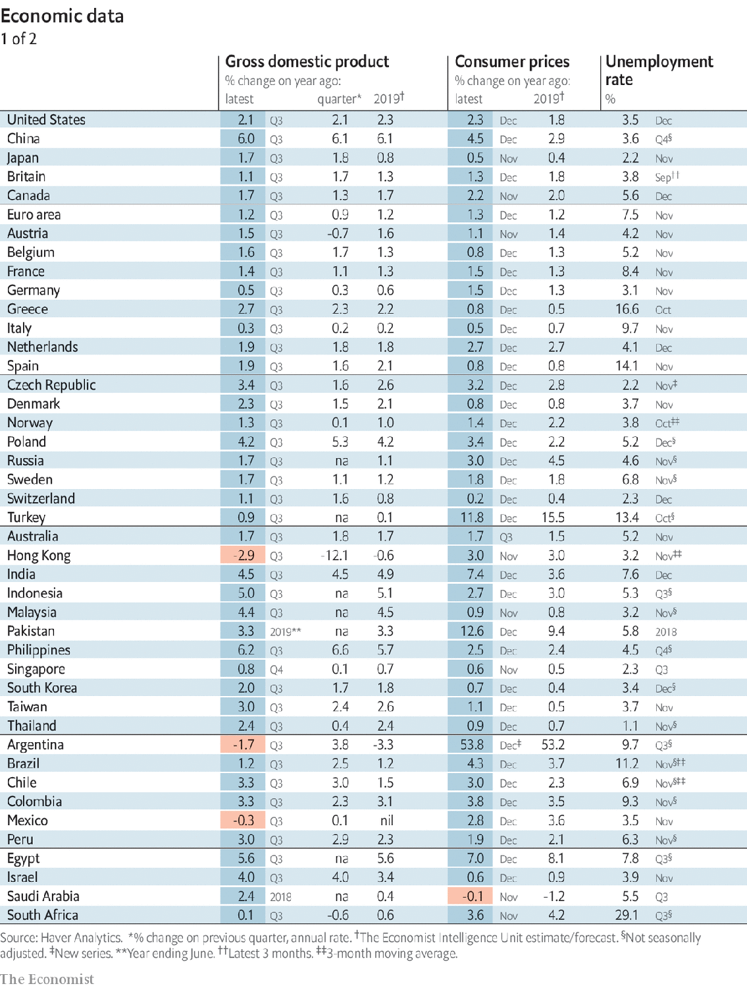

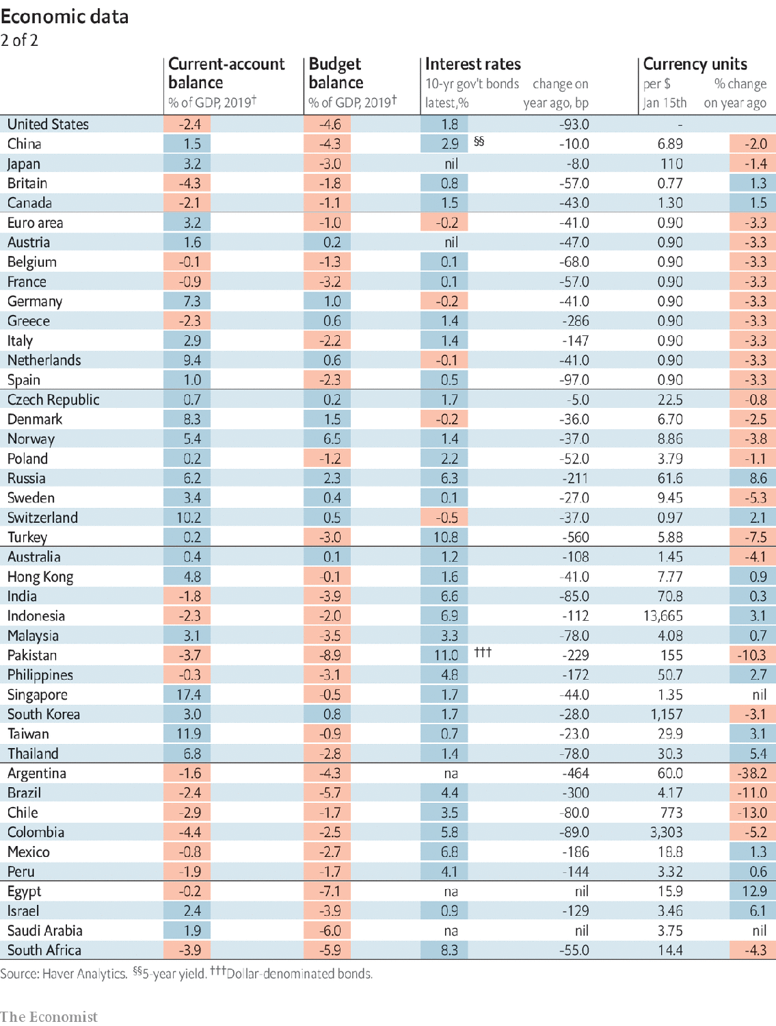

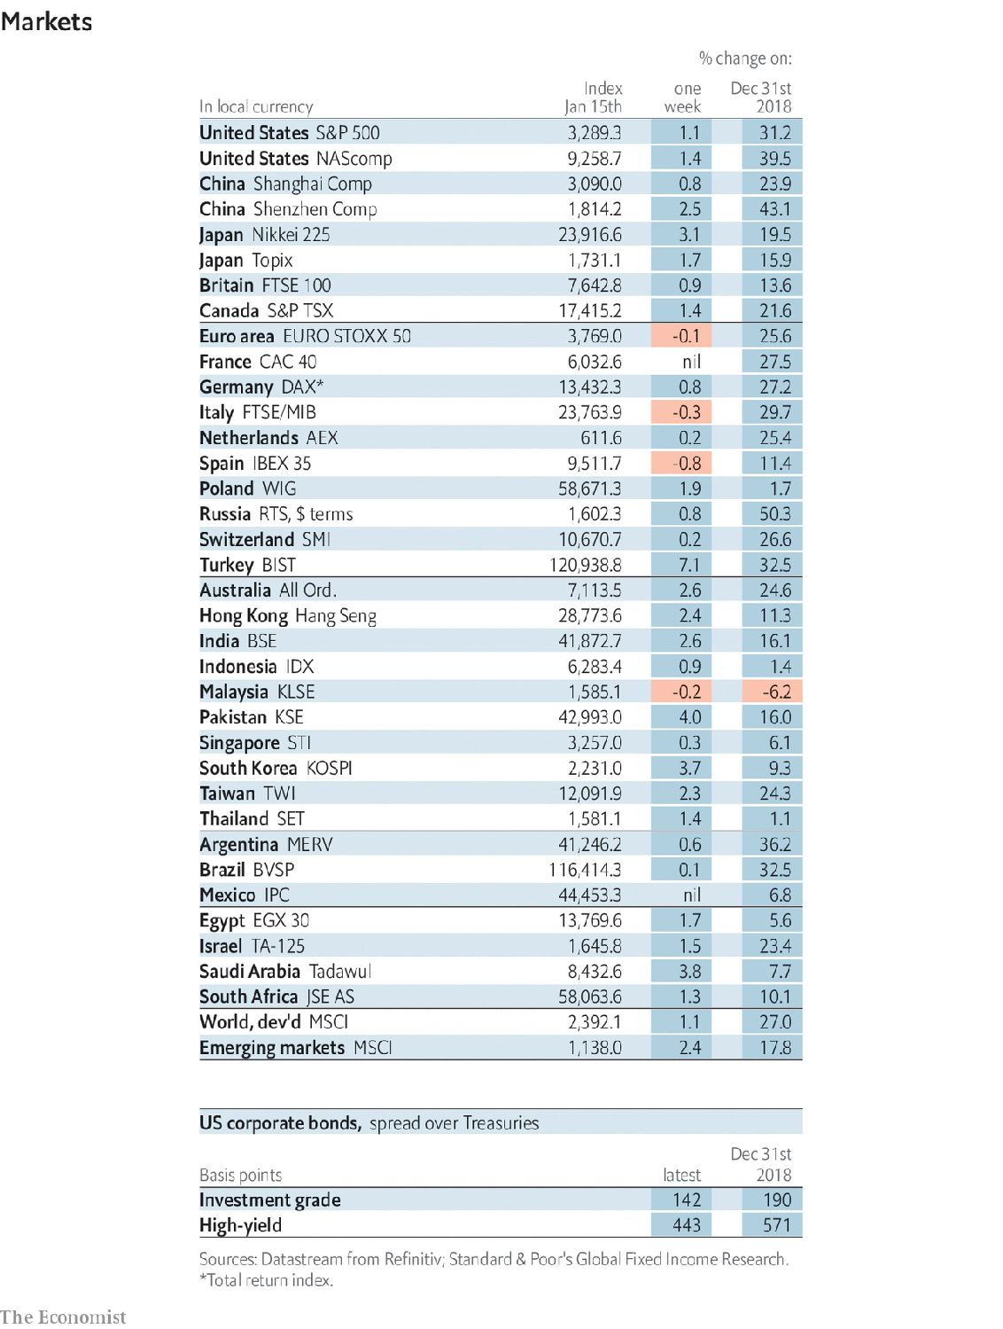

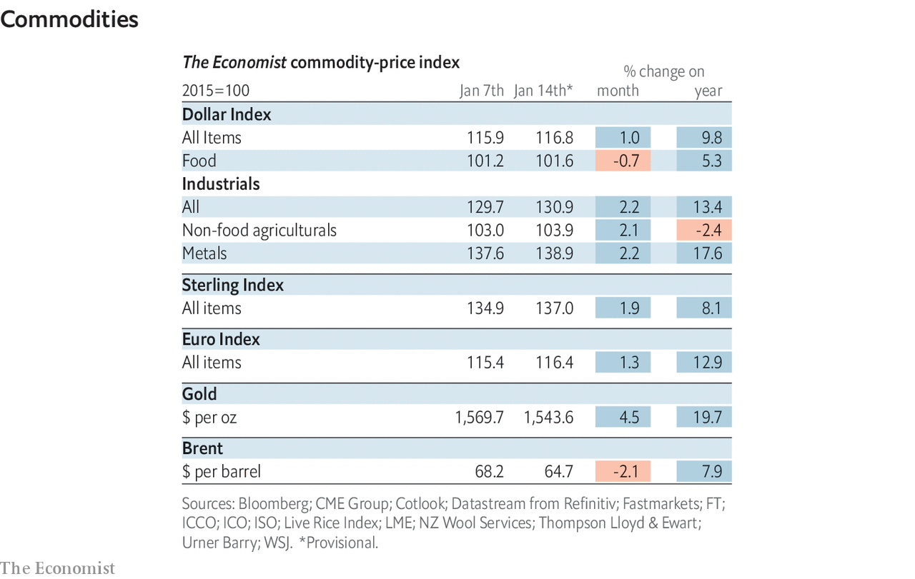

This article was downloaded by calibre from <https://www.economist.com/economic-and-financial-indicators/2020/01/18/economic-data-commodities-and-markets>

|  |  |  |  |
| --- | --- | --- | --- |
|  | Articles | Sections | Next |

|  |  |  |
| --- | --- | --- |
| Economic and ... | Sections | Obituary |

Graphic detail

|  |  |  |
| --- | --- | --- |
| Economic and ... | Sections | Obituary |

|  |  |  |
| --- | --- | --- |
| Graphic detail | Sections |  |

Obituary

Roger Scruton: Defender of the right

.

|  |  |  |
| --- | --- | --- |
| Graphic detail | Sections |  |

|  |  |  |  |
| --- | --- | --- | --- |
|  | Articles | Sections | Next |

#### Defender of the right

# Obituary: Sir Roger Scruton died on January 12th

The conservative philosopher and controversialist was 75

Jan 18th 2020 |

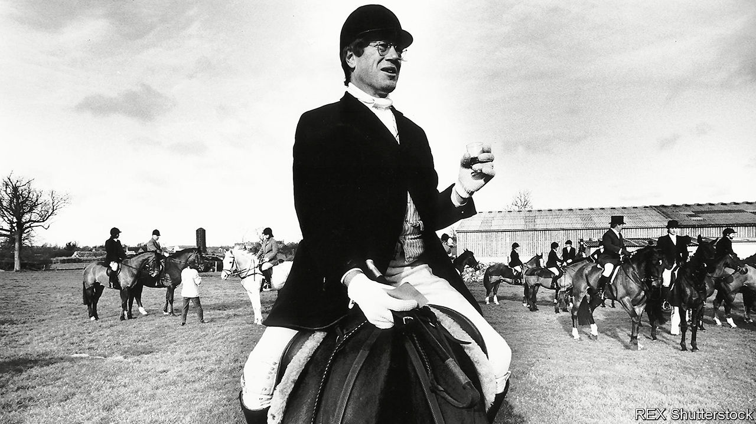

ON FROSTY WINTER mornings, or at any season, there was no greater pleasure for Roger Scruton than to ease into woollen breeches and a frock-coat, pull on his boots, mount his old horse and, in the wake of the milling hounds, set off for the hunt. His life, he had concluded, fell like Caesar’s Gaul into three parts. In the first he was a wretched youth, fighting an often drunk, ardently socialist father who, after he had won a scholarship to Cambridge, would not speak to him. In the second, restless part he travelled, wrote, and built up an academic life in philosophy at Birkbeck College and elsewhere. And in the third, from the early 1990s, he went hunting. It combined in one activity his three abiding passions: conservatism, controversy, and Englishness.

There was no doubt that in mid-life and later he more often felt like the fox, the individual plucked from his species to be scapegoated and killed. His opinions got him barred from universities and dismissed from a government commission—though, since his remarks had been distorted, he was quickly reinstated. They made him such a figure of scorn at Birkbeck that he read for the Bar in case they threw him out. Running against the prevailing modernist orthodoxy of the liberal-left, lamenting the loss of everything from classical education to stiff upper lips to England itself, he often found himself as lonely as Reynard racing for the coverts.

Being alone, he lashed out all the more. Targets worth attacking lay on every side, beginning with that ludicrous gobbledygook of Marx and Foucault and the sanctimoniousness of those who promoted it: the unparalleled bigotry of the left. He moved on to leftist “intellectuals”, fools, frauds and firebrands, as he characterised them in “Thinkers of the New Left” in 1985. He took on multiculturalism, which harmed immigrant children by not instructing them in the ways and customs of England—as well as the ridiculous charge that he was a racist, rather than a patriot, for encouraging that argument in the Salisbury Review when he was editor. Then he wondered aloud whether homosexuality, like incest, had been stigmatised for the justifiable reason that it threatened the healthy survival of the human race.

All this got him into a good deal of trouble. He did not see why it should. To speak his mind openly was surely not such an intolerable thing. His biggest lapse from the morality he saw fading on every side came when he was not open, but plotted secretly in 2002 to place pro-smoking articles in several magazines while taking a fee from Japan Tobacco. The disgrace that followed disrupted his academic life and caused him to flee to America, his pariah’s wounds now, as he admitted, deserved. After a few years he returned, though. He had to; he missed hunting too much.

## A Hegelian in Albion

The landscape he rode through was the Wiltshire claylands, lying under the ancient chalk figure of the White Horse on its hill, a country with its ancestry still evident in villages, Jacobean mansions and the patchwork of the fields. This sense of deep belonging in a place was expressed in English common law, laid down by custom, habit and precedent like a stratum of stone; it was reinforced by membership of institutions, from the cricket team to the Church of England, each with their observances. All this had to be preserved. That was why he was a conservative and, though a Kantian by instinct, a Hegelian in his conviction that people’s ideas of the world were shaped by language, tradition, culture, the spirit of a place. He had seen enough tearing down, whether by vandal developers ripping the heart from Georgian towns or by rioters in Paris in 1968, to know that he was firmly on the other side.

And this was a frustrating place to be. English conservatives found thinking precarious, and did not unite round abstractions like the French; they believed that ideas should be inherited, then ignored. He was not happy with a full-throttle defence of capitalism, and worship of the free market, as in Margaret Thatcher’s reign of terror, did not seduce him either. As he wrote in “The Meaning of Conservatism”, the core conservative value was not competition, but attachment: the defence of civil society and a certain way of life. The state should stay small not just because bureaucratisation was bad, but because when government intervened people ceased to help each other and social capital dwindled. He saw this exemplified in eastern Europe, where in the 1980s he secretly supported the Czechs against a withering communist regime which, controlling everything, left them only with emptiness. By contrast, thrown from his horse on the hunt once, he was rescued by a fellow-member who instinctively stayed behind. This precious pre-modern soul became his second wife.

The hunt epitomised other values for him. It brought the classes together not as equals, but in a common purpose. It expressed his freedom, by custom and tradition, to follow that purpose over his neighbours’ fields. The hedges he jumped were a vestige of old livestock agriculture which he, too, had preserved for some years by running a farm at Sunday Hill and leasing out his grass. The beauty of his land as he returned to it went, as Kant said, beyond the limits of reason. It made him feel at home in the universe.

And that, in the end, summed up England for him. As he argued in “England: An Elegy” in 2000, it was not a nation—it had never quite succeeded at that—but a home, in which, as in his old farmhouse, he could ease off his boots, pour a glass of wine, and know the place as his. As occupiers went in his particular part of it, he was very new, a town boy who also kept two rooms in the Albany off Piccadilly and whose accent was still foreign. But like Mustafa, the local craftsman cobbler, he had learned the ancient art of fitting in.

His ideas, too, had mellowed amid the grass. He spoke warmly of feminism as part of natural reform, decrying only the destructive kind. He regretted his thoughts about homosexuality, which was complicated. Towards any nonsense from the left, however, he remained on high alert—ready, as soon as he heard it flustering the hen-coop, to seize crop and helmet and cry “Tally ho!” ■

This article was downloaded by calibre from <https://www.economist.com/obituary/2020/01/18/obituary-sir-roger-scruton-died-on-january-12th>

|  |  |  |  |
| --- | --- | --- | --- |
|  | Articles | Sections | Next |